Тема | Джерело  (література, посилання) | Завдання
Практичне заняття 18  Тема “Odd Jobs” | 1) “Англійська мова” для студентів 2-го року навчання. “English” for Second Year Students: навч.-метод. посіб. / І. С. Ковальчук, О. Б. Сивак. – Житомир: ЖДТУ, 2018. – 156 с. | 1) ODD JOBS Video + Ex. 7-9, p.118  2) WORK Conversation questions (att)  3) CONDITIONAL SENTENCES Type 3  1) Grammar Exercise (att)  3) JOB QUALIFICATION Ex.3- 5, p.122

GRAMMAR 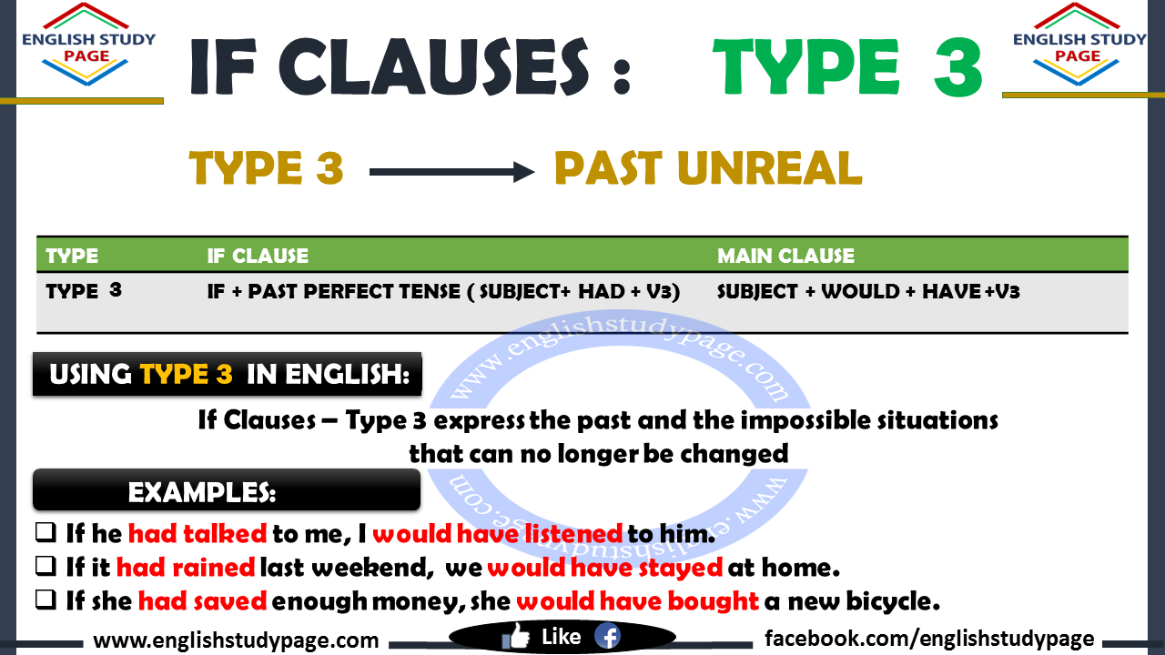
Third Conditional (умовне речення 3-го типу) – умовне речення, що виражає нереальну ситуацію в минулому та її нереальні наслідки, тобто ця уявна ситуація так і не відбулася. В більшості випадків умовні конструкції 3-го типу передають відтінок докори, критики, прикрості через щось, що не було виконано у минулому.
В умовних реченнях 3-го типу в підрядній if-частині використовується час Past Perfect, а також інколи Past Perfect Continuous, а в головній частині – модальні дієслова would, could, might з формою доконаного інфінітиву без частки to. В таких реченнях сполучник if не можна заміняти на when.
if-clause | main clause
if + Past Perfect | would/could/ might+ have +Ved (III)
If she had done the tasks in time, | she would have got a good mark.
If he had had much money, | he would have launched his own business.
If you hadn’t been talking on the phone for so long, | we might have arrived to the airport on time.

Put in the correct third conditional verb form.
1. If you __________ (not / be) late, we __________ (not / miss) the bus.
2. If she __________ (study), she __________ (pass) the exam.
3. If we __________ (arrive) earlier, we _________ (see) John.
4. If they ______________ (go) to bed early, they ______________ (not / wake) up late.
5. If he ______________ (become) a musician, he ______________ (record) a CD.
6. If she ______________ (go) to art school, she ______________ (become) a painter.
7. If I _______ (be) born in a different country, I _________ (learn) to speak a different language.
8. If she ______________ (go) to university, she ______________ (study) French.
9. If we _________ (not / go) to the party, we ______________ (not / meet) them.
10. If he ______________ (take) the job, he ______________ (not / go) travelling.
11. He ______________ (be) happier if he ______________ (stay) at home.
12. She ______________ (pass) the exam if she ______________ (study) harder.
13. We __________ (not / get) married if we _____________ (not / go) to the same
university.
14. They _____________ (be) late if they ______________ (not / take) a taxi.
15. She _________ (not / meet) him if she __________ (not / come) to London.
16. He ______________ (take) a taxi if he ______________ (have) enough money.
17. I ______________ (call) you if I ______________ (not / forget) your phone.
18. We ______________ (come) if we ______________ (be) invited.
19. She ______________ (not / do) it if she ______________ (know) you were ill.
20. He ______________ (be) on time if he ______________ (leave) earlier.

Complete the Conditional Sentences (Type III) by putting the verbs into the correct form. (HOME TASK)

- If you (study) for the test, you (pass) it.
- If you (ask) me, I (help) you.
- If we (go) to the cinema, we (see) my friend Jacob.
- If you (speak) English, she (understand) .
- If they (listen) to me, we (be) home earlier.
- I (write) you a postcard if I (have) your address.
- If I (not / break) my leg, I (take part) in the contest.
- If it (not/ start) to rain, we (walk) to the museum.
- We (swim) in the sea if there (not / be) so many sharks there.
- If she (take) the bus, she (not / arrive) on time.

