Topic 1.2. University life
Revision of vocabulary using pictures + homework checking
University Life p. 43-44 Ex. 9-10
+ Listening Comprehension about exams
+ Grammar Past Simple
Resources:
“English” for first year students : навч.-метод. посіб. для студ. всіх спец. вищ. навч. закл. / І.С. Ковальчук, О.Б. Сивак.
https://learnenglishteens.britishcouncil.org/

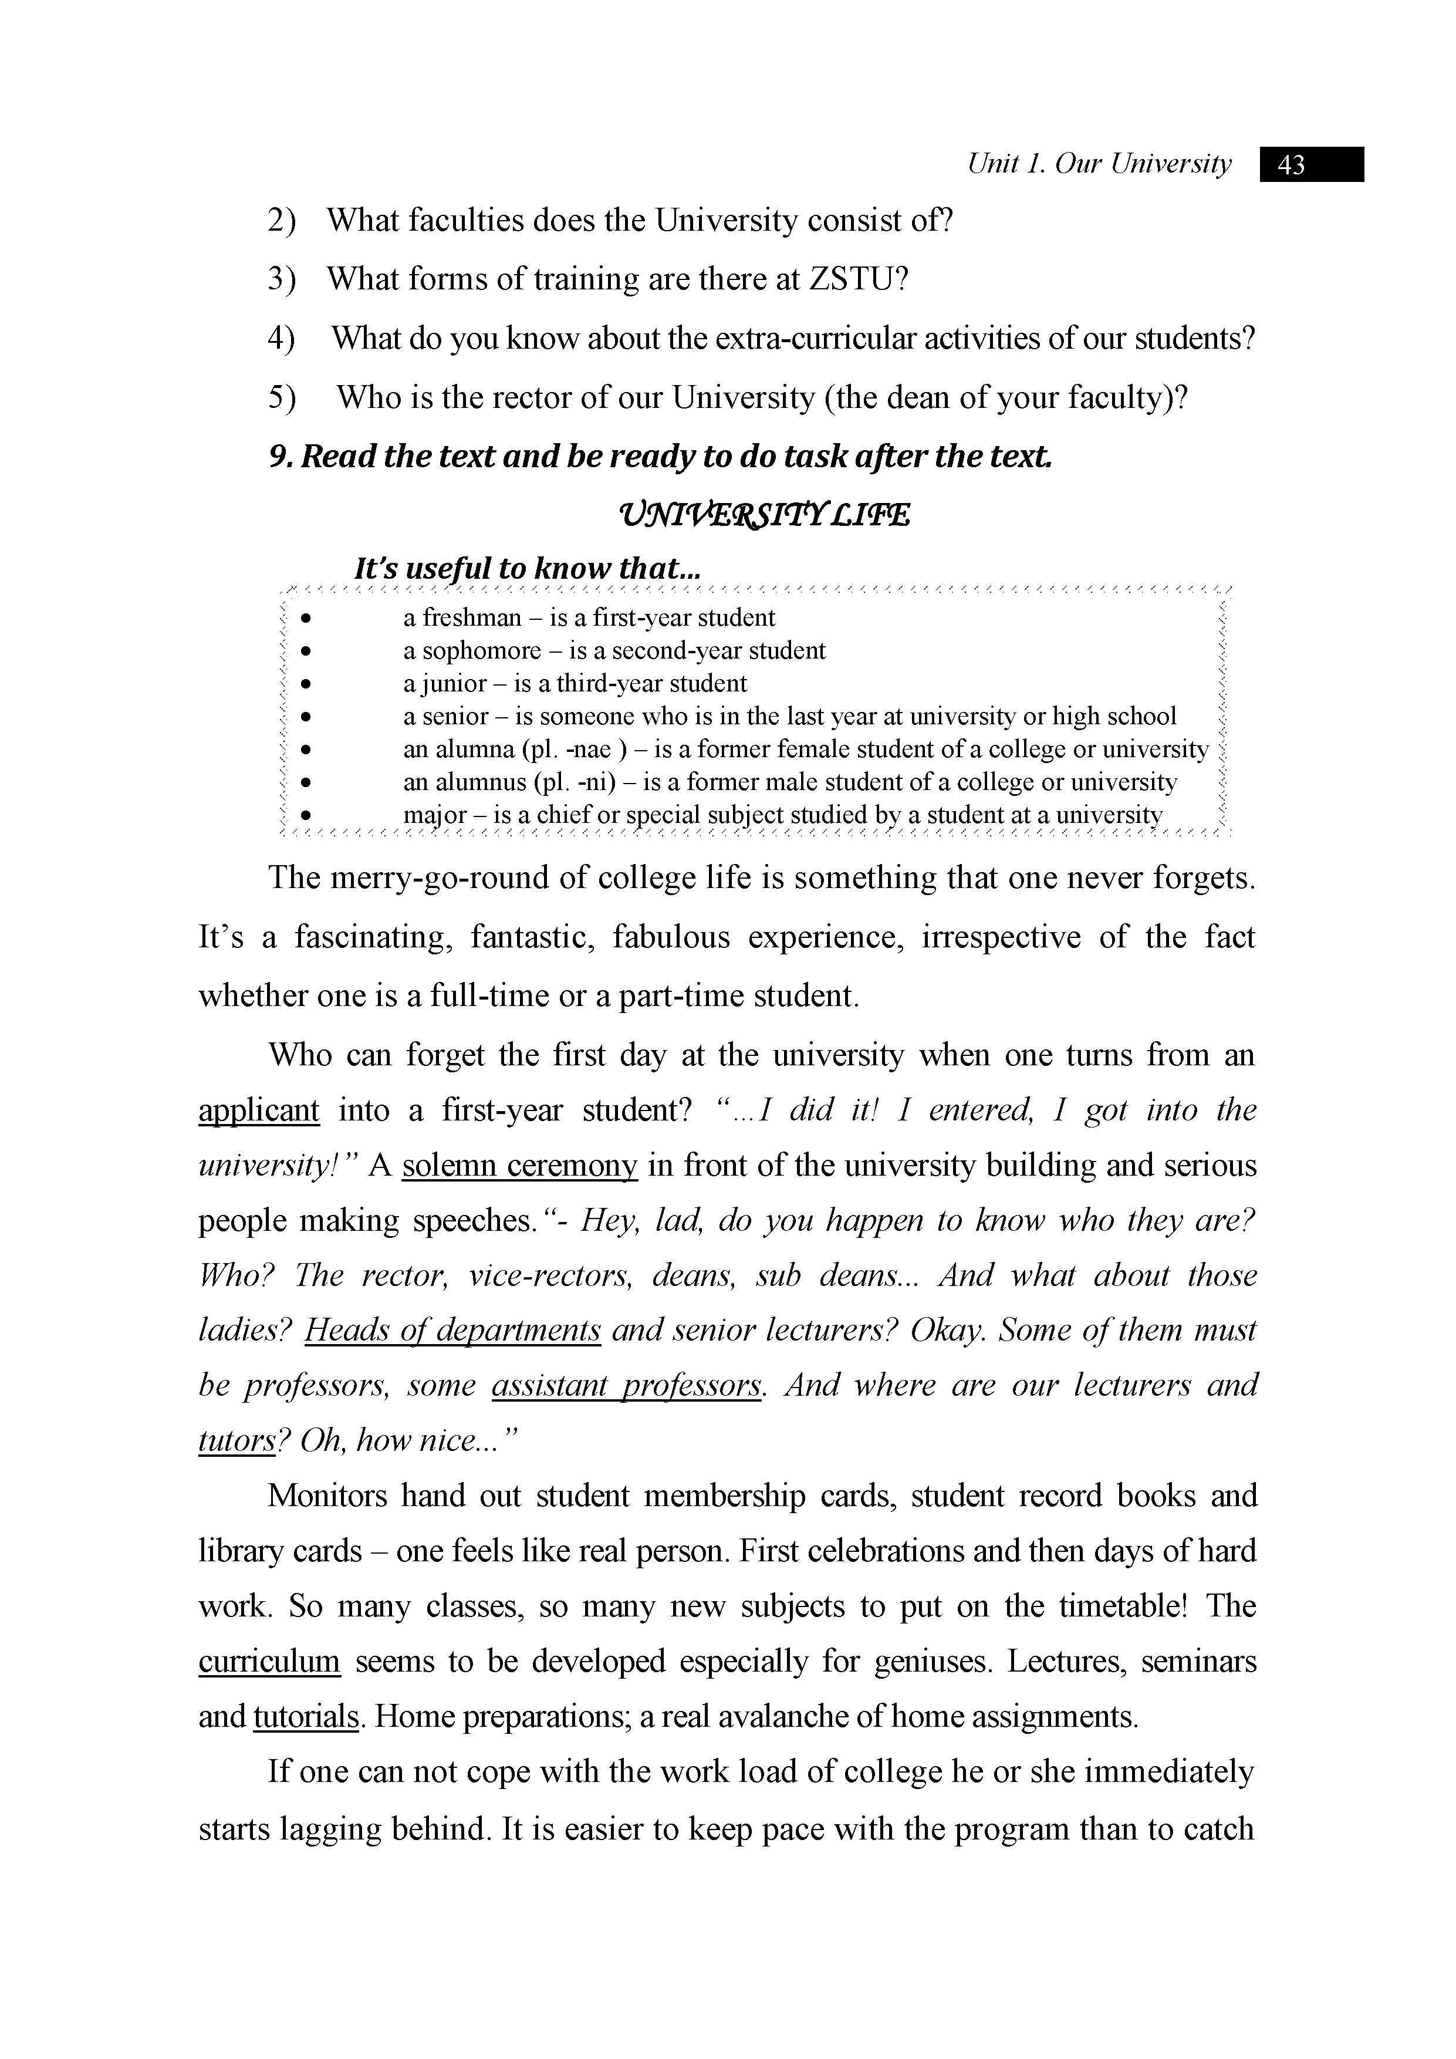

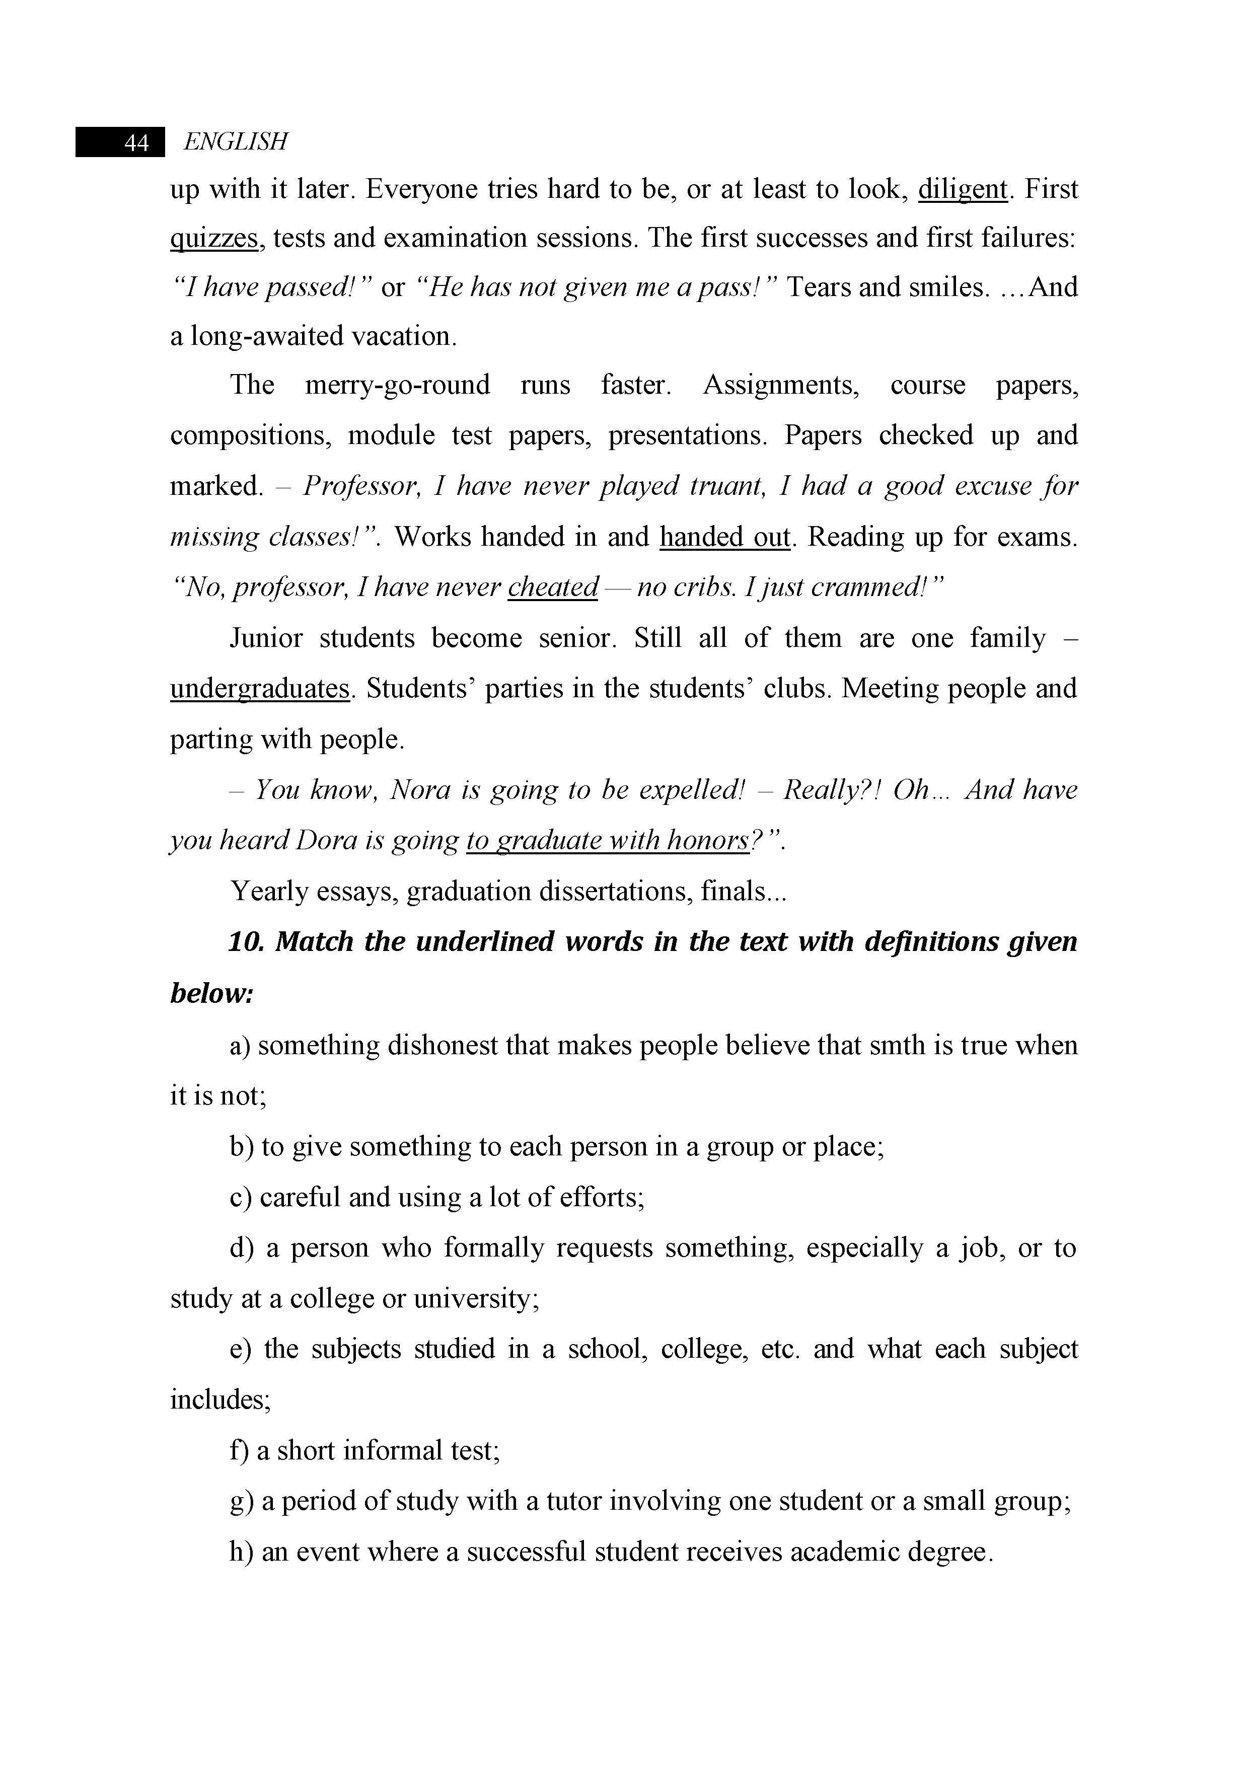

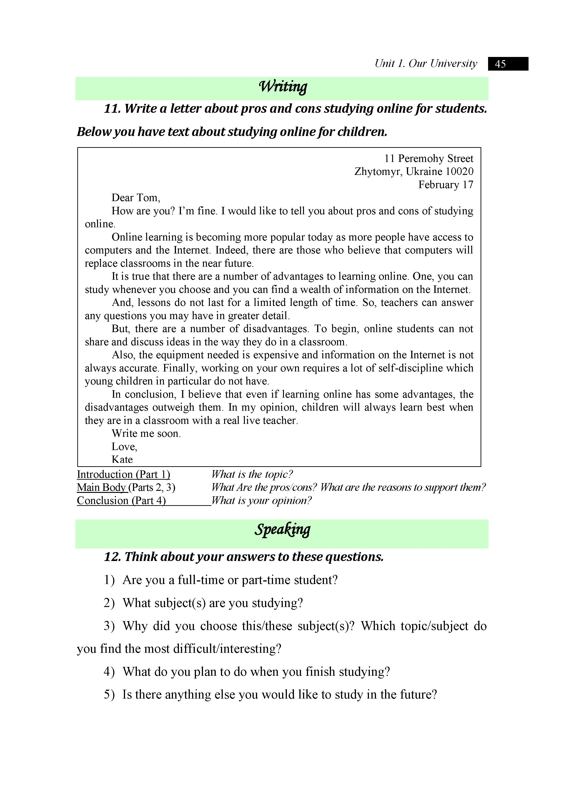

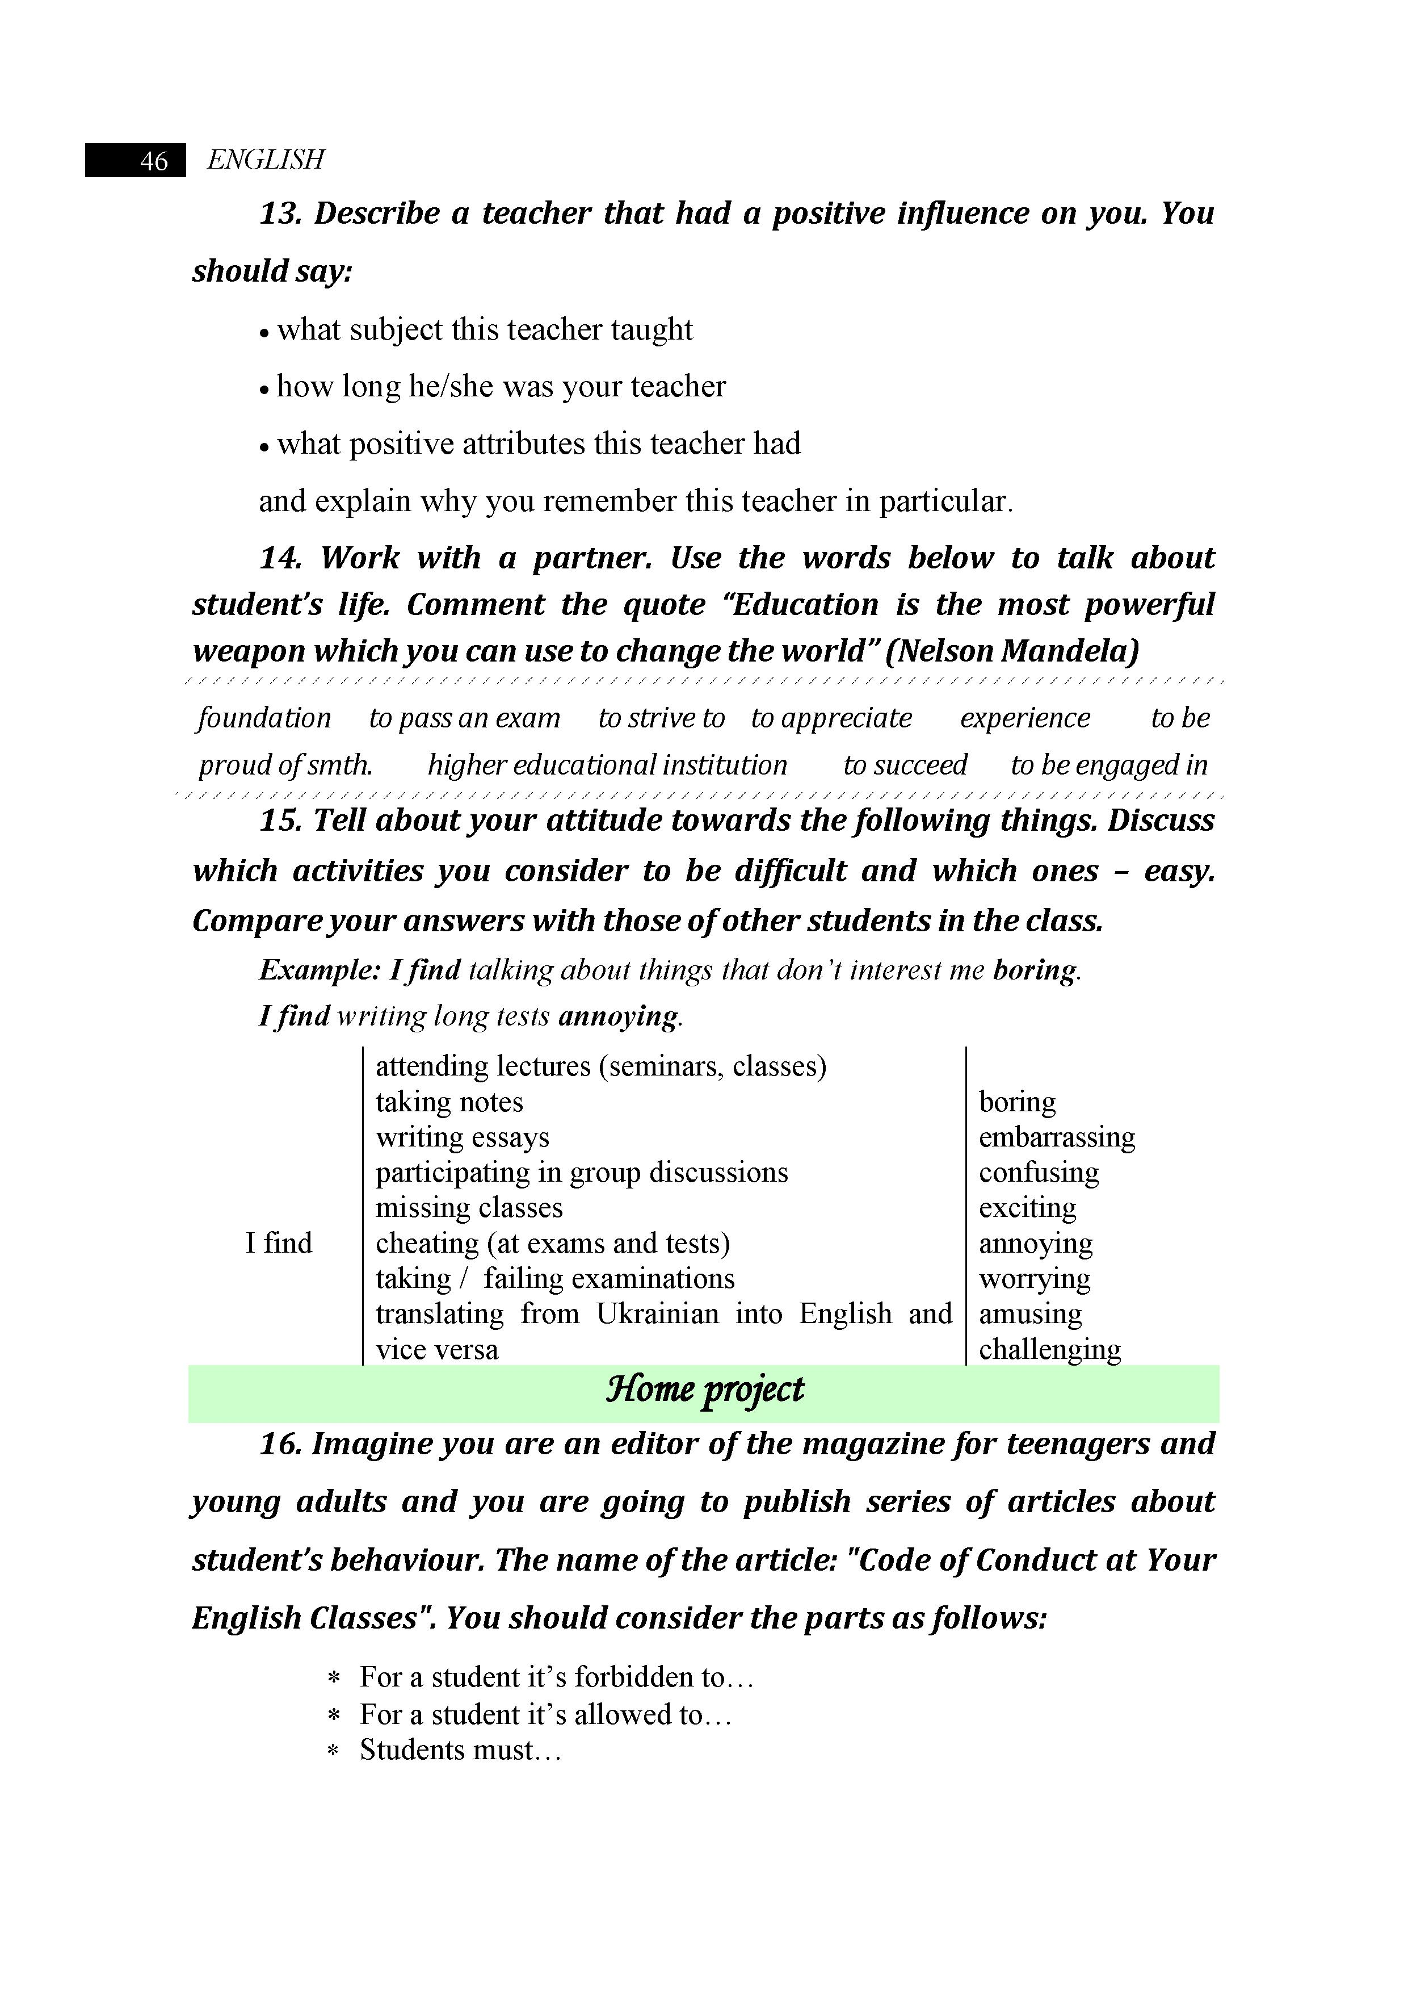

Listening:
- Soon you are going to have exams, how are you going to prepare? Your keys to success.
- Listen and mark sentences as true or false.
1. Clare is good at history.

2. Clare’s notes are too long.

3. Mark thinks you need to write everything.

4. Mark draws a crown and an ‘H’ instead of ‘King Henry’.

5. Clare doesn’t think Mark’s idea is very good.

6. Mark's way of taking notes doesn't work for Clare.
3. Fill in the gaps.
Draw Important Notes Exam Write Remember
Clare has got a history _________ on Friday. Mark is helping her. He looks at her ______________ from today. He explains that she doesn’t need to ____________ everything, just the ____________ words. She can _________ pictures too. Pictures help you ___________ facts.
- Discussion: Do you agree that writing notes is effective? Why/why not?

