Міністерство освіти і науки України
Житомирський державний технологічний університет

Л.Ф.Могельницька
О.О.Васильєва

Англійська мова для магістрів

Методичний посібник

Житомир 2015
Міністерство освіти і науки України
Житомирський державний технологічний університет

Л.Ф.Могельницька
О.О.Васильєва

АНГЛІЙСЬКА МОВА ДЛЯ МАГІСТРІВ

Методичний посібник

для магістрів

Ухвалено на засіданні
кафедри іноземних мов ЖДТУ
протокол № 14 від 20.05.2015

2015

Англійська мова для магістрів: методичний посібник / Укладачі: Могельницька Л.Ф., Васильєва О.О. – Житомир: ЖДТУ, 2015. – 77с.

Методичний посібник призначений для студентів освітньо-кваліфікаційного рівня «магістр» і має на меті формування навичок наукового, ділового та професійного спілкування англійською мовою. Посібник укладений з урахуванням комнікативного підходу до навчання англійської мови, що базується на формулі ‘ppp’ – ‘presentation – practice – production’. Методичний посібник складається з 11 розділів, кожен з яких містить навчальний текст, ситему вправ та завдань на засвоєння лексики, розуміння прочитаних матеріалів, обговорення запропонованих питань. Кожен розділ завершується творчим завданням, що дає змогу студентам продемонструвати набуті комунікативні компетенції.

Укладачі: Л.Ф. Могельницька
О.О. Васильєва

Відповідальний редактор: Л.Ф. Могельницька

Комп’ютерний набір
та верстка Ю.В. Вагнер

ВСТУП

Магістратура – це форма навчання фахівців (магістрів), підготовлених до науково-дослідної та педагогічної діяльності. Магістри повинні володіти грунтовною науковою базою і методологією наукової роботи та бути в курсі сучасних інформаційних технологій і методів отримання та обробки наукової інформації. При навчанні в магістратурі студент отримує поглиблені знання у певній науковій сфері, має можливість займатися науково-дослідною роботою.
Методичний посібник «Англійська мова для магістрів» має на меті вирішити ще одну задачу при підготовці магістрів – сприяти інтеграції в англомовну наукову та бізнес спільноту. Знання іноземної мови відкриває ще більш широкі горизонти для працевлаштування та підвищення рівня заробітної плати. Методичний посібник складається з двох блоків інформації, фокусом яких є наукова та ділова англійська мова. Перша частина посібника містить матеріали, присвячені темам «наука та науковці», «ефективне читання», «науково-дослідна робота», «публічна доповідь». Друга частина матеріалів присвячена питанням працевлаштування: «вибір професії», «перший робочий досвід», «винагорода праці», «написання резюме та співбесіда». Методичний посібник складається з 11 розділів, кожен з яких містить навчальний текст, ситему вправ та завдань на засвоєння лексики, розуміння прочитаних матеріалів, обговорення запропонованих питань. Кожен розділ завершується творчим завданням, що дає змогу студентам продемонструвати набуті комунікативні компетенції.

Contents
Module 1. Science and Scientists
Unit 1. What Is Science?....................................................................................6
Unit 2. The Importance of Science………………………………..………….15
Unit 3. Steps to Better Reading………………………………………………20
Unit 4. What is a Research Paper?....................................................................29
Unit 5. Making Presentations…………………………………………………34

Module 2. The World of Work
Unit 1. Choosing a Profession…………………………………………..……40
Unit 2. First Working Experience…………………………………………....47
Unit 3. Job Rewards………………………………………………………….50
Unit 4. Job Hunting…………………………………………………………..52
Unit 5. Designing a Resume………………………………………………….55
Unit 6. Job Interview………………………………………………………….64
Video appendix………………………………………………………………72
Module 1. Science and Scientists
Unit 1. What is Science?
Discussion points
- Why have you decided to do Master’s course? Give at least 3 reasons.
- What is the difference between Master’s and Specialist’s course in Ukraine?
- Master’s thesis is the 1st level of a scientific ladder, isn’t it? What are Ukrainian scientific degrees? European? American?
- What is science?
What is Science?
Read the article and divide it into logical parts.
The word science originates from the Latin word «scientia», meaning knowledge. Science is simply a way of looking at the world. It consists of asking questions, proposing answers and testing them against the available evidence.
A popular astronomer Carl Sagan wrote: «Science invites us to let the facts in, even when they don't conform to our preconceptions. It counsels us to carry alternative hypotheses in our heads and see which best match the facts». Science is a human construct and human ability.
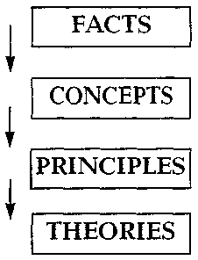
Types of Science Products
- are specific verifiable pieces of information obtained through observation and measurement
- are abstract ideas that are generalized from facts or specific relevant experience
- are more complex ideas based on several related concepts
- consist of broadly related principles that provide an explanation for a phenomenon
The purpose of a theory is to provide the best explanation based on evidence. Theories are used to explain, relate, and predict.
Students of science major in various fields of science. They take part in R&D at their institutions. The faculty and staff at the universities and institutes will help the students as they fulfill their academic and professional goals. Research advisors — well-known scientists will help their students with research. Graduate students spend most of their time in independent study and original research. For example, graduate studies in the USA can be divided into two phases:
Phase I leads to Master's degree and consists of lecture-type coursework. This degree is usually required in fields such as engineering, library science etc. The MBA or Master of Business Administration usually takes two years.
These degrees are considered stepping stones toward a PhD. Normally few, if any laboratory courses are offered. A thesis, calling for significant research and/or design effort may be required.
Phase II leads to doctoral degree — PhD (doctorate). Students who are enrolled in a doctoral program are known as PhD candidates. They will spend some time in class, but the most important work is spent in first-hand research. It may take three years or more to earn a PhD Degree. This degree normally requires four to six years of study beyond the Bachelor's degree, culminating in lengthy, in-depth, original research of a specific topic, which may be both theoretical and applied, or purely theoretical. Usually, doctoral studies focus very heavily on developing advanced scientific skills.
A PhD dissertation is considered a unique, original contribution to human knowledge. This paper must contain views, research or designs that have not been previously published. The best and the most suitable methods, techniques, approaches and procedures should be used.
Several research publications on issues relevant to the investigation should be prepared. Most universities awarding the PhD Degree also require doctoral candidates to have a reading knowledge of two foreign languages, to pass a qualifying examination that officially admits candidates to the PhD program, and to pass an oral examination on the same topic as the dissertation.
If the dissertation meets all the requirements it will be accepted and approved by a special board of academics after oral defense.
Most scientists spend many years studying and working in laboratories. Scientists can work individually or in a team. In many cases, scientists are devoted to their work and may find little time to do other things. Usually scientists are involved in studying various aspects of their fields, and work on one or two major projects at one time.
A good example of a dedicated scientist and researcher is U.S. neurosurgeon Benjamin Carson. Speaking to young people around the country, Carson always concludes with the same message: «Think big!» He explains the meaning of each letter:
T — is for talent. Recognize your God-given talent.
H — is for hope. Anticipate good things and watch for them.
I — stands for insight. Learn from people who have been where you want to go.
N — is for nice. Be nice to people — all people.
K — represents knowledge. Knowledge is the key to your dreams, hopes and aspirations.
В — is for books. We develop our minds by reading.
I — equals in-depth learning, where acquired knowledge becomes part of you.
G — stands for God. Never drop God out of your life.
«If you can learn to think big, nothing on earth will keep you from being successful in whatever you choose to do», says Carson. And eminent American astronomer Vera Rubin has given the following piece of advice to young scientists: «Don't give up. Remember that science is ever so vast; learn one thing very well. Doing so ... gives you great confidence, allows you to share knowledge with colleagues. It helps if you know what you really want to do. Work hard. Learn to give good talks. Be imaginative. If you are interested in science you must have a fundamental curiosity».

Vocabulary work
1. Give Ukrainian equivalents of the following words and word combinations: available, evidence, to conform, preconception, to major in, R&D, research advisor, to meet the requirements, board, devoted, insight, relevant.
2. Match the words with their meanings:
1. science  2. field of science  3. faculty and staff  4. research  5. scientist  6. degree  7. to focus on  8. skill(s)  9. to be involved in  10. aspiration  11. curiosity  12. aspect | a) the desire to know or learn  b) a strong desire to do smth. or have smth.  c) a title given by a university to a student who has completed a course of study  d) to direct one’s attention to smth.  e) special ability to do smth. well  f) a particular side of many-sided idea  g) to take part, to participate  h) knowledge which can be made into a system  i) serious and detailed study of a subject  j) all of teachers and other professionals  k) a person who works in science  l) a branch of knowledge or area of activity
3. Restore the context where the following words are used in the article: to counsel, goal, to require, to earn, in-depth, to anticipate.
4. Give English equivalents for: спеціалізуватися у галузі науки; науковий керівник; цілі; досягати мети; відомий науковець (вчений); самостійне дослідження; детальне вивчення; теоретичні та прикладні аспекти; навички наукової роботи; Вчена Рада; унікальний внесок; питання, що стосуються дослідження; оригінальна методика; брати участь у науково-дослідній роботі; одночасно працювати над кількома проектами; бути відданим науці; не здаватися; ділитися знаннями з колегами, бути надзвичайно допитливим.
5. Match two columns:
- Я не фахівець у цій галузі.  - Яка мета вашого дослідження?  - Вона спеціалізується у галузі прикладного мовознавства.  - Якою галуззю науки ви цікавитесь?  - Це питання стосується вашого дослідження.  - Якою наукою ви займаєтесь?  - Його дисертація відповідає усім необхідним вимогам.  - Вони беруть участь у науково-дослідній роботі.  - Мій науковий кервник - відомий вчений.  10. Вони дійшли цікавих висновків. | a) What field of science are you interested in?  b) This issue deals with your investigation.  c) His dissertation meets all the necessary requirements.  d) What science are you doing?  e) That's outside my field.  f) She majors in linguistics.  g) What is the objective of your research?  h) My research advisor is a well-known scientist.  i) They've arrived at interesting conclusions.  j) They are involved in R&D.
6. Choose the correct word and fill in the blanks.
product (produce)  production  to produce | producer (s)  productive  productivity
- We had a very _____ meeting last week.
- The two lasers combine _____ a powerful cutting tool.
- The country's main _____ is oil.
- New _____ methods have led to increased _____.
- This country is one of the world's leading oil _____.
- The wine bottle was marked «_____ of France».

(to) predict prediction predictable
- The economists _____ an increase in the rate of inflation.
- You're so _____!
- It is hard _____ when it will happen.
- His _____ turned out to be correct.
science scientific scientist
- I'm fond of reading _____ fiction.
- He is a famous _____.
- I don't need any _____proof.
to apply applied application(s)
- This rule does not _____ in your particular case.
- A new discovery has a number of industrial _____.
- Her research is both theoretical and _____.
(to) require requirement(s) required
- To carry out this plan would _____ increasing our staff by 20 %.
- This monograph is _____ reading for our course.
- Candidates who fail to meet these _____ will not be admitted to the university.
curious curiosity
- There was an intense _____ about their plans.
- I'm _____ about what happened.
(to) imagine imagination imaginative
- You can't _____ how surprised I was.
- She has a vivid _____.
- Be _____!

(to) develop development
- This was an important stage in country's _____.
- I'd like _____ my idea.
7. Choose the word or phrase (a, b, c, d) that best keeps the meaning of the underlined word or phrase.
1. There are obvious disadvantages to this plan.
a. well-known b. serious c. clear d. fundamental
2. I tried to anticipate the kind of questions they were likely to ask me at the interview.
a. solve b. guess c. remember d. discuss
3. The problem would interest the entire community.
a. whole b. large c. engineering d. small
4. It is not easy to predict this trend.
a. cause b. create c. forecast d. test
5. The author discusses all facets of most engineering fields.
a. prospects b. aspects c. issues d. forms
6. Eventually, they have worked out the basic concepts.
a. lately b. spontaneously c. finally d. gradually
7. Most of our meetings were devoted to discussing scientific problems.
a. dedicated b. confined c. conformed d. introduced
8. The vast land stretches for hundreds of miles.
a. very small b. narrow c. very large d. spectacular
9. Is there any evidence for believing that?
a. proof b. tendency c. opposition d. chance
10. He employed the one basic technique.
a. process b. procedure c. task d. objective
11. She is very dedicated to her work.
a. interested in b. committed to c. tired of d. disappointed with
12. They devoted a lot of time for the in-depth study of botany.
a. independent b. individual c. thorough d. careful
13. He made no endeavor to help us.
a. effort b. decision c. plan d. prediction
14. Human beings are much more intelligent than animals.
a. invaluable b. realistic c. curious d. clever
15. Hopefully, I'll earn this degree in a year.
a. discuss b. get c. contain d. study
16. How is your study progressing?
a. topic b. investigation c. attempt d. procedure
17. The issue deals with international cooperation.
a. demands b. touches upon c. anticipates d. allows
8. Find the synonyms in the text to the following words: to obey, aim, famous, study, to demand, to obtain, to take part, to expect, to permit.
Key vocabulary
Science, scientists, scientific, to major in, field of science, R&D, research advisor, degree, Master, Bachelor, PhD, thesis, dissertation, to earn a degree, publications, to meet the requirements, special board of academics, oral defence.
Text activities
- Comprehension check:
  - What is the origin of the word “science”? What does it mean?
  - Interpret Carl Sagan’s idea of “science”.
  - Define the main types of science products.
  - In what way are Masters / PhD candidates trained in US / Ukraine?
  - What are the requirements to earn a PhD?
  - Compare Ukrainian and American scientific degrees and ways they are obtained.
  - Comment on Carson’s massage “Think big”.
  - What does Vera Rubin advise young scientists?
2. You participate in an International Conference “Science & Scientists in the 21st century”. Choose one of the suggested roles and make a presentation: a chairperson, a Ukrainian/American student doing Bachelor’s/Master’s/specialist’s/PhD course of study, a Ukrainian postgraduate, Benjamin Carson, Carl Sagan, Vera Rubin.

Unit 2 The Importance of Science
Discussion points
- Can you remember prominent scientists of the past? the present?
- What are your associations with the scientists of the 21st century?
- Who can be called a true scientist? Has the idea of a “scientist” changed through time?
- Which adjectives in the box do you think go with a true scientist?
hard-working lazy punctual reserved emotional enthusiastic tolerant well-dressed ambitious humorous serious intelligent fun-loving absent-minded
- Indentify the characteristics of a scientist by matching the two columns.
I  1. intelligent  - objective  - creative  - open-minded  - curious  - talented  - dedicated  - persistent  II  - decision-maker  - communicator  - designer  - inventor | a) receptive of arguments and ideas  b) remaining at a task for a long amount of time to complete a task or project  c) making observations and decisions based upon evidence, not personal opinion or hearsay  d) very interested in working very hard, devoting a lot of time to complete a task or project  e) producing new and original ideas and things, inventive  f) having a high degree of mental capacity  g) having or showing special abilities for a particular type of work  h) eager to know or learn  a) searching for new discoveries  b) being able to make important choices or / and judgements  c) creating new models or designs  d) making opinions and information known and understood by others, sharing and exchanging opinions.
- Give Ukrainian equivalents for some characteristics of a scientist:
a positive approach to failure; open-mindedness, cooperation with others; tolerance for other opinions, explanations, or points of view; avoidance of broad generalizations when evidence is limited; demand for verification, longing to know and to understand; respect for logic; consideration for consequences.
- What are the motives for doing science? Read the text and say if they are the same with yours.
The Importance of Science
Thinking about science, Goethe once said: «To one man it is the highest thing, a heavenly goddess; to another it is a productive and proficient cow who supplies them with butter». The results of science and the motives for doing it are diverse.
Curiosity is the most powerful motivation for research professionals — and for many amateurs, too. Science clarifies, explains and occasionally predicts. Understanding a piece of universe can bring satisfaction and excitement to anyone.
One can do science because one believes that practically and effectively it benefits the world. A great many scientists have had this chief conscious reason. One can do science because it represents the truth. One can also do scienсe because one enjoys it. Many people like unravelling puzzles. Scientific puzzles are very good ones, with reasonable prizes.
Science serves the missions of improving health, national security, energy, the environment and communications; it creates new products, meets the demands of emerging markets and satisfies social needs. But even strong faith in science may crack in straitened circumstances.
When it comes to future justification for curiosity-driven and mission-oriented research, we encounter three related undertakings.
First, we have to rethink the case from inside the scientific community. Government, businesses and universities must demonstrate that investments in science are the only way of fulfilling long-range goals. Research executives will have to document the ample returns from past investments and then outline future paths. Setting priorities will not be easy, and stern management to ensure excellence will be essential.
Second, we should broaden the dialogue. Society must be engaged in continuing exchange about national goals and research priorities. The press, industry, nonprofit organizations must participate.
Finally, we must expand the accessibility of knowledge. The entire professional community must pay more attention to building a scientifically literate society. Support for science, and for the benefits of technology, increases with educational level. To be successful in the twenty-first century, we need more science, not less.
Text work
1. Comprehension check:
1. Interpret Goethe’s words concerning science. What does he mean? Why do people do science?
2. List the reasons for doing science.
3. What are the missions of science?
4. Comment on the problems concerning scientific development. What are the possible ways of solving them?
2. Complete the following ideas:
Curiosity is ……
One can do science because it …… the world.
it …… the truth.
one …… it.
he …… puzzles.
scientific puzzles …… prizes.
Vocabulary work
1. Give Ukrainian equivalents of the following words: diverse, occasionally, to satisfy, to improve, community, faith, essential, to expand, to access, benefit, curiosity.
2. Match the words with their meanings:
1. diverse  2. occasionally  3. to satisfy  4. to improve  5. community  6. faith  7. essential  8. to expand  9. to access  10. benefit  11. curiosity | a) completely necessary for the existence, success of smth.  b) to increase in size, number, volume  c) anything that brings help, advantage or profit  d) to reach, enter or obtain  e) firm belief, complete confidence  f) sometimes, from time to time  g) to make better  h) to give enough  i) showing variety, different  j) a group of people living together and united by shared aims and interests  k) desire to know or learn
3. Give English equivalents for: сильний стимул; професіонали та аматори; різноманітні мотиви; поліпшувати; слугувати меті; час від часу, фінансова скрута; довкілля; задовольняти потреби; довгострокові цілі; наукова спільнота; некомерційні організації; розширяти доступність знань; приділяти більше уваги; переваги науки та техніки; національна безпека; встановлювати пріоритети.

4. In the text:
  - What is diverse?
  - What happens occasionally?
  - What brings satisfaction?
  - What does science improve?
  - What and why can happen with faith in science?
  - What must we expand?
  - Support for the benefits of what?
  - What is curiosity?
5. Find the synonyms in the text to the following words and word combinations: sometimes, different, belief, most important, to increase, advantage, to reach, to make better.
6. Prepare an oral presentation about characteristics of a true scientist. Participate in the forum discussing characteristics of a true scientist. Voice your opinion on this issue.
Unit 3. Steps to Better Reading
Discussion points
- You are going to do a Master’s thesis. What are the ways of doing a research work? What is the best way to get information?
- In what way is reading important in human life / your life?
- Do people read nowadays as much as they did a decade ago? Why?
- Do you have a favorite book / poem / author? Why do you like it / him? Discuss the genres you prefer.
- Compare and discuss reading for pleasure vs reading for work, fiction vs scientific literature.
- If you want to read something for pleasure, how do you choose a book? What are the criteria? Imagine you are in the library or in a bookstore. How do you choose? What is important?
Read the text and say what is essential to become a good and fast reader.
Steps to Better Reading
Step 1. Preview
Good readers preview the text first, i.e. look over the whole passage for a moment. This helps to make them good and fast readers.
A. Read the title. The first thing to do when previewing is to read the title. Titles not only announce the subject, but also make the reader think.
B. Anticipate and predict. Anticipation and prediction are two basic reading skills that are used to guess or predict how the passage will develop. We anticipate before we read a passage, and we predict after the passage begins. Our anticipation is therefore related to our own personal background knowledge on the subject. After a passage begins we find «clues» that help us predict what is going to come next. These clues may be in the meaning or in the grammatical structure of a sentence or its vocabulary.
C. Read the opening paragraph. Some writers may announce what they hope to tell you, or why they are writing. Some writers just try to get the reader's attention — they may ask a provocative question.
D. Read the closing paragraph. Writers may have something important to say in the end. Some writers repeat the main idea once more, some draw a conclusion or summarize.
E. Glance through. Skim and scan the selection. When you're skimming, go through a passage quickly in order to get a general idea of what it is about. When you're scanning you look for specific piece of information (a figure, a date, a name) that you need.
Step 2. Read for meaning.
Individual words do not tell us much. They must be combined with other words, and readers should see words in meaningful combinations. Read in «thought groups» (or message units) — try to group the words into phrases which have natural relationship to each other.
Step 3. Grasp paragraph sense.
The paragraph is the basic unit of meaning. If you can understand the main point of each paragraph, you can comprehend the author's message.
A. Find the topic sentence. The topic sentence, the sentence containing the main idea, is often the first sentence of a paragraph. It is followed by other sentences which support, develop or explain the main idea.
Sometimes a topic sentence comes at the end of a paragraph (then the supporting details come first). Sometimes following the dominant noun through its repetitions and transformations into synonyms will eventually lead you to the main idea. Some paragraphs do not have a topic sentence. Such paragraphs usually create a mood or feeling, rather than present information.
B. Understand paragraph structure. Just as readers read for different reasons, writers write for different reasons. What purposes may an author have for writing?
1 Inform — give facts or information about a subject.
- Define — provide definitions on a subject.
- Describe — give an account of a subject in words.
- Persuade — influence a person's opinion or behavior about something.
- Explain — make plain or understandable, give the reason for or cause of.
- Entertain — interest or please.
- Illustrate, compare, contrast and so on.
Sometimes distinctions among these types are blurred, but the purpose should always relate to main idea. If the main idea is not stated somewhere within a paragraph, it must be inferred, figured out from important details of the paragraph. A good reader is able to infer the things that the author implies.
Step 4. Organize facts.
Understanding how the facts all fit together to deliver a message is, after all, the reason for reading. Good readers organize facts as they read, they discover the writer's plan by looking for a clue or signal word early іn the text which might reveal the author's structure. Every writer has a plan or outline which he follows. Sometimes the author gives you obvious signals. If he says «There are four reasons...» a good reader looks for a listing of four items. As you read the selection, keep the information in mind and relate it to the title.
Vocabulary work
1. Explain the meaning of the following words and word combinations and restore the context they are used in: preview, anticipate, predict, provocative, glance, skim, scan, grasp, paragraph, comprehend, the author’s message, the topic sentence, define, persuade, infer, figure out, imply, deliver, reveal.
2. What are the following words combined with in the text? to preview…, provocative…, glance…, to skim for…, to scan for…, to grasp…, to comprehend…, to infer…, to deliver…, to reveal….
3. Guess the word or word combination:
- look over the whole passage for a moment;
- two basic reading skills used to guess how the passage will develop;
- go through a passage quickly in order to get a general idea of what it is about;
- look for specific piece of information;
- message units;
- the basic unit of meaning;
- to understand;
- the sentence containing the main idea;
- give facts or information about a subject;
- influence a person’s opinion or behavior about something;
- provide definitions on a subject;
- interest or please;
- to express, show or mean indirectly;
- to show, to make known.
4. Give the synonyms: to forecast, to understand, a thought group, aim, to convince, to express indirectly, to figure out, to show.
Key vocabulary:
imply, inform, reveal, define, comprehend, entertain, the topic sentence, persuade, thought groups, scan, anticipate and predict, skim, preview, paragraph.
Comprehension check
1. What are the steps to better reading? Comment on every step.
- Reading practice
Read each passage and answer the questions that follow. Use context clues to determine the meaning of the unknown words.
A. Throughout the history of civilization there have been three great inventions in the field of communication. The first was the invention of writing. It enabled people to communicate with others and also to leave a written record for the future. The invention of printing allowed information to reach a wide audience. The invention of electronic communication devices has enabled people separated by vast distances to communicate. Today people can communicate by telephone to almost anyone in the world via satellite.
1. What is the main idea of the passage?
a. The importance of communication
b. Three great inventions in communication
c. How people communicate
d. The invention of the telegraph
B. The largest animal alive is the blue whale. Fully grown, these great creatures reach a length of over 30 meters. The heart of a blue whale is more than a meter in diameter. The blue whale is not a fish, even though it spends its entire life in the sea. While fish are cold-blooded, whales are warm-blooded, and they have lungs and breathe air. For all its size, a blue whale feeds mainly on tiny shrimps.
1. What is the main topic of the passage?
a. Shrimp and whales
b. Types of whales
c. The largest living animal
d. The difference between fish and mammals
C. Throughout history, gold has been precious metal, eagerly sought and cherished. It was probably the first metal to be mined because beautiful objects could be made from it — even with primitive tools. The value of gold has always been known, even before gold was used in coinage. It remains the only universally recognized standard of value in international monetary exchange.
Most of the world's refined gold is absorbed by governments and central banks to provide backing for paper currency. In addition to its use for jewelry, its special properties have led to many applications in modern science and technology. The largest gold mine is located in South Africa. The largest producing gold mine in United States is the Homestake mine in South Dakota, which yields about 570,000 ounces of gold each year. Often mines throughout the world produce even larger amount of this highly prized metal.
1. With what topic is the passage mainly concerned?
a. The value of gold
b. Primitive tools
c. Arts and industry
d. Beautiful minerals
2. The author implies that
a. the United States is the largest producer of gold in the world
b. governments control the production of gold
c. the production of gold increased rapidly
d. ancient people mined gold in large quantities
3. We can conclude that
a. gold supplies are coming to the end
b. most of world's gold is used for circulating coinage
c. gold has always been considered valuable
d. more gold is used for expensive jewelry
D. Alfred Nobel, the famous Swedish chemist, was born in a family where research and experimentation were almost second nature. His father tested the theories of explosives in a laboratory setup in their house. He was out of work, down and out, and he failed to apply his inventive spirit to establishing a prosperous endeavor.
Alfred Nobel acquired his father's knowledge of and enthusiasm for chemistry. Aside from developing dynamite commercially, Alfred claimed 355 patents including nitrocellulose and substitutes for leather and rubber, developed new methods for the production of synthetic silk. Alfred Nobel was a dedicated scientist who became very rich applying his knowledge of chemistry. He founded the Nobel Prize, just two weeks before his death, because he preferred not to be remembered as an inventor of a potentially deadly material – dynamite. So he left some of his money to reward individuals who made substantial and valuable contribution to certain areas of science, and to the good of humanity. The Nobel prizes are awarded annually in six different fields: physics, chemistry, physiology, medicine, literature, economics (which was added later), and the cause of world peace. Nobel had set up a fund of over nine million dollars and from its interest every year on December 10, the anniversary of Nobel death, prizes of about $40,000 are awarded for important inventions and discoveries.

1. What is the best title for the passage?
a. Alfred Nobel's heritage.
b. The history of great inventions.
c. Awards presented to the winners.
d. Important contributions to chemistry.
2. It can be inferred from the passage that Alfred Nobel later viewed his invention of dynamite
a. as the most valuable achievement
b. with much concern for its negative effects on humanity
c. as his father's contribution to chemistry
d. as a natural result of studying explosives
3. According to the passage, why was Nobel prize established?
a. to save money
b. to recognize worthwhile contributions to science
c. to unite scientists
d. to lay emphasis on individual research
4. It can be inferred from the passage that originally the prizes were awarded in how many fields?
a. 6
b. 7
c. 5
d. 8
- Imagine you are a professor at a university. You teach young scientists the basics of doing a research work. Prepare a lecture on “Essentials of scientific reading”.
- Imagine you are a literary critic. Write an appraisal of a book. Use the sample review.
'The Collector' is a novel written by John Fowles. It was first published in 1963, and it is a sort of horror story. It is one of the most sinister books I have ever read. It holds your attention from the start and becomes more shocking as it progresses. 'The Collector' is a good title. The 'hero', Ferdinand Clegg, collects butterflies, but he adds to his collection the girl of his dreams, Miranda, who is an art student. We learn enough about his background, an orphan brought up by his aunt and uncle, to have some understanding of his behaviour. He is a very lonely character and painfully shy, especially with women. We see him following Miranda from a distance, fascinated by her every move. There is a turning point when he wins some money, and his plans become a reality. He buys a remote country cottage, captures Miranda and keeps her there just to look at and admire. All he wants of her is to take her photograph. She is his latest and most precious 'butterfly'. One of the most interesting aspects of the story is the portrayal of Miranda, as she tries to handle the bizarre situation she finds herself in. Her behaviour goes to extremes -from trying to understand Ferdinand and be his friend to violence and trying to escape. In the end she falls ill and dies, while he does nothing to help. The reader feels all Miranda's hopes and fears until the final dreadful outcome. This is a book which, once you have started, is impossible to put down.
  - Divide the review into paragraphs. What is the purpose of each paragraph?
  - Choose the words and expressions which you think are useful to describe a
book.
  - Study the structure of a book review and the expressions that might help. Use them while writing your own review. Organize your paragraphs like this.
Paragraph 1 Factual information about the book.
Paragraph 2 An introduction to the setting and the characters. A description of the plot. (This might need two paragraphs.)
Paragraph 3 Your reactions, and the reasons why you (dis)liked it.
Paragraph 4 A conclusion.
The following expressions might help:
… tells the story of …
… based on real life/the author's experience
As the story unfolds, we see…
The story takes place in the 1950's. The story is set in Texas at the beginning of the century.
The relationship that X has with his mother …
In the end… /We don't learn until the end that …
I was impressed by …

Unit 4. What is a research paper?
Discussion points
- Have you ever faced any problems when writing a report or an article? What kind of problems did you have?
Read the text below and say if the statements after it are true or false.
Written Report
Definition of the research paper
The research paper is a typewritten paper in which you present your views and research findings on a chosen topic. Students usually work on the ‘term paper’ or the ‘library paper’ or the ‘diploma paper’, postgraduates work on their dissertations. No matter what the paper is called, the task is essentially the same: to read on a particular topic, evaluate information about it, and report your findings in a paper.
The research paper cannot be written according to a random formula but must conform to specific format. The format governs the entire paper from the placing of the title to the width of the margins, and to the notations used in acknowledging material drawn from other sources.
The format of scholarly writing is simply an agreed-upon way of doing things – much like etiquette, table manners, or rules of the road.
Interpreting the facts
After gathering all the necessary information, you must decide upon the most logical way to present it. Perhaps the key word is logical because it is through logic that you will take disparate facts and order them into a meaningful pattern. Logic will help you to discover a pattern from the facts and the results of the study; discovering a pattern and developing a viewpoint are key issues in interpretation.
Clear presentation of information can be accomplished only if you take the time to think about your task before you begin to write. Presentation of information in a logical manner will be enhanced if you cover all aspects of your topic. In covering all aspects of the topic, you will find that you will have answered many of the readers’ questions before they have had a chance to ask them.
The following outline represents the various kinds of information that it is necessary to include in most technical reports. In addition, the outline breaks a long technical report down into these components: introduction, body, and conclusion. Part 1, labelled The Problem, consists of the kind of information that must be included in the introduction of any technical report.
I The Problem
Introduction to the Problem
Statement of the Problem
Background (summary of the known and the unknown)
Definitions of Unfamiliar Terms (Operational Terms for Experiment)
Value of Study or Experiment
Limitations of Study or Experiment
By stating the problem precisely, the writer clearly and concisely defines the writing task for the reader. If purpose is always in mind, clear presentation of ideas will not be far behind.
The other parts of the Problem section are self-explanatory except for the Definition of Unfamiliar terms. You should remember that it is necessary to define any word that the reader might not understand. This is the point of definition section of any report: to define the terms used in the reports so well that they are clear to the audience.
The next four steps of the outline represent the body of the report.
II Background Information
III Designing and Procedures of Important Experiments
IV Results of Experiments
V Discussion
First, you should give enough background information to demonstrate that you have some knowledge of the subject. Your next steps are to discuss the designs and procedures of your experiment and to list these results. In listing the results, if possible, use graphs and tables for clear presentation of facts and explain whatever is necessary from the graphs and tables. The discussion is not the place to introduce new ideas, this is just a discussion of the facts presented in the body.
VI Conclusions, Summary, Implications and Recommendations
The final part of the report is used to summarize the information, to state your interpretation of the patterns reported in the body of the report and to make any recommendations you think necessary. Whereas the body of the report is used to state the facts, the conclusion is used to state your interpretation of the facts. An interpretation should always flow logically from the information presented in the introduction and the body.
Abstract or Summary
An abstract or a summary highlights the most important ideas in the proposal, manual or dissertation. Abstracts or summaries are very helpful to people outside your scientific field so they need to be worded carefully in general, not scientific terms.
After reading the text decide whether you think these statements are true or false:
- Students’ and postgraduates’ research papers usually have polar tasks.
- Research papers can be written according to a random formula.
- Students should start to present information in the research work without wasting time on thinking over the structure of the paper.
- The writing task for the reader should be defined in the introduction of the research work.
- Terms are not to be defined in the paper as readers are good experts in the problem discussed.
- Graphs and tables are strongly recommended when listing the results of the experiment.
- Conclusions differ from the body of the report in the way of presenting the facts.
Vocabulary work
1. Match the columns.
1. to present the views a) посилювати, збільшувати
2. random formula b) охоплювати всі аспекти
3. to conform to c) безладна формула
4. to evaluate information d) упорядкувати непорівнянні факти
5. to order disparate facts e) знайомити із поглядами
6. to cover all the aspects f) підпорядковувати, погоджувати
7. to enhance g) стисло визначати
8. to define concisely h) оцінювати інформацію
2. Find the words in the unit which have the opposite meaning to the words below.
1 to differ from 5 in detail
2 similar 6 colourless
3 to diminish 7 useless
4 approximately 8 scientific
Key vocabulary:
a research paper, research findings, postgraduates, to evaluate information, notations, acknowledging material, source, to discover, to develop a viewpoint, an outline, introduction, body, conclusion, to define, definition, background information, graphs and tables, summary, abstract.
Text work
1. Answer the questions.
- What is a research paper?
- Complete the ideas:
Students usually work on the ……
Postgraduates work on……
- What is the task of any research work?
- The research paper can not be written according to a random formula, can it?
- What does the specific format of writing a research work govern?
- What are the key issues in interpreting the facts?
- What are the components of a technical report?
- What information must be included in the introduction? Body? Conclusion?
- What are abstracts or summaries? In what way must they be written?

Unit 5. Making presentations
Discussion points
- Do you have any experience of making reports in public? Speak about at least three things that were particularly difficult for you when making oral presentations.
- Remember any famous speakers / your lecturers who appeal / don’t appeal to you. Analyze their presentation style. What can make a powerful public speech? What is important when making a public speech?
Read the text and make a list of the suggestions given to make your oral presentation perfect:
Oral Report
More and more young people nowadays are involved in research and have to participate in the work of different scientific conferences. At some point in your scientific life you will be asked to make a presentation and you will be expected to deliver your presentation so that others can understand you. Giving an oral presentation strikes fear into the souls of many English as the second language students, but it needn’t. Following some simple suggestions should help you overcome much of your fear of giving an oral presentation.
First, be sure to prepare for the talk thoroughly. This means gathering your facts and organizing them logically. You can also prepare for your talk by thinking about the characteristics of the audience. Are they likely to agree with your conclusions or are they likely to be hostile? If you think that the audience might be hostile, it may be necessary to prepare answers to questions that might be raised during the presentation.
You will find that audiences generally love handouts. If at all possible, prepare handouts that illustrate some important concept in your presentation. You will find that handouts, like graphs, can make difficult points easier to understand.
The organization of the total presentation includes more than just the organization of the report. It also includes the physical preparation for the presentation: finishing the speech, designing the visual aids, checking out the room where you will speak (if possible), and rehearsing the presentation until it satisfies you.
In putting the finishing touches on the speech, you need to remember the three elements for gaining and keeping the audience’s attention: 1) tell the audience what you intend to say (the introduction); 2) support, explain and expand on the topic of the presentation (the body); 3) sum up your presentation (the conclusion).
It is necessary to capture the audience’s attention at the beginning of your talk. A powerful opening gives the presentation force and momentum which will help to ensure audience interest. Because the conclusion is the last thing the audience hears it‘s necessary to make it as forceful and convincing as possible.
Once you have delivered your talk, you must ask your audience for questions. Remain calm and don’t think that others are attacking your presentation. If you are confident and at ease, you will see that people will respond to you pleasantly. If you become angry or defensive, you will lose your audience.
Vocabulary work
1. Choose the correct meaning of the word.
1. An abstract is ... a) a remark c) a paragraph
b) a précis d) a note
2. A speech is... a) an utterance c) a thought
b) a discussion d) a glance
3. A report is... a) habit c) mark
b) knowledge d) statement
4. A discussion is ... a) a view c) a talk
b) a book d) a device
2. Match the columns:
1. an animated discussion a) заключне слово
2. to make a speech b) після тривалої дискусії
3. an opening speech c) жвавий диспут
4. a debate on the repor d) вступна промова
5. a fruitful debate e) питання обговорюється
6. a closing speech f) плідна дискусія
7. a question under debate g) промовити слово
8. after much debate h) диспут по доповіді
Key vocabulary:
to be involved in research, to participate, to make a presentation, to deliver a presentation, to give a presentation, to prepare thoroughly, audience, handouts, visual aids, rehearse a presentation, to gain attention, to capture the audience’s attention, to keep attention, to intend, to sum up, a powerful opening, convincing.
Text work
1. A good report requires a lot of preparatory wok. Some specialists distinguish the procedures enumerated below. Read all of them and:
- determine which four of them you find to be the most important;
- arrange all of them in the proper order;
- divide all of them into three groups:
Planning stage.
Script stage.
Rehearsal stage.
- Recording the presentation on audiotape.
- Recording the presentation on videotape to control body language.
- Planning the presentation (aim, time, place, length, form).
- Writing the presentation out in full.
- Producing a plan.
- Writing down all your ideas.
- Choosing the best demonstration materials (documents, pictures, photos, slides, diagrams, tables, graphs, charts, objects, models, etc) and handouts.
- Producing demonstration materials and handouts.
- Reading the script.
- Producing cards with the notes of the presentation.
- Using a marker to underline the most important ideas and facts.
- Transferring the most important things into cards.
- Timing the presentation to fit the available time.
- Rehearsing the whole presentation from the cards.
- Reducing the script if necessary.
- Arranging the cards.
2. At the planning stage you should provide answers to the seven basic questions: why? to whom? what? where? when? how long? how? Say what is meant by these questions matching the questions on the the left with the information you need to answer them on the right.
why? a) What the audience knows about the subject, their
to whom? status, age, culture, specific interest – the information
what? you present should be tailored to their need;
where? b) the aims of your report, those evident and those hidden
when? c) the subject matter of the report;
how long? d) the place where the report will be delivered (a large
how? conference-hall, a small meetimg room, with the help of a
microphone or without it, etc);
e) the time ( the first report, the last one, after or before
the break, in the evening, etc).
f) the length of the report is determined by many factors,
but generally try to make your talk reasonably short;
g) the format, or the form of the report including the use of demonstration materials and handouts.
3. Translate and remember the phrases expressing your appreciation about taking part in a conference:
- I think it is a privilege for me to participate in this conference and I greatly appreciate it.
- I’d like to begin by expressing my appreciation of the opportunity to exchange information on the problems which interest all of us.
- It’s a great pleasure for me to attend this representative meeting and to have an opportunity to take part in a lively discussion here.
4. Imagine that you’ve been asked several questions after your speech. Respond to the question or apologize for lack of clarity in answers. These phrases will help you to do it in the most possible polite way and style:
- It’s a difficult question. I can’t give a detailed answer to it now.
- It’s rather a complex problem. Besides, it is beyond my subject of investigation.
- That’s a good question. Thank you for asking it. I have my own view on that problem.
- Well, your argument sounds convincing but don’t you think that...
- Oh, yes. Your remark is quite relevant. Thank you for reminding me that...
- Would you mind if I came back to your question later?
- I’m afraid you misunderstood me. I didn’t mean to say...
- I haven’t really considered the problem in this aspect, but I believe that...
5. You are going to participate in the scientific conference “Advantages of Science and Technology in the XXI century”. Prepare a written report on the topic of your Master’s Thesis. Prepare this written report for oral presentation. Use the following phrases that can help you evaluate the information:
- The central aim of this work is to present a detailed analysis on ... .
- The aim of this paper is to present a systematic survey of / to give information about ... .
- The main emphasis in this study has been placed on ... .
- This paper discusses ... .
- This work presents the history of opinion concerning ... .
- In this investigation the author makes a distinction between ... .
- Such a complex presentation of ... is achieved here for the first time in the literature on ... .
- The article/repor/book begins with the description of ... .
- The author then goes on to describe ... .
- The second half of the book/article/report is devoted to ... .
- The final chapter/paragraphs describe ... .
- The article/report/investigation will be useful to scholars and those concerned with ... .
- The article/report brings together many useful data and wealth of ideas for future development.
Module 2. The World of Work
Unit 1. Choosing a profession
Discussion points
- How did you decide what to be?
- Was it always your ambition to do this?
- Does your occupation suit you? Why?
- Are you well-suited to your job? Why?
- Contemporary world of work is ever so vast and various. It’s so easy to get lost in it! Think of advice for young people facing the choice of future profession not to make a mistake.
- Make a list of modern jobs which can help them realize their ambitions, earn money and get pleasure.
- Write a description of a profession and the qualities needed by people in this profession. Don’t name the profession, let others guess it. Example: This profession can be rewarding if you like dealing with people, especially children, but it is not very well paid. You have to know a lot about certain subjects and be quite creative. Your working day is quite short, but you have to work at home as well. One of the most attractive aspects of the profession is the long holidays.
Answer: Teaching
- There is a quiz devised by a firm of occupational consultants to match people to jobs scientifically. They have divided the modern professional world into four areas of work: People, Procedures and Systems, Communications and the Arts, Science and Engineering. Think of ten professions. Which area of work do you think each one belongs to?
- Now do the quiz and find out what’s in you for the job.

Quiz
Instructions for the quiz
Simply indicate whether you think the statements are True or False. There are no right or wrong answers, just answers which are true for you and those which are not. Circle only one alternative for each statement.
People
Circle true or false to the following: True False
I always think of other people's opinions before making decisions A C
I like working with statistics C A
I always help a colleague who has family problems A C
I frequently forget where I leave things B C
I cannot often persuade others to see my point of view C B
Personal insults don't worry me C A
In a new group of people I often feel anxious C B
I enjoy telling other people about my achievements C A
I am bored by mundane tasks B C
I always like to win when I take part in an activity C A
I am easily persuaded by the majority opinion C B
If I can choose, I do things my way first C A
Success in my job is very important to me B C
I like tasks which require a lot of physical and mental energy B C
I often question myself about how I really feel A C
If someone upsets me, I tell them that they have C B
Scoring
Total A answers _____
Total B answers _____
Total A and B answers _____
Procedures and Systems
Circle true or false to the following: True False
I like to keep things in order A C
I am quick at making conclusions about most things C A
Traditional solutions are the best A C
Other people's problems don't interest me B C
I rarely question or doubt what other people say C B
I don't always finish tasks on time C A
I feel comfortable in nearly all social situations C B
I like to predict results before beginning to do anything A C
I like working under pressure B C
I enjoy being challenged by new tasks C A
People are usually convinced by my arguments C B
Checking detail is not one of my strong points C A
Clear and distinct thought is important to me B C
I find it hard to express myself in groups B C
I always try to finish what I start A C
The beauty of nature often astounds me C B
Scoring
Total A answers_____
Total B answers_____
Total A and B answers_____

Communications and the Arts
Circle true or false to the following: True False
I would like to present TV programmes A C
I sometimes find it difficult to say what I mean C A
I think I could write good short stories A C
I could do drawings for new designs B C
My knowledge of the arts is rather limited C B
I prefer doing practical things to reading or creative writing C A
I rarely notice the design of clothes C B
I enjoy talking to others about their opinions A C
I am full of creative ideas B C
I find most fiction rather uninteresting C A
I am not very inventive C B
I am a very down-to-earth person C A
I would like to exhibit my photographs or paintings for others to see B C
I could design something which was visually attractive B C
Translating foreign languages would appeal to me A C
Unconventional people make me feel uncomfortable C B
Scoring
Total A answers _____
Total B answers _____
Total A and B answers _____
Science and Engineering
Circle true or false to the following: True False
I am good at finding the weaknesses in arguments A C
I nearly always make spontaneous decisions C A
Thinking up new ideas is easy for me A C
I'm not good at persuading others B C
I enjoy organizing things in advance C B
Thinking in the abstract helps to solve problems C A
Mending things is not one of my strong points C B
Talking about possibilities that might never happen is enjoyable A C
Other people's comments about me don't hurt me B C
I try to solve problems by intuition and personal feelings C A
I don't always finish what I begin C B
I don't try to hide my emotions C A
I find it easy to find solutions to practical problems B C
Traditional methods are usually the best ones B C
My independence is very important to me A C
I enjoy reading classical literature C B
Scoring
Total A answers_____
Total B answers_____
Total A and B answers_____
Interpretation
Ignore all C responses. They simply indicate a lack of interest in a particular area, and should not be included in your scoring.
You should now have four scores, each between 0 and 16. A score of 0-4 shows very little interest in a particular area. 5-12 is about average. A score of 13 and over shows a strong interest, and the highest of your four scores indicates which area of work is most likely to suit the requirements of your individual personality.
People
A B
Caring Influence
Medical Control
Welfare Commercial
Education Managerial
Procedures and Systems
A B
Words Data
Administrative Financial
Clerical Data Processing
Legal Information
Communications and the Arts
A B
Media Visual Arts & Design
Literary Art
Languages Design
Science and Engineering
A B
Research Practical
Physical Physical
Biological Biological
Mechanical Mechanical
Electrical Electrical
Construction Construction
Process Process
People
Within the world of People, if you have more A than B answers, you are more interested in caring for people than in influencing them. You should therefore be looking for a career in the medical, welfare or education fields: for example, doctor, dentist, psychiatrist, health visitor, radiographer, social worker, speech-therapist, teacher or lecturer. But if you have scored more B than A answers, you are more likely to feel at home in a job involving control, commerce or management: for example, the armed forces, police, prison officer, security guard, sales representative, marketing manager, property developer, advertising executive or market researcher.
Procedures and Systems
If your original score places you in the world of Procedures and Systems, more A than B answers points to a career in administrative, legal or clerical work: for example, Civil Servant, office manager, personnel manager, company secretary, solicitor, professional secretary, librarian, archivist, book researcher or records officer. If you have more B than A answers, the chances are your interest in Procedures and Systems will be better catered for in finance and data processing. Suitable careers include: accountancy, banking, valuing, economics, computer programming and systems analysis.
Communications and the Arts
In the world of Communications and the Arts, a higher A than B score should point you towards the media, literature or languages. Occupations include: journalist, radio or television researcher, advertising copy writer, translator or public relations officer.
A higher B than A score, on the other hand, indicates that you are more suited to design and the visual arts. Careers include: graphic designer, cartographer, architect, interior designer, window dresser, theatrical designer, fashion designer or photographer.
Science and Engineering
The main division in this area is between research and practice. More As suggest research, more B's suggest practice. Since most careers in this world have opportunities for both research and applied work, it is not possible to make specific suggestions to individuals on the basis of their A and B responses. Careers include: biologist, physicist, chemist, mechanical and civil engineer.
Unit 2. First working experience
Discussion points
- Do you have a job? Part- / full-time? What for do you do it: to improve your professional skills or to make money?
- Do you remember your first working experience?
- Read the interview with a woman called Liz about her first job, teaching in Tanzania.
My first job
I = Interviewer, L = Liz
I What was your first job, Liz?
L Oh, I can remember it very well. I’d just graduated and I’d just got married – two important things – and my husband got a teaching job in Tanzania. And we went out there together and my idea was ... what I hoped to do was to get a job shortly after getting there. And I didn’t really know what kind of job it would be.
I So you were just taking pot luck, really?
L Well, what happened was I thought I’d take some time to settle us in to this small town on the coast of Tanzania, north of Dar es Salaam, a town called Tanga, and I thought I’d settle us in – wherever we were going to live, I – we didn’t know. But on the very first day we were there, somebody came running up to me, literally in the street, and said ‘We hear you’re – you’re a graduate, and the local junior school’s going to close down. Please, do you think you could be the teacher?’
I The only teacher?
L No, one of two. I was to teach the six to thirteen year-olds, all nationalities, and there was also a class of five and six year-olds, all nationalities, in this small, local school. It was called Nuguvumali School. It was a very small school just outside, through the banana plantation on the hill outside of Tanga.
I But you had no experience of teaching at all?
L No. I look back now, now that I am a teacher – because I ultimately became a teacher – I look back with horror and think, ‘The only way that I think that I coped was because of … I was so ignorant, I didn’t know any better’. And every day I took the job. I felt as if I was doing a really good deed. Every day we drove out to this small school, just a little wooden school – it had a veranda all round – and the kind of thing that happened was … because it was out in the bush, there was a lot of snakes. And we had something that was very important with these children. It was a snake drill. It was important to me too, I was terrified of snakes. Unfortunately, the children weren’t frightened of snakes, so whenever the cry went up ‘A snake!’, instead of running in the opposite direction, the children would all run straight towards the snake. And I had the job of getting in between the children and the snake, and trying to say ‘No, no!’ you know, ‘Back you go – Remember the snake drill!’ and they’d cheer and cheer until they came along and chopped the snake’s head off, and the snake would go on wriggling. And then the children would cheer, and only after the final wriggle could we go back and start classes again.
I So the kids actually had a knife or something on them, did they?
L Well, the caretaker had a knife. It was not a knife, something called a panga. It’s a big African knife that they cut the grass with and the caretaker would run up with this panga and go ‘Chop! – snake finished’.
I And did you have any discipline problems with these kids?
L Well, no. The thing was, when I took over the job, I was told by this very strict teacher that in Tanzania you had to punish the children very firmly. And the way you did that was you slapped them on the leg. And I was, I was twenty remember, yeah twenty years old, and I thought ‘You slap them on the leg’, and she gave me a list of things where they were slapped on the leg. If they forgot a library book – they had a little library. And one day a little girl forgot a library book, and I thought ‘Oh dear! I’m supposed to slap her on the leg!’ And I thought ‘I can’t do that’. So I didn’t, and in fact I never really had discipline problems.
It was quite funny. I was supposed to teach them everything, I mean it was a junior school, and one of the things I was supposed to teach them was geography, and I knew nothing about geography, but as part of my university course, I’d done something about Sweden, and Swedish – mainly about the language, but as part of the course for some reason we’d done something on Swedish geography. So here I was in Africa – and I thought ‘I have to teach them geography, I don’t know any geography’ – there were no books. So I taught them about Sweden. And funnily enough of all the things I taught I think that was the most successful. They were fascinated in a country with snow, and a country where it didn’t always get light at six o’clock, and it didn’t always get dark at six o’clock, and I think that was one of my main successes. Every day I went in, and they’d say ‘Tell us some more about Sweden!’ and I didn’t have a lot to tell, really. But I don’t know if I did anything else very well, but I was very good in telling them about Sweden …
Comprehension check
- Answer the following questions:
  - What did Liz hope to do at first in Tanzania?
  - Did she manage to do this? Why/why not?
  - What sort of school did she teach at?
  - What happened when a snake appeared?
  - What was Liz’s attitude to problems of discipline?
  - Why did she teach the children about the geography of Sweden?
- Here is a summary of the conversation, but it contains factual mistakes. Find the mistakes and correct them.
Shortly after her marriage, Liz and her husband went out to Tanzania, where he had a job as a teacher. Liz hoped that she too would be able to teach after a while. However, on the first day, she was asked to teach at the local school because of her valuable university experience. She found the job difficult because she had not taught before, and the children were unused to discipline. When she looks back, Liz thinks that she didn’t teach particularly well because she didn’t know enough about the subjects she was teaching.
- Write a short essay about your first job. Present it to the class.
Unit 3. Job Rewards
Discussion points
- How are the jobs paid in Ukraine?
- Are you satisfied with your salary (if you have a job)?
- What payment would you like to get? What do you consider fair?
Read the text and try to get a general idea of what it says.
Work and Pay in Fantasia
I had a thought-provoking dream last night. In it, I was living in Fantasia - a place where people are paid according to their real value to society. There are some striking mismatches with what happens in other countries.
In Fantasia, doctors are paid for keeping people alive. A doctor is well rewarded as long as his or her patients stay healthy. But when a patient falls ill, the doctor's pay is reduced by half; and if a patient dies, the doctor has to pay massive compensation to the surviving spouse or relatives. Average life expectancy in Fantasia is 132, although doctors tend to die young.
Soldiers are paid on the same lines as doctors. In peacetime they get a reasonable wage, but as soon as war breaks out the government stops paying them. Officers earn far less than ordinary soldiers, and generals get least of all. This is because of the Fantasian principle that power is its own reward; people can have either money or power, but Fantasians avoid giving them both. Members of the House of Long Sentences (the Fantasian Parliament) get expenses payments, but no salary; the Prime Minister gets the least generous expenses.
Teachers' pay is worked out according to their teaching ability (pupils vote), their pupils' test results and the level at which they teach. On average, primary school teachers get double the pay of secondary school teachers, who in turn are wealthy by comparison with university teachers.
Housewives or househusbands receive a basic salary from the state, plus an extra 16,500 Fantasian Grotniks (about $4,500 US) annually for each small child in the family.
People who do dirty, strenuous, dull or distasteful work (e.g. rubbish collectors, coal miners, factory workers or sewage workers) are at the top of the Fantasian wages scale. Other highly-paid workers include gardeners (Fantasians like looking at flowers), hospital nurses and librarians. Among the poorest-paid workers are advertising agents, TV weather forecasters, traffic wardens and bank managers. Pop singers, who are all employed by the state, are paid starvation wages and allowed to give one concert a year (Fantasians don't like listening to loud noises).
The best-paid people in Fantasia are writers. Guess what I do for a living.
Comprehension check
- What is the basic principle of payment in Fantasia?
- How are doctors/soldiers/officers/MPs/teachers/housewives/househusbands /others paid in Fantasia? Draw the parallels with Ukraine. What do you consider fair?
- Give the Ukrainian equivalents to the words and word combinations: to pay, value to society, to reward, to reduce, to pay compensation, a wage, to get a reasonable wage, to earn, to get expenses payments, salary, to get the pay, to receive a basic salary, at the top of the wages scale, highly-paid workers, the poorest-paid workers, the best-paid workers, employed by the state, starvation wages.
- Work with two or three other students. Discuss which of the following should be paid most, which should be next best paid, and so on. You must produce an agreed group answer, listing the jobs in order of pay: army general, rubbish collector, government minister, head of large factory, hospital nurse, policeman / policewoman, primary school teacher.
- Choose a job, and talk for two minutes giving reasons why your job should be the best paid one in the country.

Unit 4. Job Hunting
Discussion points
- Congratulations! You have earned Master’s degree! Welcome to the job market! How can you find a job?
- Give Ukrainian equivalents to the words and word combinations:
a post, a position, to apply for a job, to appoint, an applicant, application, to attend an interview, experienced, to have experience in one’s field, to hire, to employ, an employer, an employee, to seek a position, to look for a job, work background, to dismiss, competitive, responsibility, obligation, skillful, reference, experimental period
The situation of job finding makes people consider job offers in mass media. Read the following text about job advertisemets. Consider some examples of them.
Job Advertisements
The situation of job finding makes people consider job offers in mass media. Today jobs are being advertised through radio broadcasts, television, newspapers and magazines. In small business, as a rule, they prepare their own copies and give them to different newspapers. They may also prepare form letters or circular-letters and distribute them by themselves. Big business uses various advertising mass media means to attract many candidates for a vacancy and to choose the best to be employed.
Reading newspapers and magazines one has a chance to choose the position to apply for. A job advertisement in most cases is supposed to include a description of the job, the company, the requirements, the location, the salary, benefits, and the promotion prospects.
The language of advertisement is a specific one, so is the language of job advertisements. The typical phrases used in them are:
- the start you need …
- here is your chance
- aged between … and …
- we expect you to be …
- show a capacity for …
- you will need (energy, a good presence, experience in the field of, etc.)
- this job calls for …
- you will be responsible for …
- it will include preparing …
- 5+years previous experience in …
- English (Computer, Book-keeping, etc.) essential
- net monthly salary …
- competitive salary around …
- wide range of benefits
- relocation expenses
- free life and medical insurance
- open to men and women
- only men (women)
- please send your CV now: by FAX 222-00-45
Job advertisements may be different. Some of them are long giving details about the company itself, considering a job offer in details, describing the potential abilities, capacity for business and human qualities of a person needed. Some other job advertisements may be brief, businesslike and informative. Local newspapers usually contain several pages of advertisements. They are grouped in various categories. In the category of job advertisements there may be one sentence making a job ad.
- Answer the questions:
How does small business / big business advertise their jobs?
What does a job advertisement include?
What are the typical phrases used in job advertisements?
What are the two types of job advertisements?
- Analyse job advertisements from a newspaper. Devise a structure of a job advertisement. Make a list of useful vocabulary.
- Imagine you are a personnel manager. There is a vacancy in your company. Think of a position, tasks, requirements, benefits, promises and write a job advertisement to a newspaper to find an employee.
Unit 5. DESIGNING A RESUME
Discussion points
- Do you know what a CV stands for?
- What is the difference between a CV and a resume?
- Have you ever written a resume? What information did you present there?
When you apply for a job you are likely to be asked to present your resume or CV. What shoud it look like? Read the following text to be able to answer the questions.
Designing a Resume
When you apply for a job or wish to continue your education, you are likely to be asked to present your resume, or CV (curriculum vitae). What is widely known in Europe as a CV is better known in the USA as a resume. This document may prove crucial for your future, so special attention should be paid to the appropriate style.
What should a resume look like? First, it ought to be easy to read: not too much material crammed on a page, easily headings, and, if you prefer, short phrases rather than full sentences. Second, it ought to give your vital statictics: your name, address. Third, the resume ought to suggest where you are headed professionally (perhaps in a section called “Qualification and Experience”, including education and work experience, or two sections titled “Work Experience” and “Education”).
The ordering of information is important in the section on qualification and experience. Generally, you want to put your most relevant and impressive qualification list. If you have a lot of relevant work experience you should list that before your educational experience. If you have only a little work experience, you will have to emphasize your education and its special features.
What makes you different from any other student with your degree? Have you had any specific research? Do you have a number of honours and extracurricular activities? You might want to highlight them in a separate section titled “Honours and Activities”, since such features show that you are enough organised to handle several activities at one time.
Finally, you need a section titled “References”, which either states that references are available on request or lists your references’ names (and addresses), if these are particularly impressive. Before you list someone as a reference, ask the person if he or she is willing to serve in this role. It is impolite and potentially disastrous to list people without their approval.
There are some international guidelines concerning what to put in CV, in what order. Consider two patterns of CV. The first is more detailed with the names of people giving an applicant letters of recommendation which are sometimes enclosed (attached). The second CV is briefer.
A resume gives you an opportunity to present a positive picture of yourself to a prospective employer. You are expected to give information about your skills, your experience, and your education. Employers understand that college students may have limited experience in the business world. Think of headings that allow you to emphasize your strengths. For example, if you have never done paid work, do not use Business Experience. You can use Work Experience if you have done volunteer or other unpaid work. If the experience you offer an employer is that you have run school or social events, you might use Organisational Experience. If your greatest strength is your academic record, put your educational attainments first.
Pattern I
Curriculum Vitae
Name
Date of birth
Nationality
Present address
Education
Qualifications
Business Experience
Present employer
Present job (in some detail: about a paragraph)
Publications (if any)
Previous jobs (with dates, but few details, unless the latter are important)
Languages spoken (say whether spoken fluently)
Leisure activities (not too much detail)
Referees (names and addresses of two people who can give confidential details about your character and ability)
Notes
1. Ideally you should not need more than one or a maximum of two sides of A4 paper for your CV. It must attract interest, yet leave you things to say at the interview and encourage the reader to want to meet you! Your CV may be one of dozens received, so it must stand from the others.
2. Don’t mention salary in your CV or in your letter: this must remain for the interview.
Pattern II
Personal details
Date of birth
Place of birth
Parents
Marital status
Education
Business experience
Qualifications
Comprehension check
- What should a resume look like?
- Why is ordering of information important?
- How can you make yourself different from other applicants?
- What is peculiar of the section titled “References”?
- Consider two patterns of resumes. What are the common and different features?
- What are the three extremely important blocks of any resume?
- What is the difference between Business Experience and Work Experience?
- What is the best size of a resume?
- Consider the CV written by David Brown. What information does he present? How old is he? What do his parents do? Where did he study? What are his special qualifications? What job can he apply for?
Curriculum Vitae
Personal details:  Date of birth:  Place of birth:  Parents:  Marital status:  Education: | David Brown, 21 South Road, Richmond,  Surrey RD7 6AJ  16 March 1987  Richmond, Surrey  Thomas Brown, businessman  Edith Brown, art teacher  Single  Richmond Primary School  Richmond Senior School  GCE O level mathematics,  French, German, art.  GCE A level German, French, art
Business experience:
2 years’ employment in the Richmond Antiques Mart
Special qualifications:
I am currently attending an evening course in Marketing and Sales at the Richmond Business School and have passed the intermediate examination with Credit
Read some more recommendations on designing a resume.
A general rule is to send a typed Curriculum Vitae. CV must be clean, correct and clear. A dirty, illiterate CV can create a bad effect before an interview.
If you are going to include your photo, make sure it does you justice.
All this is more important than you may think. Don’t forget you are participating in job marketing campaign. It is your CV that helps companies to see what type of person you are.
Give your CV a lot of air. It should be attractive to the eye. An interviewer, a person who has the power to interview people, may make some notes and marks on CV before seeing you and talking to you.
If you had some previous jobs, give details only concerning your last one.
In English-speaking countries, it is a good general rule to give the names, addresses and telephone numbers of those people who give information about your ability, professional skills and character. It is good to have some authoritative people to address to and get letters of recommendation from them. Such letters are supposed to show you in a positive light and create some favourable response about you.
Answer the following questions using suitable words and phrases from the text:
- What are the three vital pieces of information to be included in a resume?
- What are the stylistic features of a good resume?
- What would you highlight in your own work experience (education)?
- What are the possible tricks when you have to fill up a page?
- Do you have any impressive qualifications which you feel are worth including in your resume?
- What recommendations would you follow to design a good resume?
- Consider some examples of mini resumes from Kyiv Post or any other newspaper or magazine. Analyze the structure and vocabulary. Design your own mini resume.
- Read some more examples of resumes and say what positions the candidates apply for, what you know about their education, experience and skills.
John H. Mill
38 Park Avenue, A-226
New York, N.Y. 11298
Tel. (312) 493-8332
OBJECTIVE | A position as a bookkeeper.
SUMMARRY | 12 years of experience in every routin work in this field. Perfect knowledge of computers and statistics.
QUALIFICATIONS | Made up all kinds of financial reports, balances and production planning.
EXPERIENCE | FRISKO DOCKS, Inc
1980-1990 | San Francisco, California. Deputy Chief of Planning, Commerc Dpt. In charge of account books, statement, new ideas in planning.
1978-1980 | SAKHA Co, Ltd New York, N.Y. Accountant. Prepared accounts and balance sheets of every kind.
EDUCATION | LONDON SCHOOL of ECONOMICS  London, Great Britain, Bachelor(ec.).
PERSONAL | Arrived in the United States February, 1978. British subject. Married, one child.
REFERENCES | Available upon request.

Fred Guzman
65 Baker Street
San Francisco, California
(213) 789-3015
Objective | To manage an auto repair shop.
Experience
1980-Present | Mechanic. Forest Auto Service, 346 Mission Street, San Francisco, California. Supervise auto repairs; diagnose and make repairs; check work; submit bills; have experience with American and foreign cars.
1977-1980 | Maintenance Mechanic. A&R Plastics, Inc., 32 Pueblo Drive, Los Angeles, California. Repaired all production machinery; made all electrical repairs; did general maintenance.
1975-1977 | Superintendent. Buena Vista Apartments, Cali, Colombia. Complete charge of fifty apartments; repaired all plumbing; did carpentry work, painting and landscaping; assisted in all electrical work.
Education
Present | Alemany Community College, San Francisco, California. Studying English.
1972-1973 | Attended Universidad del Valle, Cali, Colombia. Completed one year of engineering training.
1972 | Graduated from high school, Cali, Colombia.
Special Skills | Book-keeping and billing.  References available on request.

Olena Petrova
Blvd. Shevchenko, 28
Kyiv, Ukraine
03004
Objective: | Internship
Special Skills: | Fluent in written and spoken English, speak French and German. Able to operate PC in Windows 95 program, good word processing. Able to keep business correspondence.
Experience:
May 4-12, 1998 | Registration clerk, interpreter during the EBRD Annual Meeting for the Board of Governors in Kyiv.
1997-present | Volunteer for ACCELS. The work includes some secretary duties, social work and assistance in testing for the FSA FLEX.
Education:
1997 | Kyiv Slavonic University, Ukraine. Presently entrolled. Major: Banking and Finance.
1996-1997 | Carl Albert High School, Midwest City, OK, the USA. Have taken courses in Typing, Driving, Current Political Issues, Government, French etc.
1993-1996 | Gymnasia of Dragomanov Pedagogical University, Kyiv. Philological Department. Have taken courses in English, German, Psychology, World Art and Culture, Country-side of the USA and Great Britain.
1988-1993 | Secondary school #159 with English specialization, Kyiv.
References: | Available on request.
James Rogers
Home: 564-87-90
Office: 555-56-87
1450 Pinewood Drive
Washington, D.C. 20045
OBJECTIVE:
A position in which financial planning skills can be used.

BACKGROUND:
A highly motivated, self-taught strategist, with ten years of successful results in developing financial plans. Well-organized business manager.

KEY ACCOMPLISHMENTS:
- Improved personal finances from state of debt to a substatial net worth, through research and application of new principles.
- Developed and refined a system of reliable rules to avoid common mistakes.

EMPLOYMENT:
-ABC scientific, Inc., TX1991 to present
Distribution Center Supervisor
- The Retail Chain Princeton, OK 1988-1991
Supervisor
- Northeast US/Eastern Canada 1986-1988
Regional manager

EDUCATION:
- Minneapolis Business College, Minneapolis, MN
Business communication
- Georgetown University, Washington, D.C.
Business management

INTERESTS:
- Vice-President, St. John’s Club
- Swimming, skiing and horseback riding.

- Do you know the difference between a resume and a CV? Read the following passage and explain it in English.
Життєпис
(Curriculum vitae (CV))
Життєпис (CV) в основному відрізняється від резюме тільки обсягом (до 6-8 сторінок). Він призначений для кандидатів на високі посади або для роботи за кордоном. Потенційний роботодавець бажає отримати детальну інформацію. Зазвичай Ви надаєте фотографію, свої адресу і телефон, особисті та паспортні дані і більш докладно характеризуєте Ваші освіту та кваліфікацію. Наведемо для прикладу одну з функціональних частин CV людини, яка претендує на керівну посаду в галузі машинобудування.

Objective: Senior position in engineering management
HIGHLIGHTS OF QUALIFICATIONS
- Business oriented; able to understand and execute broad corporate policy.
- Strength in analyzing and improving engineering and administrative methods.
- Effective in facilitating communication between management and project team.
- Proven ability to manage both large and small groups and maintain productivity.
- Successful in negotiating favorable design and construction contracts.
- Write your own resume using Resume Worksheet.
Resume Worksheet
List everything in an easy-to-read form. Decide on a format you would like to use. Include th following information.
1. Personal Data Your name, address, phone number.
2. Objective/Position Applied for Write the kind of position you are looking for.
3. Experience Names of jobs, places, dates, and descriptions of exactly what you did.
4. Education List the schools you have attended. Include dates and subject areas you studied, starting with your most recent school.
5. Other List any other information which you think might be helpful. Examples: special skills, hobbies, organizations, community service, languages you speak.
6. References List names and addresses of two or three references, or write “References available on request.”

Unit 6. JOB INTERVIEW
Discussion points
- Have you ever attended a job interview? What did you talk about?
- Did the employer ask any personal questions?
- Did he give you any practical tasks to solve?
- Do you know what to do to make your job interview successful?
Now your resume is lucky to be chosen by an employer. You are invited for a job interview. Read the text and make a list of useful tips for applicants.
Job Interview
Getting the job you have applied for can sometimes depend on the successful job iterview.
When you go for a job iterview, make sure you arrive on time. An employer will form a poor first impression if you show up late. If you realise you may be delayed, call ahead and explain the problem.
During the interview the employer will try to find out what kind of person you are, what experience you have, and how you can fit into the job situation.
After you have got an appointment, review the information that you wrote on your application form and resume. Be prepared to explain your skills and abilities specifically. Bring a resume to the interview. The resume is a printed sheet that tells about your education and work experience. It serves as a written record for the employer.
Go to the interview alone; don’t take your friends or children with you. Plan to arrive about ten minutes before the appointment time. Wear the proper clothes. Do not appear in outfits that are too fancy. Likewise avoid a ragged and wrinkled look. You should have a neat, clean appearance to make a good impression.
During the interview be honest and modest about yourself. Do not make claims that are not true. You should mention but not brag about past accomplishments.
Pay attention as the interviewer talks, answer all the questions clearly and intelligently. Try not to seem bored, even if you realise that the job doesn’t interest.
Here are some of the questions that employers try to answer when they are interviewing future employees:
- What is this person really like?
- Does this person have the skills to do the job I have available?
- Will this person fit the team I have now?
- How quickly can this person learn?
- Will this person be willing to work hard and put the interests of the organization first?
Finally, be prepared to ask your own questions about the job, know the type of work and benefits you want from the position. Write down these questions before you go to the interview. An employer will be interested if you ask intelligent questions about the work you may be doing. Before you leave, there should be a clear understanding about all aspects of the job.
At the close of the interview, express your thanks and be sure that the interviewer knows how to contact you if he or she wants to hire you.
Read the sample job interview. What are the parts of the interview?
Job Interview
TST Systems was looking for candidates for the position of Commercial Director. Three applicants came for an interview after they had submitted their Resumes. The third and the most successful was Mr Klimenko. Here is the interview with him.
- Good morning, sir.
- Good morning. Come in. Mr. Klimenko, isn't it? Please take a seat. You will have to excuse me a moment while I finish signing these letters. Meanwhile please fill in the application form ... There, that'll do. Now I can concentrate on you, Mr. Klimenko. Tell me, how long were you in your last job with Alpha?
- Five years. I am only leaving because the firm is moving to Sevastopol, but I think a change will do me good.
- What do you know about our company? Have you got any questions for me?
- I know that this is a very promising company, so I'd like you to inform me what will be the major focus of efforts in the next few years?
- We plan to expand our activities with English-speaking countries, mainly England, to buy equipment and technologies from there and run training programs here. We need a team of creative people to make our company competitive in the world market.
- What will my responsibilities and obligations be during the first year?
- Well, first of all to be responsible for our contacts with English partners. You will need to skillfully negotiate for and buy equipment. The job will involve much travelling. There is likely to be a trade fair in London soon, which we hope you will be able to go to.
- What are your main strengths?
- I think they are: reliability, loyalty, and energy.
- OK. Do you work well under pressure?
- Yes. I am accustomed to working under pressure.
- Are you a leader, an entrepreneur by nature?
- Yes, I think so.
- All right. Now, Mr Klimenko, I am quite prepared to offer you a job with us. You have excellent references from your previous job. You'll start on $450 and if you do well we'll review it after three months. The hours are from nine to five thirty, with an hour for lunch and a fortnight's holiday. Does that suit you? Any questions?
- What about travel? Where will I go and for what length of time?
- Mostly to England for not longer than a month.
- All right. When do you want me to start, sir?
- In a week, if possible.
- I am afraid I can't start working till the 10th October.
- No problem. We'll be seeing you on the 10th then?
- Yes, certainly. Thank you very much. Goodbye.
- Goodbye.
Comprehension check
- What position is vacant at TST Systems?
- Why is Mr. Klimenko leaving his last job?
- What are TST Systems plans?
- What will Mr. Klimenko’s responsibilities and obligations be during the first year?
- What are Mr. Klimenko’s main strengths?
- Will Mr. Klimenko have to go on business trips?
- What will his work schedule be?
- How long will the probation period last?
Key vocabulary
Job interview, an applicant, to submit a resume, to fill in the application form, a promising company, to expand activities, a team of creative people, competitive, responsibilities and obligations, strengths, references, previous job
According to M.Pote, D.Wright, G.Lee from Pergamon Institute of English an interview consists of five parts. They are: introduction, referring to the CV, knowledge of the company, testing, rounding off. Imagine you were invited to an interview. Prepare to act it out with a partner in front of the class. Use the structure and useful phrases suggested below.
1. Introduction (putting the candidate at ease)
Please come in / Do come in
Please sit down / Do have a seat
Make yourself comfortable (friendly) at home
You’re Mr. Jones, I believe? I’m Mr. Smith.
It’s Mr. Jones, isn’t it?
Allow me to introduce Mr. X (our … Director) and I’m John Smith
This is Mr. X (our Personnel Manager)
2. Referring to the CV/letter of application
I’d like to go into more detail about your CV (if I may).
Could you tell us more about …?
I see in your CV/letter that … Could you tell us a little more?
I gather from your CV that …
3. Knowledge of the firm
Could you tell us why you want to come here work for us?
What do you know about our company?
How do you feel you can help our company?
What does our company offer for you?
4. More testing/difficult questions
What would you do if …?
Let us suppose that you are a manager of our firm. What would you do if …?
Let’s pretend you’re the Personnel Manager. I’d like you to interview me!
What makes you think you can be of use to us?
What special talents can you offer us?
What made you leave your last company?
Don’t you think you are too old/young to work for us?
What, in your opinion, are your strong and weak points?
What sort of work do you see yourself doing for us?
Don’t you feel this job is more suited to a woman/a man?
What sort of salary are you thinking of?
What career do you have in mind?
What career prospects do you have?
Do you intend to make your career with us?
Do you have some questions which you’d like to ask us?
Do you like travelling?
Are you prepared to travel?

5. Rounding off the interview
I think we’ve covered just about everything. Thank you very much.
If you have no other questions, I think we’ll close things here.
We’ll be getting in touch with you in the next two weeks / shortly.
We’ll inform you of our decision by letter / phone in the next ten days.
We’ll be contacting you as soon as a decision has been taken.
When looking for a job bear in mind the following
DOs and DON'Ts For Job Seekers
- DO learn ahead of time about the company and its product. Do your homework.
- DO apply for a job in person.
- DO let as many people as possible know you are "job hunting."
- DO stress your qualification for the job opening.
- DO mention any experience you have which is relevant to the job.
- DO talk and think as far as possible about the future rather than the past.
- DO indicate, where possible, your stability, attendance record and good safety experience.
- DO assume an air of confidence.
- DO approach the employer with respectful dignity.
- DO try to be optimistic in your attitude.
- DO maintain your poise and self-control.
- DO try to overcome nervousness and shortness of breath.
- DO answer questions honestly.
- DO have a good resume.
- DO know the importance of getting along with people.
- DO recognize your limitations.
- DO make plenty of applications.
- DO indicate your flexibility and readiness to learn.
- DO be well-groomed and appropriately dressed.
- DON'T keep stressing your need for a job.
- DON'T discuss past experience which has no application to the job situation.
- DON'T apologize for your age.
- DON'T be untidy in appearance.
- DON'T display "cocksuredness."
- DON'T beg for consideration.
- DON'T mumble or speak with a muffled voice.
- DON'T be one of those who can do everything.
- DON'T hedge in answering questions.
- DON'T express your ideas on compensation, hours, etc. early in the interview.
- DON'T hesitate to fill out applications, give references, take physical examinations or tests on request.
- DON'T hang around, prolonging the interview, when it should be over.
- DON'T go to an interview without a record of former employment.
- DON'T arrive late and breathless for an interview.
- DON'T be a "know it all" or a person who can't take instructions.
- DON'T isolate yourself from contacts that might help you find a job.
- DON'T feel that the world owes you a living.
- DON'T make claims if you cannot "deliver" on the job.
- DON'T display a feeling of inferiority.
- DON'T write incorrect information on your CV to make it look better.
LETTER OF RECOMMENDATION
Sometimes applicants need to submit a letter of recommendation. Such a letter is written by some referee. An applicant is characterised by a person who has known him/her for some period of time. Referees mention ability, capacity and capability of a person, express their opinion about his/her potential ability to study and to work. In short, it provides individualised information about the applicant.
Plan to a letter of recommendation
- How long have you known the applicant?
- Evaluation of an applicant as a student (if a referee knew him as a student).
- Professional background.
- Professional competence and skills.
- Maintenance of professional level by ongoing development of knowledge and skills.
- Practical achievements.
- Potential ability.
- Personality.
Write a letter of recommendation for your friend using the abovementioned instructions.

VIDEO APPENDIX (comes from New Cambridge English Course)
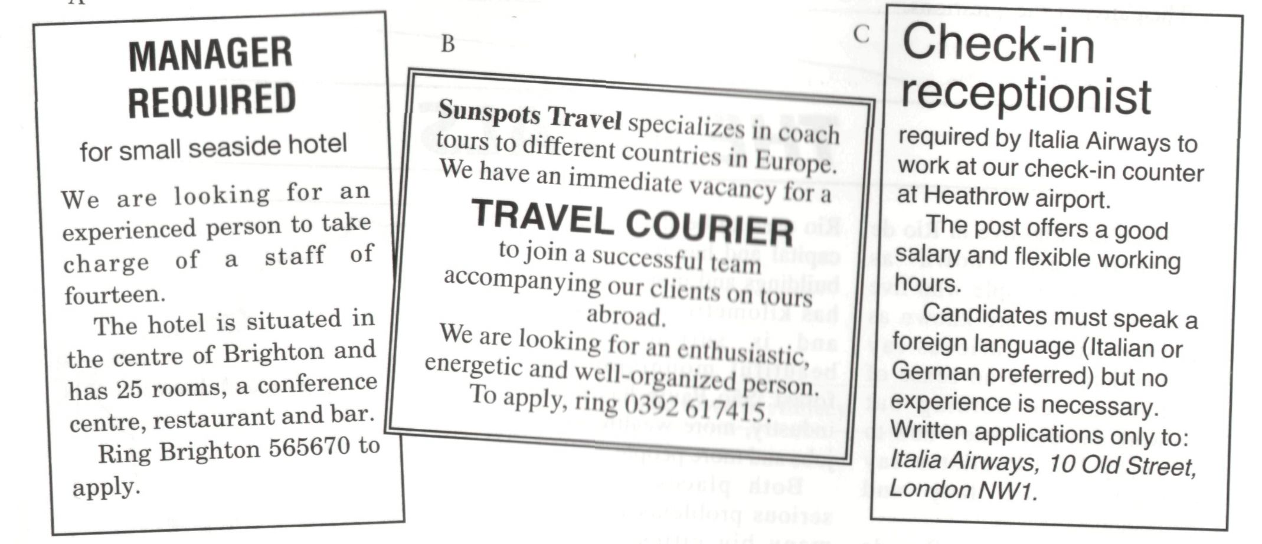
Look at the three job advertisements and answer the questions.
- Which jobs require experience?
- Which jobs require foreign languages?
- For which jobs do you need to travel?
- Which job has the most responsibility?
These two people are looking for a new job
Which of the three jobs do you think they should apply for?
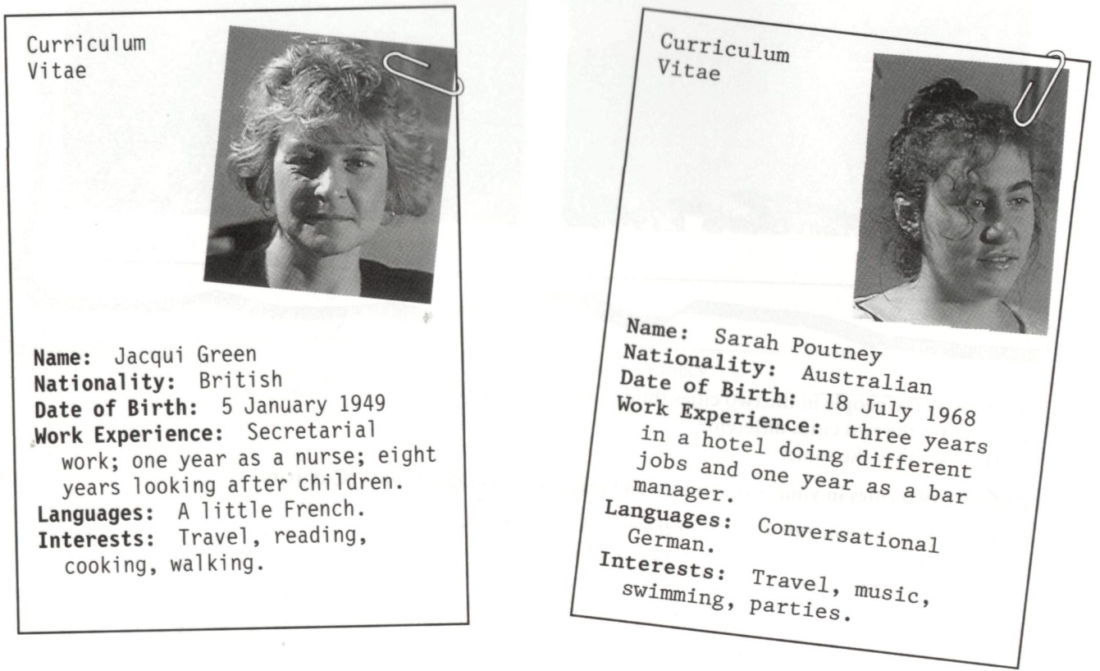

Watch the video all the way through. Which of the three jobs in Task A are Sarah and Jacqui being interviewed for?
Watch the section 'Before the interview' and choose suitable words from the vocabulary box to complete the sentences.
1. a) At the interview, Jacqui wants to look……………………. .
b) At the interview, Sarah wants to look……………………. .
2. a) Jacqui seems to be a(n)…………..person.
b) Sarah seems to be a(n)…………...person.
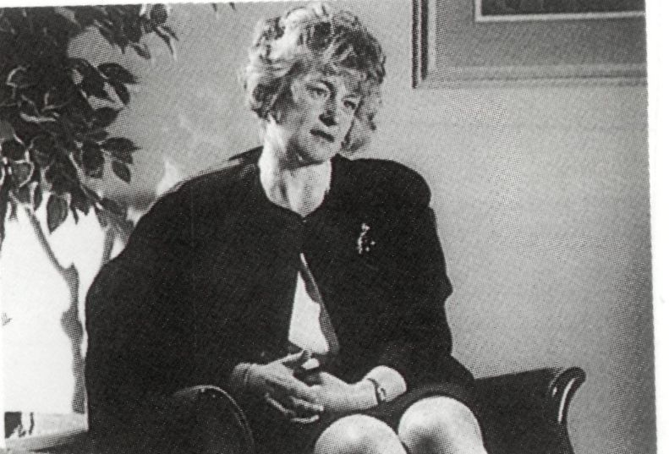
shy relaxed
experienced anxious
aggressive inexperienced
calm confident
professional friendly
ambitious intelligent
Watch the section 'Present jobs'. Then fill in the missing names in the sentences.
1 ………………….has recently arrived in Britain.
2…………………..working for a newspaper.
3…………………..looking for a job with long-term prospects.
4…………………..doing anything that comes along.
Watch the section 'Past experience'. 'True' or 'False'
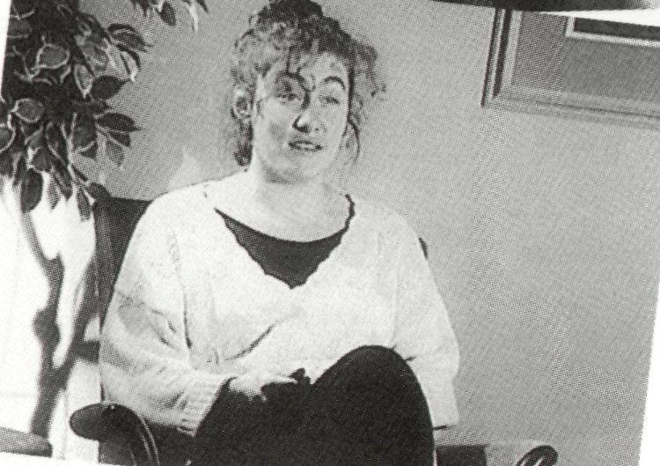
- Sarah spent three years working in a hotel.
- Jacqui worked as a child-minder when she was eighteen.
- Sarah found the tourists at the hotel difficult.
- Sarah has worked as a hospital nurse.
- Jacqui has worked with people of different ages.
- Both of them have secretarial experience.
Look at the countries and languages in the box. As you watch the section “Travel and languages”, note down which countries Sarah and Jacqui have visited and what languages they can speak. Write “J” for Jacqui and “S”for Sarah.

Countries visited
Spain ( ) ( ) Denmark ( ) ( ) Italy ( ) ( )
France ( ) ( ) Portugal ( ) ( ) Germany ( ) ( )
Sweden ( ) ( ) Egypt ( ) ( ) Canada ( ) ( )
Mexico ( ) ( ) Thailand ( ) ( ) Indonesia ( ) ( )
Languages spoken
French ( ) ( ) German ( ) ( ) Spanish ( ) ( )
Watch the fifth section, 'Reasons for applying', and fill in the missing information.
- Jacqui enjoys t………………
- Sarah likes the idea of w………….with t……………
- Jacqui believes she has certain s………..that will benefit the c…………
- Sarah thinks the idea of travelling is e……………
Watch the video all the way through again. Fill in the table with your comments and decide whether Jacqui and Sarah are suitable candidates for the vacant job.
 | Jacqui Green | Sarah Poutney
Appearance
Personality
Experience
Travel and languages
Overall impression
Discuss with a partner who impressed you most in the interview and who, in your opinion, should get the job.
Work in pairs. One person should be the interviewee and the other the interviewer.
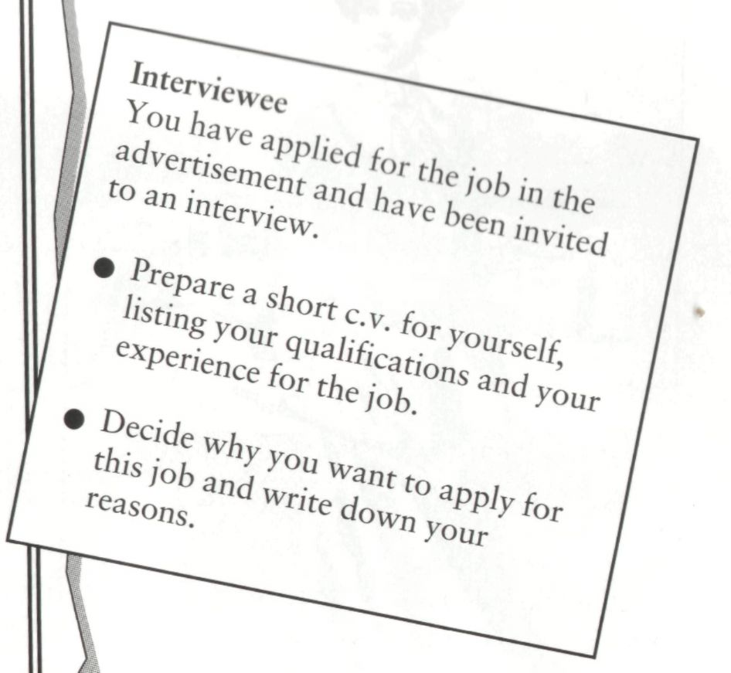

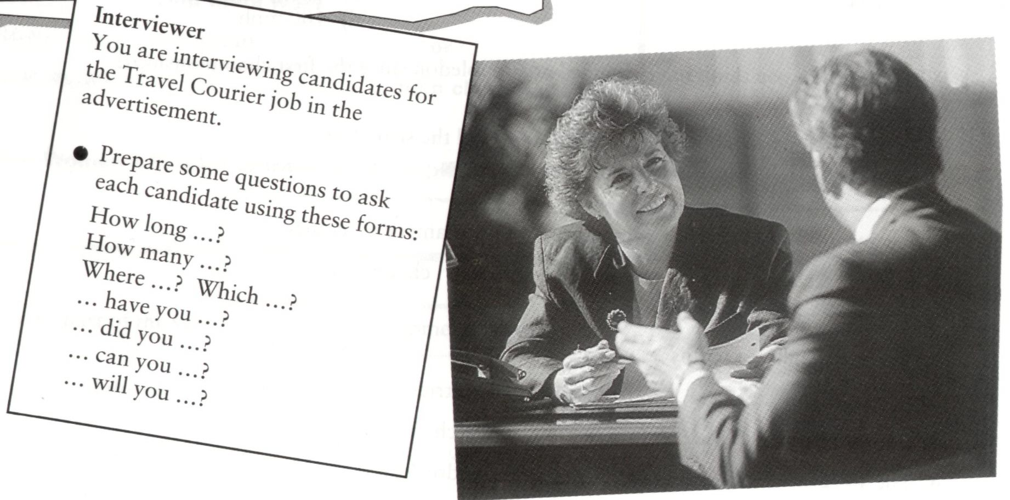

Reference Literature

1. Англійська мова. Методичні матеріали та завдання по проведенню практичних занять з англійської мови для аспірантів інженерних та економічних спеціальностей / Упорядник: Пономарьова О.І., Зеленін Г.І. – Харків: УІПА, 2007. – 32 с.
2. Богацкий И.С., Дюканова Н.М. Бизнес-курс английского языка. – 2-е изд. перераб. – Киев: Логос, 1997. – 352 с.
3. Навчальний посібник для студентів факультету економіки та менеджменту (спеціальність «Облік та аудит») , / Укладачі: Курносова Н.О., Курносова Р.В., Вознюк О.С. – Житомир: ЖІТІ, 2002. – 172 с.
4. Ilchenko O.M. English for Science and Technology. – К.: АТ «Кодр», 1996. – 242с.
5. Soars J. & L. Headway. Upper-Intermediate. Student’s book. – Oxford: Oxford University Press, 1997. – 136 p.
6. Swan M., Walter C. The New Cambridge English Course. Intermediate. – Cambridge: Cambridge University Press, 1996. – 145 p.
7. The New Cambridge English Course. Video Teacher’s Guide 2. – Cambridge: Cambridge University Press. – 92 p.

