Модульна контрольна робота
З теми: From Hi-Fi to Wi-Fi
Variant 1
- Match words with definitions.
- To suffer | - help and advice that is given to someone about their work, education, or personal life
- Addictive | - to find someone or something, either by accident or because you were looking for them
- Guidance | - to use time, energy, goods etc
- Beneficial | - a situation in which it is difficult or impossible to move because there are so many cars or people
- To consume | - to experience physical or mental pain
- Jam | - to have an accident in a car, plane etc by violently hitting something else
- To crash | - An activity that is so enjoyable that you do not want to stop
- To discover | - having a good effect

- Fill in the gaps with prepositions.
- They are looking ____ a product, just as surely as a shopper at the local mall is.
- The lights switch _____ automatically when it gets dark.
- ‘Is your printer working?’ ‘Wait a minute – it’s not plugged ____.
- The truck speeded ____ going down the hill.
- Did you find ____ whether there are any seats left?
- Get ___ a number 73 bus at the corner. That will take you to Islington High Street.
- Gradually, he built ____ to a mile a day, roughly five days a week.
- Don’t forget to turn the lights ____ when you leave.
- Fill in the gaps with the missing word.
Possible Send Trouble Without Access Estimate Effect Technology
The Internet
We live in the age of the internet. Also, it has become an important part of our life that we can’t live 1. ________ it. Besides, the internet is an invention of high-end science and modern 2. _________. Apart from that, we are connected to internet 24×7. Also, we can 3. _______ big and small messages and information faster than ever. It is very difficult to 4.__________ the area that the internet cover. Also, every second million people remain connected to it with any problem or issue. Apart from that, just like all the things the internet also has some good and bad 5. _________ on the life of people. So the first thing which we have to do is learn about the good and bad effect of the internet. Good effects of the internet mean all those things that the internet make 6. _____________. Also, these things make our life easier and safer. Bad effects of the internet mean all those things that we can no longer do because of the internet. Also, these things cause 7._______ for oneself and others too. You can 8. ________in any corner of the world. Also, it is very easy to use and manage. In today’s world, we cannot imagine our life without it.

- Fill in the blanks in present simple or present continuous.
- What is he doing? He at his desk. (sit)
2. Listen, someone at the door. (knock)
3. On my way home I usually to drink a cup of coffee. (stop)
4. Architects plans of the buildings. (make)
5. Look at Betty: she the piano. (play)
6. At this moment I my pupils' exercises. (correct)
7. Where are you? I my lessons in the study. (prepare)
8. She a lot of money. (earn)

- Read the text and mark sentences as true or false.
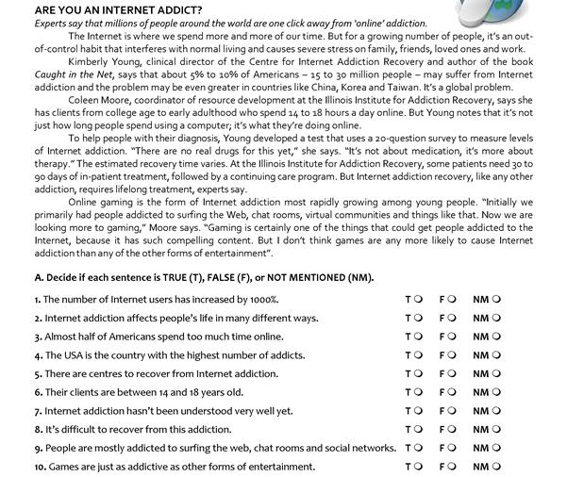
- Choose 1 topic and write a short essay (15 sentences).
- How the Internet Changed the Way People Think?
- Role of the Internet in Political Campaigns.
- Gadgets and How Teenagers Are Using Them.

Variant 2
- Match words with definitions.
- To estimate | - involving talking and working together
- Impressive | - having a strong influence or effect
- interactive | - having many different uses or skills
- Annoyed | - Something that makes you admire it because it is very good, large, important etc
- Versatile | - to move very quickly, especially because you need to be somewhere very soon
- To modify | - to make small changes to something in order to improve it and make it more suitable or effective
- profound | - a calculation of the value, size, amount etc of something made using the information that you have, which may not be complete
- Rush | - slightly angry

- Fill in the gaps with prepositions.
- I could tell she was building ____ to some kind of announcement.
- Do you mind if I switch the light ___?
- The police might be looking ____ him in Rome now.
- I need to find ____ more about these night courses.
- We got ____ the train at Lime Street station.
- Marion filled the kettle and plugged it ____.
- Nancy, if you don't speed ___ we'll be here until midnight.
- You forgot to turn the oven ____!

- Fill in the gaps with the missing word.
Misinformation Installed Invention Change Field Weak Spend Communication
Mobile Phones
Mobile phones have brought a miraculous1. ______ all over the world. Years ago people could not even imagine that there would be such an 2. __________that we would be able to talk to anyone in any corner of the world. Due to mobile phones, revolutionary changes have come in every 3. _______. After the invention of mobile phones, people have benefited from it, so its results have also shown positive. In today’s mobile phones, you can easily 4. ___________ with your family and kith, send messages, watch videos, take any photo with the camera 5. ________ in it, as well as play internet where We can take information around the world. But there are as many advantages as there are benefits from mobile phones, people have started using it everywhere, people 6. ________ most of their time playing with their mobile phones and get used to it. Due to this, their eyes become 7. ______ and at the same time due to being given mobile to children at a young age, they do not feel like writing and studying.Due to mobile internet connectivity, children may receive 8. _________ or visit websites they do not want.

- Fill in the blanks in present simple or present continuous.
1. Chris near the table. (stand)
2. We often tea for breakfast. (take)
3. William to our workshop on Mondays. (come)
4. Let's wait a moment still. Tom soon. (come)
5. I must run home, mother for me. (wait)
6. The telephone often during supper. (ring)
7. Stephen a cigarette now. (smoke)
8. It hard at the moment. (snow)

- Read the text and mark sentences as true or false.

- Choose 1 topic and write a short essay (15 sentences).
- How the Internet Changed the Way People Think?
- Role of the Internet in Political Campaigns.
- Gadgets and How Teenagers Are Using Them.

