Task 1
People are having problems using these machines. Listen and number the pictures.
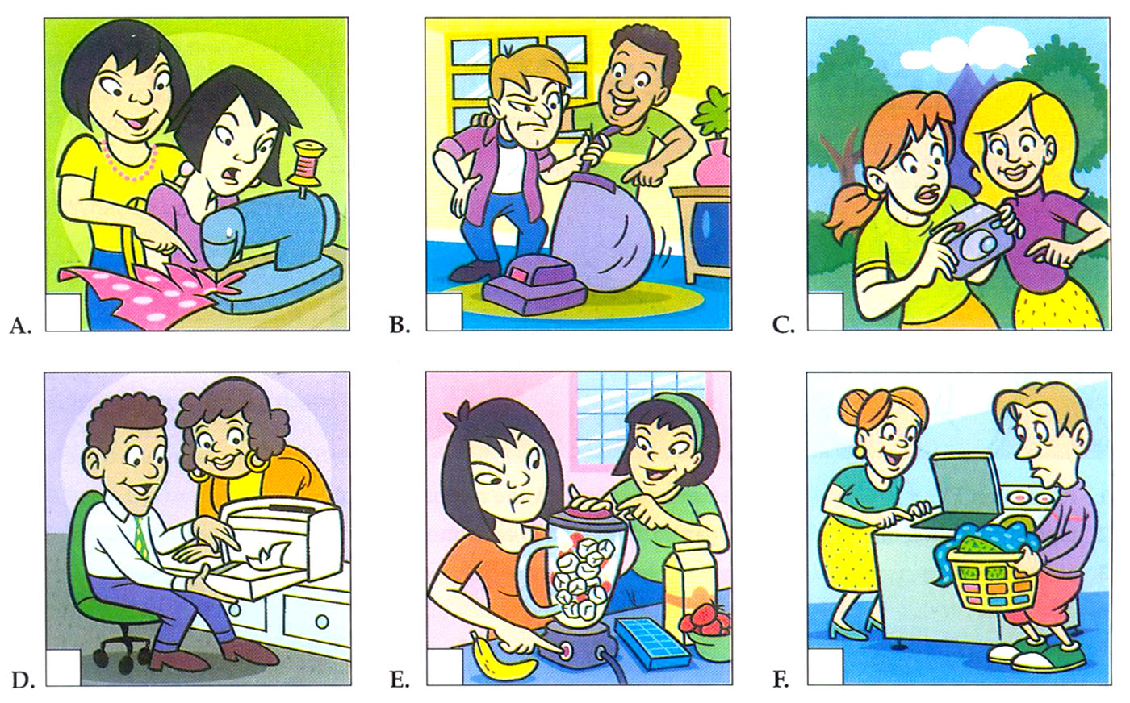

Task 2
Listen again. What is the problem with each machine? Circle the correct answer.
1. a. She needs more film.
b. The batteries are dead.
c. It’s too dirty.
2. a. He put in too much soap.
b. He put in too much clothing.
c. He put in too much money.
3. a. There’s no dust bag.
b. The dust bag is empty.
c. The dust bag is full.
4. a. She used the wrong paper size.
b. She put in too much paper.
c. She didn’t use enough paper.
5. a. The dress is the wrong color.
b. The needle is too big.
c. The needle is to small.
6. a. She put in too much sugar.
b. She put in too much fruit.
c. She put in too much ice.

Task 1
People are talking about machines and appliances. Listen and match the products on the left with the features on the right.
1. flat screen TV ….
2. laptop computer ….
3. air conditioner ….
4. clothes dryer ….
5. dishwasher ….
6. lawn mower ….
a. You can adjust it with the remote control.
b. You can fit it in a small apartment.
c. You don’t have to rinse anything.
d. It weighs only one and a half kilos.
e. You can run it for an hour without adding gas.
f. You can hang it on the wall.

Task 2
Listen again. Are these statements true or false? Check the correct answer.
 | True | False
1. You shouldn’t put it near a window. | ◻ | ◻
2. You should keep it in the case when you carry it. | ◻ | ◻
3. You should open the windows when you use it. | ◻ | ◻
4. You shouldn’t touch the lint filter. | ◻ | ◻
5. You shouldn’t put any soap in it. | ◻ | ◻
6. You shouldn’t put your hand under the machine.

People are describing their favorite gadgets and machines. Which gadget is each person describing? Listen and write the correct letter.

Listen

1. …….
2. …….
3. …….
4. …….
5. …….
a. dishwasher
b. flat screen TV
c. laptop computer
d. camera
e. cell phone

Resources:
https://english-practice.net/listening-exercises-b1-gadgets-and-machines/

