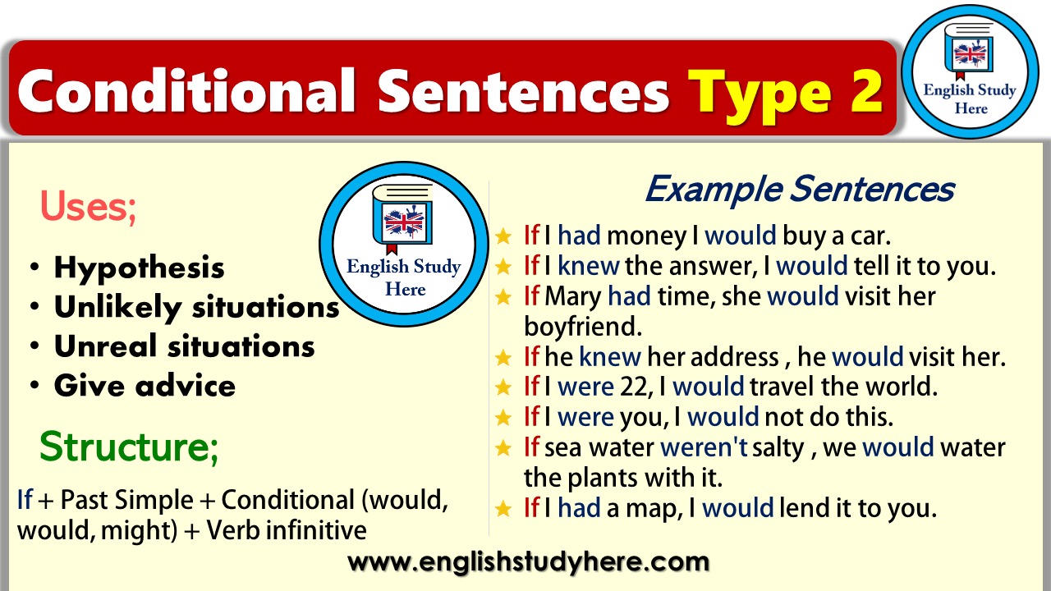

Second Conditionals - put the verb into the correct tense:
1. If I _________________ (be) you, I _________________ (get) a new job.
2. If he ______________ (be) younger, he ____________ (travel) more.
3. If we ___________ (not / be) friends, I ___________ (be) angry with you.
4. If I ____________ (have) enough money, I ____________ (buy) a big house.
5. If she ___________ (not / be) always so late, she ___________ (be) promoted.
6. If we ___________ (win) the lottery, we ____________ (travel) the world.
7. If you ________ (have) a better job, we __________ (be) able to buy a new car.
8. If I ____________ (speak) perfect English, I ___________ (have) a good job.
9. If we __________ (live) in Mexico, I ____________ (speak) Spanish.
10. If she __________ (pass) the exam, she ________ (be) able to enter university.
11. She __________ (be) happier if she ____________ (have) more friends.
12. We _________ (buy) a house if we ___________ (decide) to stay here.
13. They _______ (have) more money if they _______ (not/buy) so many clothes .
14. We __________ (come) to dinner if we ____________ (have) time.
15. She _________ (call) him if she ___________ (know) his number.
16. They _______ (go) to Spain on holiday if they _________ (like) hot weather.
17. She _________ (pass) the exam if she ____________ (study) more.
18. I ________ (marry) someone famous if I _________ (be) a movie star.
19. We never ___________ (be) late again if we __________ (buy) a new car.
20. You _________ (lose) weight if you _________________ (eat) less.

Complete the sentences.
- If I had more money, …………….
- …………………. if people ate better.
- If I knew it before, ………………….
- Our kids would be happier if ……………
- If I were you, …………………
- If you were more careful, ………………….
- If I could change the world, ………………….

Make up five own sentences using the Conditional Sentences Type II.
WHAT WOULD HAPPEN TO THE EARTH IF………………..?

Examples:
- If people were not so careless, the Earth wouldn’t be in danger.
- Many fish wouldn’t die if factories didn’t dump so many chemicals into rivers and oceans.

