Task 1

Look at the pictures. Think in what ways they are the same and different.



Task 2

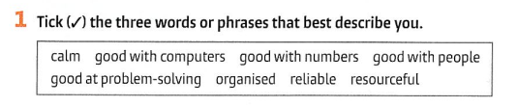

Task 3

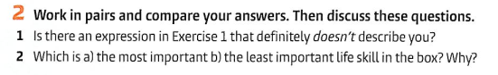

______________

______________

______________

Task 4



Write them here:

__________

_________

_________

Task 5

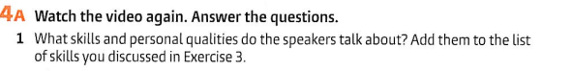



_____________

_____________

_____________

_____________



1

2

3

Discuss with the partner



Task 6

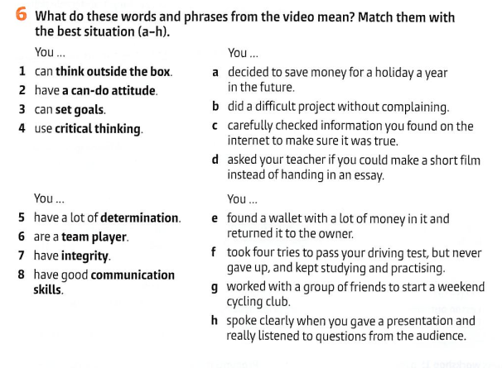

Write here:

|  |  |
| --- | --- |
|  |  |
|  |  |
|  |  |
|  |  |
|  |  |
|  |  |
|  |  |



    
    
    
    

 

 