# DEMO

LEAD-in.

Look at the pictures. What is it about?



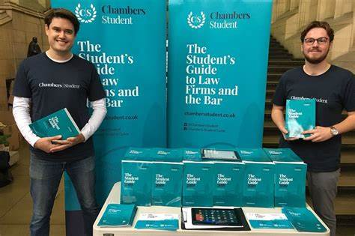



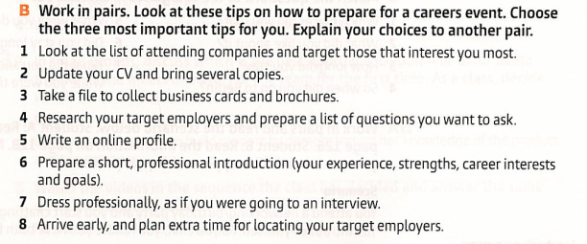

TASK1

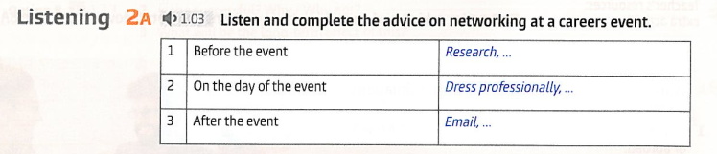



Task 2

Listenin 1

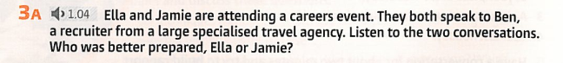

Listening 2

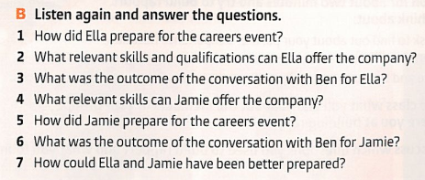

Discussion

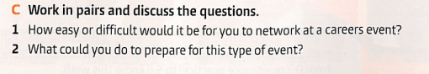

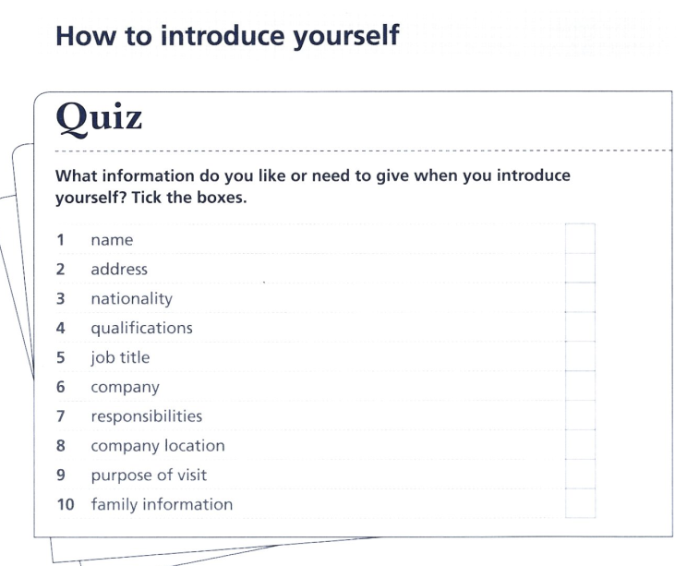

TASK 2

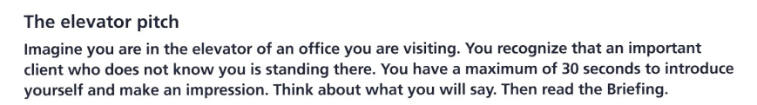

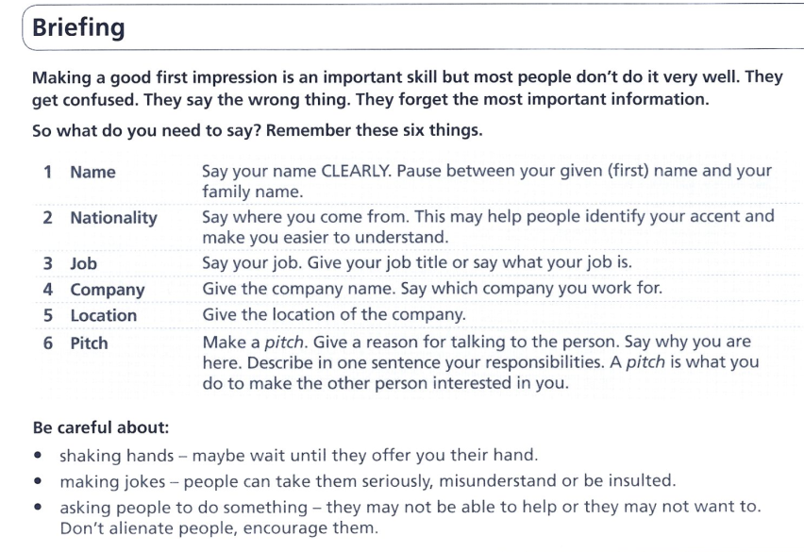

TASK 3

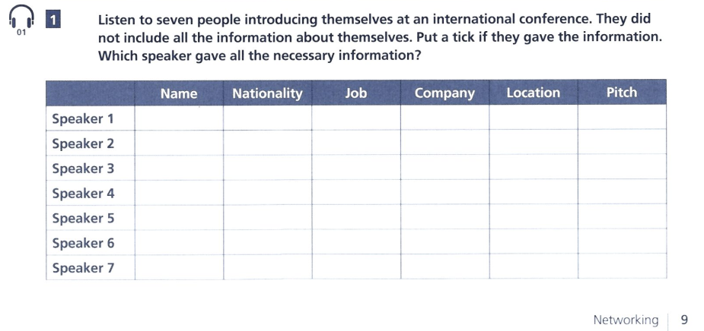

|  |  |  |  |  |  |  |
| --- | --- | --- | --- | --- | --- | --- |
|  |  |  |  |  |  |  |
|  |  |  |  |  |  |  |
|  |  |  |  |  |  |  |
|  |  |  |  |  |  |  |
|  |  |  |  |  |  |  |
|  |  |  |  |  |  |  |

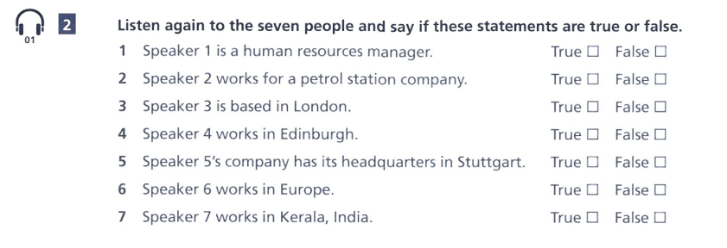

|  |  |
| --- | --- |
|  |  |
|  |  |
|  |  |
|  |  |
|  |  |
|  |  |

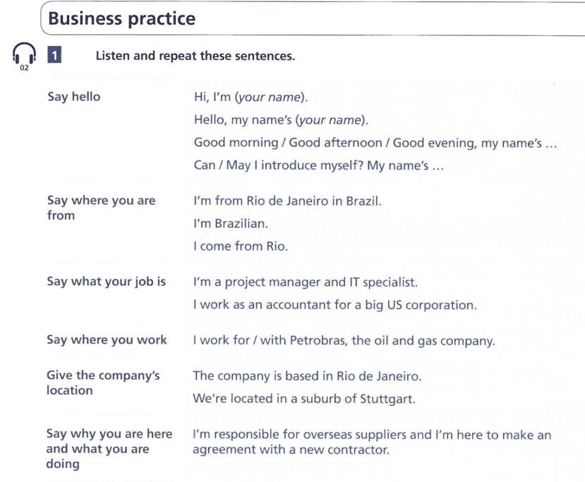

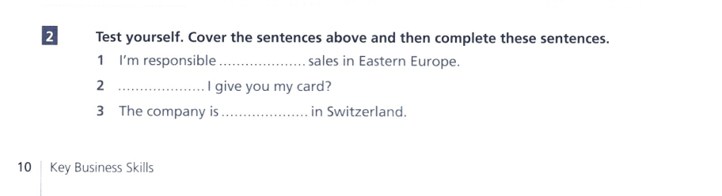

-

-

-

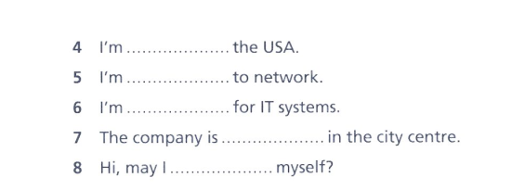

-

-

-

-

-

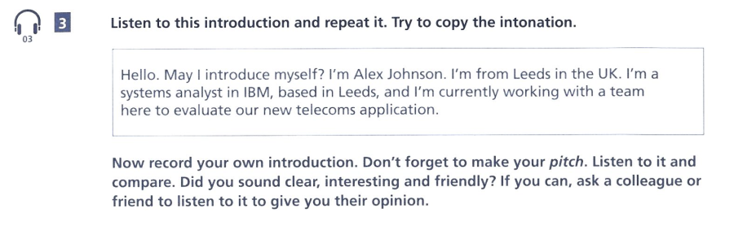

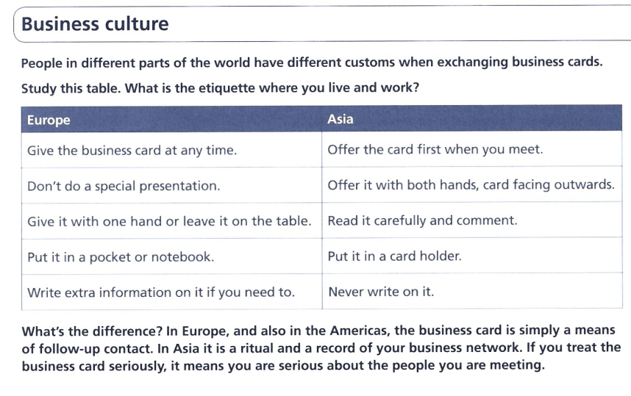

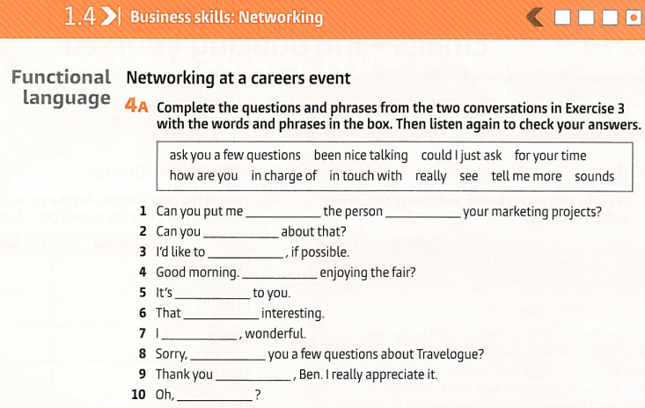

-

-

-

-

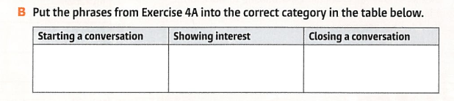

|  |  |  |
| --- | --- | --- |
|  |  |  |
|  |  |  |
|  |  |  |
|  |  |  |

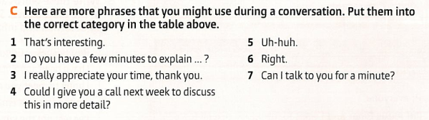

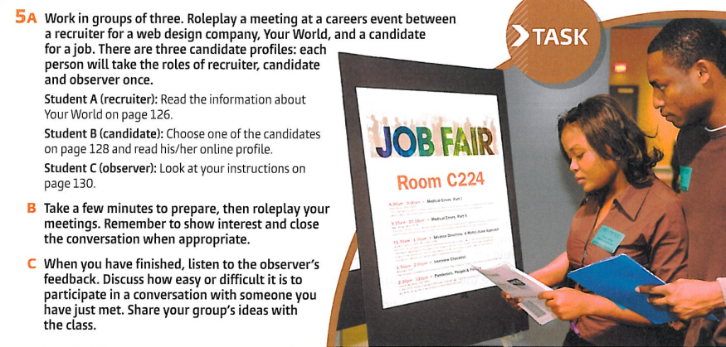

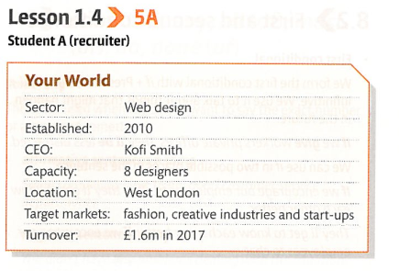

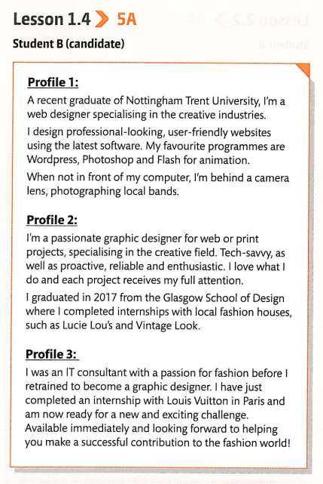

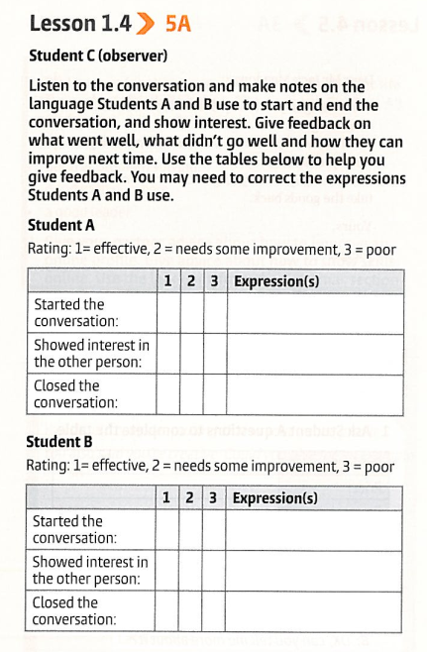

OBSERVER:

A

|  |  |  |  |  |
| --- | --- | --- | --- | --- |
|  |  |  |  |  |
|  |  |  |  |  |
|  |  |  |  |  |

B

|  |  |  |  |  |
| --- | --- | --- | --- | --- |
|  |  |  |  |  |
|  |  |  |  |  |
|  |  |  |  |  |

Intro

Student A

I am a recent graduate of Yale Law School with a passion for environmental law and social justice.

During my time at Yale, I focused on constitutional law and environmental regulations, graduating in the top 10% of my class. I've gained practical experience through internships with the Environmental Defense Fund and a federal judge, where I honed my skills in legal research and writing.

I'm proficient in essential legal tools like Westlaw and LexisNexis, and I have a strong track record in drafting various legal documents.

Beyond academics, I took a leadership role as president of the Environmental Law Society and dedicated time to pro bono work at local legal clinics.

I'm eager to start my legal career and am particularly interested in opportunities where I can apply my environmental law expertise. I'm available to start immediately and excited about the prospect of bringing fresh ideas and enthusiasm to your team.

Student B

I'm Olena Kovalenko, a recent graduate from Kyiv National University of Law with a focus on international and comparative law.

I completed my studies with honors despite the challenging circumstances in Ukraine, which has instilled in me a deep resilience and adaptability. My academic strengths lie in international human rights law and European Union law, areas where I'm passionate about making a difference.

During my studies, I interned with a prominent NGO in Kyiv, working on cases related to war crimes documentation and refugee rights. This experience sharpened my skills in legal research, case analysis, and report writing in both Ukrainian and English.

I'm fluent in Ukrainian, English, and I'm currently improving my German. These language skills, combined with my international perspective, position me uniquely to work on cross-border legal issues.

Outside of my studies, I volunteered with local organizations providing legal assistance to internally displaced persons, which gave me invaluable practical experience and deepened my commitment to human rights.

I'm excited about the opportunity to bring my unique background and fresh perspective to a law firm or organization working in international law or human rights. I'm particularly interested in roles that allow me to leverage my understanding of Eastern European legal systems and current geopolitical challenges.

I'm eager to start my career and I'd be grateful to learn more about any opportunities you might have that align with my background and interests.

MATERIALS:

[8 Do's and Don'ts of Attending a Job Fair | Indeed.com](https://www.indeed.com/career-advice/finding-a-job/dos-and-donts-of-job-fair) <https://www.indeed.com/career-advice/finding-a-job/dos-and-donts-of-job-fair>