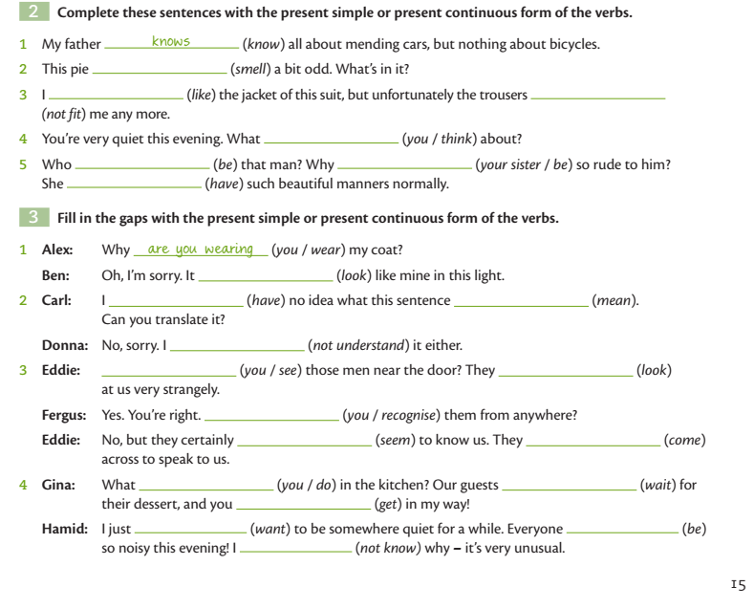
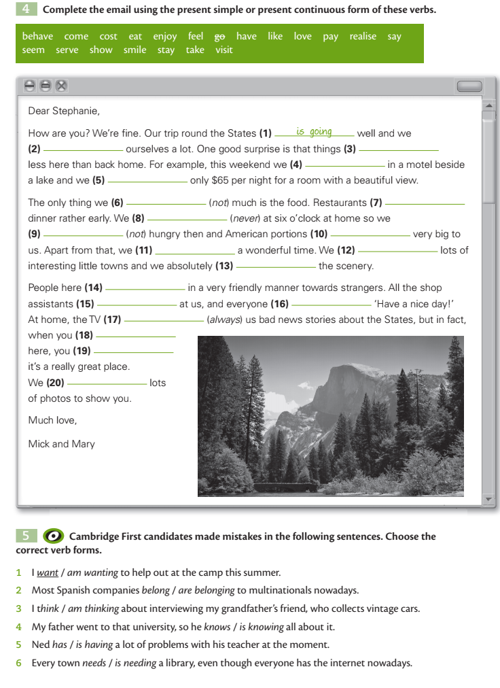
Do the task online :
1. Present continuous – I'm doing, I'm not doing, Are you doing? - Page 3 of 3 - Test-English
2. Present simple vs present continuous - Test-English
3. Present simple vs present continuous - Page 2 of 3 - Test-English

