New Language Leader (Intermediate) Coursebook

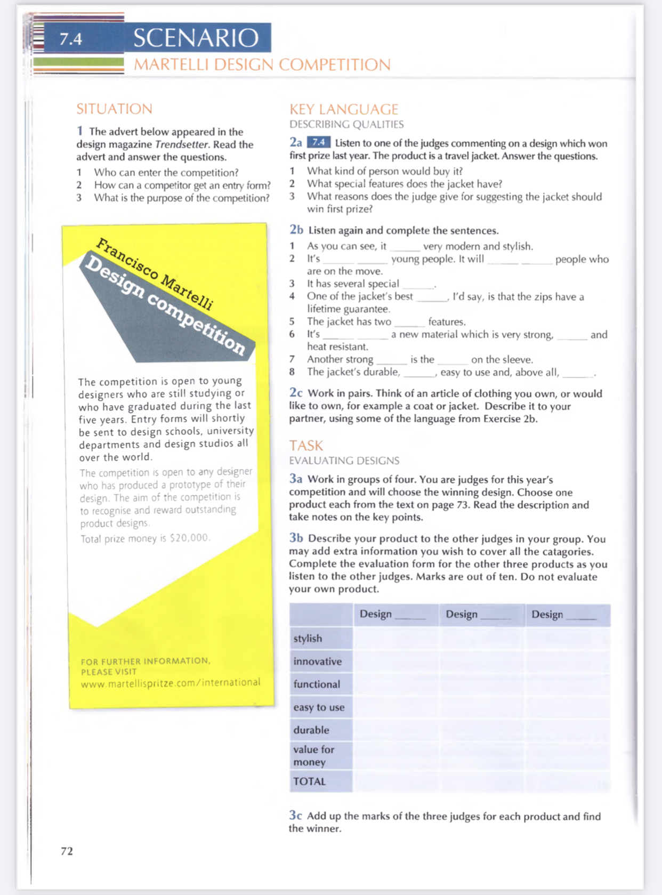

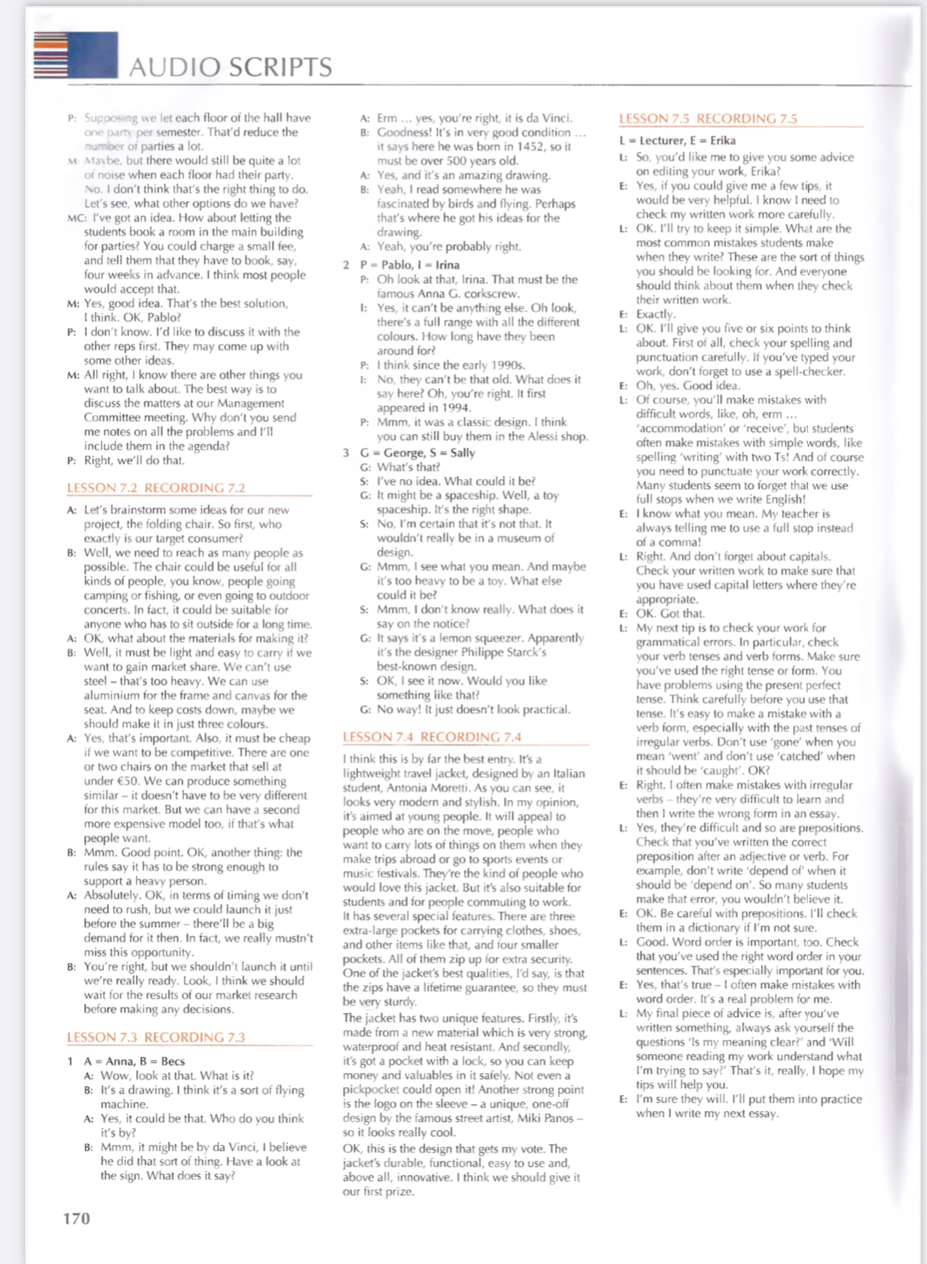

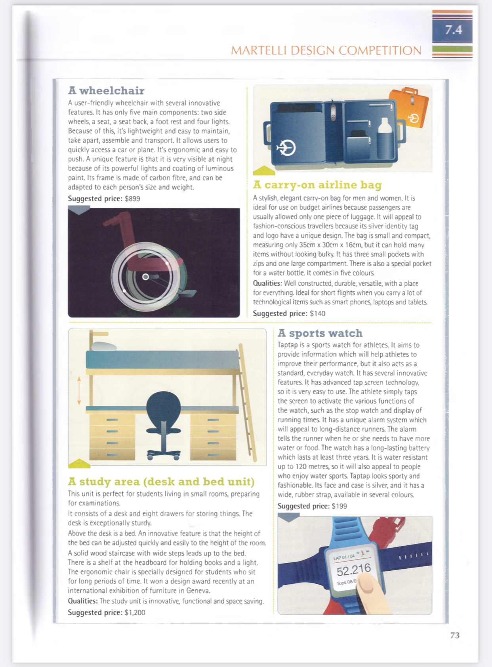

Home Task - Language Leader (Intermediate) Workbook
Ex.1,2 p.46
Ex.4,5а (аудио 2.9) p.48
