English for Mining Engineers (C.В. Суховецька)
For Third year students (ГЕФ)
To-do list (список завдань):
- Study Grammar material – Numbers
https://www.vocabulary.cl/Basic/Numbers.htm
- Study Grammar material - Present Perfect
- P. 79 ex. 1. 2. 3. 4. 5.
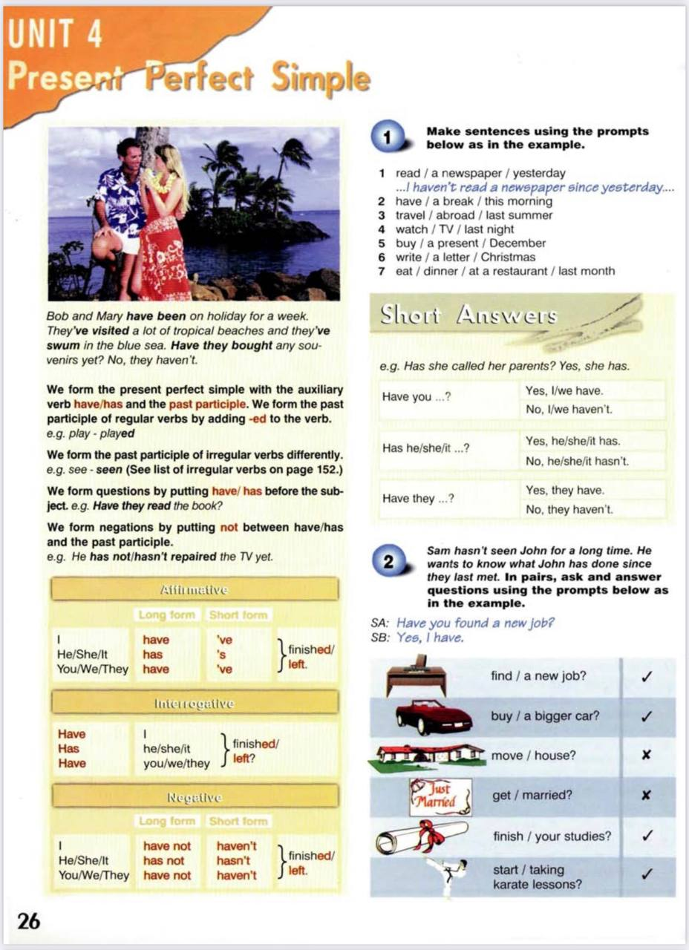

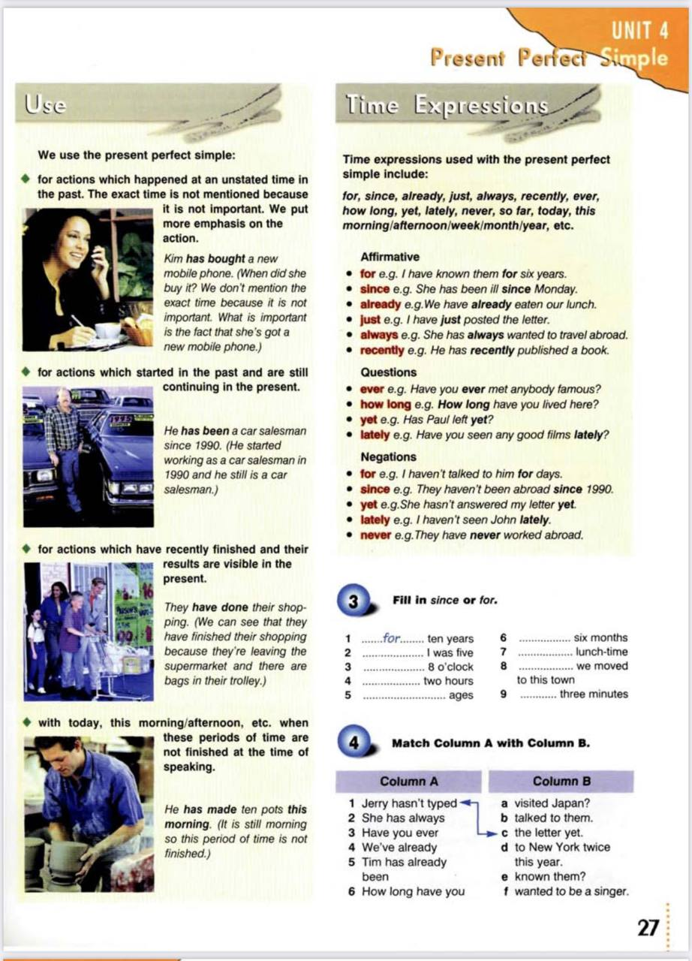

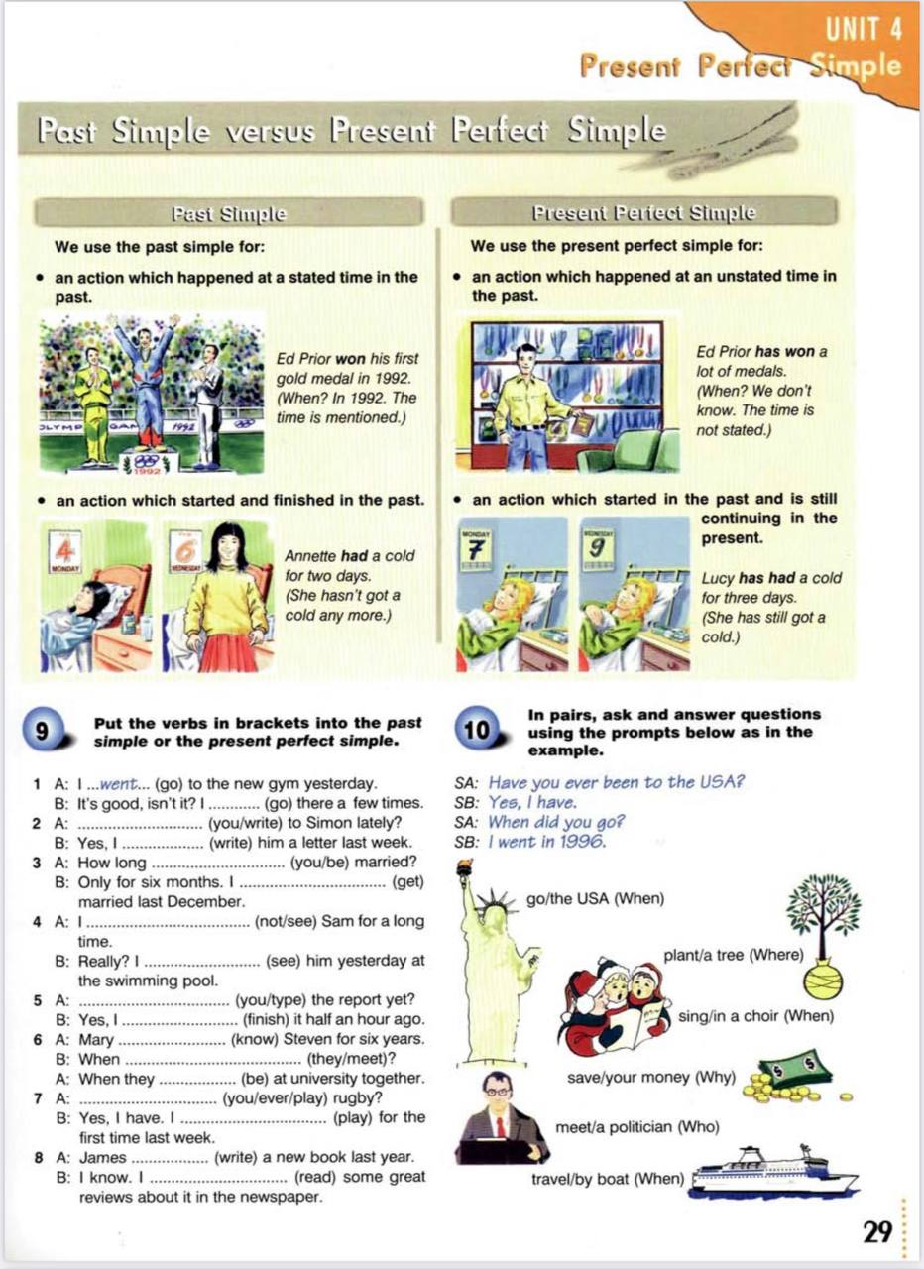

PRESENT PERFECT

Exercise I. Write sentences in Present Perfect.
1. They/play/football - __________________
2. He/speak/English - __________________
3. I/write/a poem - ___________________
4. We/not/wash/the car - __________________
5. Nancy/not/meet/her friends- __________________

Exercise II. Write questions in Present Perfect.
1. They/finish/their homework - __________________
2. She/visit/her friend- ___________________
3. The maid/clean/the house - ___________________
4. He/drive/the van - __________________
5. You/ever/write/a poem - __________________

Exercise III. Put the verbs into the correct form (Present Perfect or Simple Past).
1. I (not/work) ______ today.
2. We (buy) ______ a new car last week.
3. We (not/plan) ______ our holiday yet.
4. She (not/see) ______ her mother for a long time.
5. He (write) ______ a beautiful poem yesterday.

Exercise IV. Put the verbs into the correct form (Present Perfect or Continuous).
1. I think the waiter (forget) ______ us. We (wait) ______ here for over half an hour and nobody (take) ______ our order yet.
2. I think you're right. He (walk) ______by us at least twenty times. He probably thinks we (order, already) ______.
Exercise V. Write the past participle of the following irregular verbs.
speak -
catch –
eat -
understand -
begin -

