Market Leader (Intermediate)
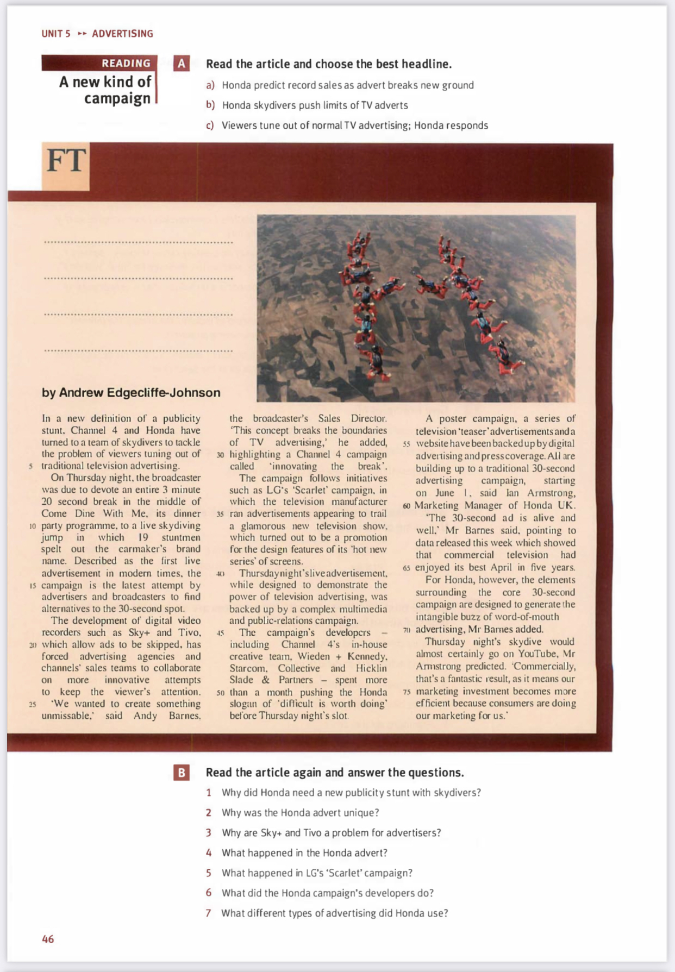
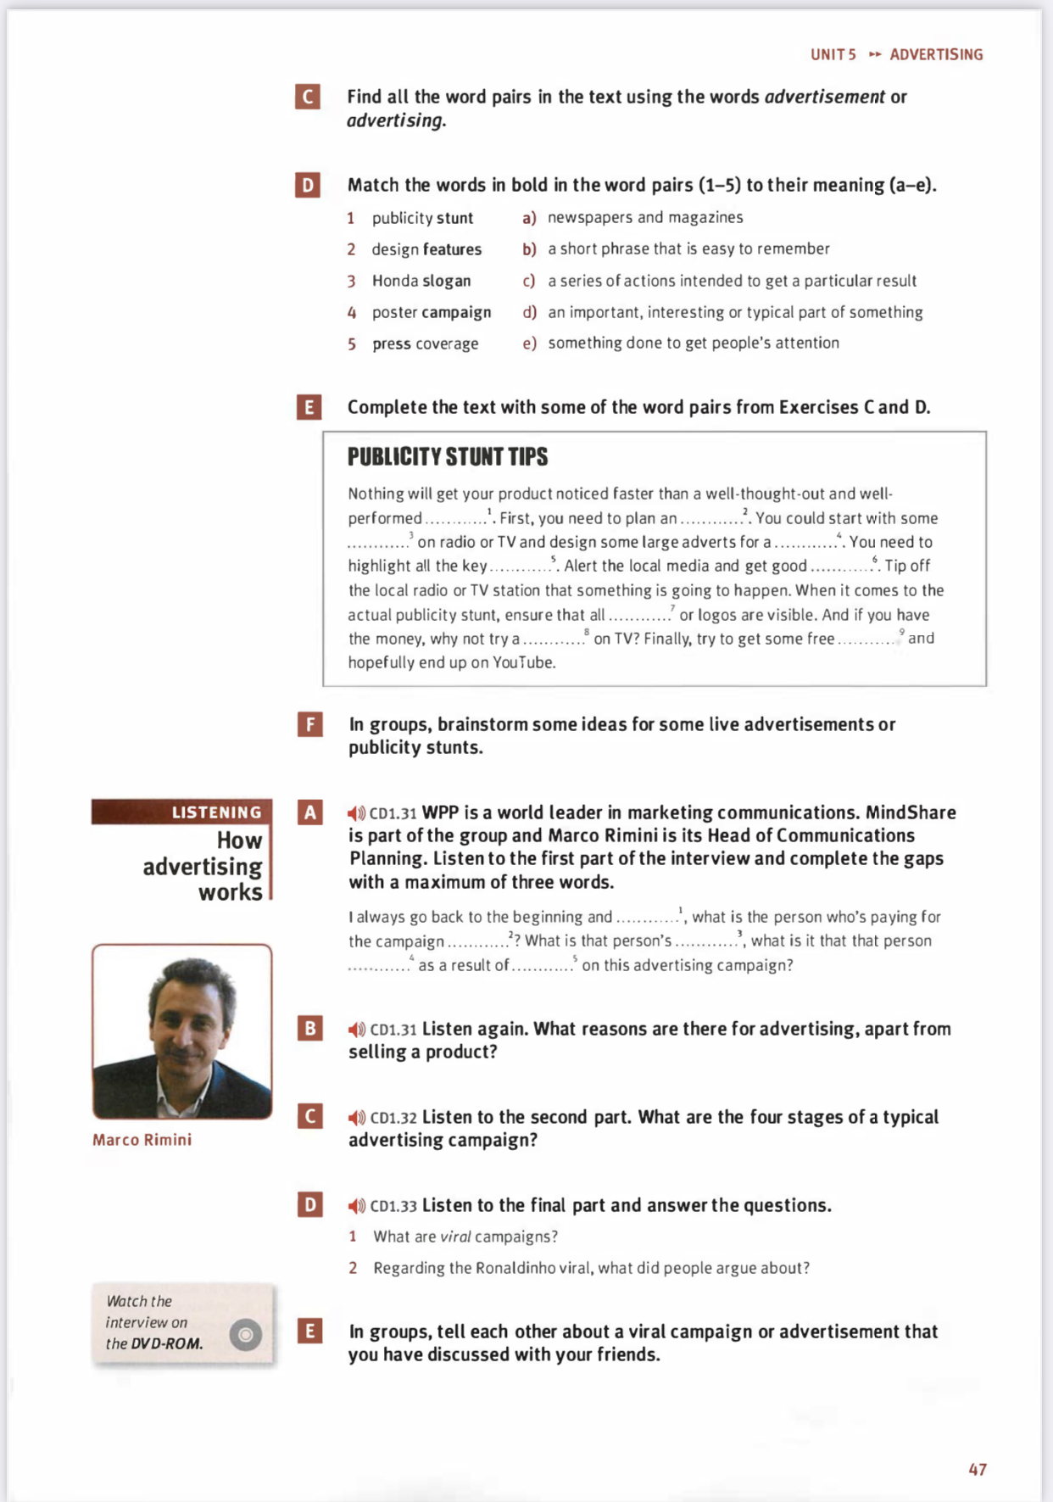
Home task:
- Ex. F, page 45
- Ex. E, page 47

