Market Leader (Intermediate)
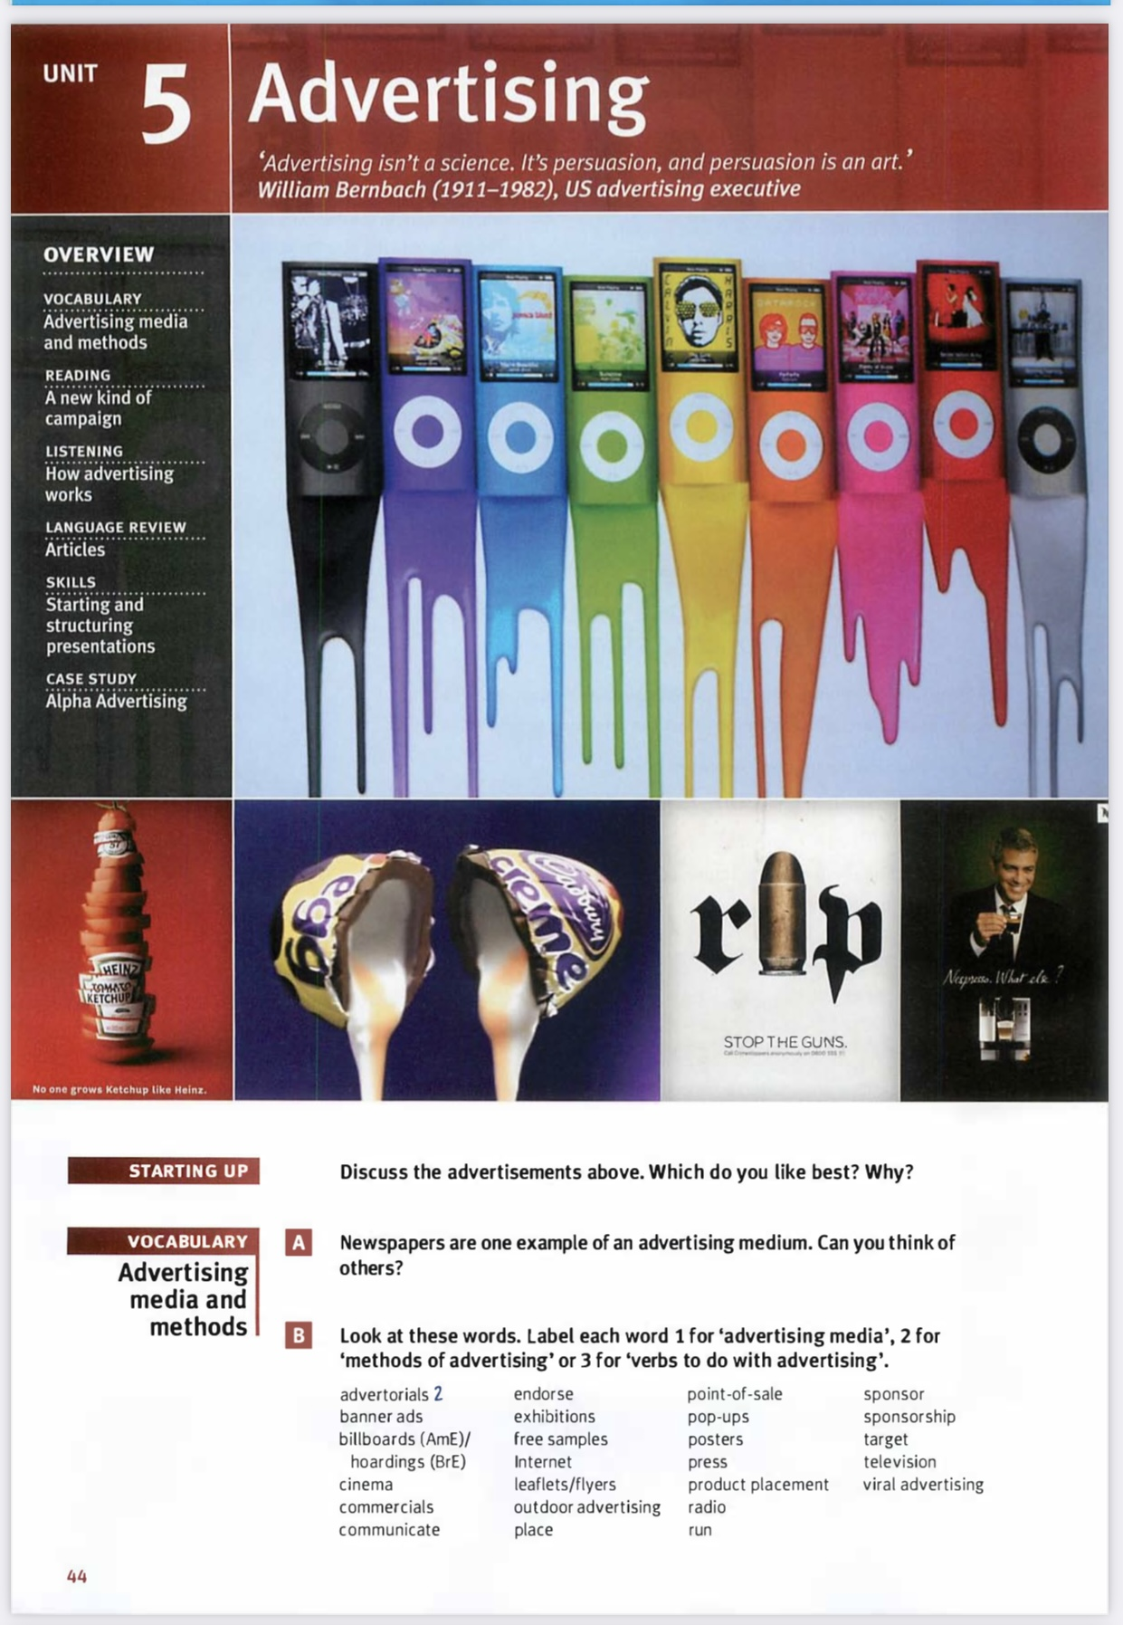
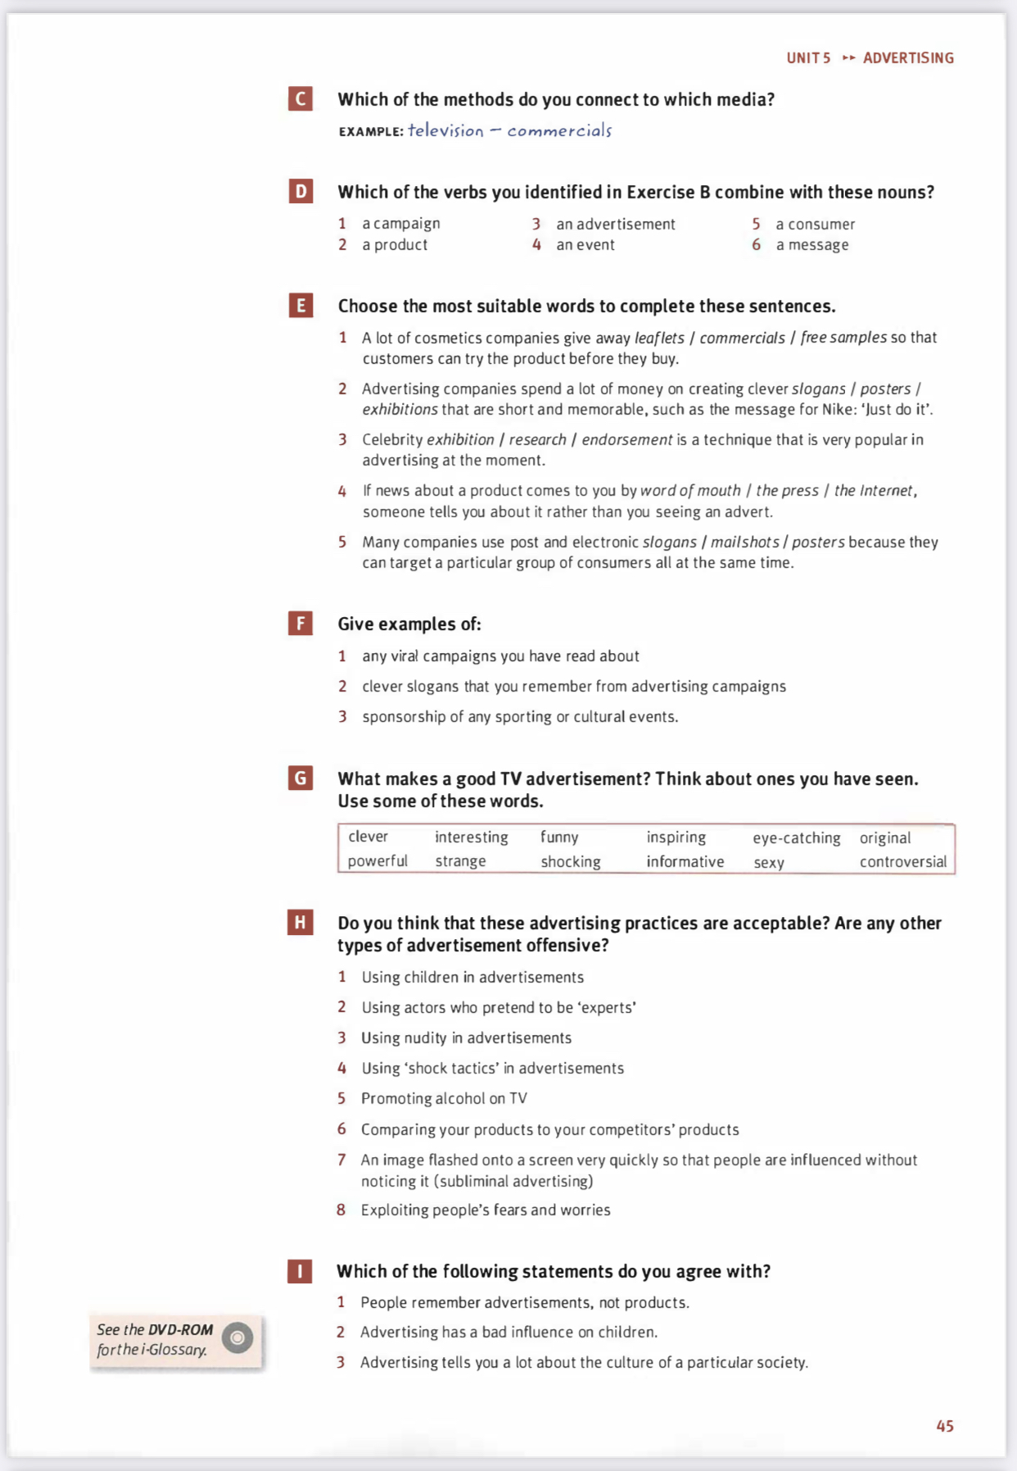
Home task:
- Write an essay (5-10 sentences) – What do you think about advertising? Is it usefull or useless?
- Choose one or more pictures, write what attracts your attention and what annoys you (5-10 sentences).

