Заняття о 11:40, 13 квітня 2021
Група БІ-20

- Answer the questions. (In the written form)
Do you like travelling?
What countries are you dreaming to visit?
What countries are you planning to visit?
Are they different countries?
What places of interest are the most famous in these countries?
- What is it? Where is it? Can you remember anything about this ancient place?
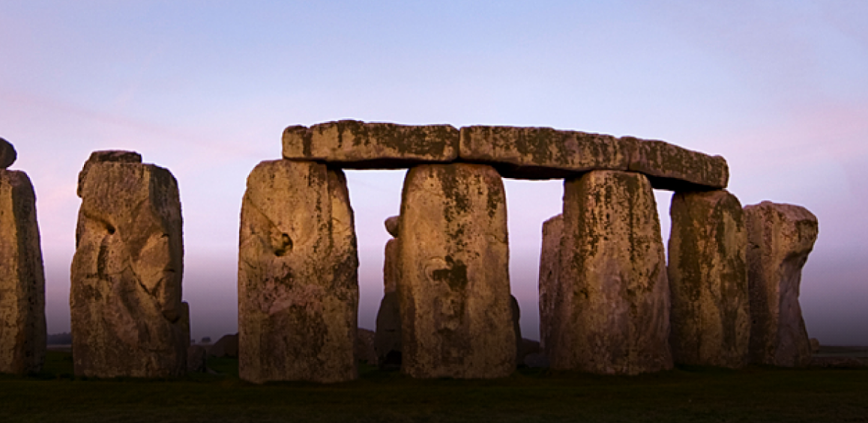
- Fill in the gaps in the following text
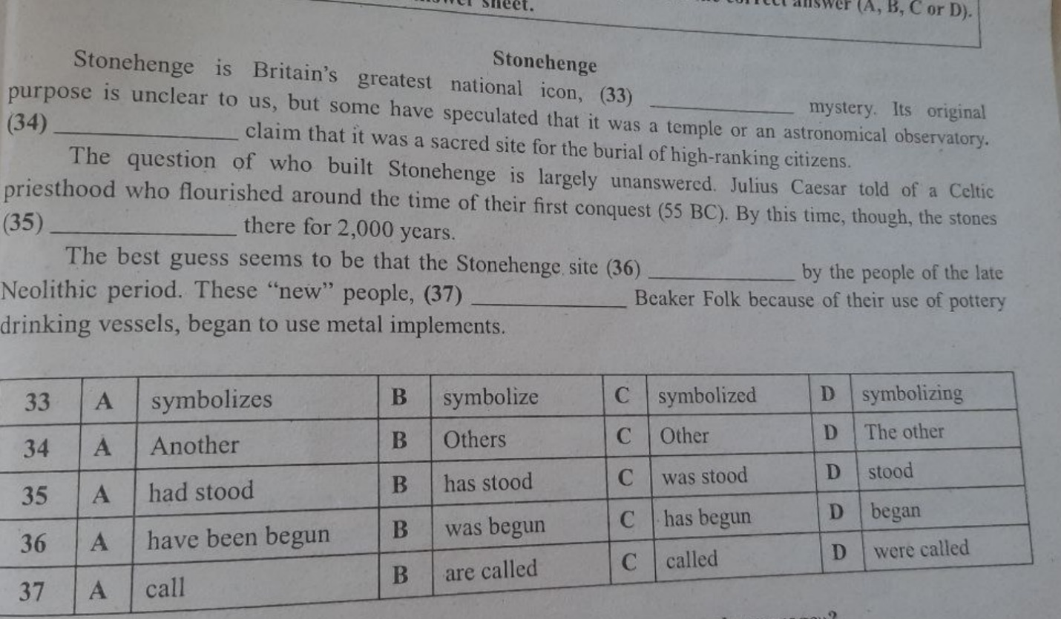

- Do 3 tests following the link:
https://test-english.com/grammar-points/b1/another-other-others-the-other-the-others/?__cf_chl_jschl_tk__=5e274f85c7759802115c518a2cb7236d01142695-1618227955-0-ARlWNKBDgcrQpQ5lVEB714ovVymz_K9WukclMSVHnJ0ty-Rwb6RjpXc3NeJCNMdBdpOE0NaDe633QXs4MTWHHLg27UcqhD62znkPjZMbbBXxXXdaMQHj_JfUSCI2DiNfr9fmf7Xmu6KsFXXhFq_4GGfSiMdcNm72Y8Dfm3MXHwwO2nAbWX42WpHwSYYgqTZ0i7CFzamJaOnfMNepSCwGVv8yhb2o2r2v3J0Mgn60Zw6hNTBO5DGIloxCu2tqc_1zKxKWGhrrvndykB7b9NG7uPabP4GXACTJSJ-cridHbhbvbuIr8udbLM8AgznQYbTejU2VbtZo6liYOpcGDqM2yPbzatJKgBZ2UV_A0nijEdLTXdOWhEaYYQYqw9hL64ZpMt5JskjAaph0QZxMYG6EIgukiFClHg6dxlV1eOosuo7X19Qx3I_sEIta6aGBQw8OJpQgjI0651Wzakri5SGav3HEtVz1_YnP2tKYKZq6hN0Tx2amiTKTF9Kryf630fy0jBN0spGTDasz-jQ9CvXCJ1I
- Check yourself:
- There's no ___ way to do it.
other
the other
another

Some people like to rest in their free time. ___ like to travel.
Other
The others
Others

This cake is delicious! Can I have ___ slice, please?
other
another
others

Where are ___ boys?
the other
the others
others

The supermarket is on ___ side of the street.
other
another
the other

There were three books on my table. One is here. Where are ___ ?
others
the others
the other

Some of the speakers went straight to the conference room. ___ speakers are still hanging around.
The other
The others
Another

This is not the only answer to the question. There are ___ .
the others
others
another

Please give me ___ chance.
other
the other
another

He was a wonderful teacher. Everyone agreed it would be hard to find ___ like him.
another
other
the other

