English for Mining Engineers (C.В. Суховецька)
For Third year students (ГЕФ)
To-do list (список завдань):
- Study Grammar material - Past Perfect
- P. 79 ex. 6. 7. 8. 9

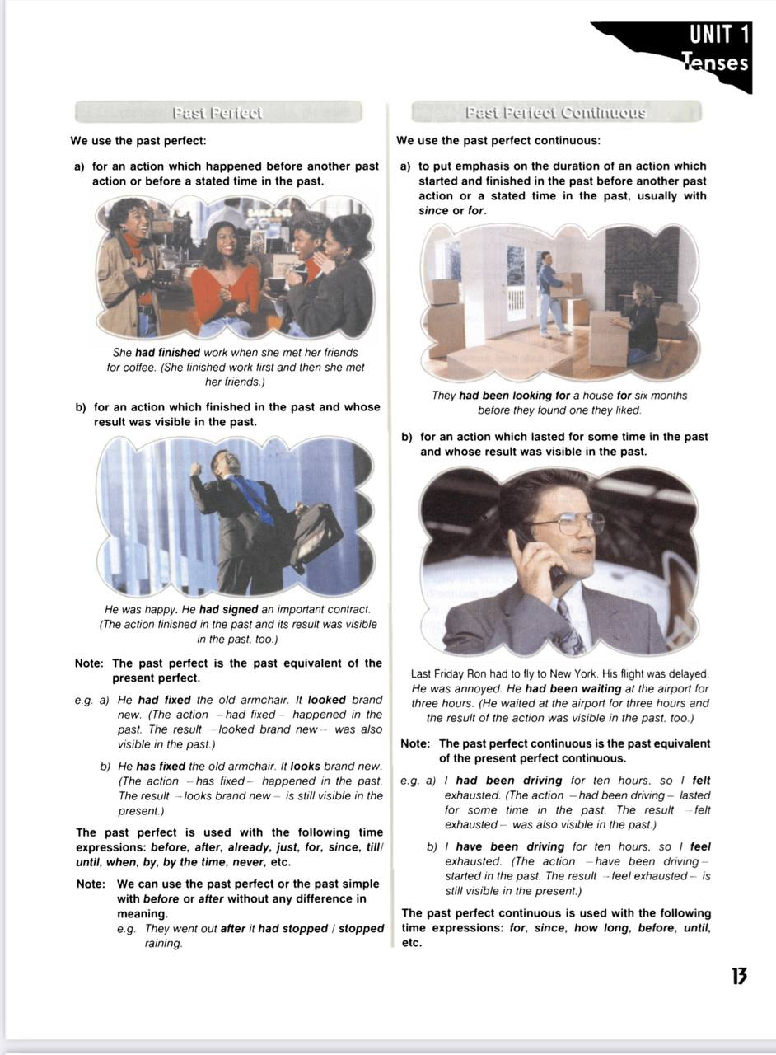

PAST PERFECT
Exercise VI. Complete the sentences in Past Perfect (affirmative form.)
1. I lost the key that he (give) to me.
2. He told me that he (see) the film.
3. I went outside as I (hear) a noise.
4. When they came home, Liza (cook) dinner.
5. We could not send you a postcard because we (lose) your address.
Exercise VII. Complete the sentences in Past Perfect (negative).
1. The waiter served something that we (not/order).
2. He went to the country which he (not/visit) before.
3. She picked out the red dress, which she (not/wear) for ages.
4. He (not/swim) in the beach before that day.
5. His mother was angry because he (not/do) the shopping for her.
Exercise VIII. Complete the questions in Past Perfect.
1. (you/finish) your homework before you went to the cinema?
2. Why (you/not /clean) the bathroom before you took a bath?
3. (you/have) breakfast before you left the house?
4. (she/manage) to find a place to stay when she went to London?
5. Where (she/stay) before she moved to live with her friend?
Exercise IX. Put the verbs into the correct form (Past Perfect or The Simple Past)
1. The storm (destroy) the house that they had built.
2. The children (clean) the blackboard they had used to do the mathematics exercise.
3. When she went out to play, she (do / already) her homework.
4. She (eat) all of the food that we had made.
5. He took off the jacket he (put on) before.

