English for Mining Engineers (C.В. Суховецька)
For Third year students (ГЕФ)
To-do list (список завдань):
- Grammar Past Continuous and Future Continuous, pictures p. 20, 21, 42, 21
- P. 78-79 ex. 5, 6, 7.
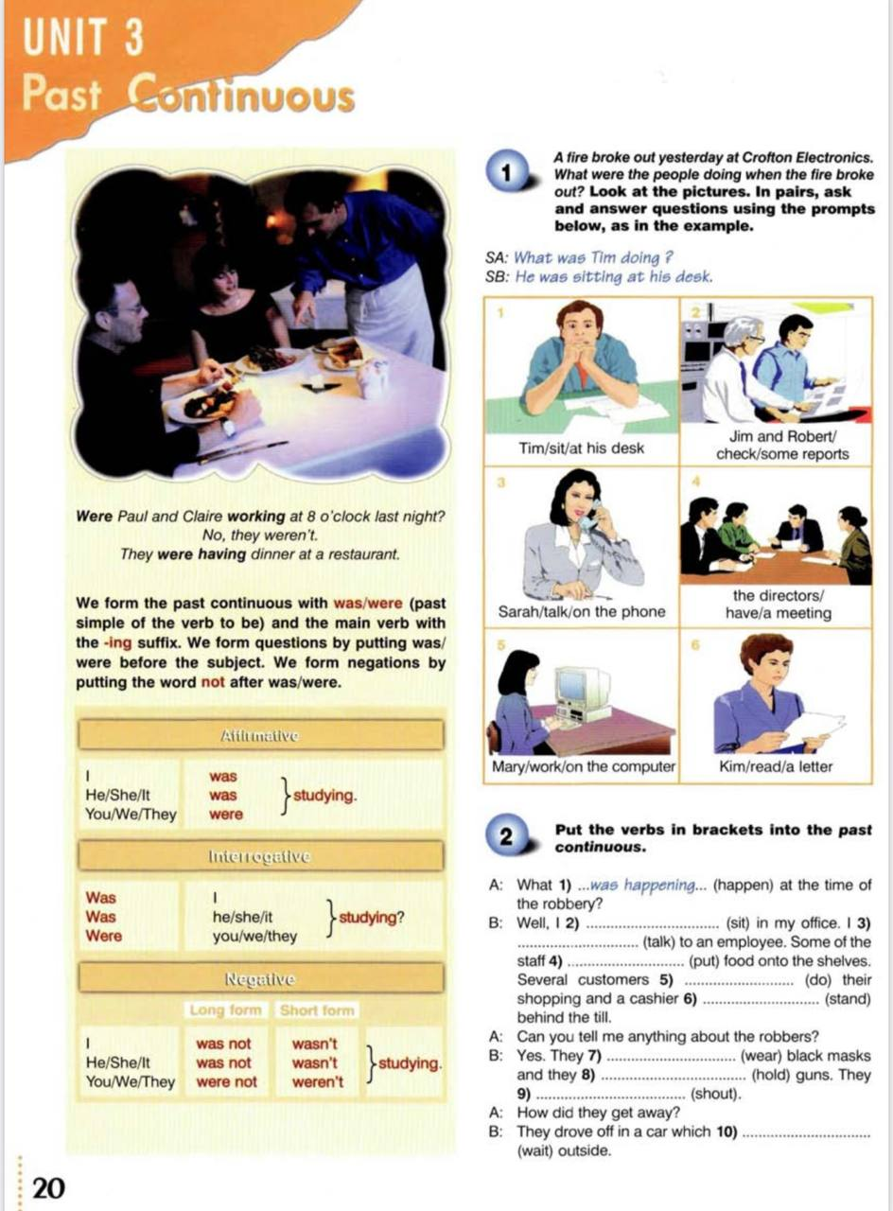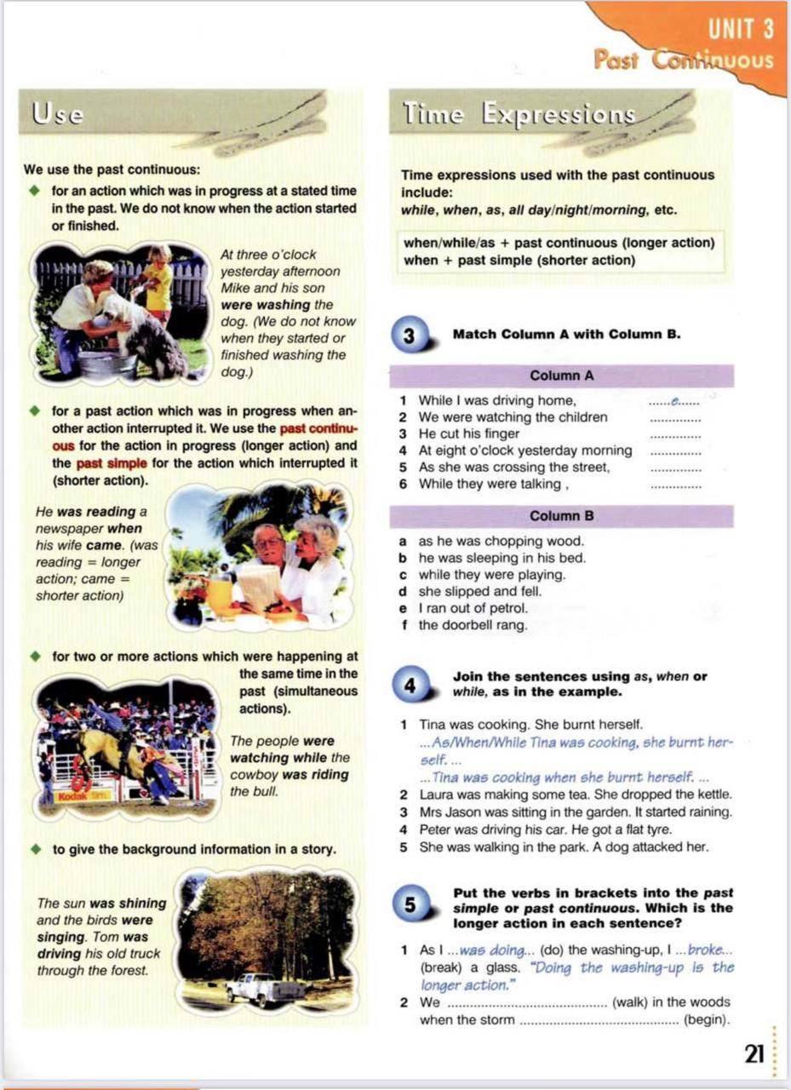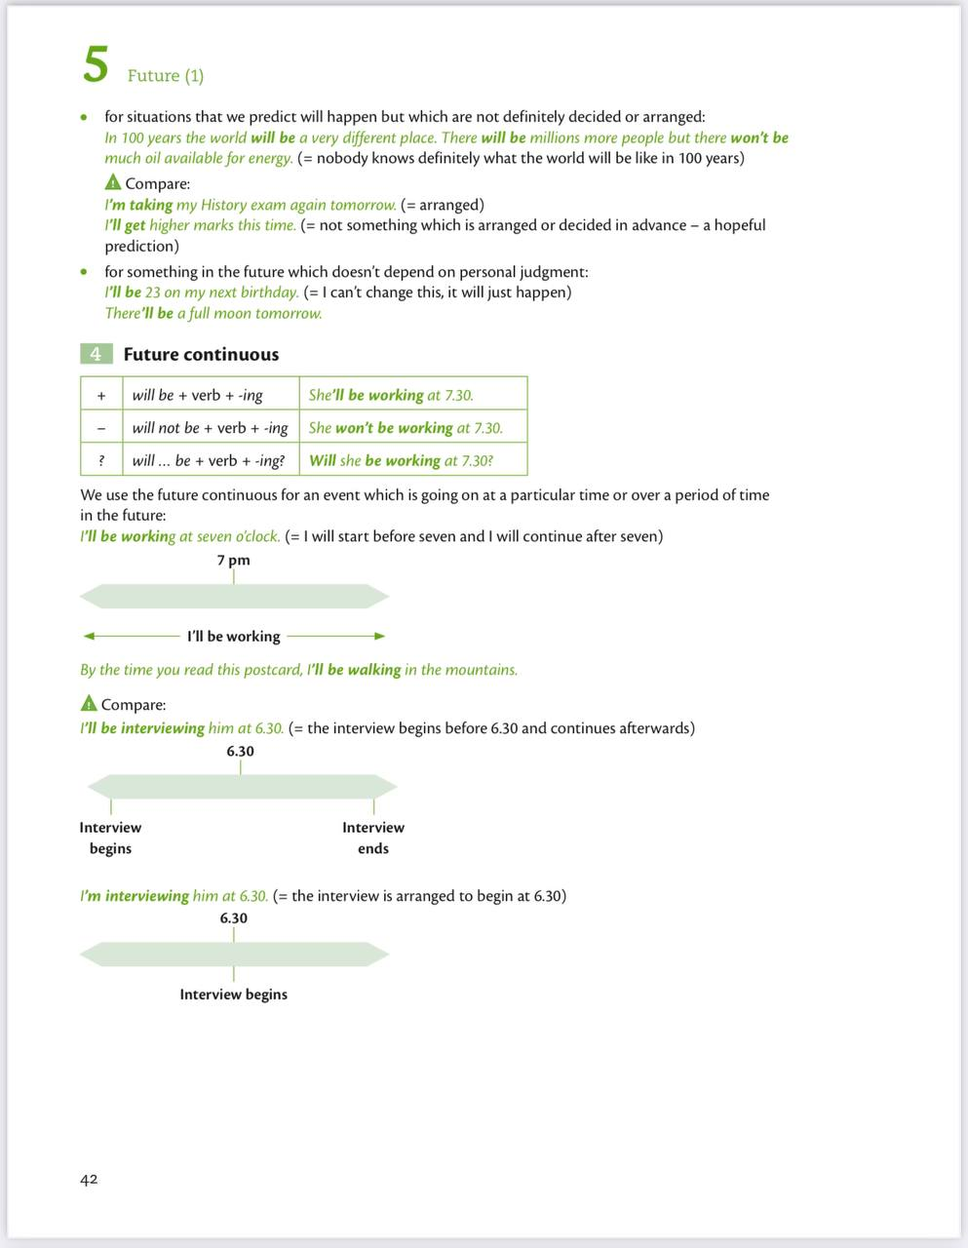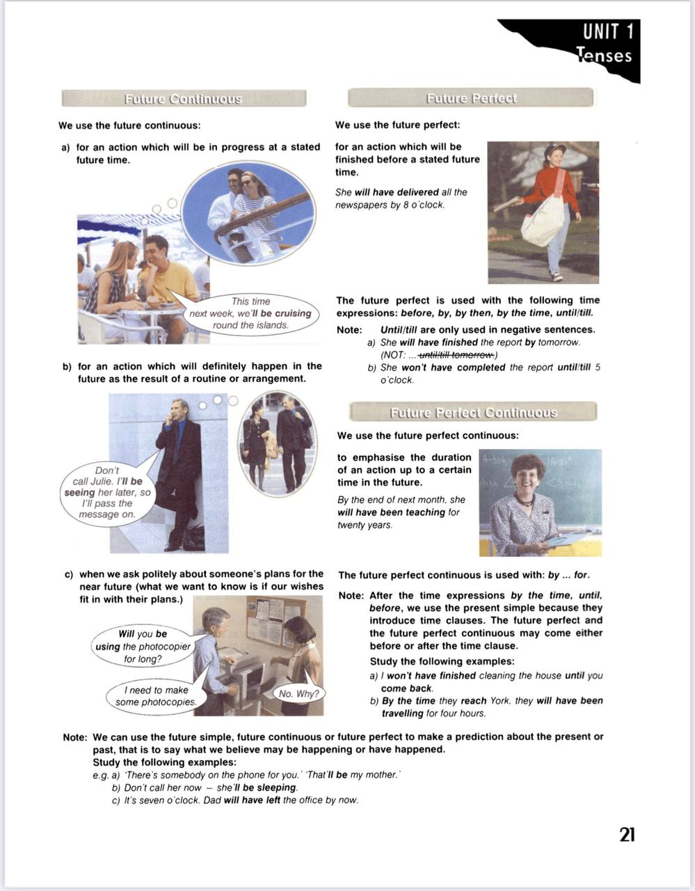

PAST CONTINUOUS

Exercise V. Put the verbs into the correct form (Past Continuous).
1. When I phoned my friends, they (play) ______ monopoly.
2. Yesterday at six I (prepare) ______ dinner.
3. The kids (play) ______ in the garden when it suddenly began to rain.
4. I (practice) ______ the guitar when he came home.
5. We (not / cycle) ______ all day.
6. While Alan (work) ______ in his room, his friends (swim) ________in the pool.
7. I tried to tell them the truth but they (not / listen) ______.
8. What (you/do) ______ yesterday?
9. Most of the time we (sit) ______ in the park.
10. I (listen) ______ to the radio while my sister (watch) ______ TV.
11. When I arrived, they (play) _______ cards.
12. We (study) ______ English yesterday at 4:00 pm.

Exercise VI. Write correct sentences:
Yesterday at 6 pm your family were doing different things. (Write positive sentences in Past Continuous).
1. My mother/read/a novel.__________________
2. My father/watch/a movie.__________________
3. My elder sister/writing/in her diary.__________________
4. My two brothers/listen/to the radio.__________________
5. My little sister and I/not/watch/a movie.__________________
6. We/talk/about school.__________________
FUTURE CONTINUOUS
Exercise VII. Put the verbs into the correct form (Future Continuous).
1. Tomorrow morning we (work).
2. This time next week we (have) a party.
3. At midnight I (sleep).
4. This evening we (watch) a talk show.
5. They (not/do) their homework this afternoon.
6. He (listen) to music.
7. I (read) a book this evening.
8. (walk/you) home this afternoon?
9. He (not/draw) tomorrow morning
- They (argue) again?

