Variant 1
- Name the pictures.
1. 2.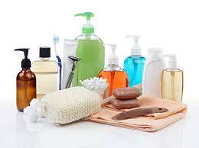 3.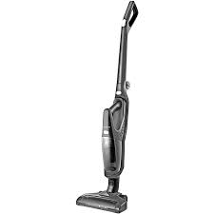4.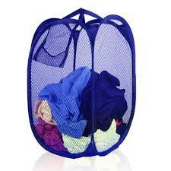
5. 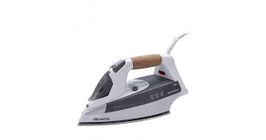6. 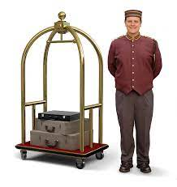7. 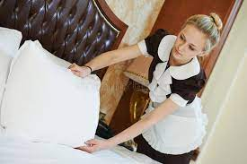 8.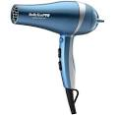
- Match words with definitions.
- bellboy | - place for guests to swim inside the hotel
- to check-in | - arrange to stay in a hotel
- Maximum capacity | - large open area at the front of the hotel
- guest | - a staff member who helps guests with their luggage
- lobby | - a piece of paper that guests display in the car window while in the hotel parking lot
- Indoor pool | - the most amount of people allowed
- Parking pass | - go to the front desk to receive keys
- to book | - a person that is staying at the hotel

- Make up your own 5 senteces using words from Ex.1,2
- Read the dialogue and fill in the gaps.
suitable Visa queen-size reservation dial credit card certainly
A: I have a 1.____________. My name is John Sandals.
B: May I see your ID, please, Mr. Sandals?
A: 2. ___________. Here it is.
B: Thank you. Do you have a 4. _________, Mr. Sandals?
A: Yes, I do. Do you accept American Express?
B: Sorry, sir, just 5. ______ or MasterCard.
A: Here's my VISA card.
B: Okay. You're in room 507. It's a single 6_________ bed, spacious, and nonsmoking. Is that 7. __________?
A: Yes, it sounds like everything I expected.
B: Here's your key, sir. If you need anything, just 8. ______ 0 on your room phone
- Read the text and choose the best title, prove your choice.
There are many types of hotel, big and small. Big hotels, which are part of a 'group', offer guests a standard that does not vary from one location to another. Hotels can be awarded 'Stars' if their facilities match the Tourist Boards specifications. The more stars, the higher the standards. There is also a 'Red Star' accolade awarded for excellent cuisine.
People expect rooms with ensuite facilities. There is also a choice of single, double or family rooms to book. Hotels in large busy cities often have triple glazed windows to help reduce the noise of passing traffic.
When you stay in a hotel, the facilities are reflected in the price of the accommodation. Many establishments have swimming pools, squash courts, health clubs, gymnasiums and indoor play areas for young family members. Some of these activities can be used by non-residents, providing they pay the subscription fee. There are hotels with golf courses in their grounds. Some have lakes that are offered to guests who wish to fish or take out a boat to fill their leisure time.
A good hotel with pleasant helpful staff contributes to making a holiday enjoyable and encourages return visits. Christmas cards are sent to regular guests from the hotel management. A varied choice of fresh food beautifully presented in a dining area with lovely views, all add to the holiday experience.
If the guests do not wish to dine in the restaurant, room service is an alternative. A menu is supplied in the room from which guests can order. When the food is ready, a member of staff will bring it to the room. If the guests have to leave early in the morning before the dining room is serving breakfast, an order can be placed the night before leaving and breakfast will be delivered to the room at the desired time. There is always a list of the restaurant opening times in the room.
Most hotels ask their guests to vacate their rooms by 10 o'clock on the day of their departure. This is so the staff have enough time to clean the room, make up the bed and generally tidy the area, before the next occupants arrive. New visitors to a hotel do not usually have access to their room until after mid-day.
- Read the text again and choose the best answer to the questions.
1) Why are hotels awarded stars?
A) They indicate the number of rooms in the building.
B) The stars are a way of knowing what facilities they offer.
C) They tell guests the hotel is open all year.
D) The stars indicate the size of the grounds.
2) Why do hotels in busy cities have double and triple glazed windows?
A) It helps to reduce noise levels.
B) To stop the sun shining in.
C) To keep the window cleaners busy.
D) They give a clearer view.
3) What facilities are offered to non-residents?
A) Only the bedrooms.
B) Non-residents are not welcome.
C) Only play areas for children.
D) The dining room, adjacent golf courses and the fitness areas.
4) What does room service mean?
A) Food and drink can be delivered to your room.
B) The guests have to leave.
C) An electrician comes to turn off the lights.
D) The room is ready for cleaning.
5) Why are guests asked to vacate their rooms by 10 am on departure day?
A) To check nothing has been stolen.
B) So that the room can be cleaned ready for the next occupants.
C) So the room can be repainted.
D) To let the staff sit in it when they are tired.
6. Choose one of the following topics and write as much as you can. Select a topic that you think would be interesting to write about.
- Describe the people who work in a hotel.
- Explain what happened the last time you visited a hotel.
- Describe the different types of hotels from where you live.

Variant 2
- Name the pictures.
1. 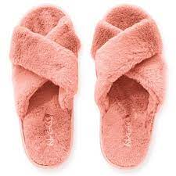2. 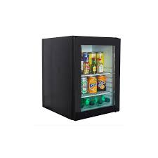3.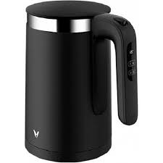4. 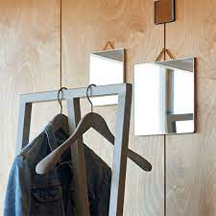
5. 6. 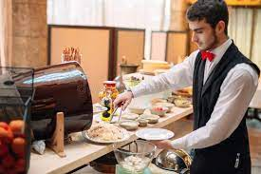7. 8.
- Match words with definitions.
- Adjoining rooms | - the place where guests go to check in and out and to get information
- To check out | - bags and suitcases packed with personal belongings
- valet | - extra large bed
- Damage charge | - a window that offers a nice image for guests
- reception | - two hotel rooms with a door in the centre
- view | - staff that parks the guests' vehicles
- baggage | - to return the keys and pay for the bill
- king-size bed | - money a guest owes for repairs to hotel property (when caused by violent or careless acts)

- Make up your own 5 senteces using words from Ex.1,2
- Read the dialogue and fill in the gaps.
acceptable forward Reserve smoking per night full name queen-size reservation
A: I'd like to 1.________ a hotel room.

B: That should be no problem. May I have your 2. ________, please?

A: My name is John Sandals.

B: Hello, Mr. Sandals. My name is Michelle. What days do you need that reservation, sir?

A: I'm planning to visit New York from Friday, April 14 until Monday, April 17.

B: Our room rates recently went up. Is that okay with you, Mr. Sandals?

A: How much 3. ________ are we talking about?

B: Each night will be $308.

A: That price is perfectly 4. ___________.

B: Wonderful! Do you prefer a 5. ________or nonsmoking room?

A: Nonsmoking, please.

B: Next question: Is a 6. _________ bed okay?

A: That sounds fine.

B: Okay, Mr. Sandals. Your 7. __________ is in our computer. All we need now is a phone number.

A: Certainly. My phone number is 626-555-1739.

B: Thank you, Mr. Sandals. We look 8. _________ to seeing you in New York!

- Read the text and choose the best title, prove your choice.
There are many types of hotel, big and small. Big hotels, which are part of a 'group', offer guests a standard that does not vary from one location to another. Hotels can be awarded 'Stars' if their facilities match the Tourist Boards specifications. The more stars, the higher the standards. There is also a 'Red Star' accolade awarded for excellent cuisine.
People expect rooms with ensuite facilities. There is also a choice of single, double or family rooms to book. Hotels in large busy cities often have triple glazed windows to help reduce the noise of passing traffic.
When you stay in a hotel, the facilities are reflected in the price of the accommodation. Many establishments have swimming pools, squash courts, health clubs, gymnasiums and indoor play areas for young family members. Some of these activities can be used by non-residents, providing they pay the subscription fee. There are hotels with golf courses in their grounds. Some have lakes that are offered to guests who wish to fish or take out a boat to fill their leisure time.
A good hotel with pleasant helpful staff contributes to making a holiday enjoyable and encourages return visits. Christmas cards are sent to regular guests from the hotel management. A varied choice of fresh food beautifully presented in a dining area with lovely views, all add to the holiday experience.
If the guests do not wish to dine in the restaurant, room service is an alternative. A menu is supplied in the room from which guests can order. When the food is ready, a member of staff will bring it to the room. If the guests have to leave early in the morning before the dining room is serving breakfast, an order can be placed the night before leaving and breakfast will be delivered to the room at the desired time. There is always a list of the restaurant opening times in the room.
Most hotels ask their guests to vacate their rooms by 10 o'clock on the day of their departure. This is so the staff have enough time to clean the room, make up the bed and generally tidy the area, before the next occupants arrive. New visitors to a hotel do not usually have access to their room until after mid-day.
- Read the text again and choose the best answer to the questions.
1) Why are hotels awarded stars?
A) They indicate the number of rooms in the building.
B) The stars are a way of knowing what facilities they offer.
C) They tell guests the hotel is open all year.
D) The stars indicate the size of the grounds.
2) Why do hotels in busy cities have double and triple glazed windows?
A) It helps to reduce noise levels.
B) To stop the sun shining in.
C) To keep the window cleaners busy.
D) They give a clearer view.
3) What facilities are offered to non-residents?
A) Only the bedrooms.
B) Non-residents are not welcome.
C) Only play areas for children.
D) The dining room, adjacent golf courses and the fitness areas.
4) What does room service mean?
A) Food and drink can be delivered to your room.
B) The guests have to leave.
C) An electrician comes to turn off the lights.
D) The room is ready for cleaning.
5) Why are guests asked to vacate their rooms by 10 am on departure day?
A) To check nothing has been stolen.
B) So that the room can be cleaned ready for the next occupants.
C) So the room can be repainted.
D) To let the staff sit in it when they are tired.
6. Choose one of the following topics and write as much as you can. Select a topic that you think would be interesting to write about.
- Describe the people who work in a hotel.
- Explain what happened the last time you visited a hotel.
- Describe the different types of hotels from where you live.

