Практичне заняття 16_04.05.2022
Class-work. Grammar spot. Active Voice.
Verb “to be”
Infinitive | Past | Past Participle
to be (am, is, are) | was/ were | been

Present Tenses
Am – I am
Is – he, she, it is
Are – we, you, they are
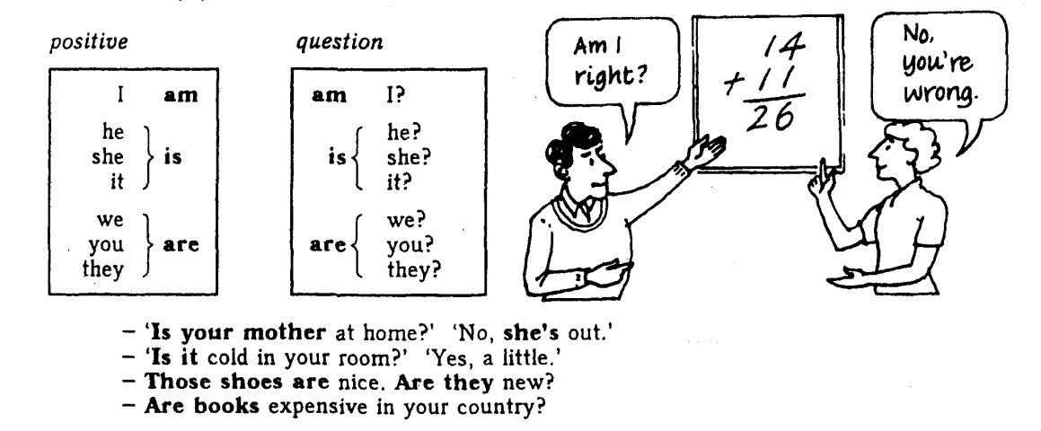

Past Tenses

Where were you yesterday?

Verbs
Auxiliary
to be
to have
to do
Sense
Infinitive | Past | Past Participle
to have (have/ has) | had | had
to do (do/ does) | did | done

Tenses
 | Indefinite/ Simple | Continuous | Perfect
Usage | FACT | PROCESS | RESULT
 | V | be + V-ing | Have + V₃
Present | I am a student. (am – auxiliary and sense v.)  I am not a student.  Am I a student?  I study at university. (study – sense v.)  I do not study at university.  Do I study at university?  I do my homework. (do – sense v.)  I do not do my homework.  Do I do my homework?  He does his homework.  He does not do his homework.  Does he do his homework? | I am working on the project at the moment. (am – auxiliary v., work – sense v.)  I am not working on the project at the moment.  Am I working on the project at the moment?  He is looking at the window.  He is not looking at the window. Is he looking at the window?  They are reading books.  They are not reading books.  Are they reading books? | I have been to Paris twice. (have – auxiliary v., be – sense v.)  I have not been to Paris twice.  I have never been to Paris.  Have I ever been to Paris?  He has finally met you.  He has already met you.  He has not met you yet.  Has he met you yet?
Past | I was a student. You were a student.  I was not a student. You were not a student.  Was I a student? Were you a student?  I studied at university.  I did not study at university.  Did I study at university?  I did my homework.  I did not do my homework.  Did I do my homework?  He studied at university.  He did not study at university.  Did he study at university? | I was working on the project at the moment.  I was not working on the project at the moment.  Was I working on the project at the moment?  He was looking at the window.  He was not looking at the window.  Was he looking at the window?  They were reading books.  They were not reading books.  Were they reading books? | I had been to Paris twice.  I had not been to Paris twice.  I had never been to Paris.  Had I ever been to Paris?  He had finally met you.  He had already met you.  He had not met you yet.  Had he met you yet?
Future | (will not = won’t)  I will be a student. You will be a student.  I will not be a student. You will not be a student.  Will I be a student? Will you be a student?  I will study at university.  I will not study at university.  Will I study at university?  I will do my homework.  I will not do my homework.  Will I do my homework? | I will be working on the project at the moment.  I will not be working on the project at the moment.  Will I be working on the project at the moment?  He will be looking at the window.  He will not be looking at the window.  Will he be looking at the window?  They will be reading books.  They will not be reading books.  Will they be reading books? | I will have been to Paris.  I will not have been to Paris.  Will I have been to Paris?  He will have met you in person.  He will not have met you.  Will he have met you yet?

