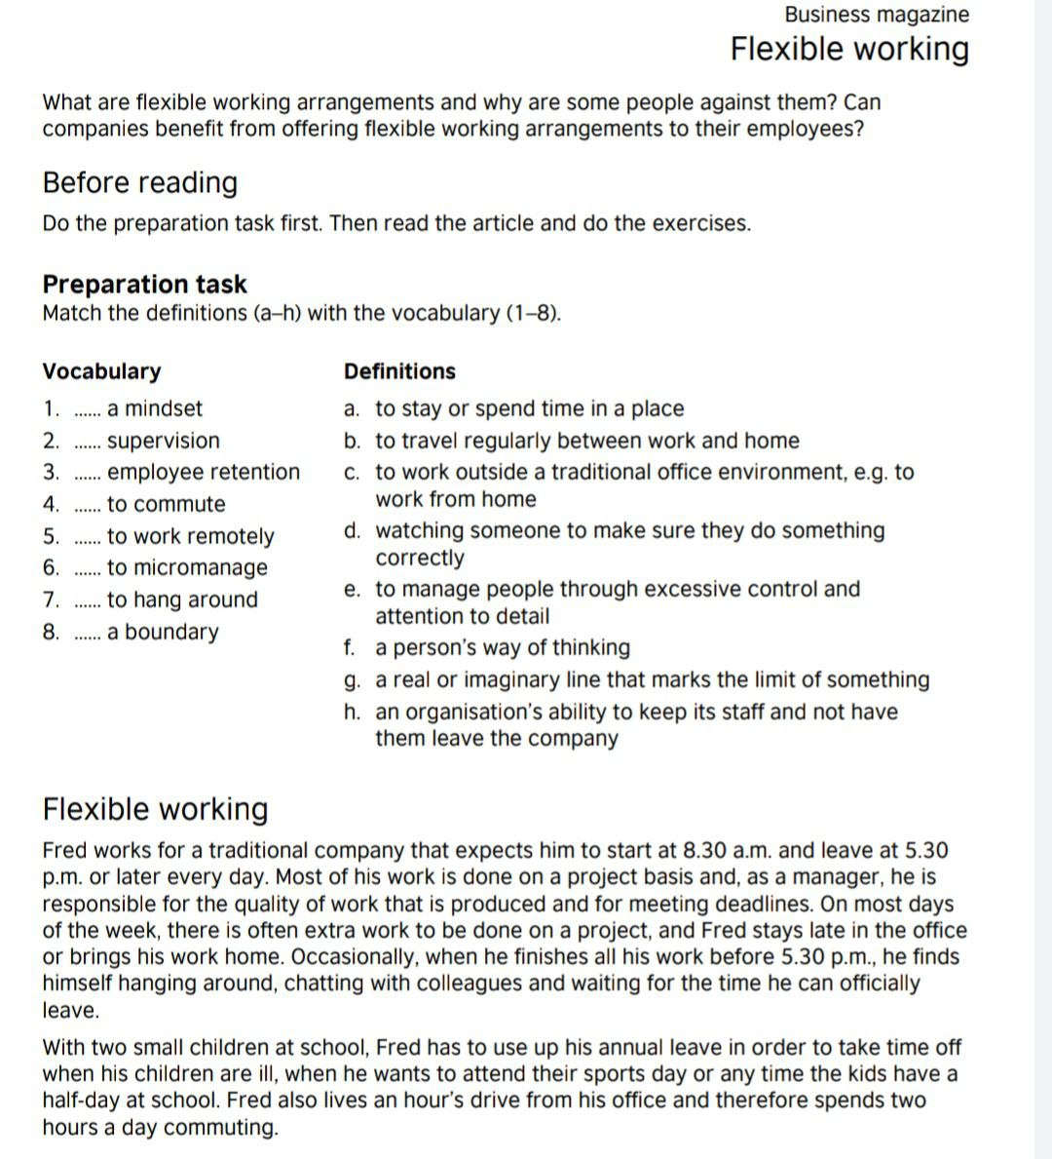

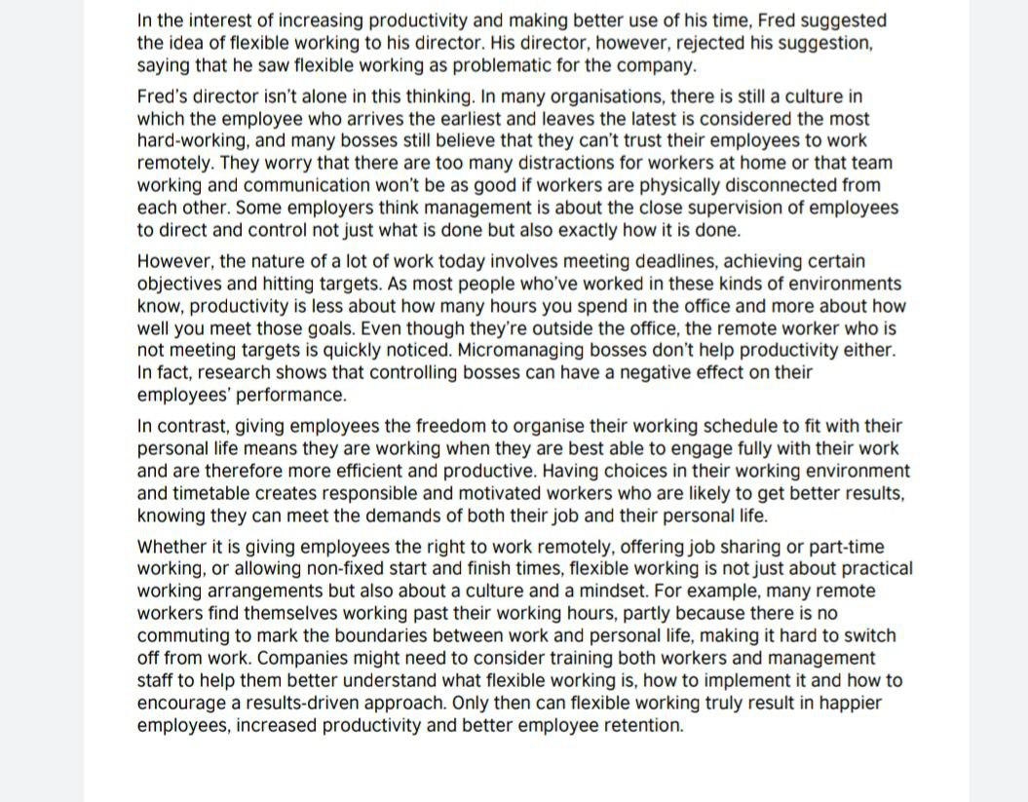
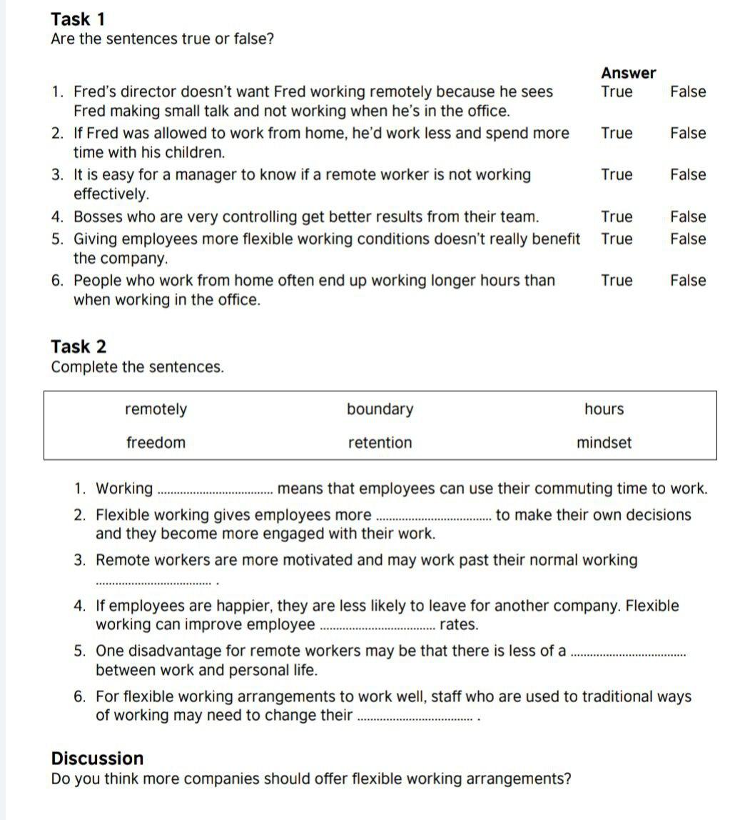
Resources: https://learnenglish.britishcouncil.org/sites/podcasts/files/LearnEnglish-Business-magazine-Flexible-working.pdf

