Тема 2. Borrowings. Translation loans.

- The etymological peculiarities of the English vocabulary.
- Etymological doublets.
- International words.
- Authors’ neologisms

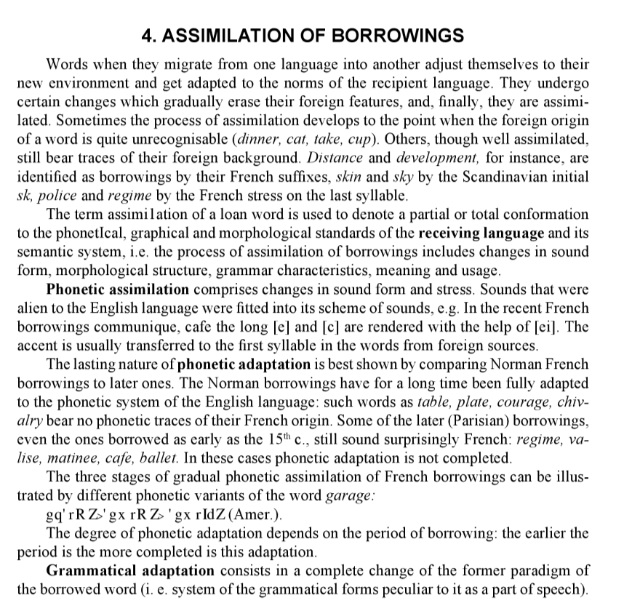
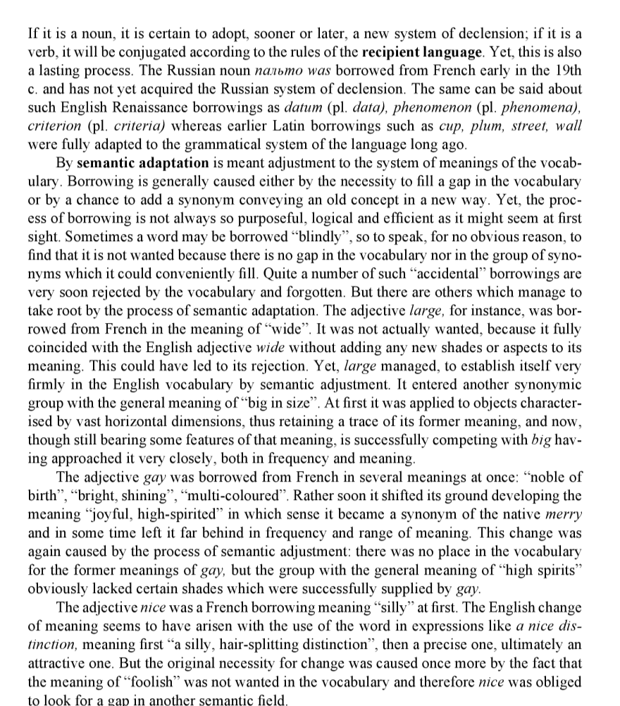
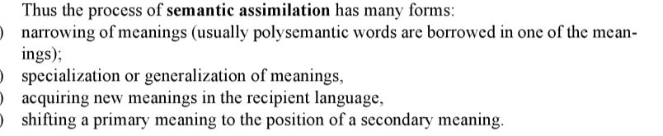
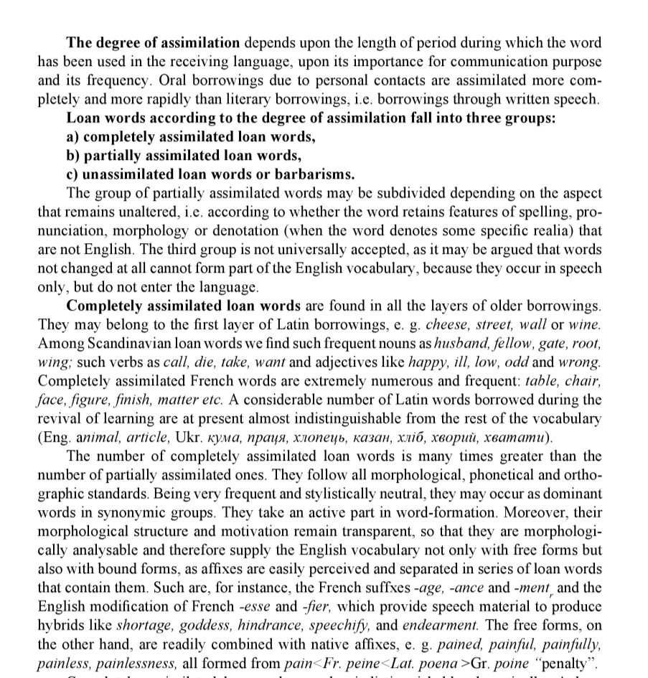
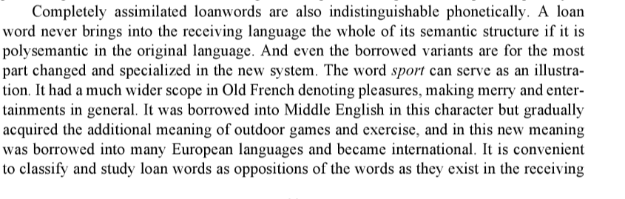

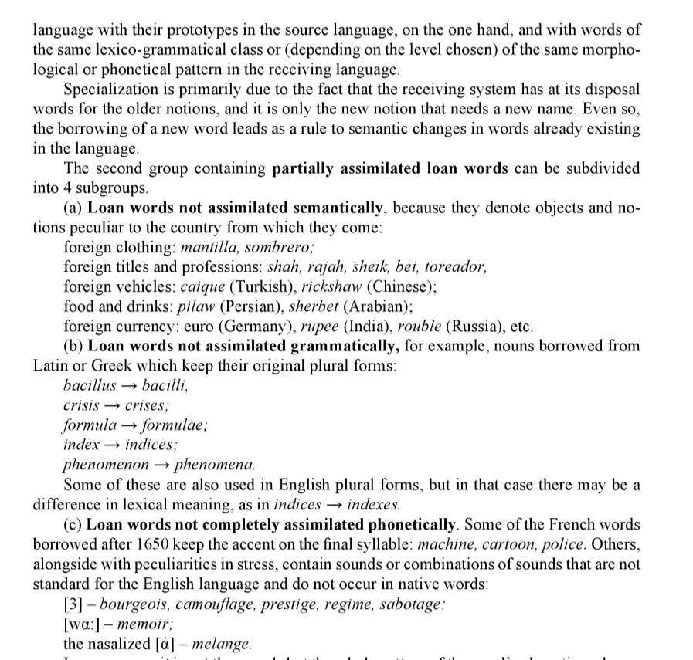
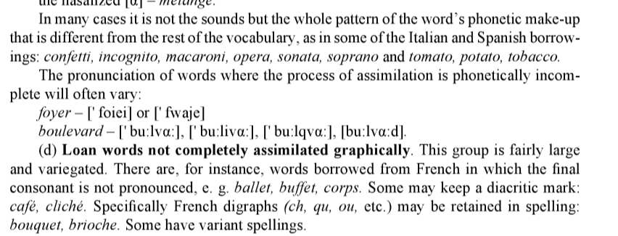

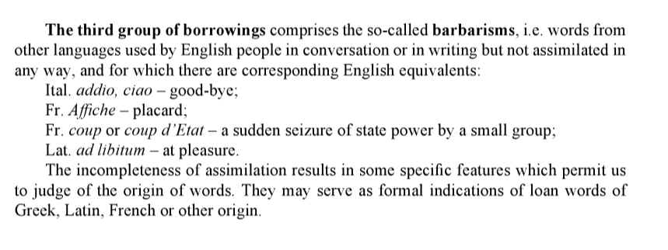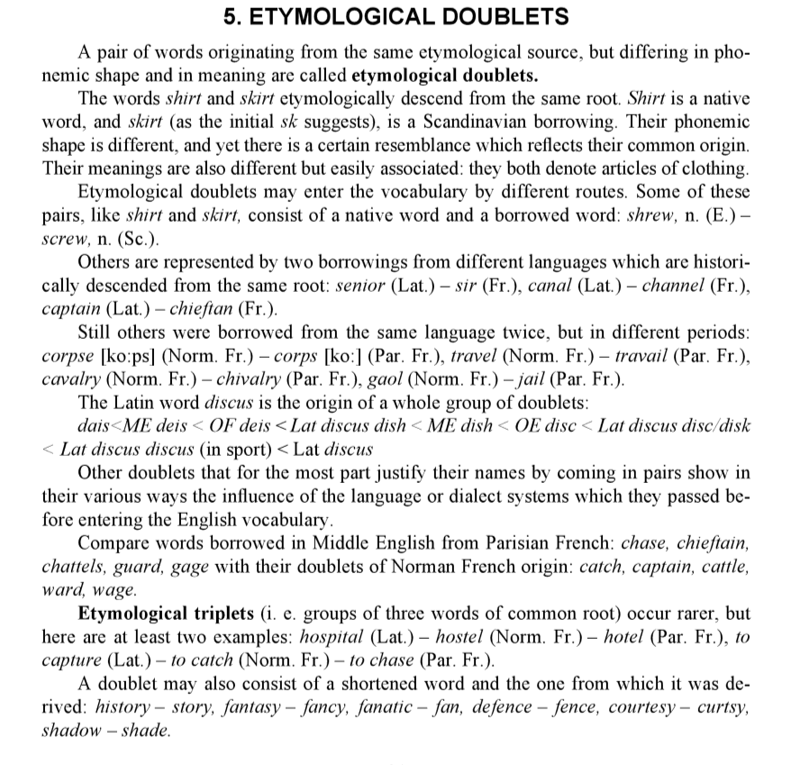
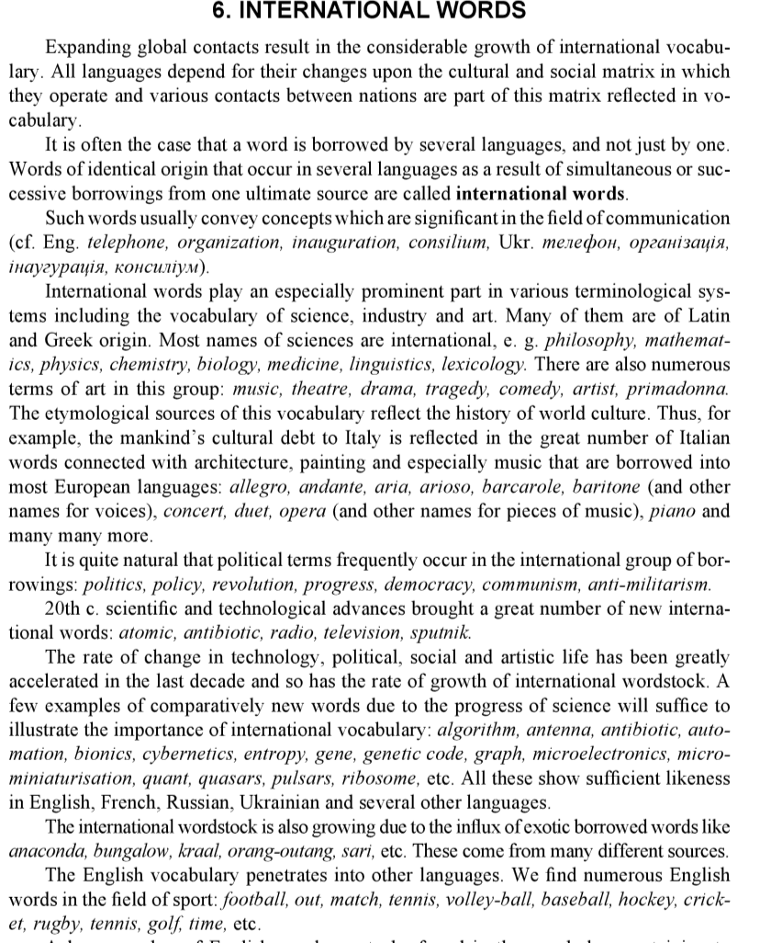
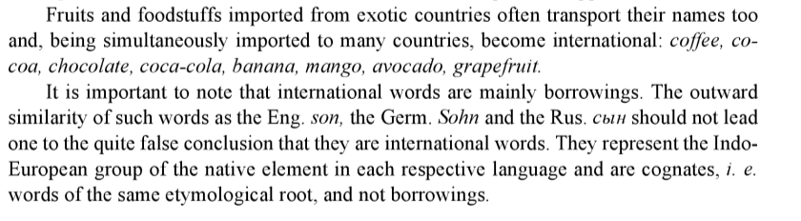

Here are some great examples of neologisms introduced by writers and their stories:

Banana republic
This word was introduced by O. Henry in his book of collected works Cabbages and Kings. It later became a term exploited in politics and it stands for a politically unstable country dependent on a product exported (bananas, for example).
Tropico is the excellent nation-builder game that simulates a Caribbean banana republic during the Cold War. The Daily Beast.

Beatnik
Jack Kerouac, the voice of the Beat Generation, actually invented the term “Beat Generation”. “Beatnik” was suggested by Herb Caen, a San Francisco columnist, similarly to the Russian word “sputnik”, which was popular at that time. The term stands for a person associated with the “Beat Generation”.
He was far, far different than the laughing, beatnik jabbering, youngster he had always seemed. Black Man’s Burden.

Cyberspace
William Gibson coined this word first in his sci-fi short story. It became better known after his novel “Neuromancer” was published a few years later.
This time Kate didn’t hesitate pressing send and watched her mail vanish from the out-box into cyberspace. Fallen Woman.

Freelance
This up-to-date term appeared long ago, when Walter Scott suggested it for the first time. According to his novel Ivanhoe, ”Free Lances” were hired as militants for a fee.
As a freelance writer, I depend for my living on easy relations withmagazines, creative-writing departments, and so on. The Daily Beast.

Hard-Boiled
It means tough when speaking about personal traits of character. What’s more, thanks to this term, a hard-boiled fiction genre appeared later. It stands for a detective story in which a cool cynical detective deals with crimes.
Because it lacks the stylish voice of a hard-boiled detective noir, it sometimes feels coldly industrious. The Daily Beast.

Butterfingers
Charles Dickens introduces this term in his “The Posthumous Papers” of the Pickwick Club book in 1836 and it stands for a clumsy person.
And, as every boy in the world knows, it is a great disgrace to be called “butterfingers.” Half-Past Seven Stories.

Chortle
No surprise this term belongs to the great inventor Lewis Carroll as well as the number of other fancy words. It’s made of “chuckle” and “snort”. You can only image the sound.
They will not actually steal, but they will cheat you every time and chortle over it. The American Egypt.

Doormat
Charles Dickens again. Speaking about a person “doormat” was first used in Great Expectations.
His rookie flailing set back the peace process (such as it was) and made him look like a doormat. The Daily Beast.

Factoid
It is a doubtful fact presented in the press without any extra proofs. People usually accept it as true, but unfortunately it’s not true. It was introduced by Norman Mailer.
McCarthy contributes the factoid, “We have four million more government jobs in America than manufacturing jobs.” The Daily Beast.

Feminist
“Féministe” came from the French language thanks to Alexandre Dumas and it suited public taste.
Marjorie Wilkes Huntley was a New Age feminist, a widow, and a librarian. The Daily Beast.

Gremlin
Gremlins, small beings, which caused mechanical problems in aircraft, appeared in Roald Dahl’s story for the first time.
Whatever the gremlin was, it wasn’t exactly an auspicious start for a fifty million-mile hop. Deepfreeze.

Meme
Can you imagine that this word was not coined in the 2000s? Everybody talks about memes, everybody creates memes nowadays. However, it was a faraway 1976 when Richard Dawkins invented it.
“He was constantly dealing with this meme of not being able to close the deal,” Jurkowitz says. The Daily Beast.

Nerd
This word was presented along with some other weird creatures’ names coined by Dr Seuss: it-kutch, preep, proo, nerkle, seersucker. However, only nerd survived. The term stands for a boring person.
She was one of the only female characters I could think of that was different and weird without being the nerd. The Daily Beast.

Oxbridge
First, Oxbridge was introduced as a fictional institution in William Thackeray’s novel. And then it started to stand for a combined name of Oxford and Cambridge.
And, without removing his hobnails, or his corduroys, he sprang lightly into the Oxbridge racing-boat. Punch, or the London Charivari.

Pedestrian
There was no word to name a person walking on foot, until William Wordsworth invented it.
The Crisis in American Walking Tom Vanderbilt, Slate How we got off the pedestrian path. The Daily Beast.

Scientist
William Whewell wrote “The Philosophy of the Inductive Sciences”, in which he expressed perplexity regarding the fact there is no name for a person dealing with science. This way “scientist” was born.
Skill as a scientist and skill as a writer rarely inhabit the same person, but when they do, the results can be incredible. The Daily Beast.

Workaholic
Dr. Wayne Oates set this word, when wrote his book Confessions of a Workaholic: The Facts about Work Addiction. The suffix -holic denotes addiction, as in the word “alcoholic”. Oates viewed work as a kind of addiction as well.
The workaholic with the love of white suits and the slogan, “Let’s KeepMoving!” The Daily Beast.

Twitter
This onomatopoeic (phonetic imitation of sound – twitting in this case) word is prescribed to Geoffrey Chaucer. He seems to be a great contributor to the English language dictionaries in that he provided them with a number of original words.
To catch the “real” tweeter, Weiner explained that he had hired an Internetsecurity firm to investigate. The Daily Beast.

Yahoo
Who on earth doesn’t know this word now? However, not every person is aware of its origin. The word “Yahoo” was first presented in Jonathan Swift’s novel Gulliver Travels. Yahoos were primitive cruel creatures with materialistic attitudes.
When will the Left learn that this is not simply a nation of dimwitted yahoos? The New York Times.

3.4 Neologisms
The development of science and technology resulted in the coinage of new words and terms in every language. These new coinages are named neologisms, or innovations (from Greek neos «new», logos «word») .
Neologisms are words and phrases coined to name some new (not known before) things and concepts. These are words and word-combinations which native speakers of a language consider new ones either in their form or meaning.
Neologisms appear in the language by means of:
- word-formative derivation (forming the new words from morphemes that already exist in the language using well-known patterns);
- semantical derivation (giving to an existing word a new second meaning, based on resemblance of a newly denoted phenomenon with some known one);
- borrowing the words from other languages, dialects, jargons, etc.
Thus, neologisms can be divided into:
- lexical (new words);
- phraseological (new set expressions);
- semantic (new lexico-semantic variety of a set expression). Semantic neologisms are the words that have been in use in the language for a long time already but that acquire new meanings now.
“Word-formative (or derivational) innovations” must be considered a separate category that materializes in new word-formative elements (ideally, they are also represented by new word-formative patterns). The role of each productive affix must be thought to be more important in comparison with the role of a lexical or phraseological neologism because each word-formative model gives birth to numerous lexical neologisms and expands word-building possibilities (cyber-: cybercash, cybercommuter, cyberinvesting, cybersurf; nano-: nanothermometer, nanooptics, nanoanything; -ware: software, hardware, treeware (друкарські видання).
The creation of neologisms is usually caused by the necessity of giving names to new things, phenomena, concepts which are the result of constant development of economy, science, culture; the result of an increase in the intensity of communication with other nations and states. Modern scientific and technical terminological systems are most actively enriched with new coinages: cyberspace, dot-com-era,on-line company, blogosphere, neuroeconomics, culturnomics, etc. These are lexical neologisms that perform a nominative function. This group also includes the words coined from lexemes that existed in the language before: corporate – corpocracy («корпократія» - влада корпорацій у сучасному світі), Wal-Mart (мережa торгівельних підприємств) – Wal-Martian (людина, що зазвичай купує товари в такій крамниці); word burst (неологізм – різке зростання частотності вживання слова за конкретний період часу) – bursty words, word burstiness, etc.
Besides lexical innovations used for naming things, neologisms are coined to substitute an old name for a new, more accurate, more comprehensive one, the one that to a greater extend corresponds to phonetic, lexical, word-formative and other norms of the language.
As neologisms are a historical category their belonging to the passive vocabulary is not eternal. They are accepted as new words until the things they name become widely used. Since this time they are no longer neologisms. The further use of neologisms is justified if there is a necessity of their performing either communicative, nominative or figurative functions. When there is no such a necessity, the new coinage is needless and has no prospect of coming into the active vocabulary of the language. It also happens when neologisms do not correspond to the lexical system of the language, or to its grammatical structure, or phonetic patterns.
Speaking is the sphere in which neologisms constantly appear. They are not fixed anywhere, as a rule, and are quickly substituted for new ones. Sometimes they come to the literary variety. Individually author’s neologisms are often found in the literary (belles-lettres) style, especially in poetry, more seldom – in journalistic genres which are close to literary ones. Author’s neologisms make the text emotionally expressive. Therefore, for non-literary styles author’s neologisms are not typical because expressiveness is excessive and unnecessary in this case.
Talking about author’s neologisms we can’t but mention the term “occasionalism”, the phenomenon which requires special attention. Some reseachers believe that the terms “author’s neologism” and “occasionalism” are synonyms: «Author's, individual-stylistic, occasional neologisms follow certain aims. One of their peculiarities is that the laws of certain language units formation are broken during creating them". Individually author's neologisms (occasionalisms) are words created by writers and poets with the aim of making the text more expressive”.
Rozental and Golub claim that «…we should distinguish author's neologisms from occasionalisms – words created «occasionally», in certain conditions of speech communication, which contradict the language standard and differ from usual ways of word formation in the language».
Thus, we admit that author's neologism is a word or word's meaning, created by the writer, poet, publicist for defining new or invented phenomena of reality, newly invented things or terms. The book as the source of information has less feedback with the reader in comparison with newspapers, magazines, and the Internet. Correspondingly, the author should choose the language means more thoroughly so that the reader could be able to understand the information the author is conveying to him. Using certain language means takes on special significance when the author doesn’t only use the native language vocabulary but also invents new words to denote the events created by him and stated in his work. The author’s aim is to convey the matter of the object, notion or occurrence, which is clear in his mind but not yet known to the reader, in the briefest but most valuable language form.
So, occasionalisms (from Latin occasionalis – “accidental”) are words that are coined according to the models existent in the language, but that are not in wide use.
Occasionalisms are of individual character, used in the definite context that gives an opportunity to reveal their meaning. As opposed to neologisms, occasionalisms are said to be of a “one-time” character.
The term «occasionality» is relative in a way. In fact, all new units start their life as “occasionalisms” as they appear in a certain act of speaking. However, a great number of lexical units that appeared “occasionally”, came into common use and got into the active vocabulary of the language. Occasional were once considered the words cyberspace, couch potato, soap opera, etc. Lexical units become common if they define the concepts connected with essential present-day problems. The scope of popularization through mass media and advertising helps the words to come into wide use, too.
Рекомендована література
1. Анікеєнко І. Г. Практикум з курсу лексикології англійської мови для студентів ІІІ курсу / І. Г. Анікеєнко, Л.Ф. Бойцан, Л. В. Ганецька. – Київ: Вид-во КДУ, 1999. – 72 c. 14
2. Верба Л. Г. Порівняльна лексикологія англійської та української мов / Л. Г. Верба. –Вінниця: Вид-во Нова книга, 2003. – 160 с.
3. Гороть Є. І Теоретична й практична лексикологія сучасної англійської мови / за ред. Є. І. Гороть. – Луцьк : Волин. нац. ун-т ім. Лесі Українки, 2011. – 340с.
4. Ніколенко А. Г. Лексикологія англійської мови – теорія і практика /А. Г. Ніколенко. – Вінниця: Нова книга, 2007. – 528с.

