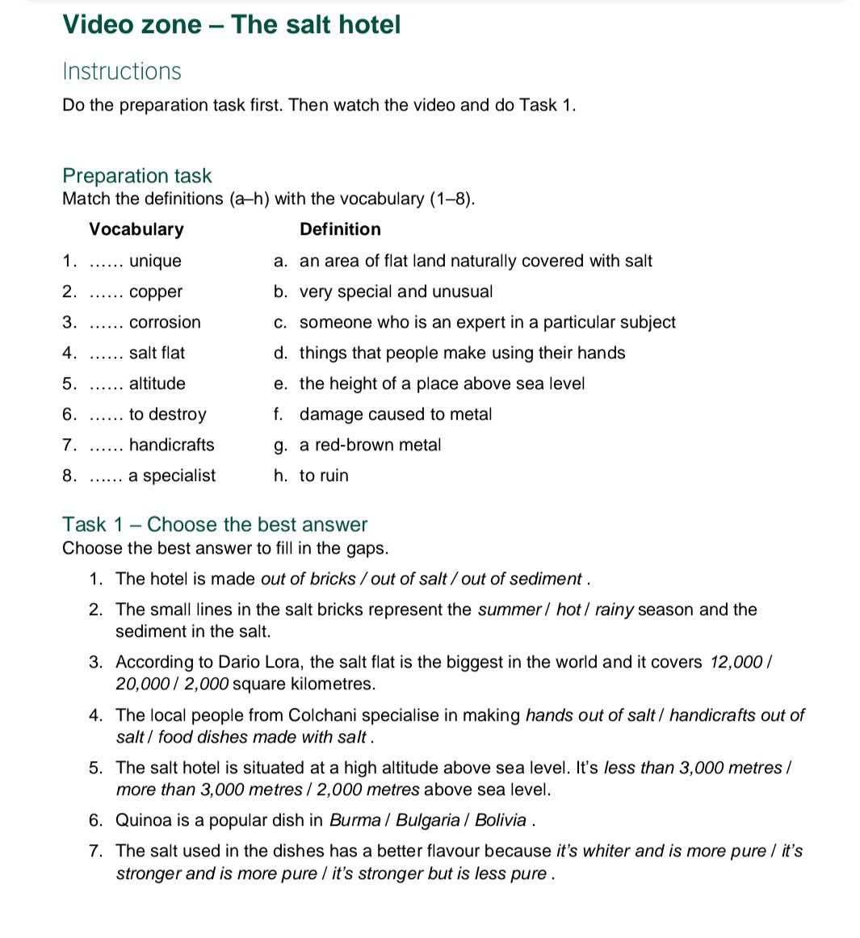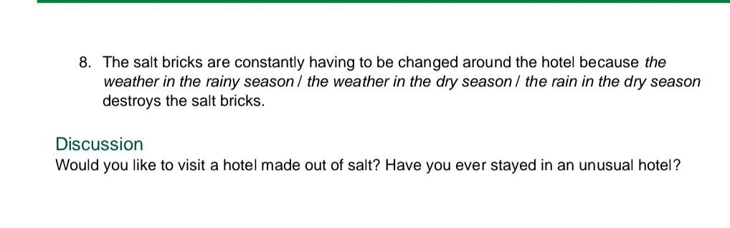
Resources: https://learnenglish.britishcouncil.org/general-english/video-zone/the-salt-hotel

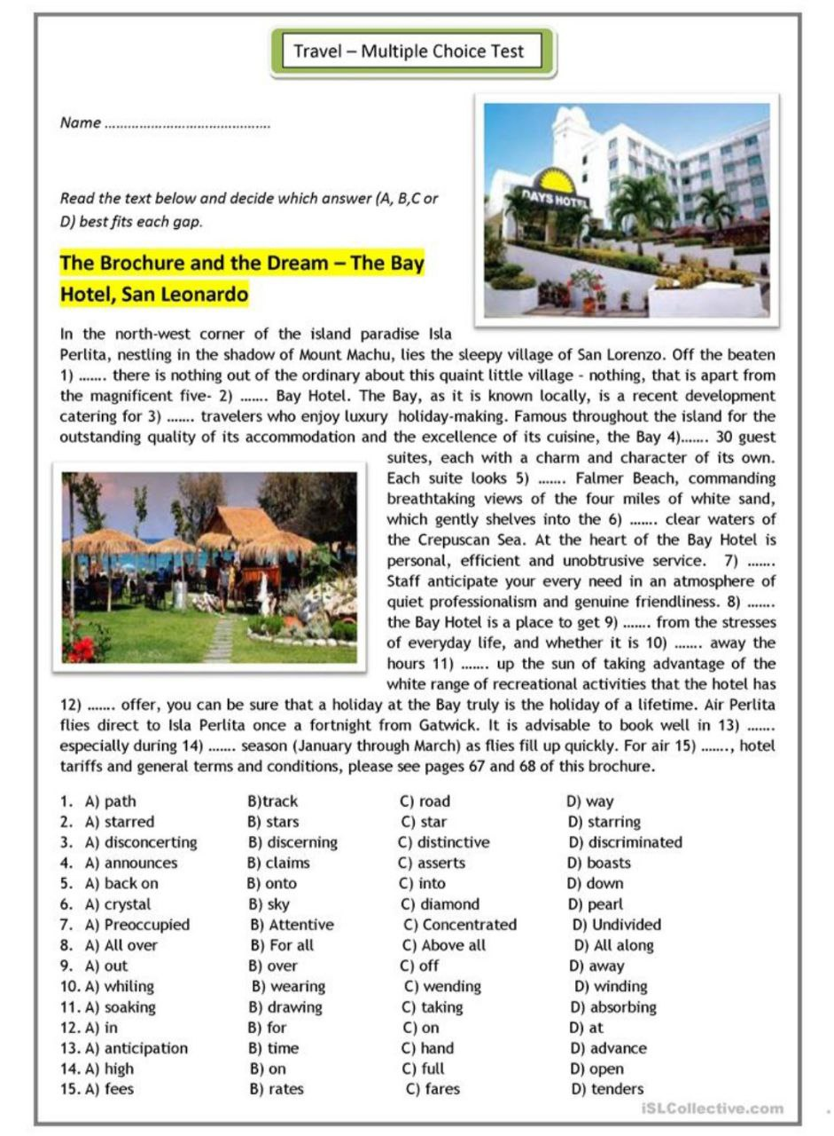
Homework: Prepare your own brochure

