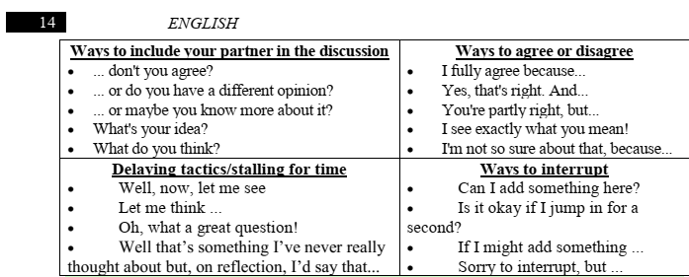
Read the article and be ready to talk about it in class:

Source URL: Is AI dangerous? - Explore the article & Decide yourself - DataFlair (data-flair.training)

1. Autonomous Weapons
AI is programmed and is an automated device, which means it’s depended on no one. Imagine if it is misused and is programmed to do something dangerous, as is the case with autonomous weapons programmed to kill, is one way AI can possess risks.
Not only people who want to use it for their personal reasons but also for the nations too. It is even possible that the nuclear arms race can be replaced with a global autonomous weapons race.
The President of Russia, Mr.Vladimir Putin said: “Artificial intelligence is the future, not only for Russia but for all humankind. It comes with enormous opportunities, but also threats that are difficult to predict. Whoever becomes the leader in this sphere will become the ruler of the world.”

2. Social Manipulation
We know that social media uses autonomous-powered algorithms which are very effective at target marketing. This algorithm helps in knowing who we are, what we like and helps us to easily draw insights from it.
Everyone is on Facebook, but everyone was not aware that Facebook was using the user’s information. This is the biggest example of Social Manipulation. There were several investigations done to determine the fault of Cambridge Analytica and others associated.
50 million Facebook user’s data has been manipulated and still, people share their personal life on the platform.
This data was manipulated, it is also done by spreading propaganda to individuals identified through algorithms and personal data. This is a major drawback of AI.
It can target users and spread whatever information they like. That too, in whatever format they want and scan out the most convincing – fact or fiction.
3. Invasion of Privacy and Social Grading
This is a very dangerous thing, that AI allows marketers to do. An individual’s personal life can be tracked easily. His every move can be detected, as well as what he does in his daily routine can be known.
In today’s time, you will find cameras everywhere. Also, with facial recognition algorithms who you are can be easily known.
For example – In no time, China will start using Social Credit System. This will power it by providing information of about 1.4 billion citizens. Then, on the basis of the personal score, based on how an individual behaves their personality can be decoded.
Things like, how do they do jaywalk, do they smoke in non-smoking areas and how much time they spend playing video games. All such answers can be known.
But, what I believe is that it is worse than an invasion of privacy. Someone keeping a check on your moves is more like social oppression.

4. Misalignment between Goals and Machines
Humans value AI-powered machines because of their efficiency and effectiveness. But, if goals that are set are not clear then it could be dangerous. Suppose if a machine isn’t armed with the same goals that one has, then there might be a disparity.
For example – If a command of take me to the airport is given. Now the machine will look for the fastest route possible. Since it doesn’t possess emotions or sense it will not be aware of the rules of the road or road safety.
It doesn’t know the value of human life. So, a machine might take you to the airport as quickly as possible, but leave behind a trail of accidents.

5. Information Track without Consent
Machines collect, track and analyze so much about a person. So, it’s possible for them to track you as an individual and possess all the necessary information. It’s also possible to use the information against that person.
For example – An insurance company might tell you that, you’re not insurable based on the number of times you were caught on camera talking on your phone. Your boss might withhold a job offer based on your “social credit score” and not on your resume.

Summary
Every coin has two sides and so does AI. Any powerful technology can be misused. In today’s time, artificial intelligence is used for many good causes. Like, just to name a few, it is helping in making better medical diagnoses, finding new ways to cure cancer and make our cars safer. But, unfortunately, as the AI capabilities expand it is getting misused too. It is used for dangerous or malicious purposes by some people.
Since AI technology is advancing so rapidly, it is crucial for us to make sure that the technology is in safer hands. It is very important for us to develop it positively while minimizing its destructive potential.
Now, I think you must have got the answer to the questions – Is AI dangerous and if yes, then how it poses danger to humanity? If you have any other questions in your mind, do let us know in the comment section.

