English for First Year Students (Сивак О.Б., Ковальчук І.С.)
To-do list (список завдань):
- P. 33-35 ex. 2, 3, 4, 5
- P. 35 ex. 6 – Read and translate the text.
- P. 36-37 ex. 7, 8, 9, 11, 12

LIFESTYLES
Objective:
to
develop
students’ reading and speaking skills;
You only live once, but if you do it right, once is enough
Mae West

Warming-up
- Work in pairs. Look at the photos. Think about your grandparents and their lifestyle when they were young (compare: eating habits, free time activities, social relationships)
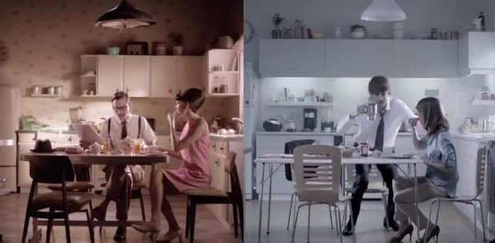

Useful expressions:
My grandparents ate much less red meat than me.
My grandparents walked more than I do.
I speak to my friends more on the phone than my grandparents.

Vocabulary
- Work individually. Match the phrases (1 – 8) with pictures (a – h). Use your dictionary to check that you understand all the phrases.
1) peaceful | 3) sporty | 5) glamorous | 7) exciting
2) hectic | 4) boring | 6) adventurous | 8) calm

a) | b) | c)
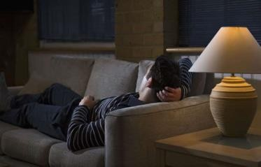

d) | e) | f)
g) | h)
Check your answers
1 |  | 2 |  | 3 |  | 4 |  | 5 |  | 6 |  | 7 |  | 8
- Match the following word-combinations with the definitions.

Word-combinations | Definitions
1) peaceful | a) not interesting or exciting
2) hectic | b) beautiful and smart, especially in a showy way
3) sporty | c) stimulating, inspiring
4) boring | d) willing to try new or difficult things
5) glamorous | e) quiet and calm
6) adventurous | f) without worry
7) calm | g) full of activity, or very busy and fast:
8) exciting | h) fond of sport or outdoor activities
- Complete the sentences with phrases from task 2.
- “Dusty's apartment is soooo ” Darian complained.
- Modern life is becoming more by the minute.
- “ down” the nurse said.
- The island attracts travelers.
- A new and life lay ahead of him.
- She could make ordinary people feel , and glamorous people feel ordinary.
- We need to find a alternative to war.
- Bob will grow up to be either or clever.

- Make up sentences of your own with word-combinations from task 2.

Reading
- Read the text and answer the questions:
- How does your lifestyle compare to British teenagers?
- Are they more active than you?
A Generation of Couch Potatoes
Word focus:
Sedentary: involving little exercise or physical activity
Blame: to say or think that someone or something did something wrong or is responsible for something bad happening
Lots of teenagers have posters of their sports hero on their bedroom wall. But do they follow the healthy examples set by these athletes? British parents are worried that young people are not as fit and healthy as
in the past. Why is this?
According to the British Heart Foundation, 13 to 15 year olds are spending too much time doing sedentary activities such as watching TV or playing computer games. A special report describes a generation of couch potatoes, young people sitting around at home, growing up in their bedrooms, travelling by car and in serious danger of heart disease as they get older. Is this their fault? Are young people lazy?
Many parents don’t allow their children to play outside or walk to school by themselves. “I ring my Dad on my mobile and he picks me up from the station. It’s 10 minutes’ walk from home but he thinks it is dangerous,” says 14 year old Carrie. Some teenagers blame their over protective parents for making them unfit. It is certainly becoming more difficult to encourage young people to have an active life and protect their hearts. In recent years schools have spent less time

on sports. “My Mum did lots of hockey and netball at school but we didn’t have time for that this year because we had so many exams to prepare,” says Ben, 16.
- Answer the questions after the text.
- Do teenagers follow healthy lifestyle?
- Why are sedentary activities bad for health?
- What is the best way to spend free time for teenagers?
- Match the underlined words in the text with definitions given below:
- to get or bring someone or something from somewhere;
- to inspire with hope, to give support;
- a sport played by two teams of seven players, usually women or girls, in which goals are scored by throwing a ball through a net hanging from a ring at the top of a pole;
- to make or get something or someone ready for something that will happen in the future;
- a statement;
- (an) illness of people, animals, plants, etc., caused by infection or a failure of health rather than by an accident;
- a person who watches a lot of television and does not have an active life;
- the possibility that something bad will happen.
- Read the text again. Are these sentences true (T) or false (F) or is the information not mentioned (NM) in the text?
- Lots of teenagers don’t have posters of their sports hero on their bedroom wall.
- Couch potatoes are young people sitting around at home, growing up in their bedrooms, travelling by car.
- It is certainly becoming more difficult to encourage young people to have an active life and protect their hearts.

- In recent years schools have spent more time on sports.
- The article tells us about Tom.

Writing
- Write a letter to your friend about your lifestyle.

Speaking
- Think about your answers to these questions.
- What is your daily routine like?
- Which period of your life do you like the most?
- What success have you got in your life for which you feel proud?
- What is your lifestyle like?
- Talk about yourself having a healthy lifestyle. You should say:
- What stops you from having a healthy lifestyle?
- What are the disadvantages of not having a healthy lifestyle?
- What can you do in order to have a healthier lifestyle?
- Work with a partner. Discuss your lifestyle. Which adjectives in task 2 best describe the life you live? Which adjectives describe the life you would like to have in the future? Are there any differences?

Home project
- Imagine you are an editor of the magazine for teenagers and young adults and you are going to publish series of articles about unhealthy lifestyle. The name of the articles: What Are the Dangers from Using Drugs, Alcohol, Unhealthy Food, Smoking?

