Topic: Relationships
Look at the quote under the title of thetopic, do you agree/disagree, why/why not.
Ex. 1-4 (write down the translation of phrasal verbs), 5 (make up 4 sentences)
Ex. 7-10 (reading activity) Ex. 12 (ask your groupmate and share with us his/her ideas)
Homework: learn new words, Ex. 15 (make up presentation)

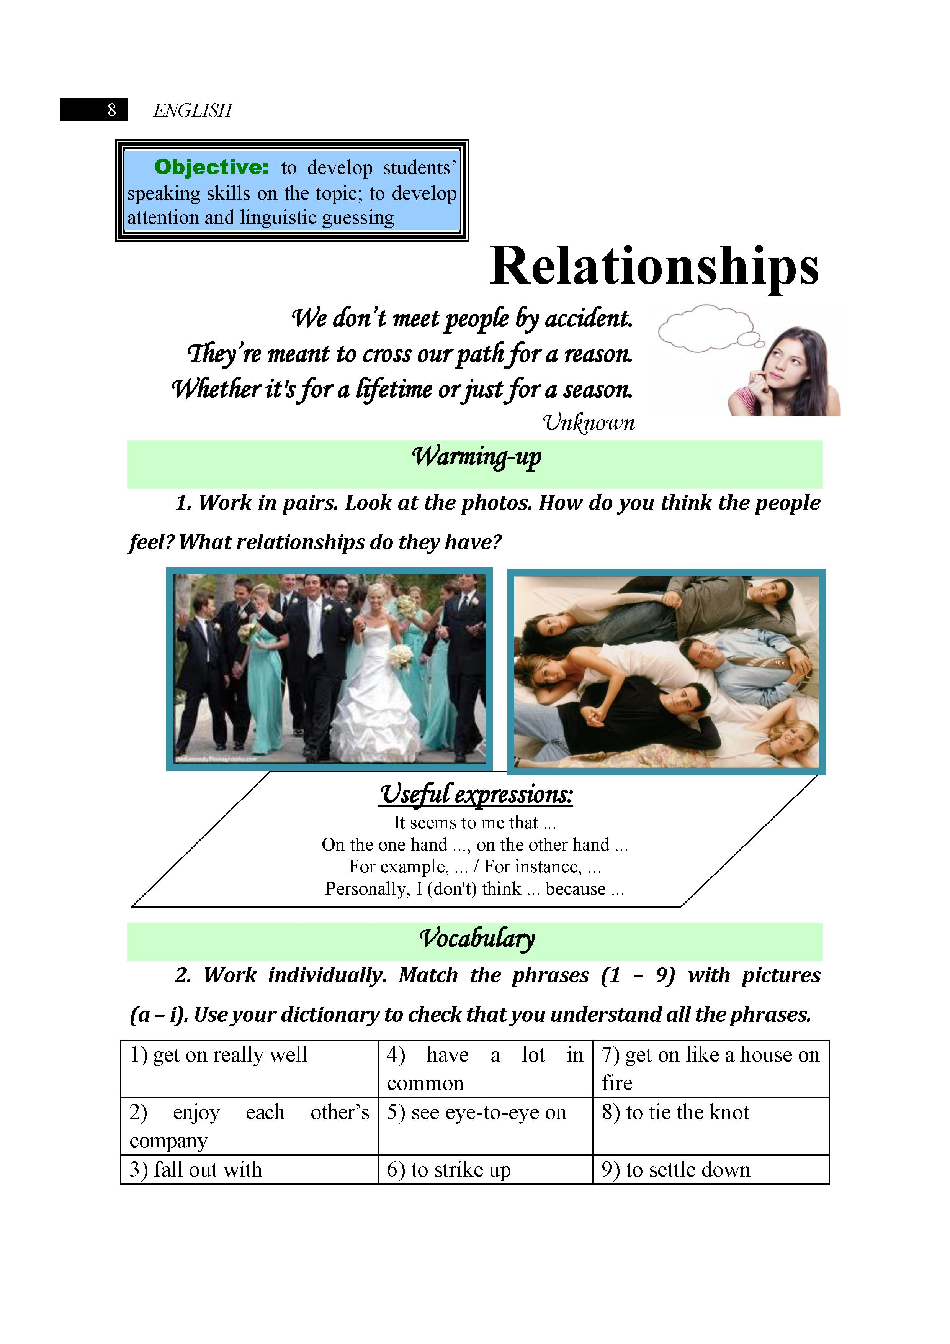
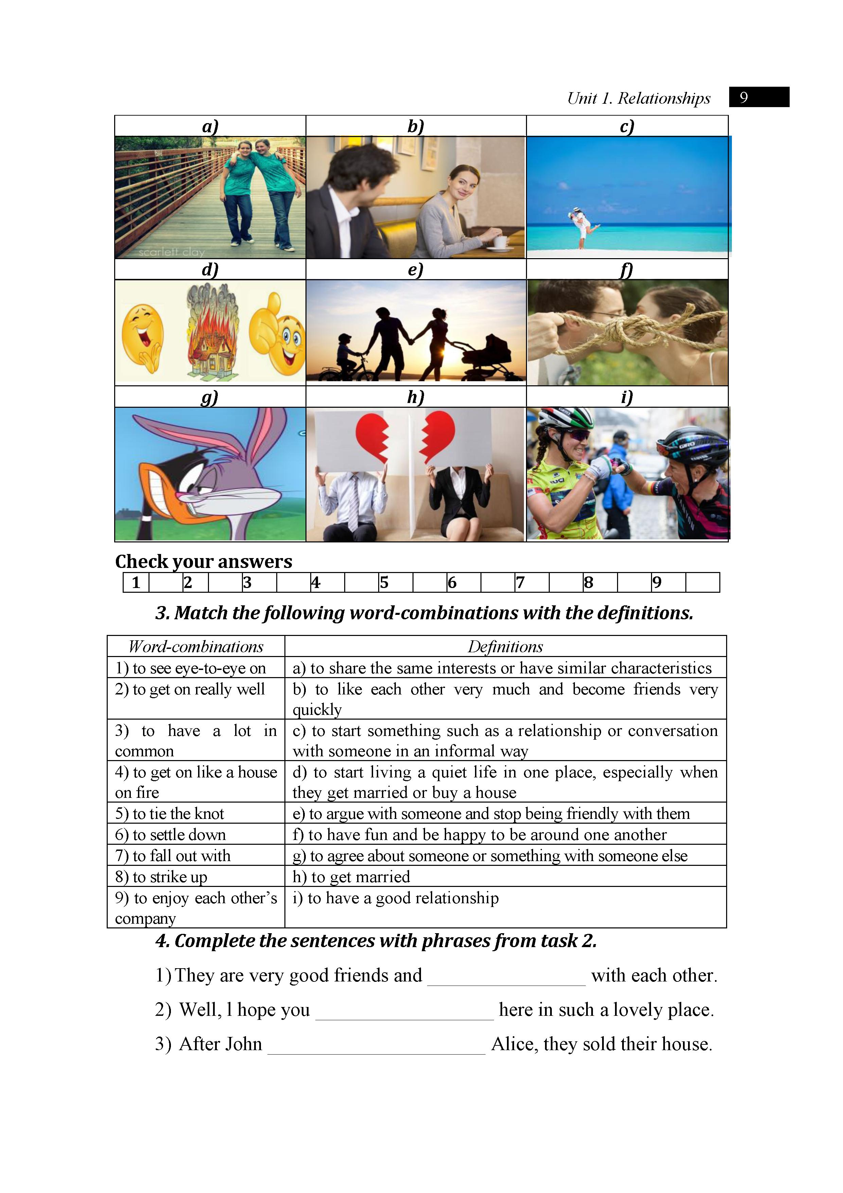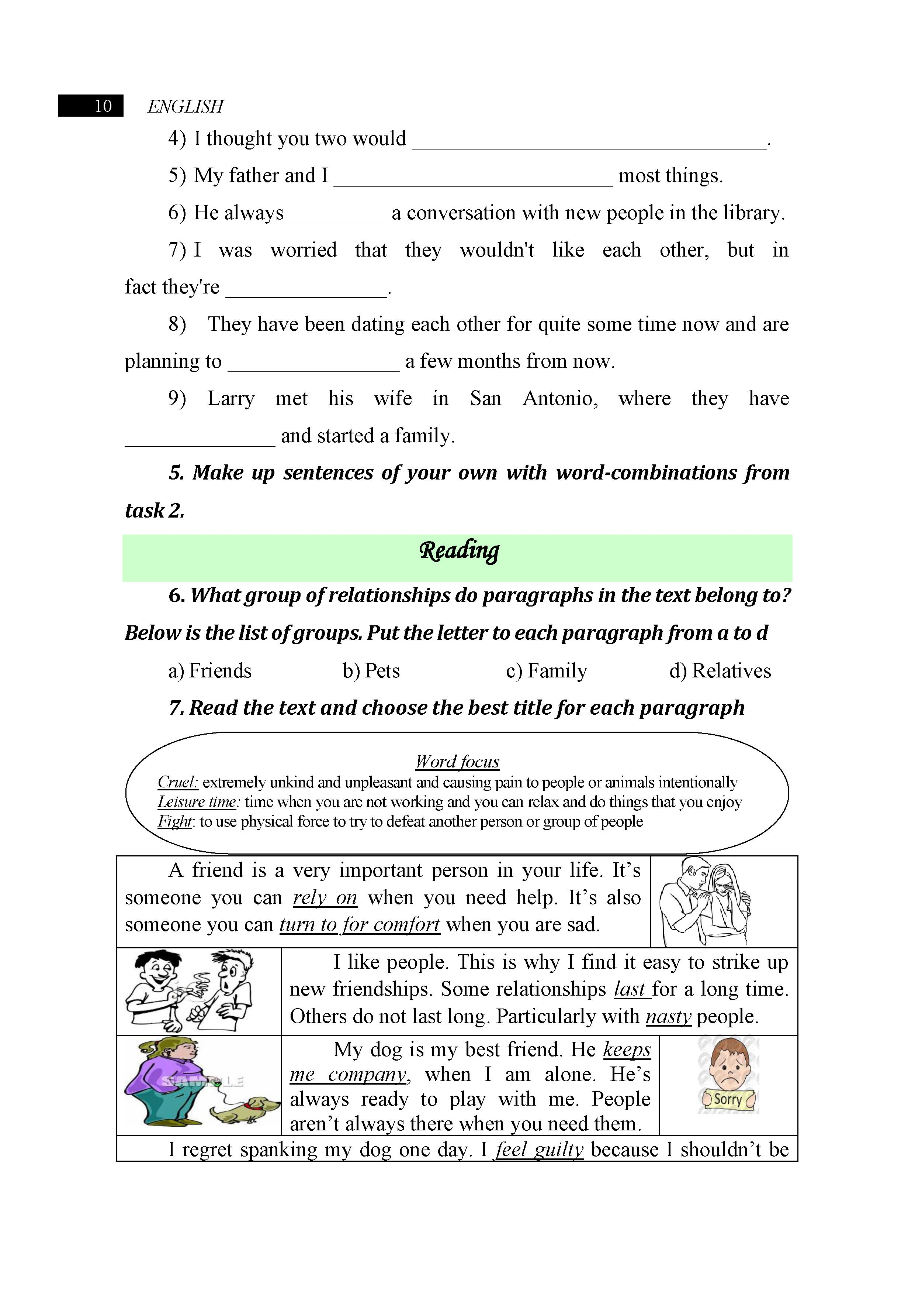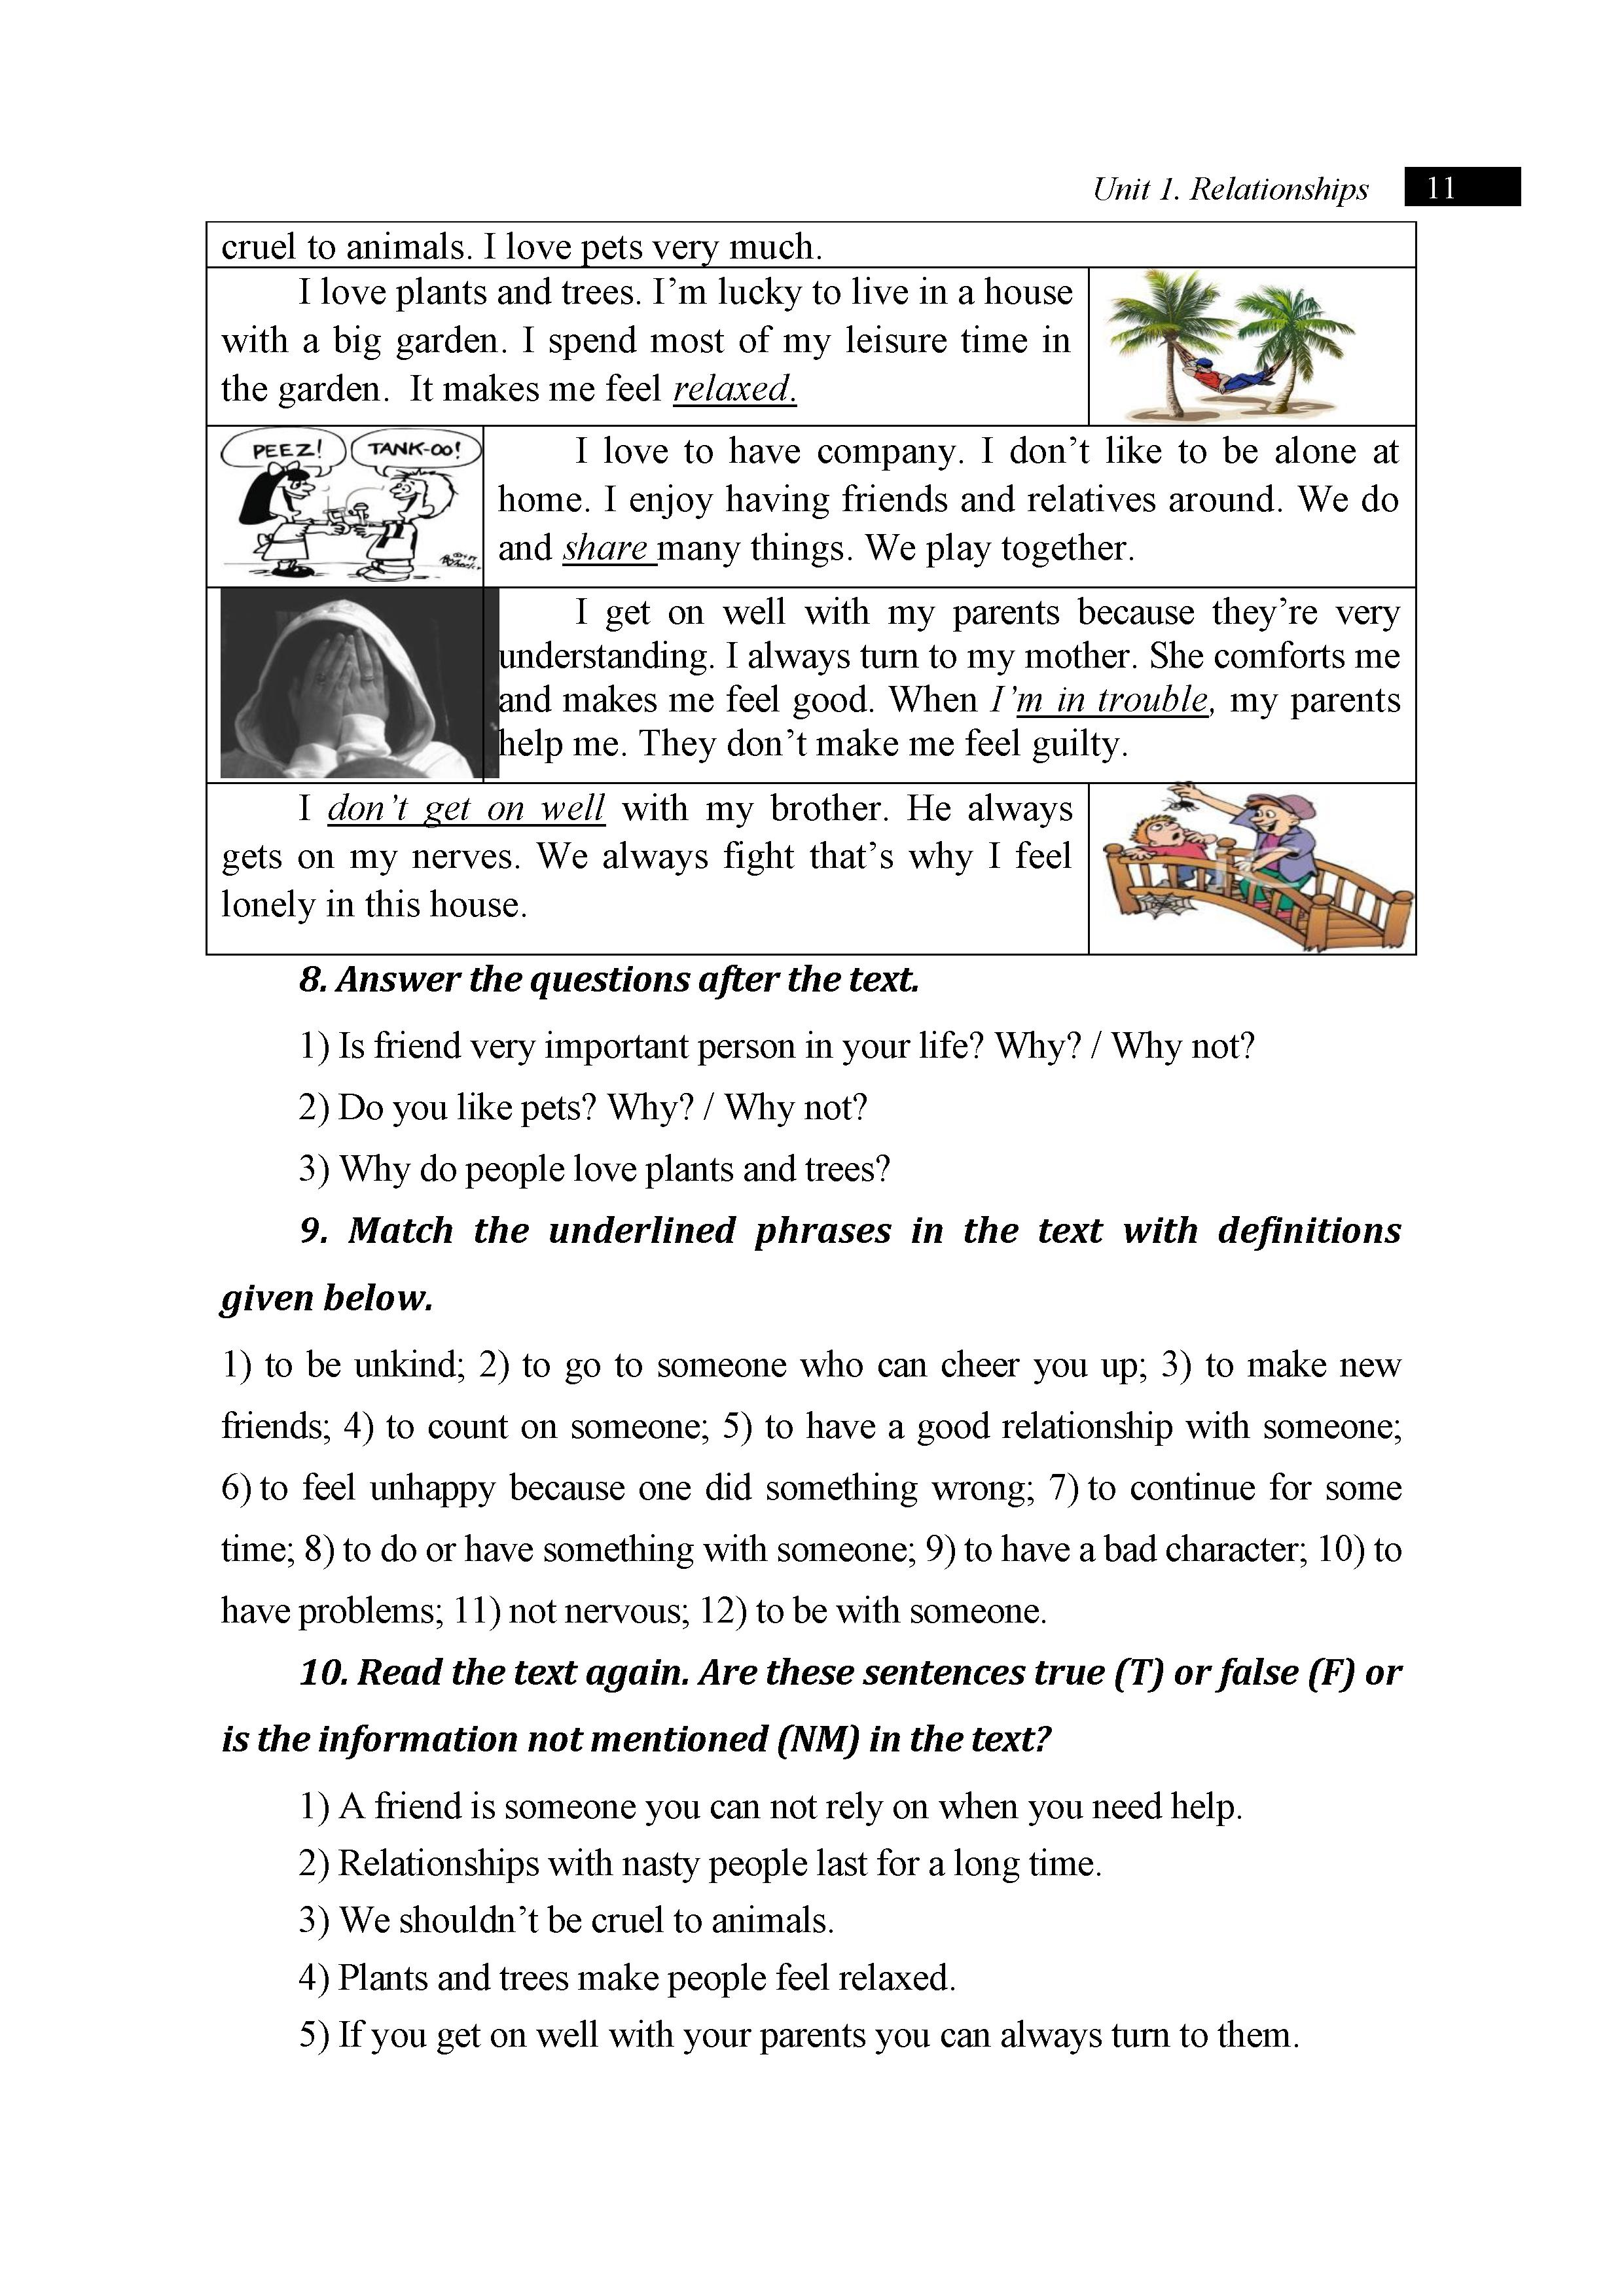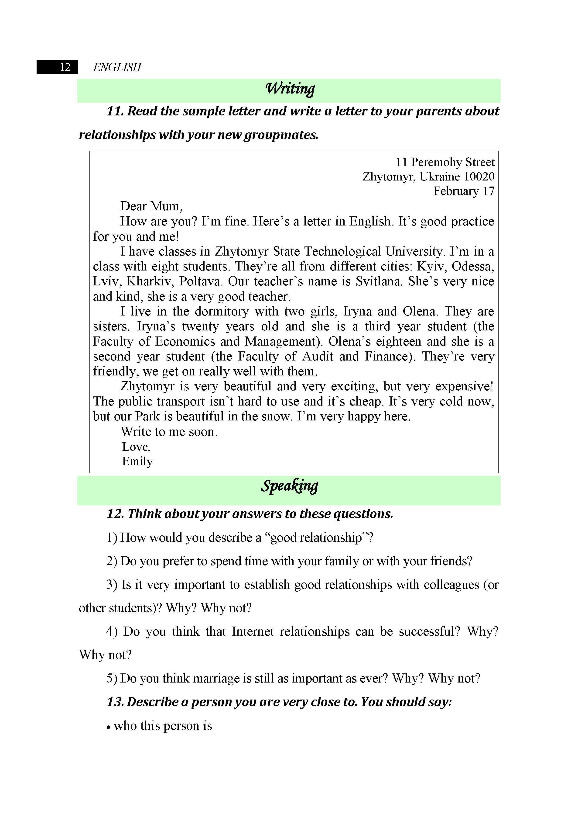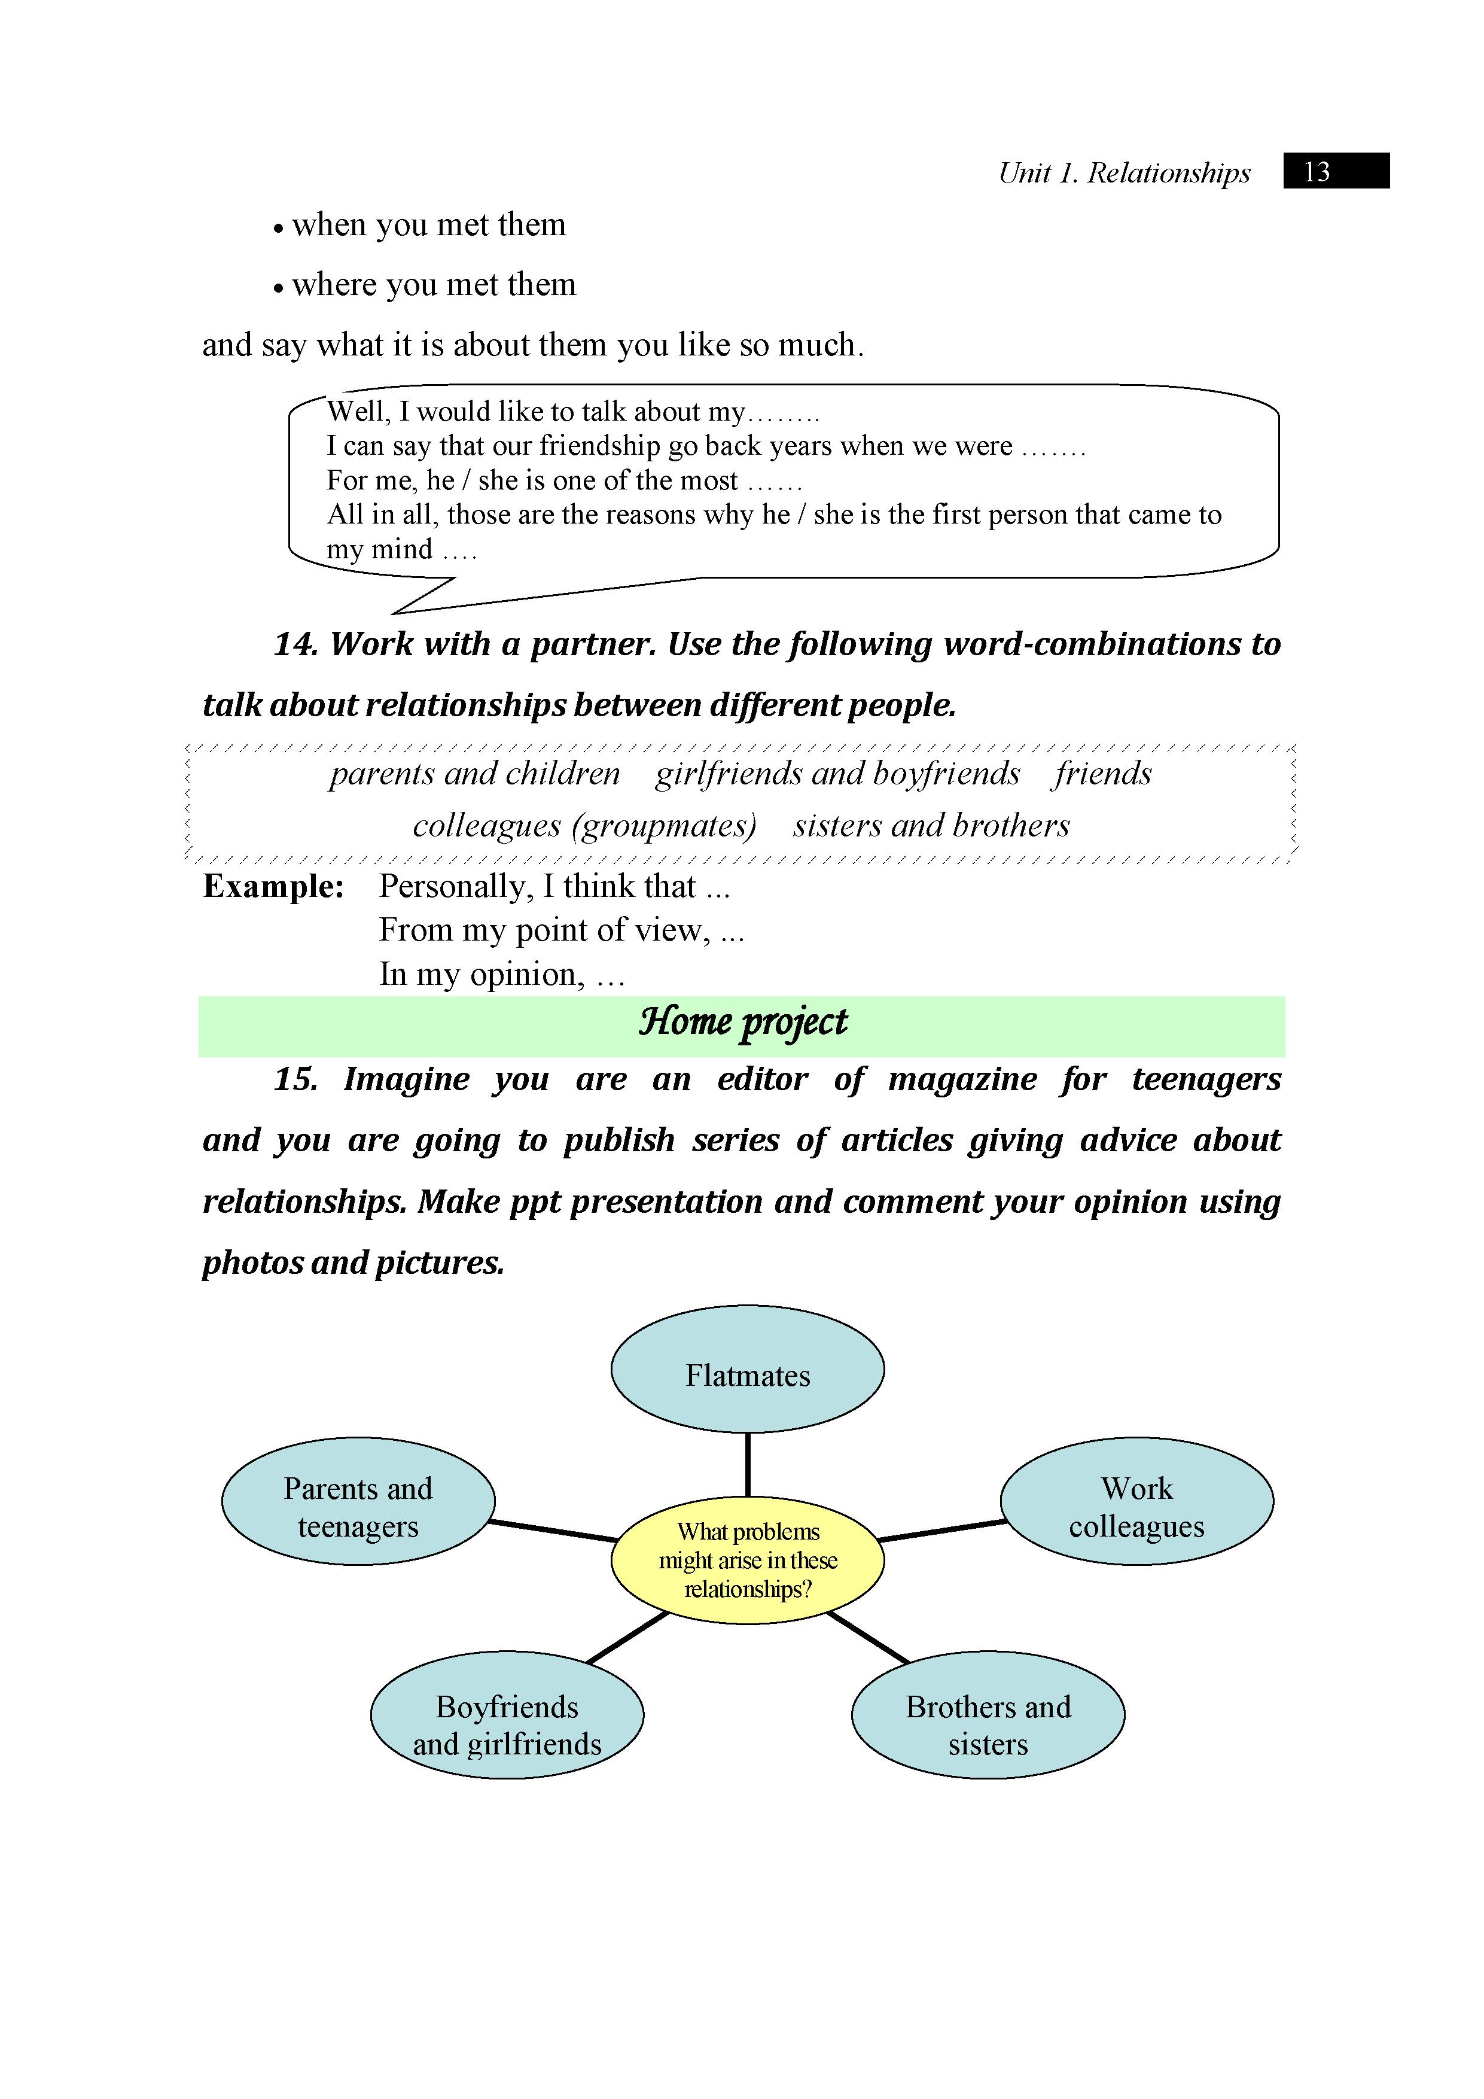
Resources:
“English” for first year students : навч.-метод. посіб. для студ. всіх спец. вищ. навч. закл. / І.С. Ковальчук, О.Б. Сивак.

