Лекція 7. Context.
- Types of context.
- Grammatical and lexical context.
- Change of meaning.
- Broadening (or Generalisation) of meaning.
- Narrowing (or Specialisation) of meaning.
- Metaphor.
- Metonomy.

Meaning and Context
(In the beginning) One of the most important “drawbacks” of polysemantic words is that there is sometimes a chance of misunderstanding when a word is used in a certain meaning but accepted by a listener or reader in another. It is only natural that such cases provide stuff of which jokes are made, such as the ones that follow.
Customer. I would like a book, please.
Bookseller. Something light?
Customer. That doesn’t matter. I have my car with me.
In the conversation the customer is honestly misled by the polysemy of the adjective light taking it in the literal sense whereas the bookseller uses the word in its figurative meaning “not serious”, “entertaining”.
Generally speaking , it is common knowledge that context is a powerful preventative against any misunderstanding of meanings. For instance, the adjective dull, if used out of context, would mean different things to different people or nothing at all. It is only in combination with other words that it reveals its actual meaning: a dull pupil, a dull play, a dull razor blade, dull weather, etc. Sometimes, however, such a minimum context fails to reveal the meaning of the word, and it may be correctly interpreted only through a second degree context, as in the following example: The man was large, but his wife was even fatter. The word fatter here serves as a kind of indicator pointing that large describes a stout man and not a big one.
Semantic structure of a word depends upon the word’s relationships with other words in typical contexts.

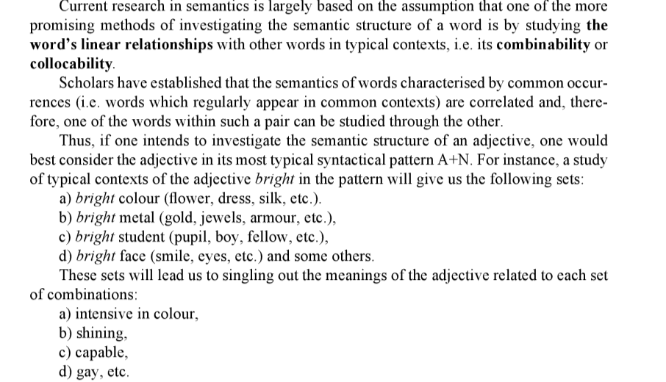

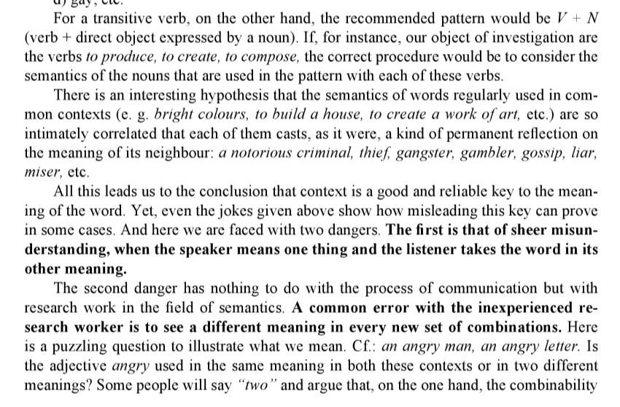
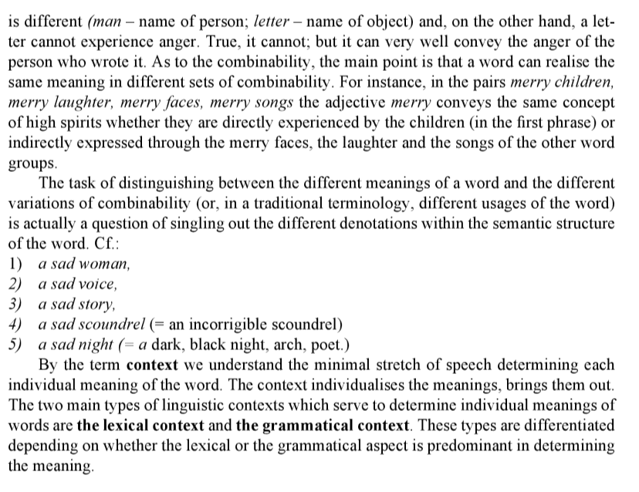

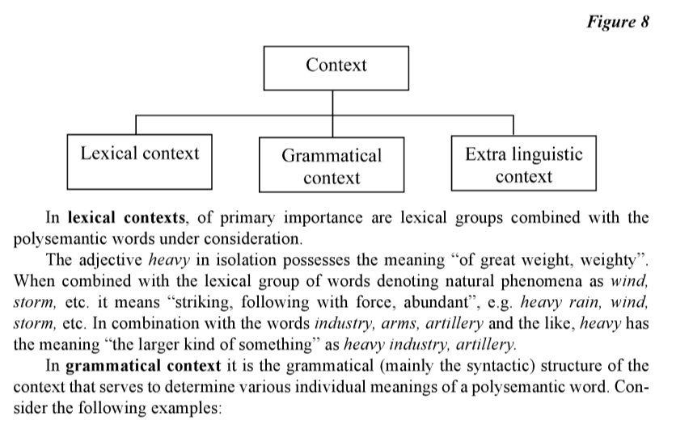
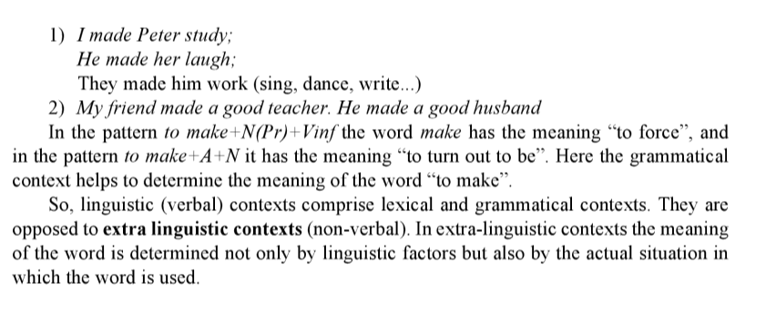
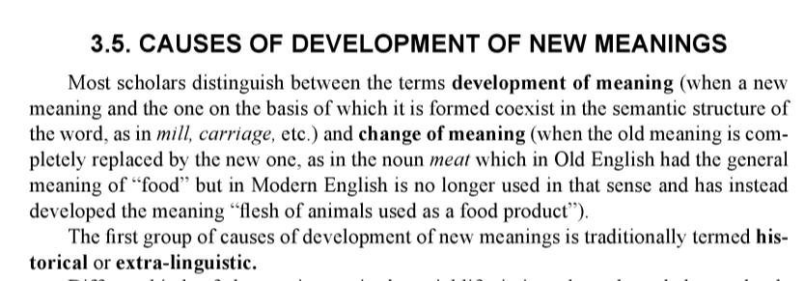
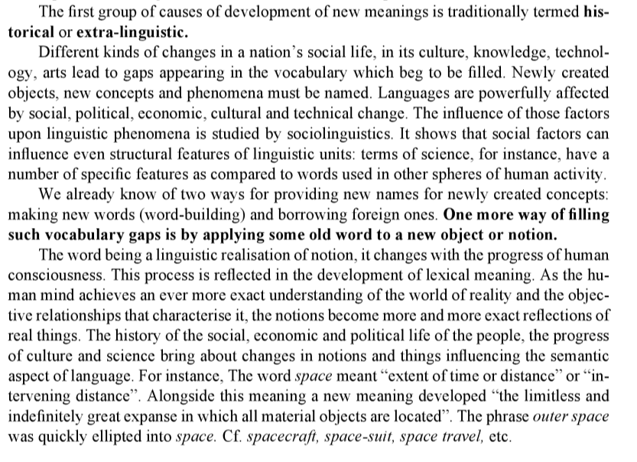
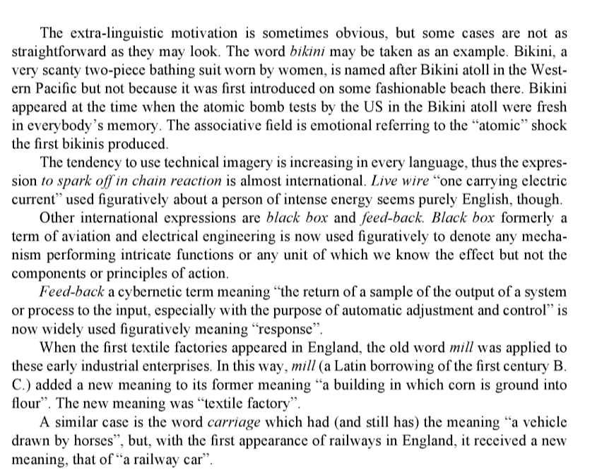
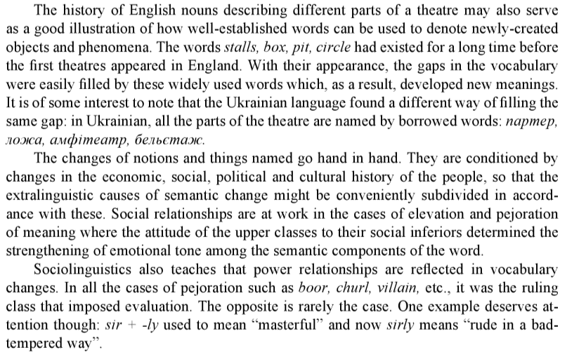

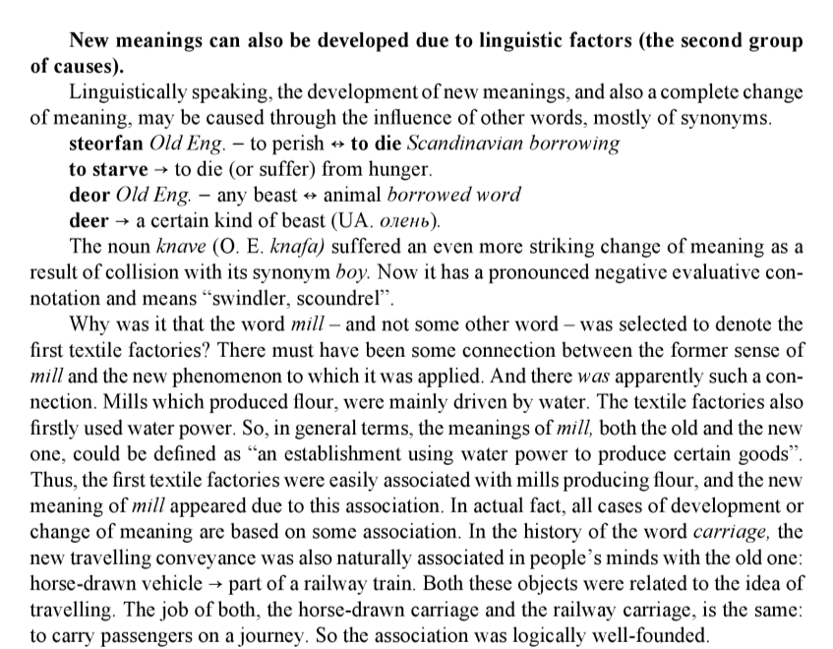

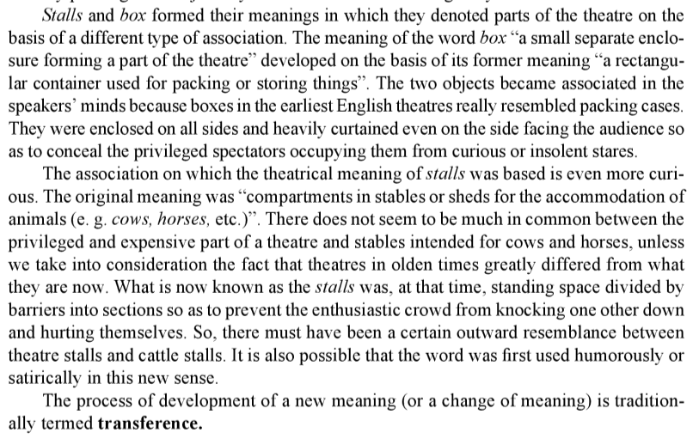

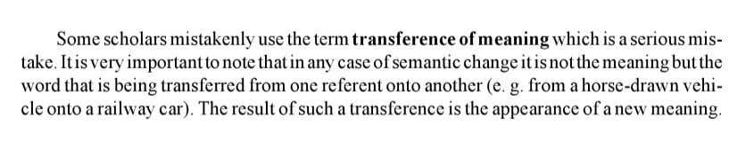
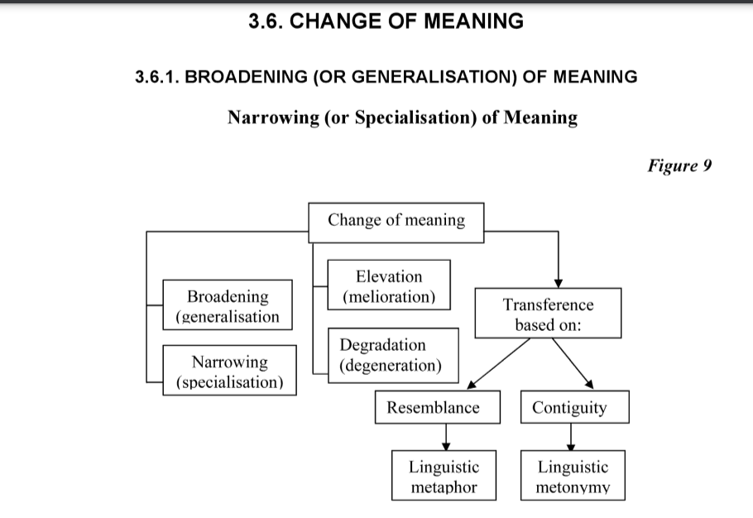
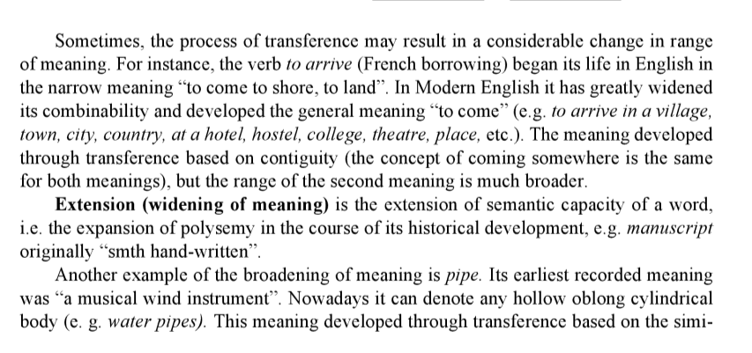
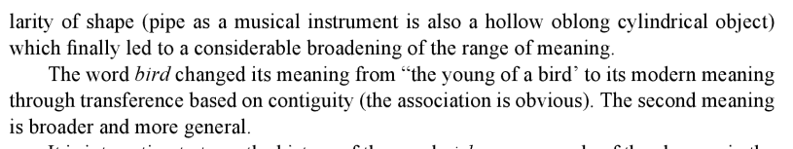
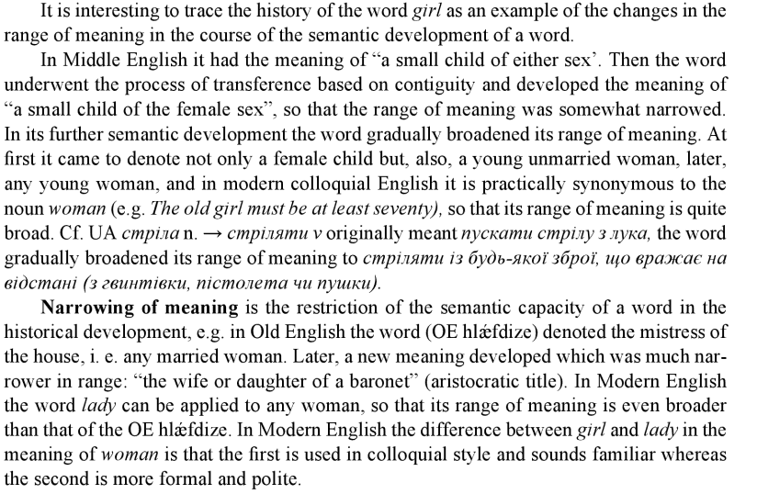
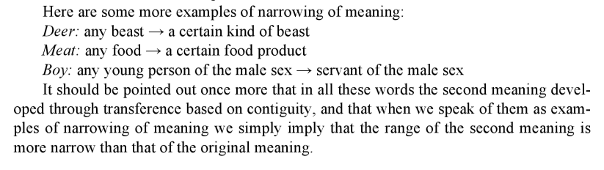
Рекомендована література:
1. Анікеєнко І. Г. Практикум з курсу лексикології англійської мови для студентів ІІІ курсу / І. Г. Анікеєнко, Л.Ф. Бойцан, Л. В. Ганецька. – Київ: Вид-во КДУ, 1999. – 72 c. 14
2. Верба Л. Г. Порівняльна лексикологія англійської та української мов / Л. Г. Верба. –Вінниця: Вид-во Нова книга, 2003. – 160 с.
3. Гороть Є. І Теоретична й практична лексикологія сучасної англійської мови / за ред. Є. І. Гороть. – Луцьк : Волин. нац. ун-т ім. Лесі Українки, 2011. – 340с.
4. Квеселевич Д.І., Сасіна В.П. Практикум з лексикології сучасної англійської мови. –Вінниця: Вид-во Нова книга, 2001. – 126 с.
5. Мостовий М.І. Лексикологія англійської мови / М. І. Мостовий. – Харків: Вид-во Основа, 1993. – 172 с.
6. Ніколенко А. Г. Лексикологія англійської мови – теорія і практика /А. Г. Ніколенко. – Вінниця: Нова книга, 2007. – 528с.

