DEMO

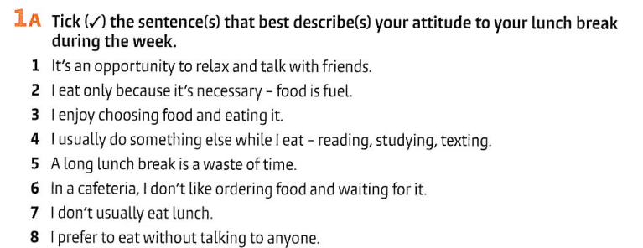

|  |  |  |  |  |  |  |  |
| --- | --- | --- | --- | --- | --- | --- | --- |



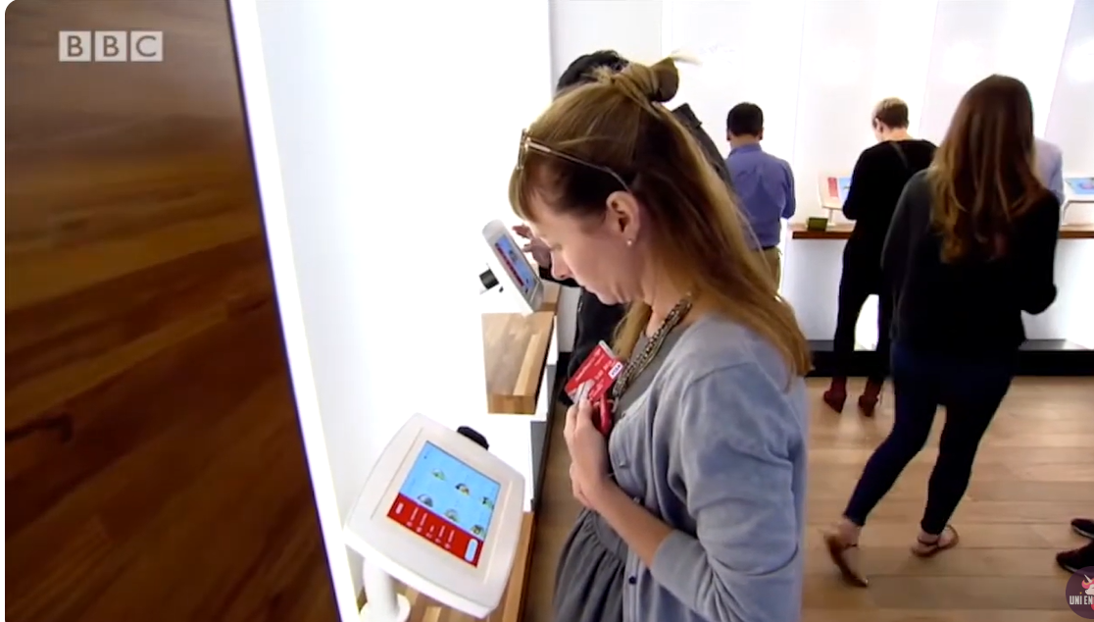

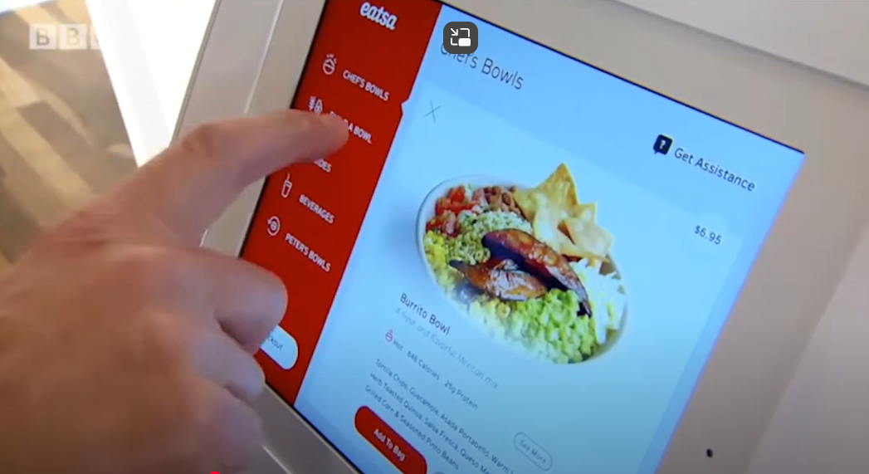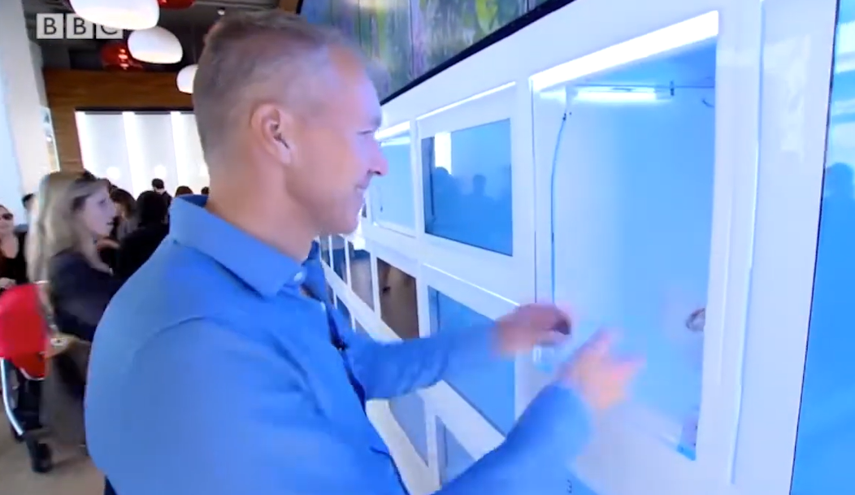

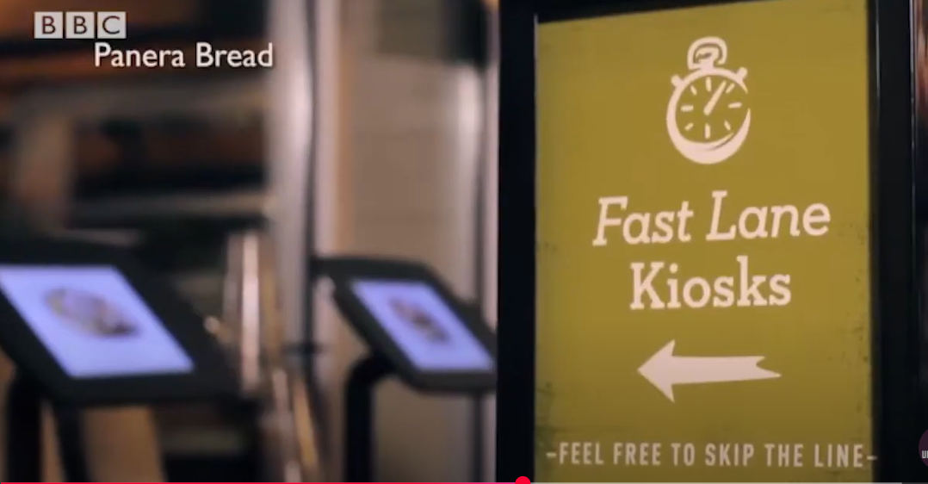

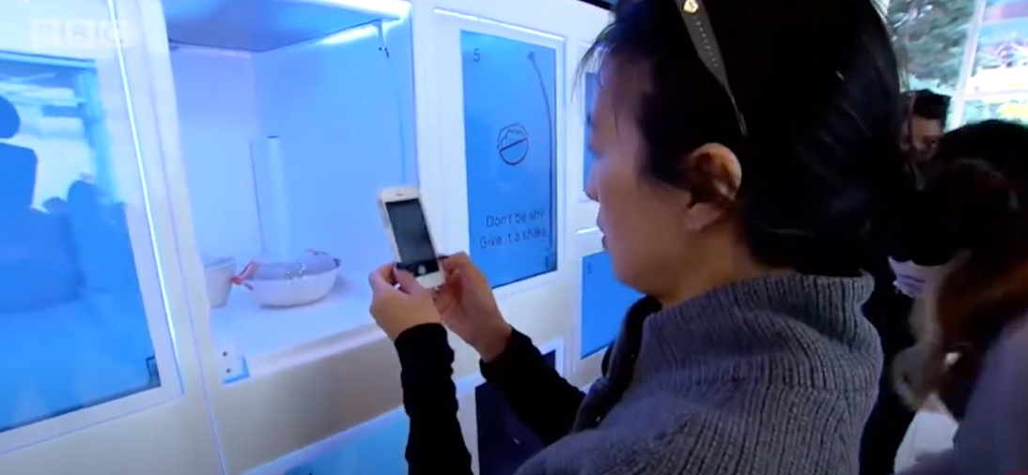



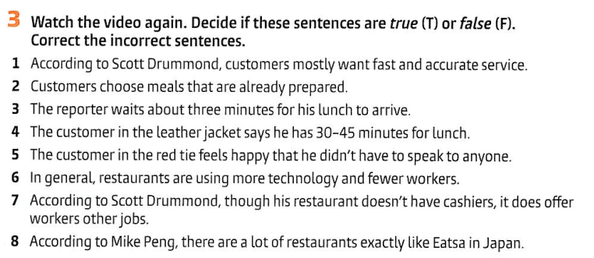

(or do the task in Quizziz)

|  |  |  |  |  |  |  |  |
| --- | --- | --- | --- | --- | --- | --- | --- |

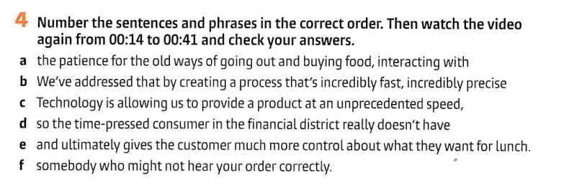

|  |  |  |  |  |  |
| --- | --- | --- | --- | --- | --- |

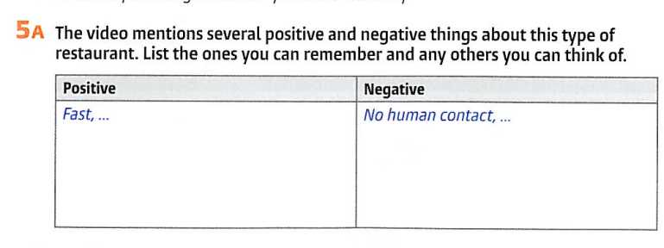

|  |  |
| --- | --- |



|  |
| --- |

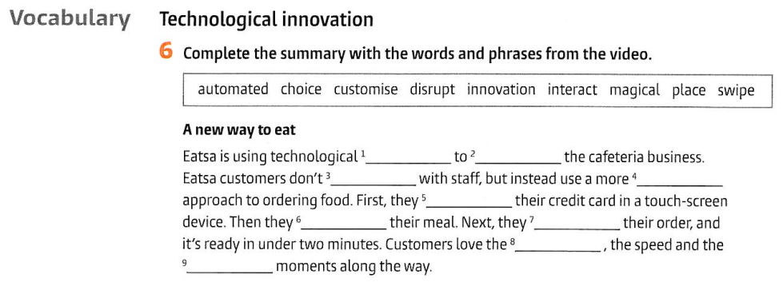

|  |  |  |  |  |  |  |  |  |
| --- | --- | --- | --- | --- | --- | --- | --- | --- |

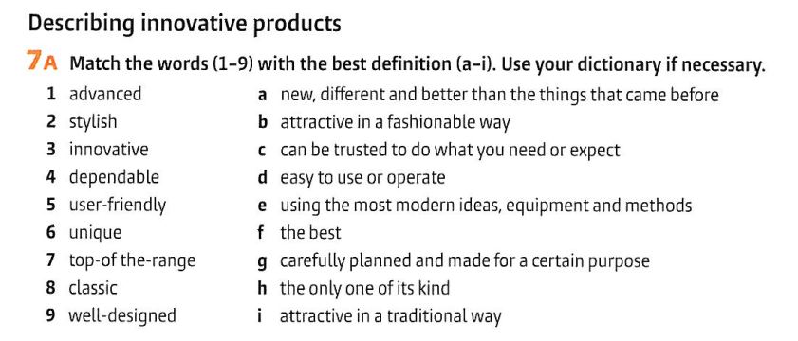

|  |  |  |  |  |  |  |  |  |
| --- | --- | --- | --- | --- | --- | --- | --- | --- |

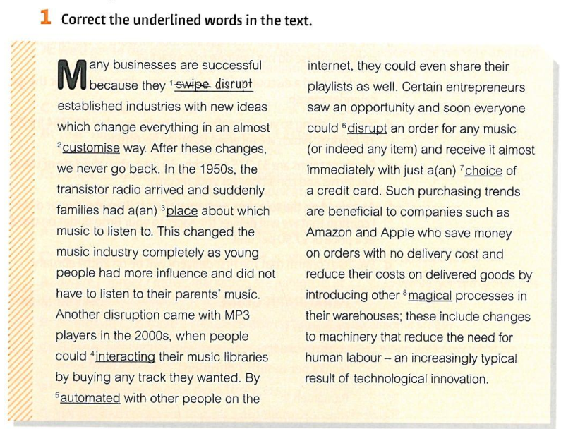

|  |  |  |  |  |  |  |  |
| --- | --- | --- | --- | --- | --- | --- | --- |

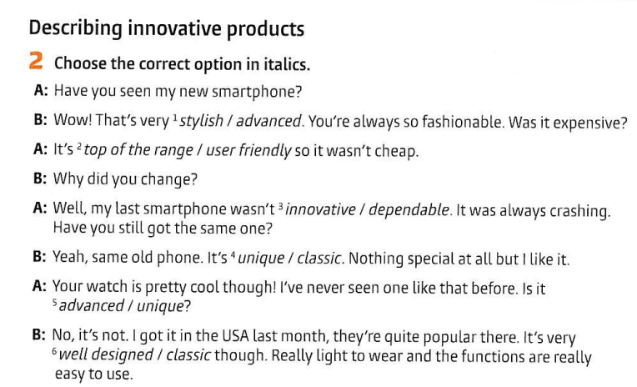

|  |  |  |  |  |  |
| --- | --- | --- | --- | --- | --- |

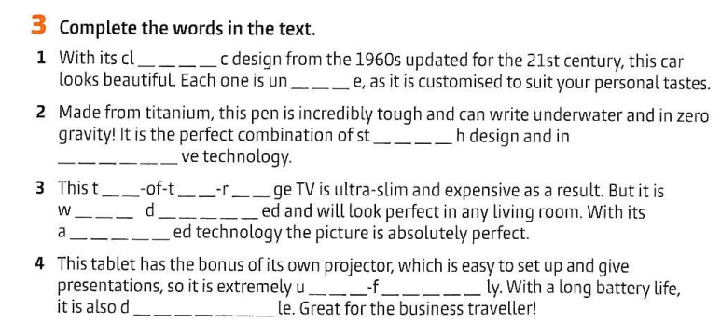

|  |
| --- |
|  |
|  |
|  |

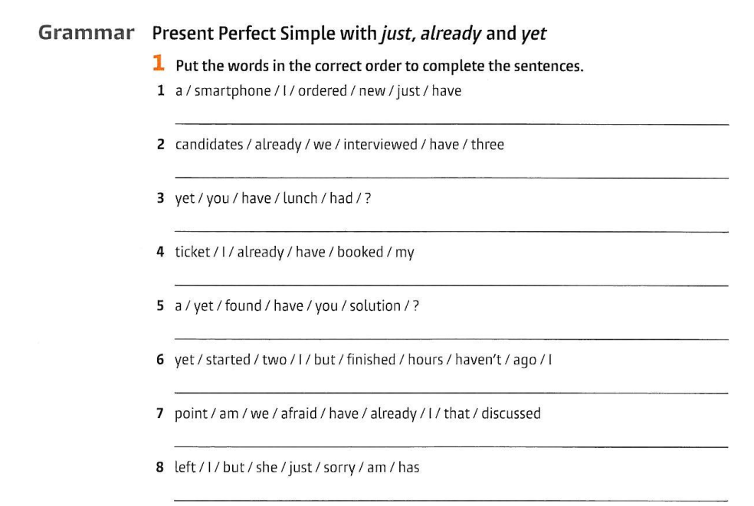

|  |  |  |  |  |  |  |  |
| --- | --- | --- | --- | --- | --- | --- | --- |

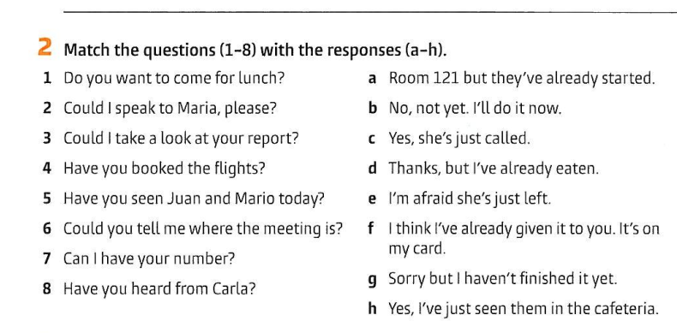

|  |  |
| --- | --- |
|  |  |
|  |  |
|  |  |
|  |  |
|  |  |
|  |  |
|  |  |

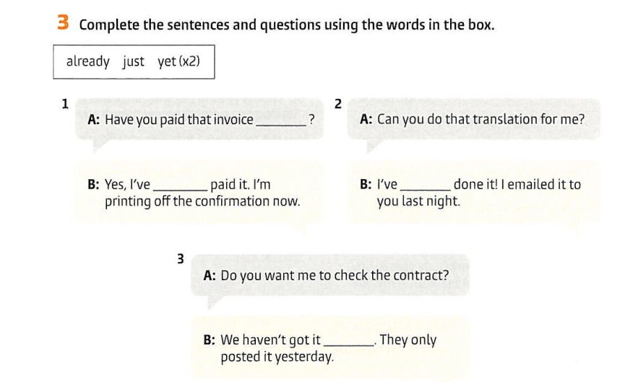

|  |  |
| --- | --- |
|  |  |
|  |  |

materials taken from Business partner B1 WB, p. 25