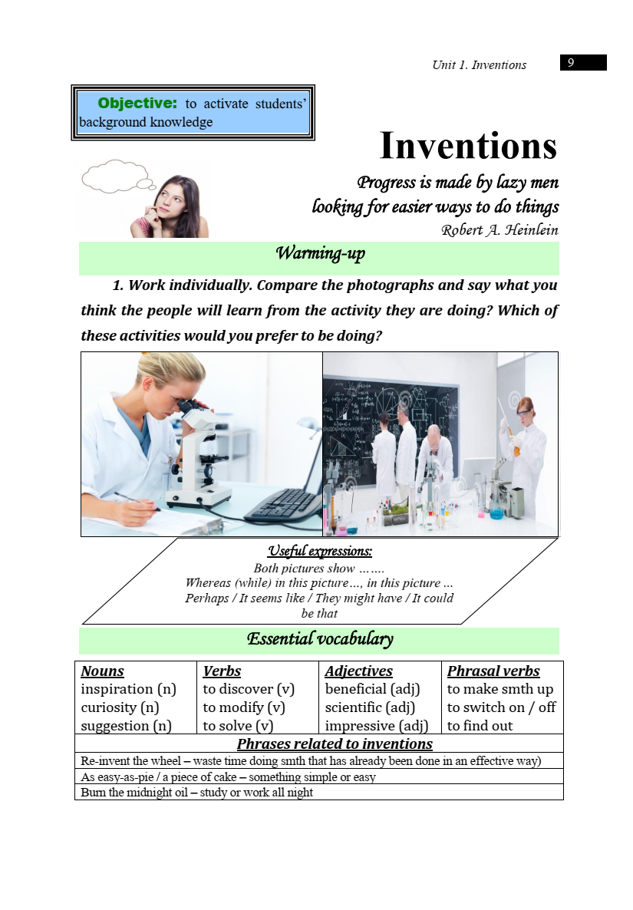

taken from ‘English for 2nd year students’ Сивак, Ковальчук