DEMO

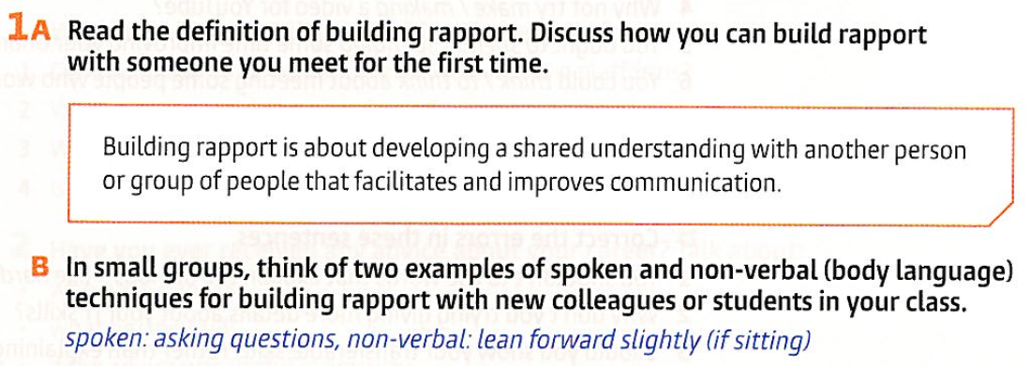

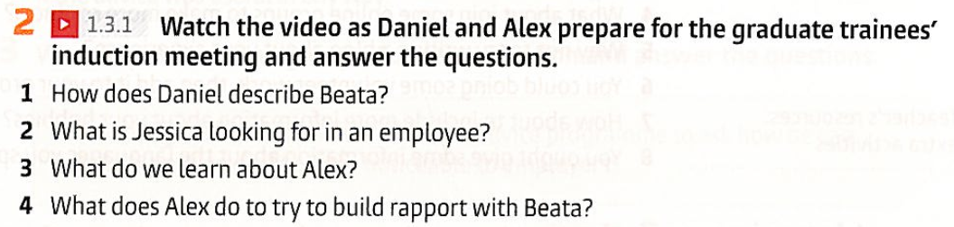

|  |
| --- |
|  |
|  |
|  |

Watch two options of the introduction. 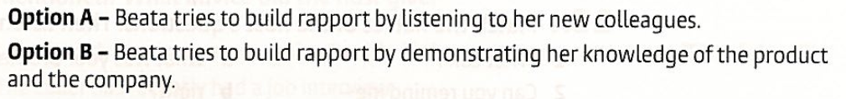

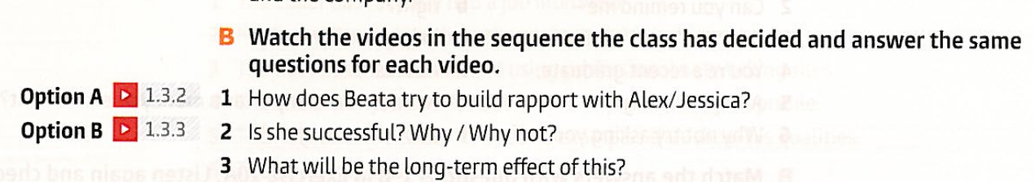

|  |  |
| --- | --- |
|  |  |
|  |  |

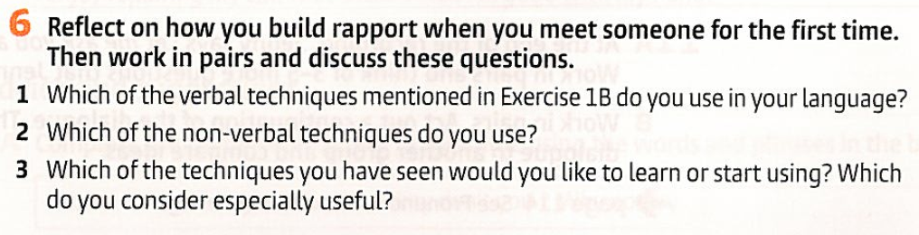

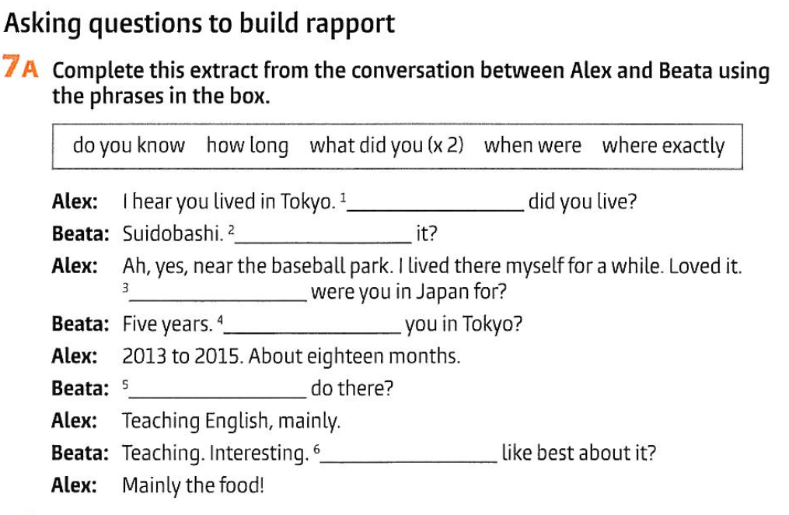

|  |
| --- |
|  |
|  |
|  |
|  |
|  |

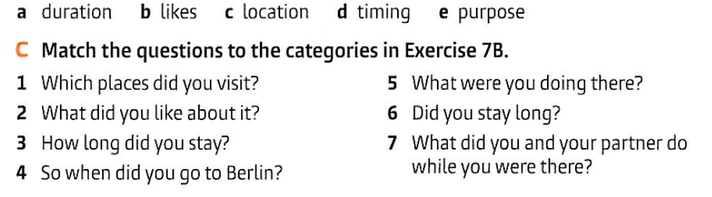

|  |  |  |  |  |  |  |
| --- | --- | --- | --- | --- | --- | --- |

Choose one topic and talk about it



  
  