DEMO

Lead-in

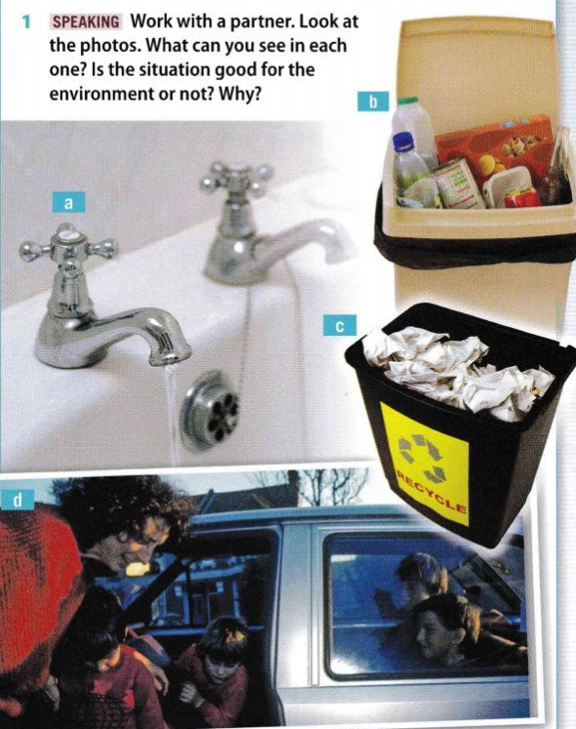

Task 1

Look at the sentences and complete the rules.

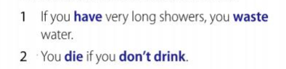



**If+_____________, _____________.**



|  |
| --- |



|  |
| --- |

Task 2

**Complete the sentences. Put the verb in the correct form.**

1. If it’s sunny, people often ____ (go) to the beach.
2. If it ___________ (not rain) for months, the result is usually a drought.
3. If it rains a lot for months, there _________ (be) often floods.
4. If you don’t water plants, they (die).
5. If it ________ (be) very sunny, it’s bad for your eyes.
6. If the sun _____________ (shine) all day, the temperature goes up.

Task 3

**Complete the sentences:**

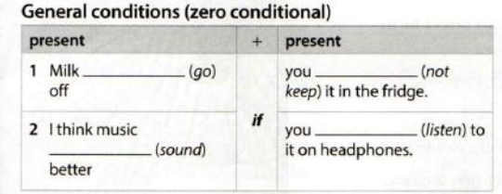

Milk _________(go) off if you ___________(not keep) it in the fridge.

I think music _________ (sound) better if you _________ (listen) to it on headphones.

If I promise to do something, I ________ (do) it.

Task 4

**Finish the sentences:**

If you sit too close to the TV, ___________________________.

If you go to bed late, _____________________________.

I feel sad if _________________.

I enjoy English classes if ___________________.

My friends are happy if ______________________.

My parents are happy if ____________________.

**PART 2**

**Read the article. Do you agree or disagree with the idea?**

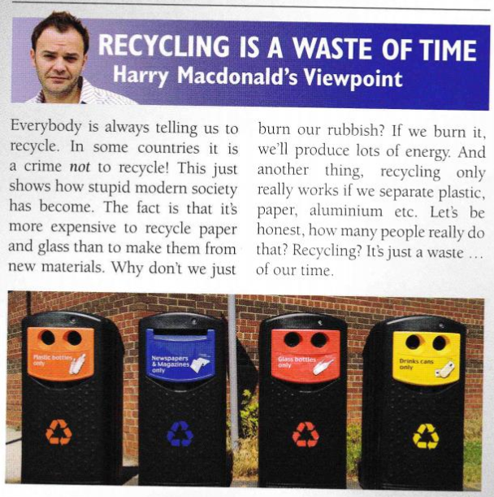

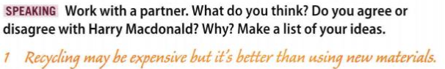

**If we burn it, we’ll produce lots of energy.**

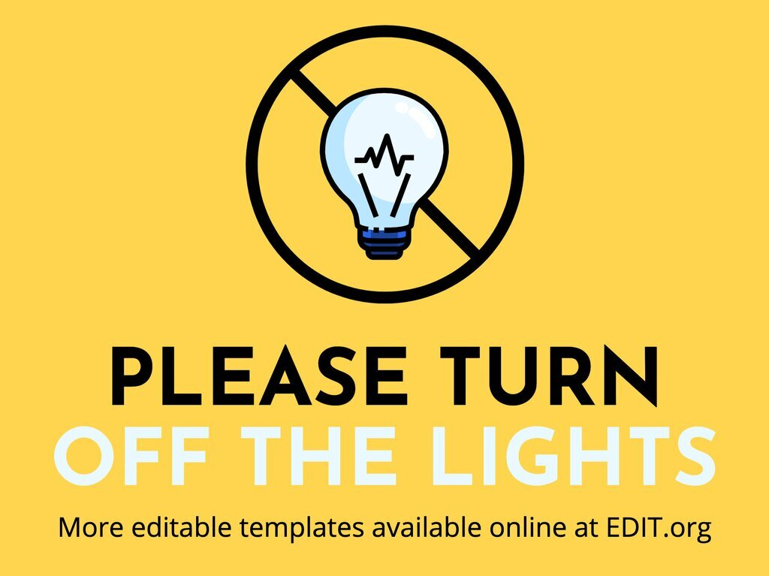

**Look at the sentences and complete the rules.**

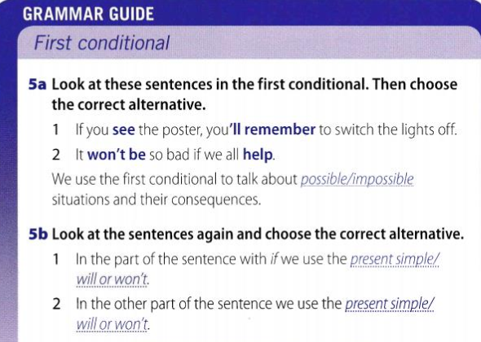

We use First conditional to talk about *possible / impossible* situations and their consequences.

In the part of the sentence with *if* we use the _____________.

In the other part of the sentence we use ______________.

Task 1

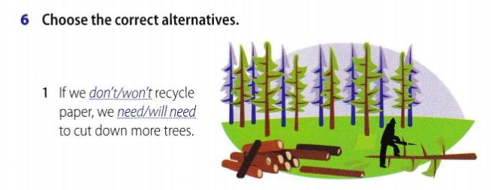

If we *don’t / won’t* recycle paper, we *need / will need* to cut down more trees.

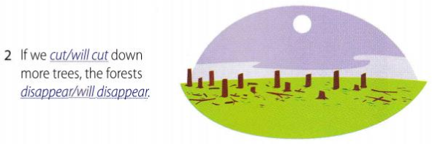

If we *cut / will cut down* more trees, the forests *disappear/ will disappear.*

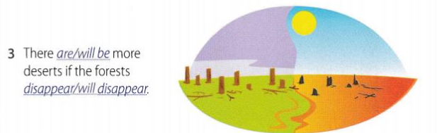

There *are / will be* more deserts if the forests *disappear/ will disappear.*

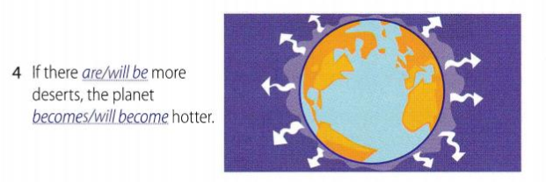

If there *are/ will be* more deserts, the planet *becomes/ will become* hotter.

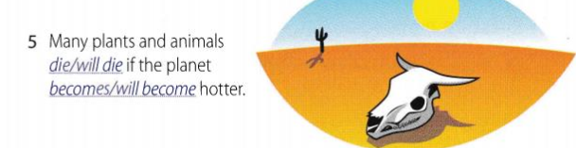

Many plants and animals *die/ will die* if the planet *becomes/ will become* hotter.

Task 2

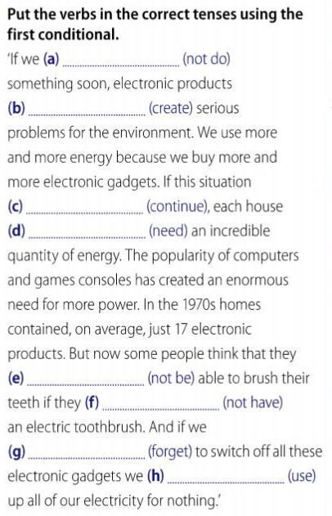

|  |
| --- |
|  |
|  |
|  |
|  |
|  |
|  |
|  |

Task 3

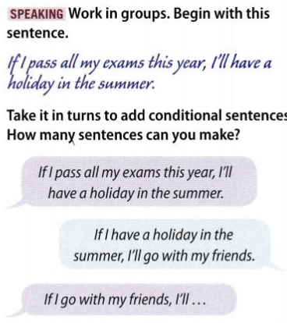

Task 4

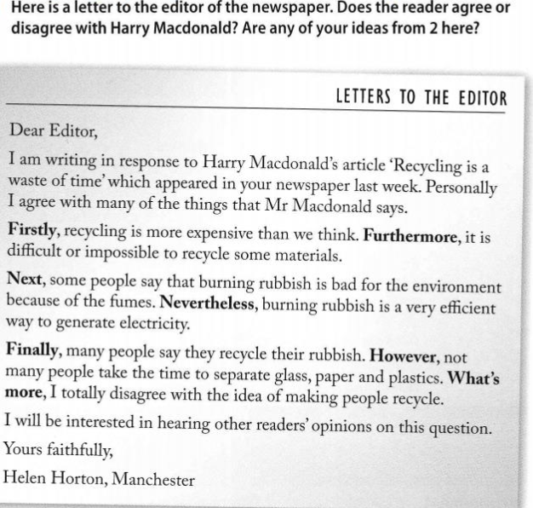

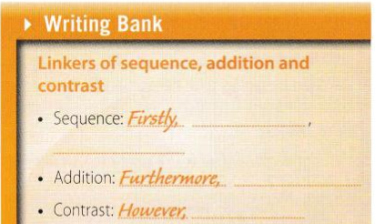

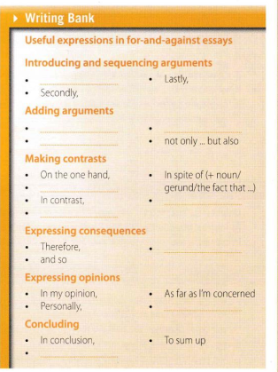

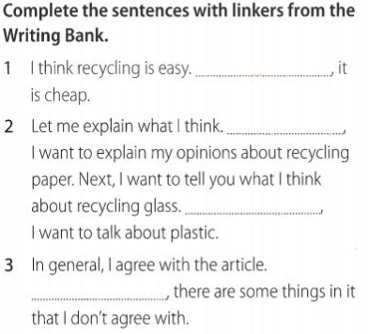

|  |
| --- |
|  |
|  |

Task 5

Write a letter to the editor in response to the article. Express your ideas.