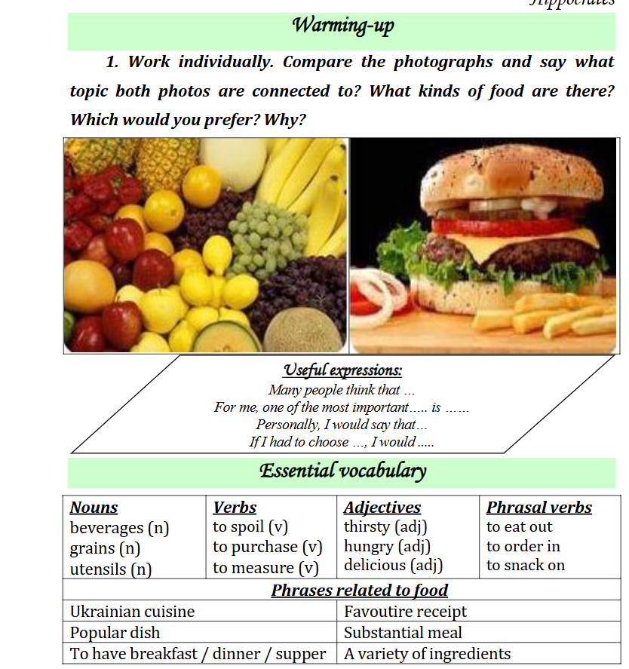

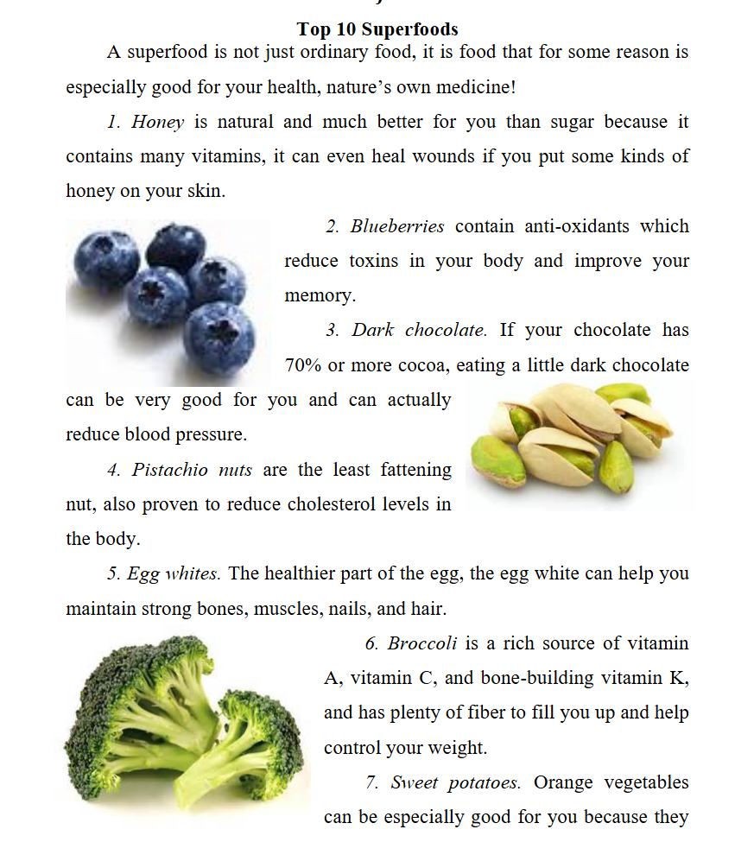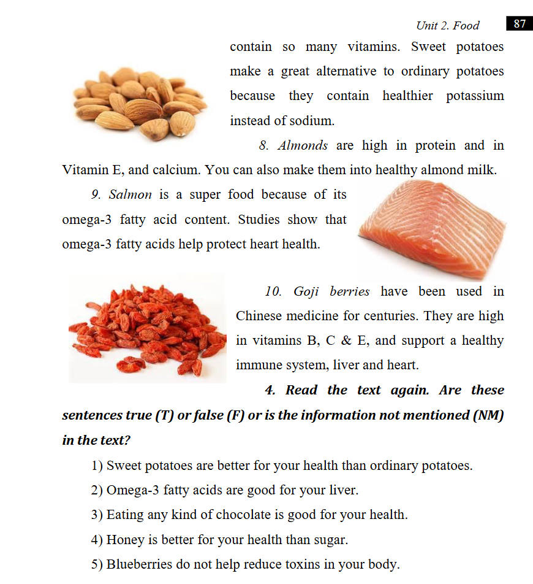

|  |  |
| --- | --- |
|  |  |
|  |  |
|  |  |
|  |  |

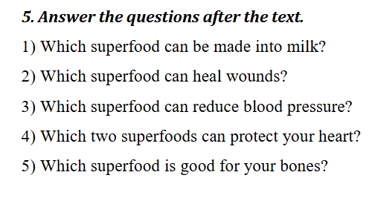

|  |  |  |  |  |
| --- | --- | --- | --- | --- |

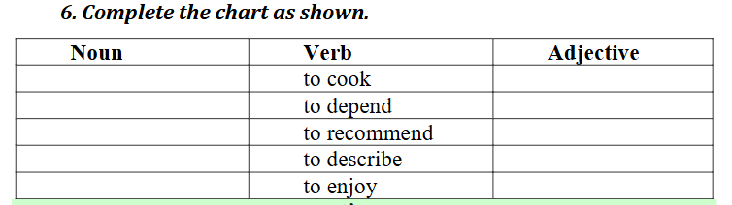

|  |  |  |
| --- | --- | --- |
|  |  |  |
|  |  |  |
|  |  |  |
|  |  |  |
|  |  |  |

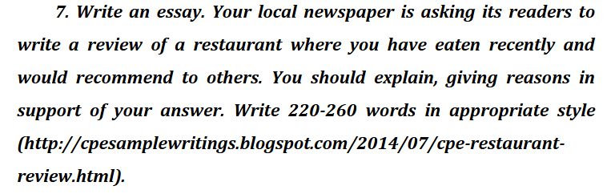

|  |
| --- |

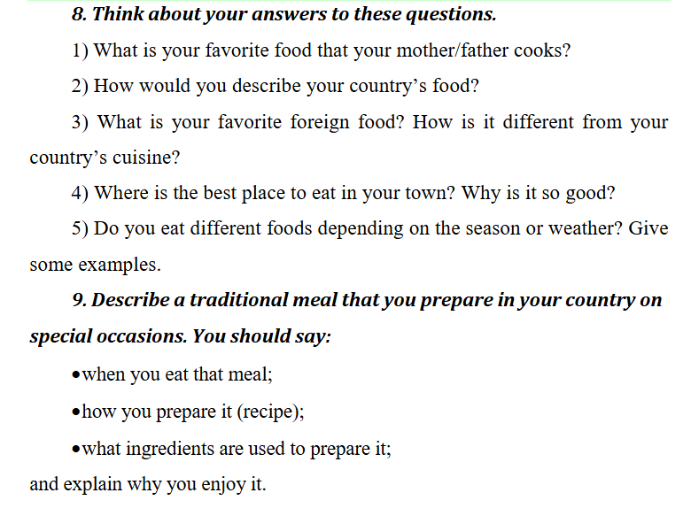

Make a menu



    
    
    