DEMO

materials taken from Roadmap B2 p.102-

What is the difference between travel and tourism?

|  |  |
| --- | --- |

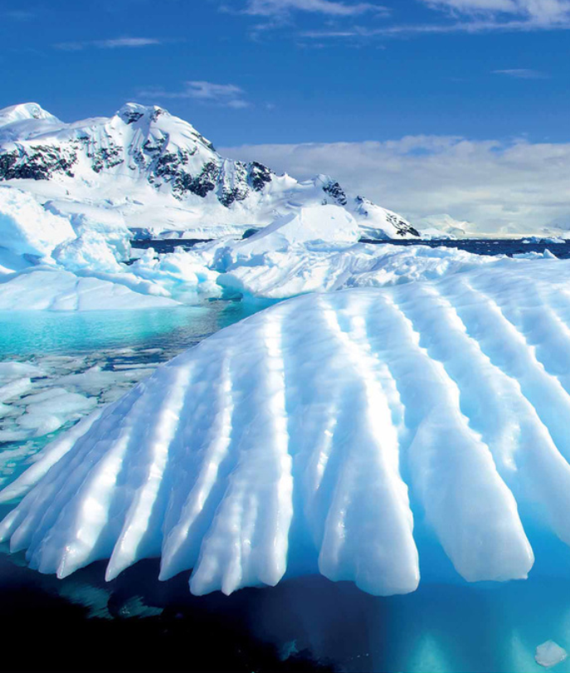

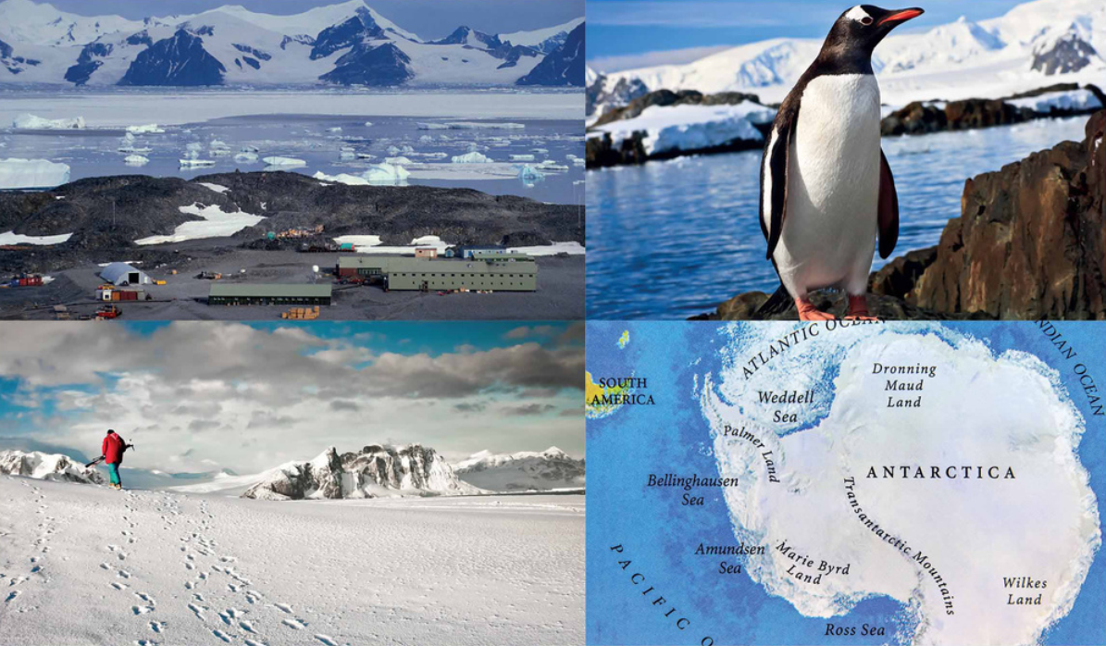

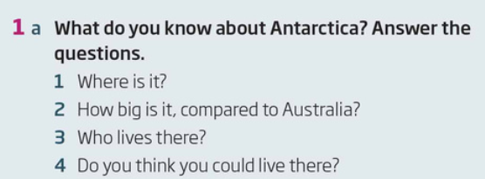

|  |  |  |  |
| --- | --- | --- | --- |



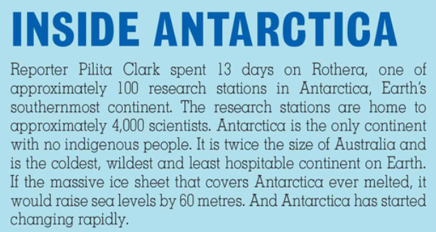

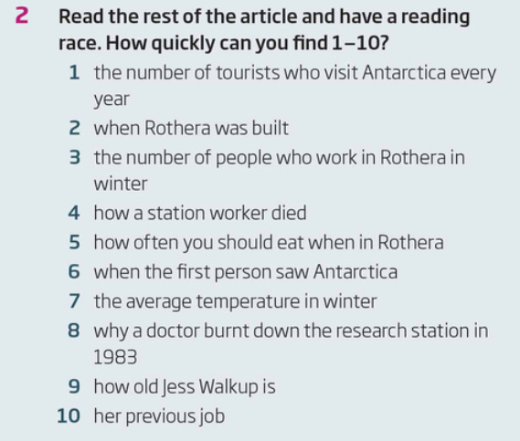

|  |  |  |  |  |  |  |  |  |  |
| --- | --- | --- | --- | --- | --- | --- | --- | --- | --- |

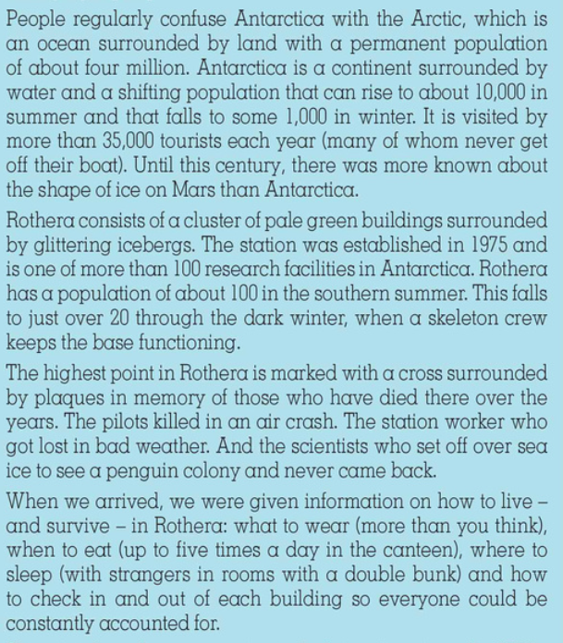

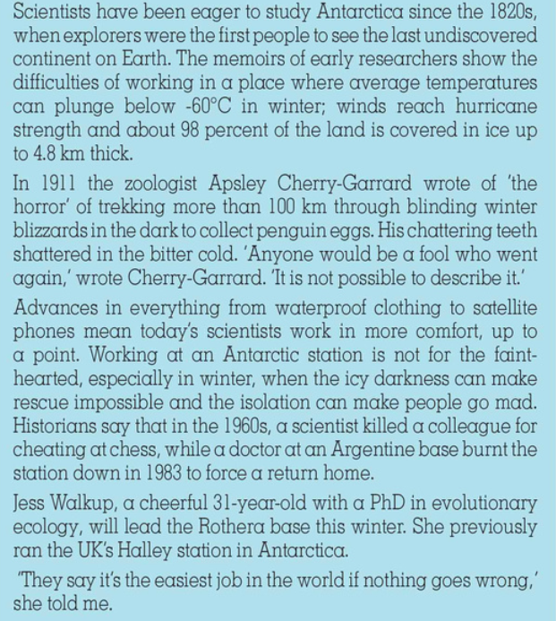

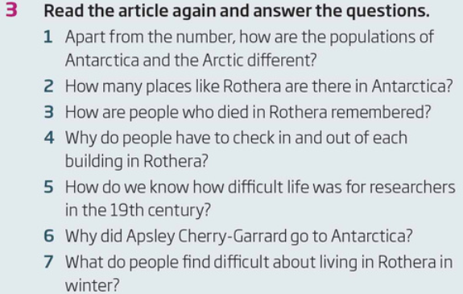

|  |  |  |  |  |  |  |
| --- | --- | --- | --- | --- | --- | --- |

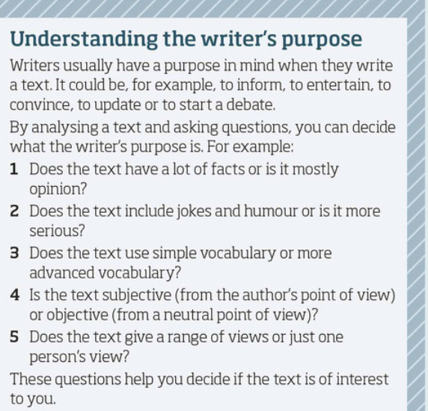

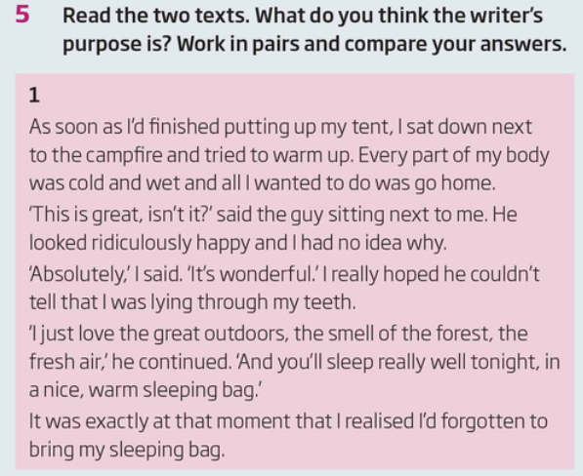

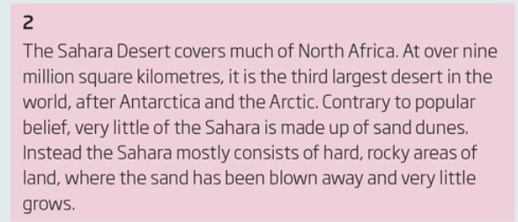

|  |
| --- |
|  |

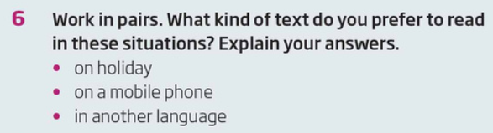

|  |
| --- |

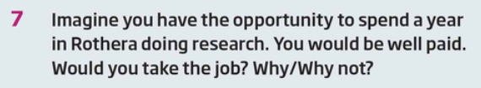

|  |
| --- |

Design an eco-friendly travel itinerary for a specific destination.

Create a presentation on cultural learning opportunities.