DEMO

materials taken from Business Partner B1 SB, p. 71

Business Partner B1 WB, p.35

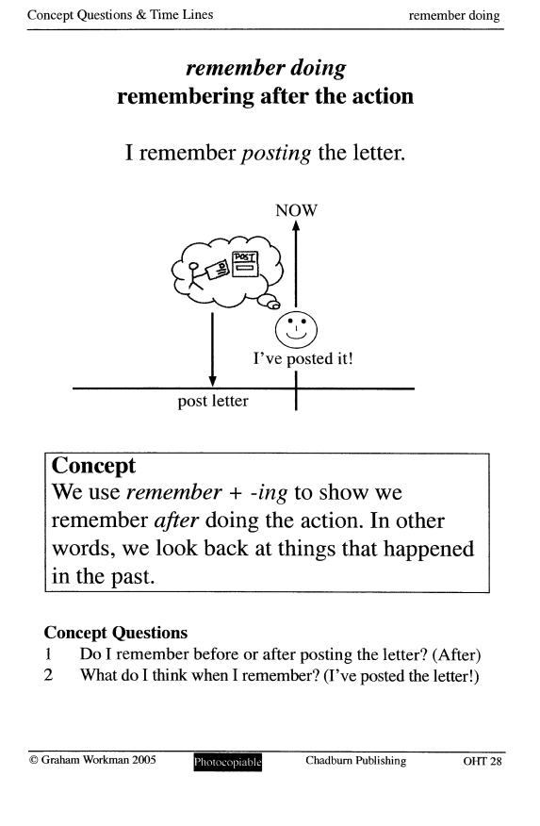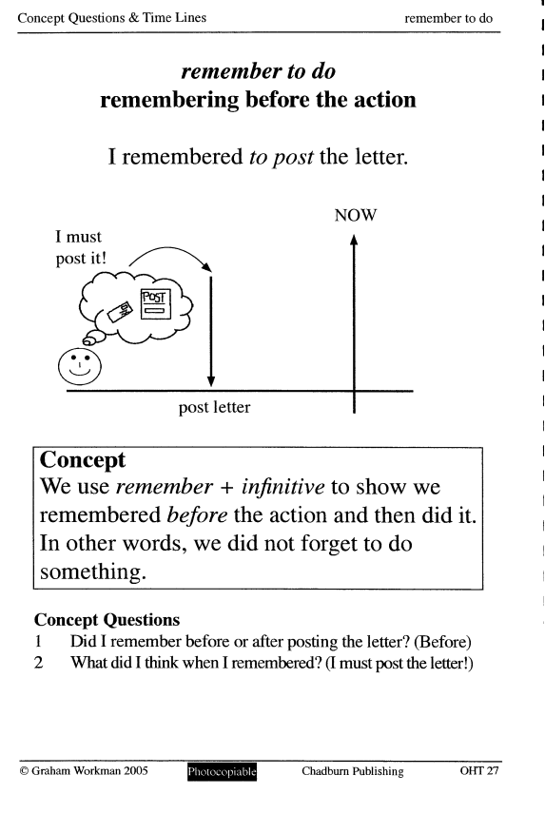

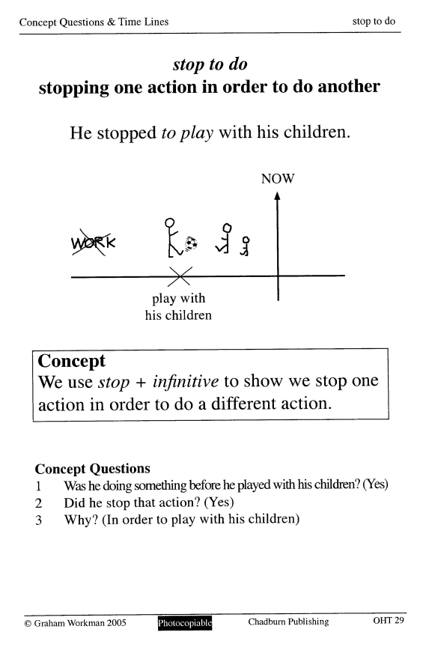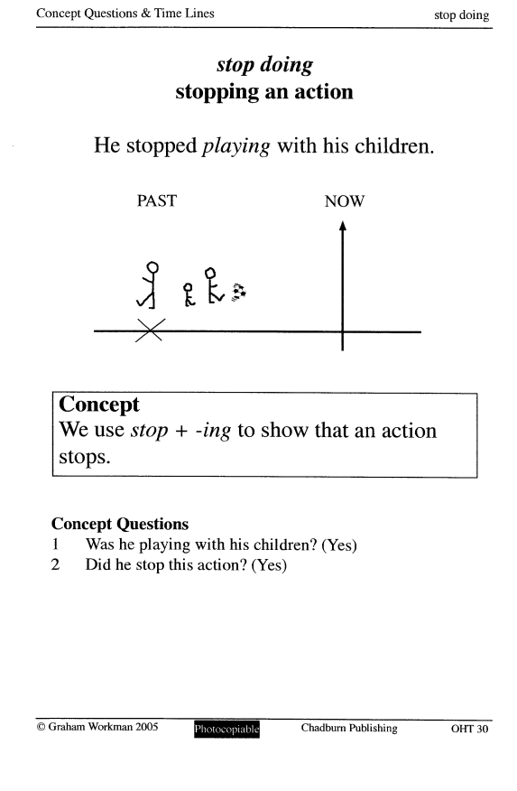

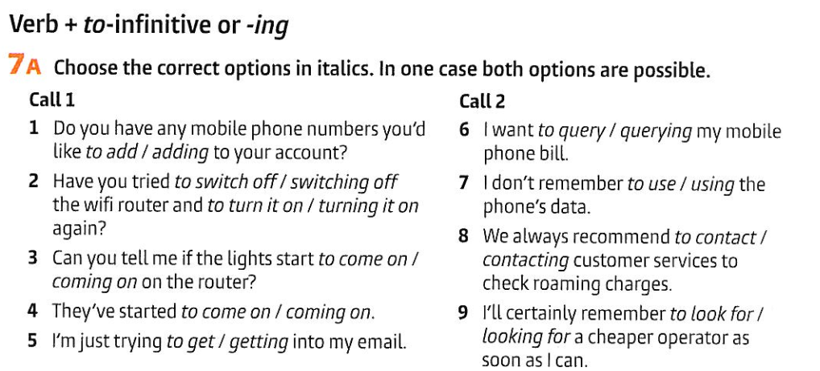

|  |  |
| --- | --- |
|  |  |
|  |  |
|  |  |
|  |  |

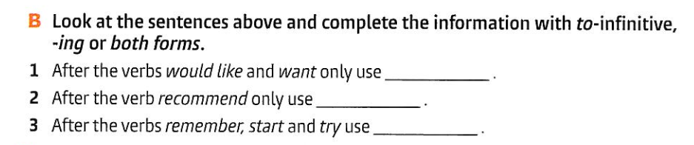

|  |
| --- |
|  |
|  |

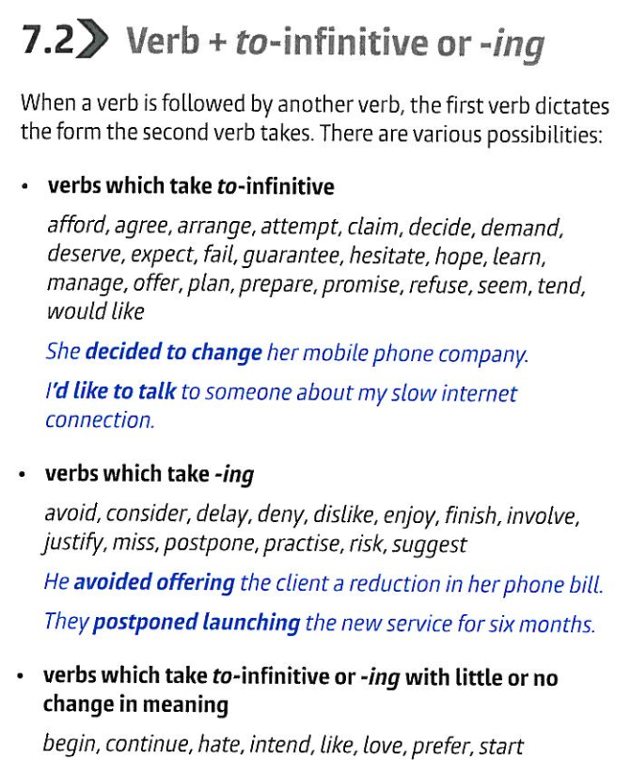

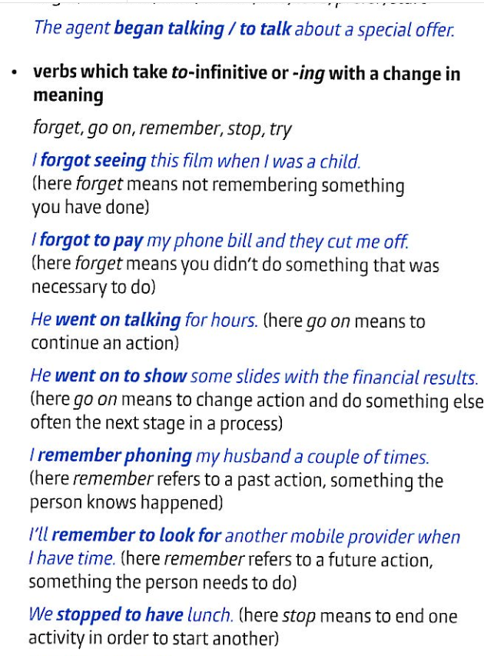

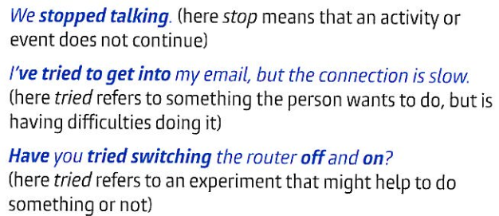

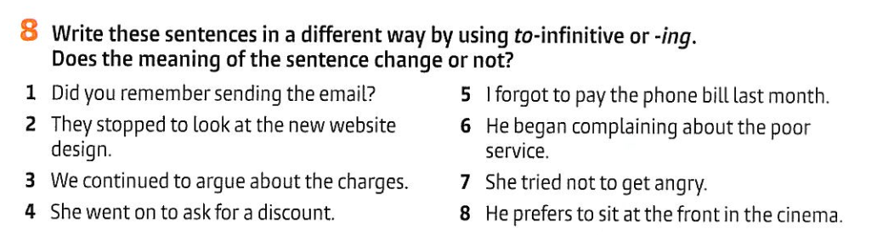

|  |  |
| --- | --- |
|  |  |
|  |  |
|  |  |

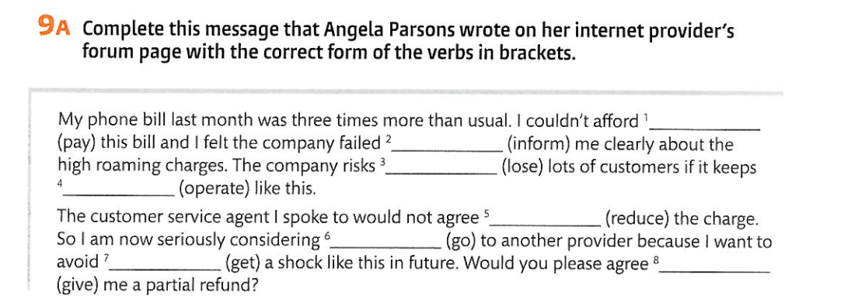

|  |  |
| --- | --- |
|  |  |
|  |  |
|  |  |

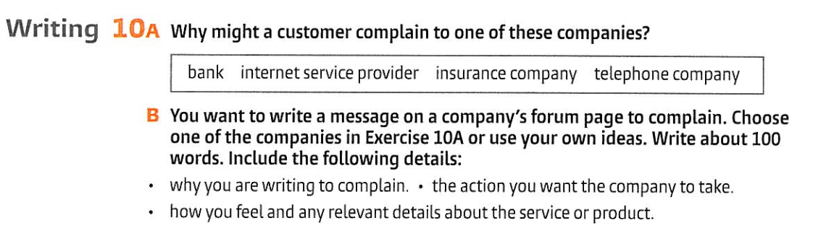

|  |
| --- |

**Home tasks**

