DEMO

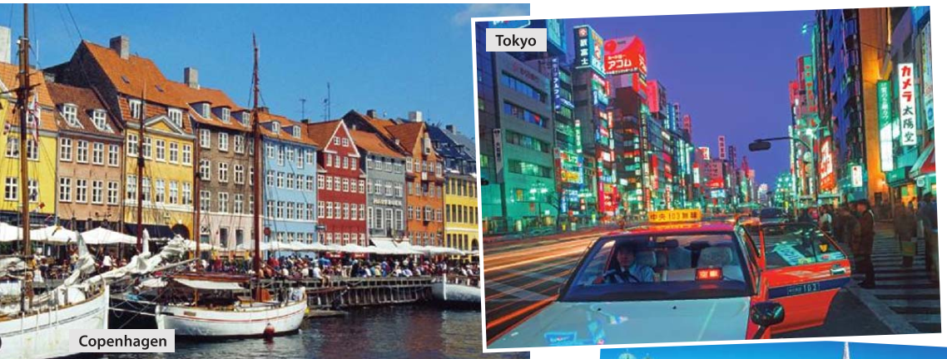

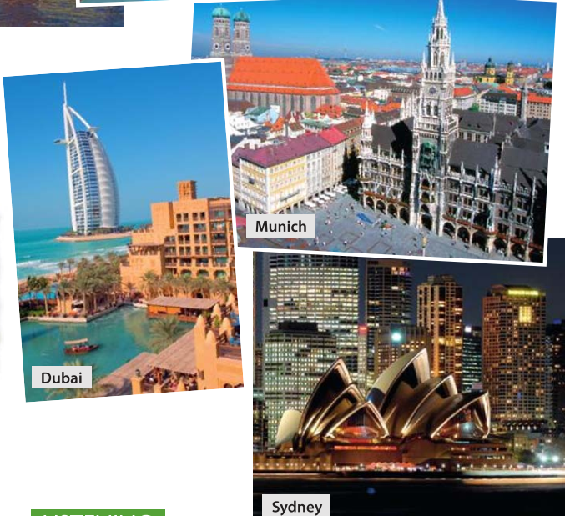

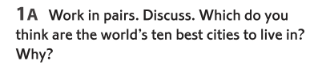

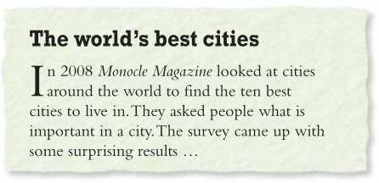

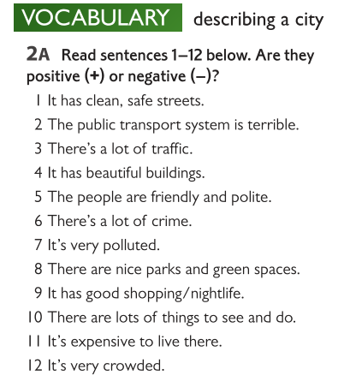

|  |  |  |  |  |  |  |  |  |  |  |  |
| --- | --- | --- | --- | --- | --- | --- | --- | --- | --- | --- | --- |

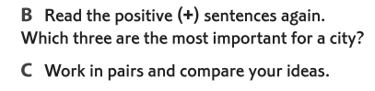

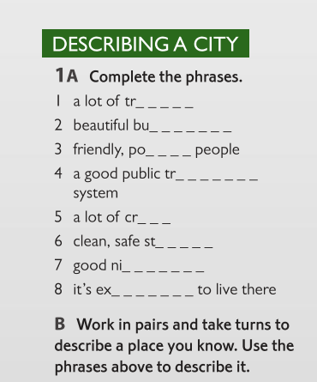

|  |
| --- |
|  |
|  |
|  |
|  |
|  |
|  |
|  |

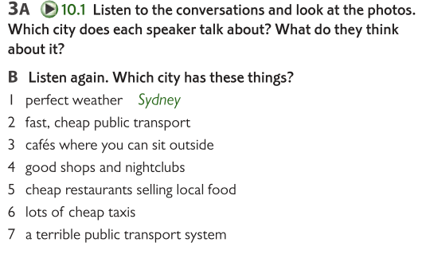

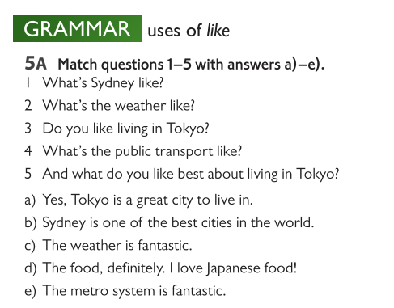

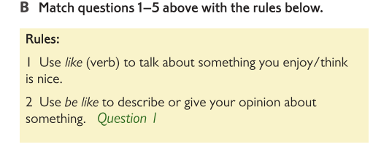

|  |
| --- |
|  |
|  |
|  |

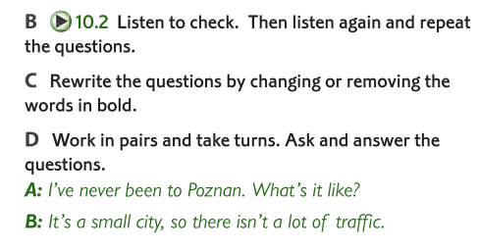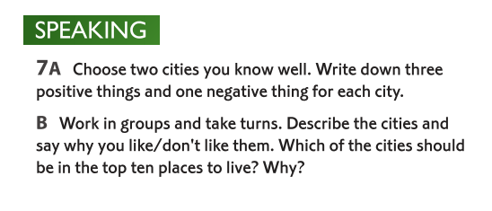

materials taken from SpeakOut Pre-Intermediate p.98