DEMO

materials taken from Roadmap B2 p. 120

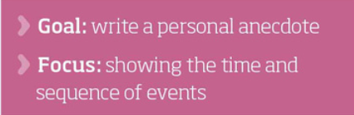

How do you understand the phrase ‘stand up for yourself’?





  
  



  
  