DEMO

materials taken from Business Partner B1, p68.

 

 

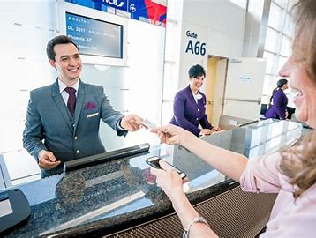 

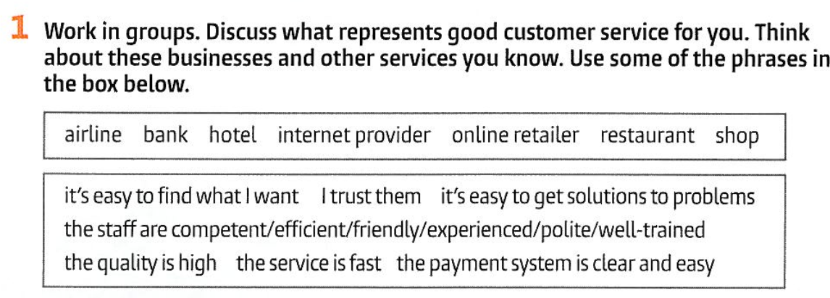

|  |
| --- |

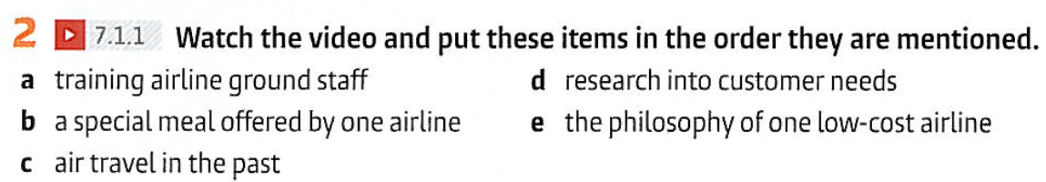

<https://www.youtube.com/watch?v=n-R1wdachTI&ab_channel=UniEnglish>



  
  