DEMO

Focus 2

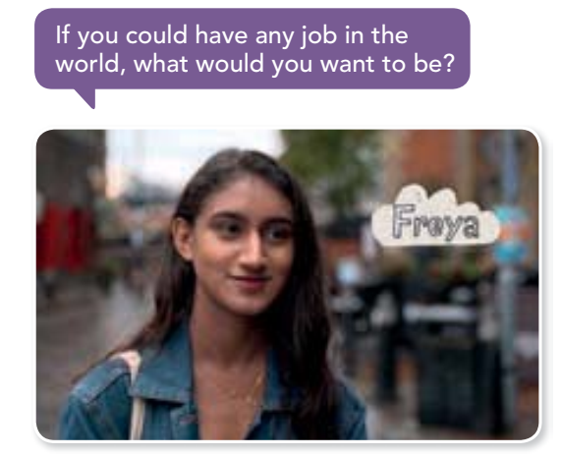

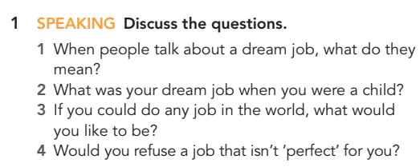

|  |
| --- |
|  |
|  |
|  |

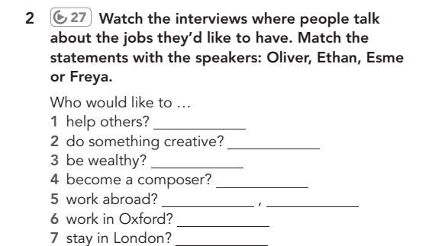

|  |  |  |  |  |  |  |
| --- | --- | --- | --- | --- | --- | --- |

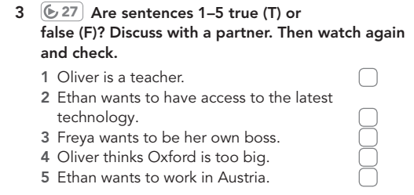

|  |  |  |  |  |
| --- | --- | --- | --- | --- |

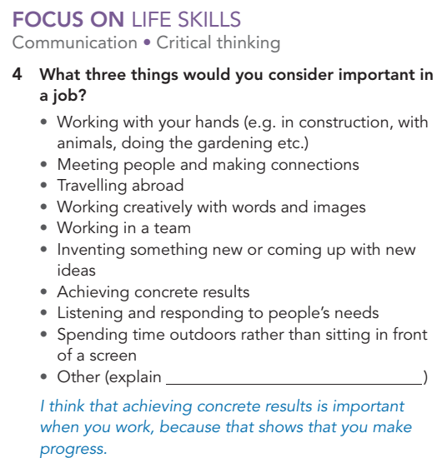

|  |
| --- |

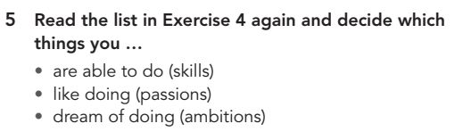

|  |
| --- |
|  |
|  |

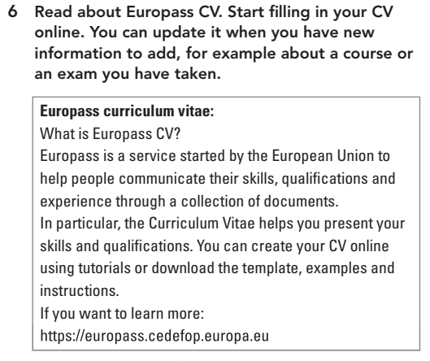

[europass.europa.](https://europass.europa.eu/en/create-europass-cv)

