DEMO

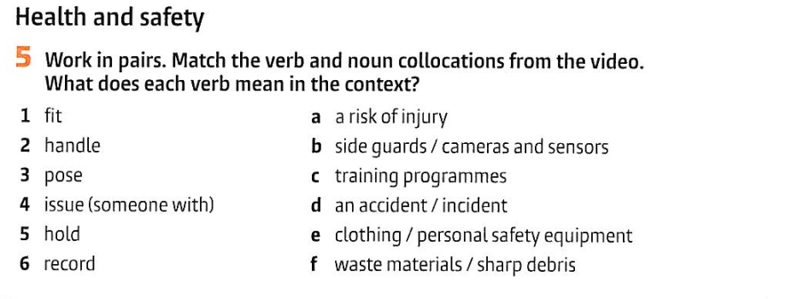

|  |  |
| --- | --- |
|  |  |
|  |  |
|  |  |
|  |  |
|  |  |

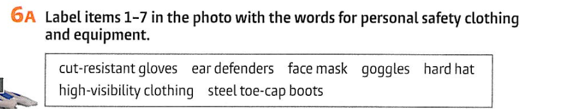

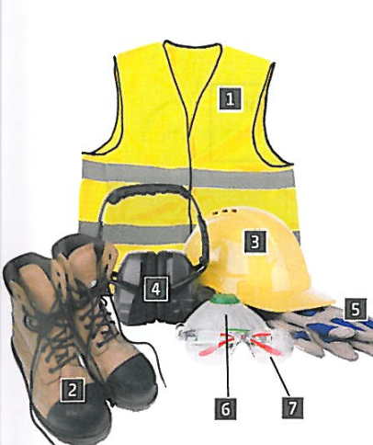

|  |  |  |  |  |  |  |
| --- | --- | --- | --- | --- | --- | --- |

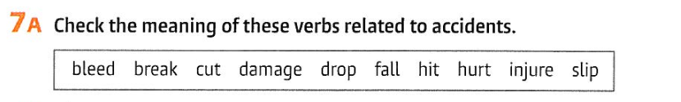

|  |  |  |  |  |  |  |  |  |  |
| --- | --- | --- | --- | --- | --- | --- | --- | --- | --- |

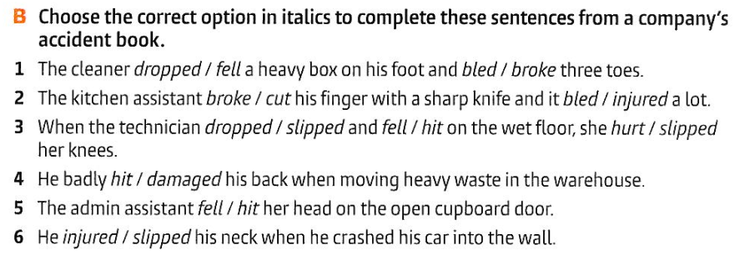

|  |
| --- |
|  |
|  |
|  |
|  |
|  |



|  |
| --- |

9.

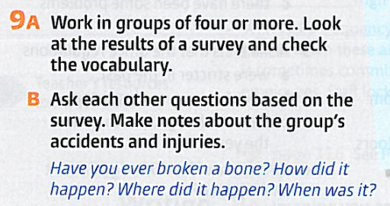

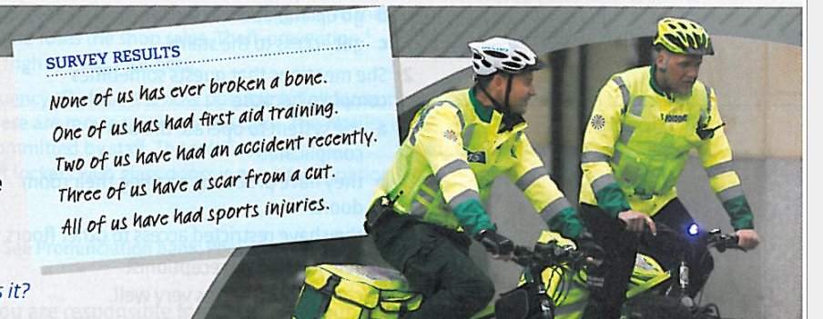

to break a bone

to have first aid training

to have an accident

to have a scar

to have an injury

| Have you ever broken a bone? |
| --- |
| Have you ever … |
|  |
|  |
|  |

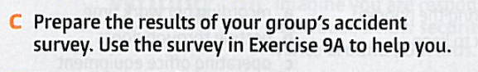

| None of us …  One of us …  Two of us …  Three of us …  All of us … |
| --- |