DEMO

|  |  |
| --- | --- |
|  |  |
|  |  |
|  |  |

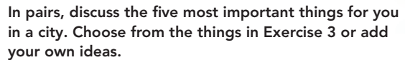



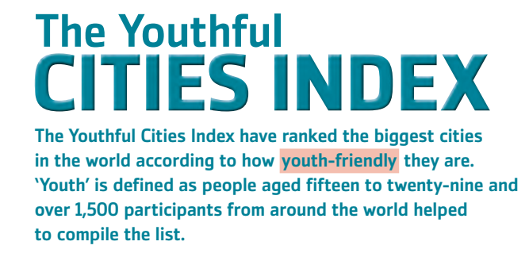

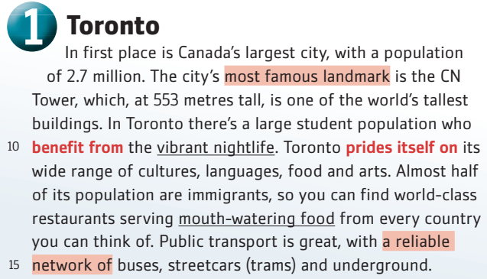

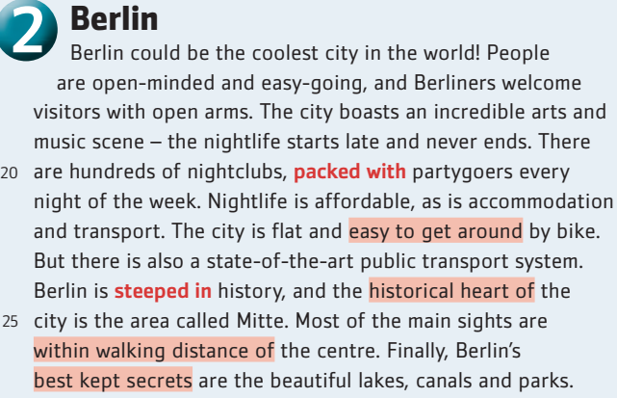

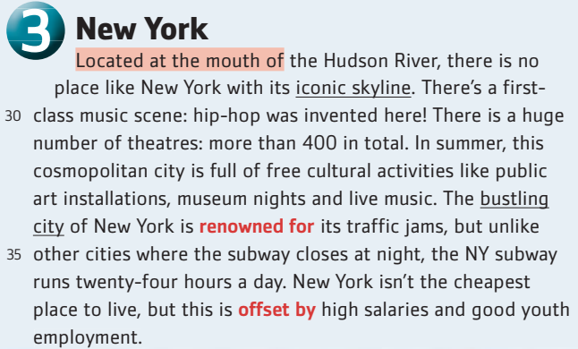

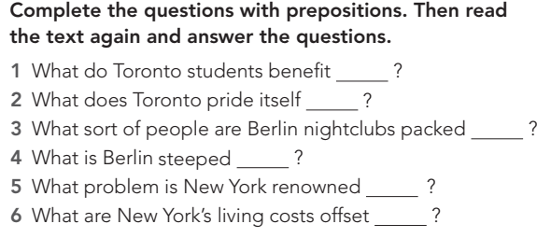

|  |  |  |  |  |  |
| --- | --- | --- | --- | --- | --- |

**Complete with your ideas:**

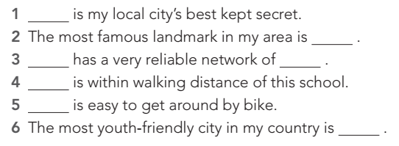

|  |  |  |  |  |  |
| --- | --- | --- | --- | --- | --- |



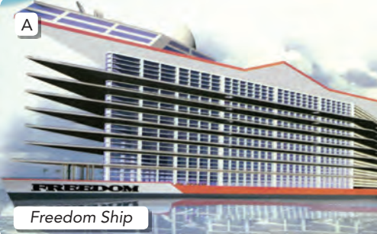

**B** 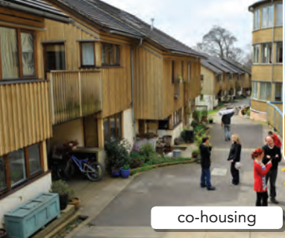

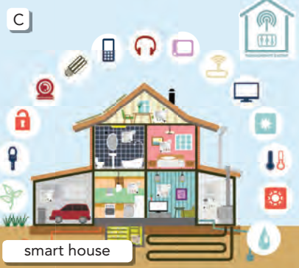

|  |  |
| --- | --- |
|  |  |
|  |  |



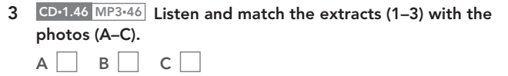

|  |  |  |
| --- | --- | --- |

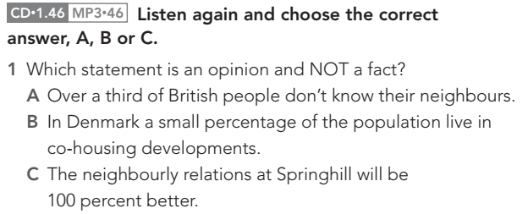

|  |
| --- |

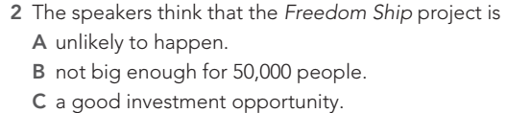

|  |
| --- |

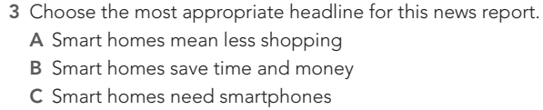

|  |
| --- |

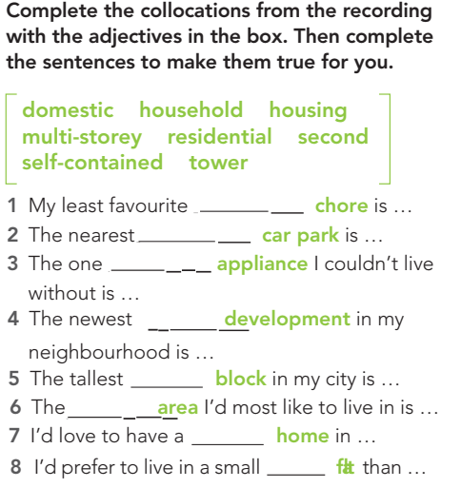

|  |  |  |  |  |  |  |  |
| --- | --- | --- | --- | --- | --- | --- | --- |

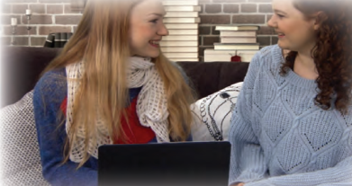

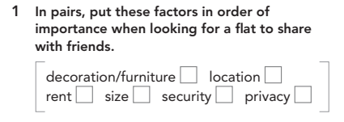

|  |  |  |  |  |  |
| --- | --- | --- | --- | --- | --- |

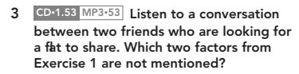

|  |  |
| --- | --- |

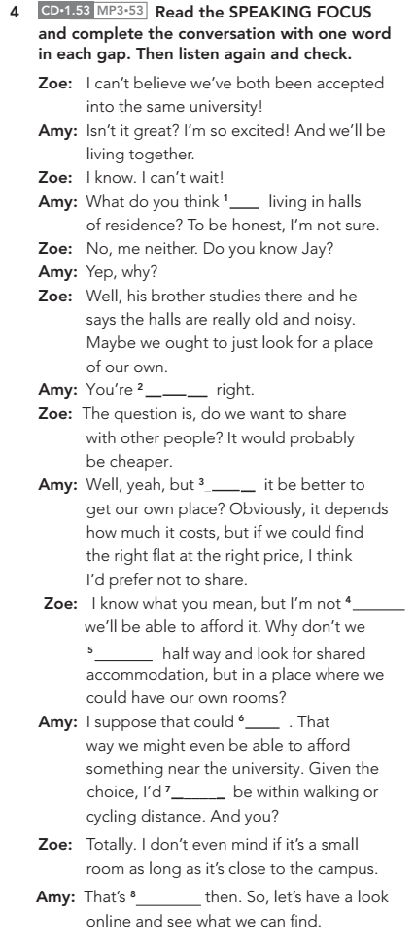

|  |  |  |  |  |  |  |  |
| --- | --- | --- | --- | --- | --- | --- | --- |

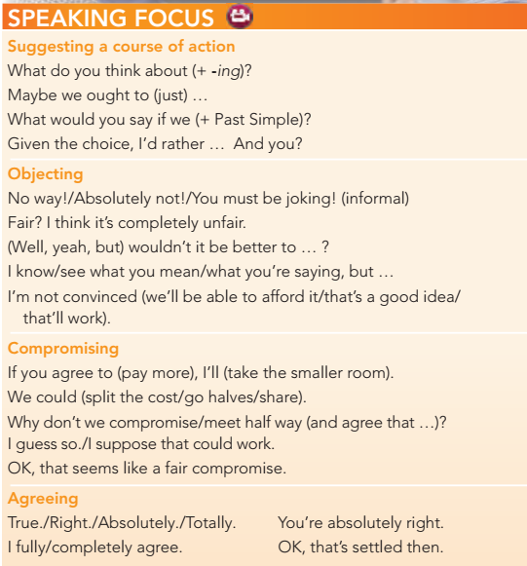

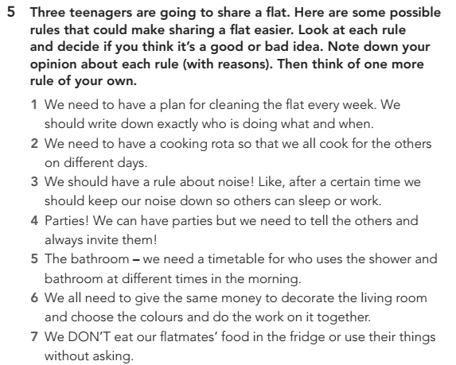

|  |  |
| --- | --- |
|  |  |
|  |  |
|  |  |
|  |  |
|  |  |
|  |  |

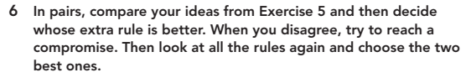

Materials taken from Focus 4 p.p 40-47