DEMO
Materials taken from: Way to Success , 2d year
Work and jobs – B2 English Vocabulary - Page 2 of 4 - Test-English

Lead- in




Task 1

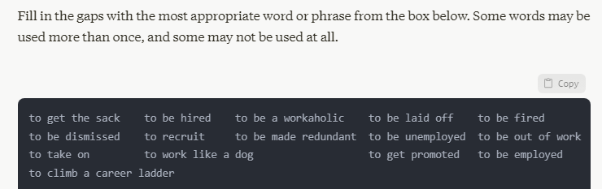

After years of hard work, Sarah finally managed __________________ from assistant to manager.
The company had to __________________ 100 employees due to financial difficulties.
John is always the first to arrive and the last to leave the office. He's such __________________.
Despite his best efforts, Tom __________________ for consistently missing deadlines.
The new project is very demanding. We need __________________ additional staff to handle the workload.
Mary __________________ at the factory for 20 years before retiring.
He's been __________________ for six months now and is struggling to find a new position.
If you want __________________, you need to show initiative and take on extra responsibilities.

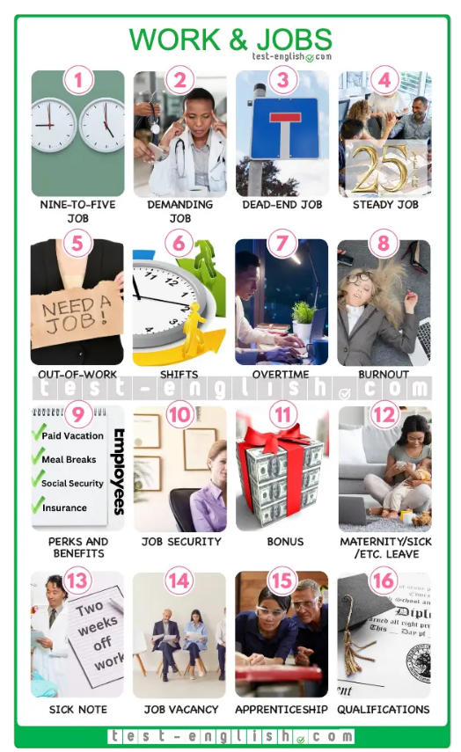

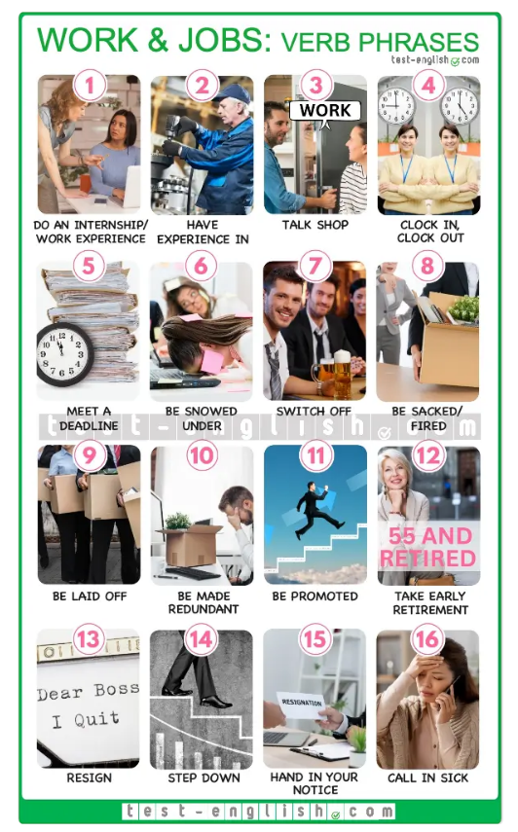
Task 2
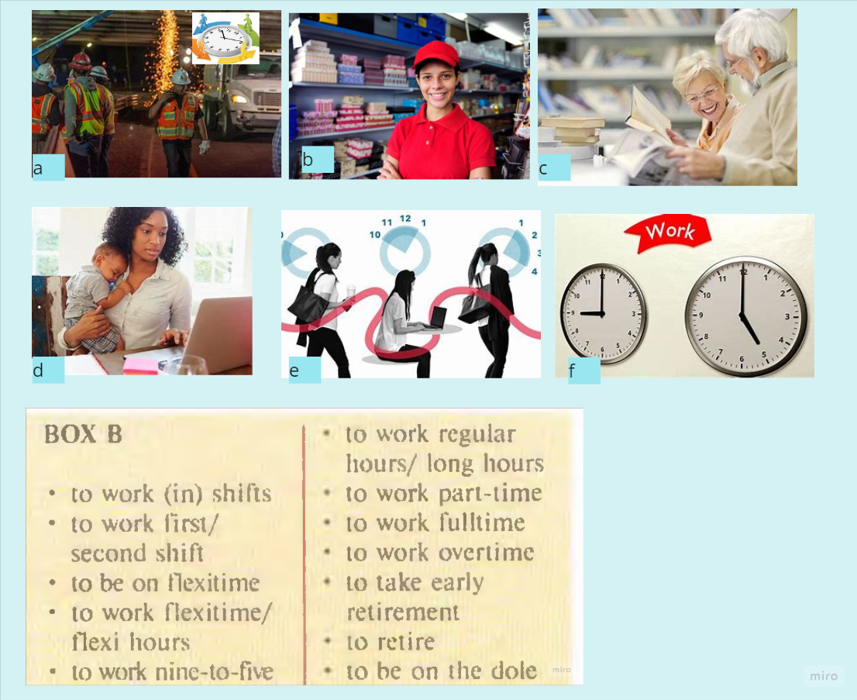
Match with the pictures

