DEMO

Task 1

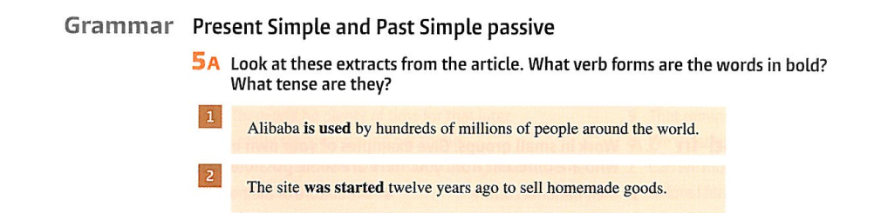

|  |
| --- |
|  |



|  |
| --- |

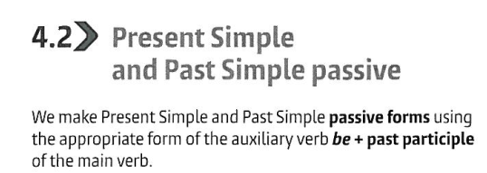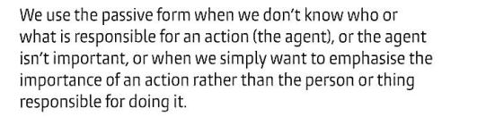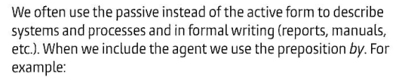

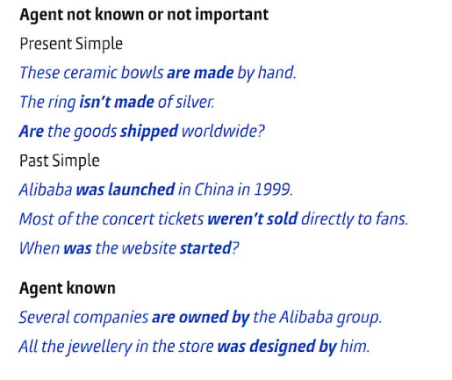

Task 2



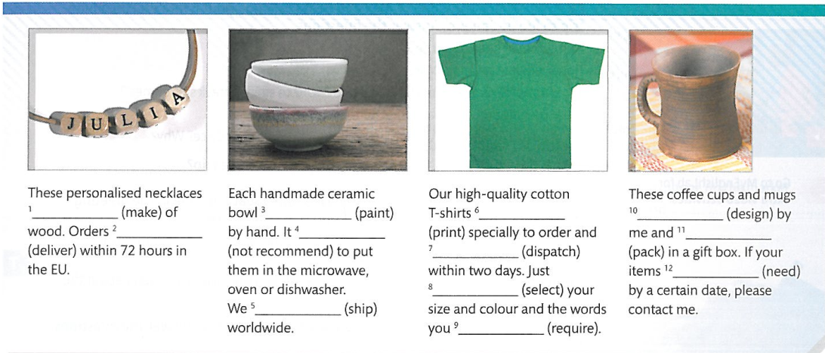

|  |  |  |  |
| --- | --- | --- | --- |

Task 3

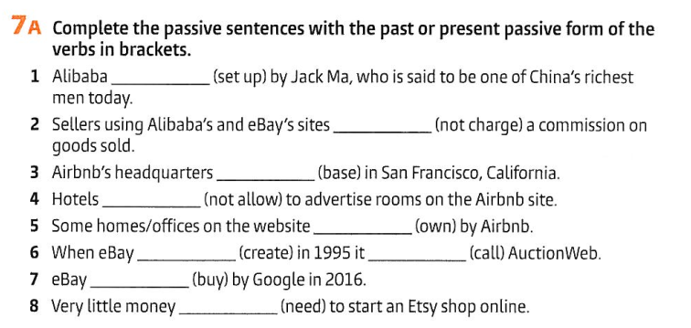

|  |  |  |  |  |  |  |  |
| --- | --- | --- | --- | --- | --- | --- | --- |



Task 4

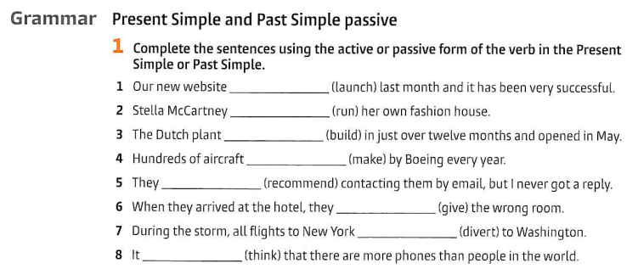

|  |  |  |  |  |  |  |  |
| --- | --- | --- | --- | --- | --- | --- | --- |

Task 5

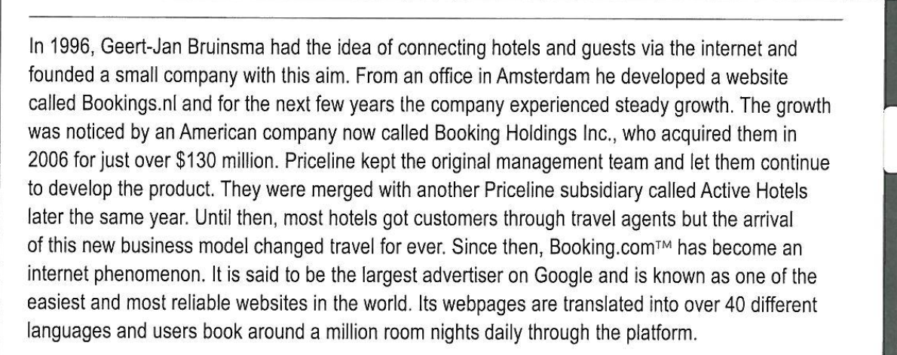

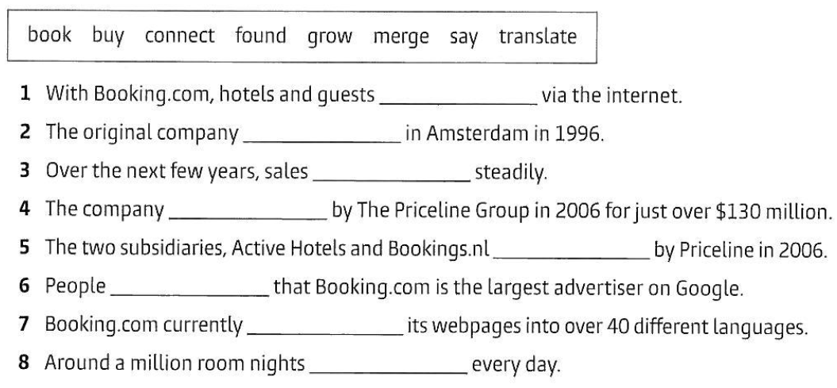

|  |  |  |  |  |  |  |  |
| --- | --- | --- | --- | --- | --- | --- | --- |

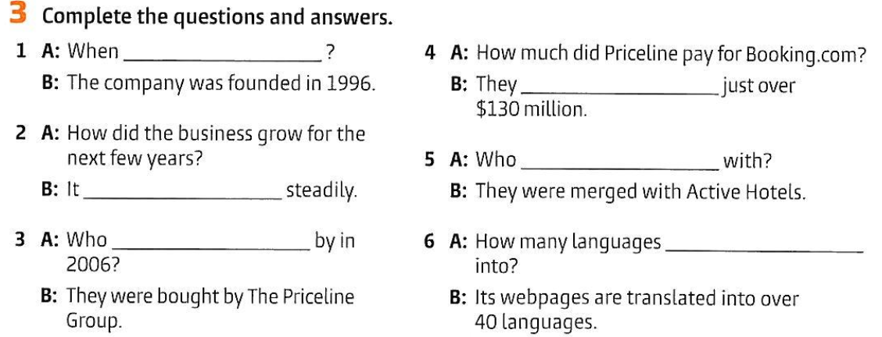

Task 6

|  |  |  |  |  |  |
| --- | --- | --- | --- | --- | --- |

Task 7

|  |
| --- |

Example (written by Chat-GPT)

Let me help you draft a sofa business description.

LUXE LOUNGERS: Custom Modular Sofas

Transform any space with our premium modular sofas. Each piece is handcrafted using sustainable materials and can be configured to your exact specifications. Our innovative snap-lock system lets you easily rearrange modules to create different layouts. Choose from performance fabrics in 50+ colors, all stain-resistant and pet-friendly. We offer 3D visualization tools to preview your custom configuration, plus white-glove delivery and assembly. Built for modern living, backed by a 10-year warranty.

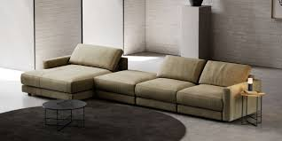

Materials taken from Business Partner B1 SB, p.41, 121, WB p. 20.