DEMO

materials taken from Roadmap B2. p. 8-9

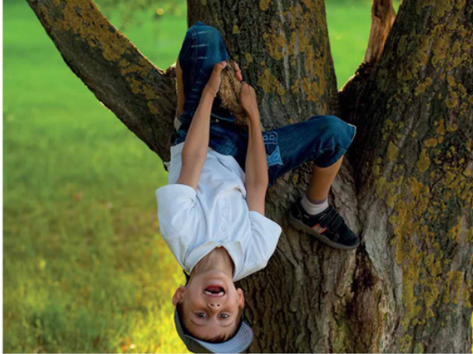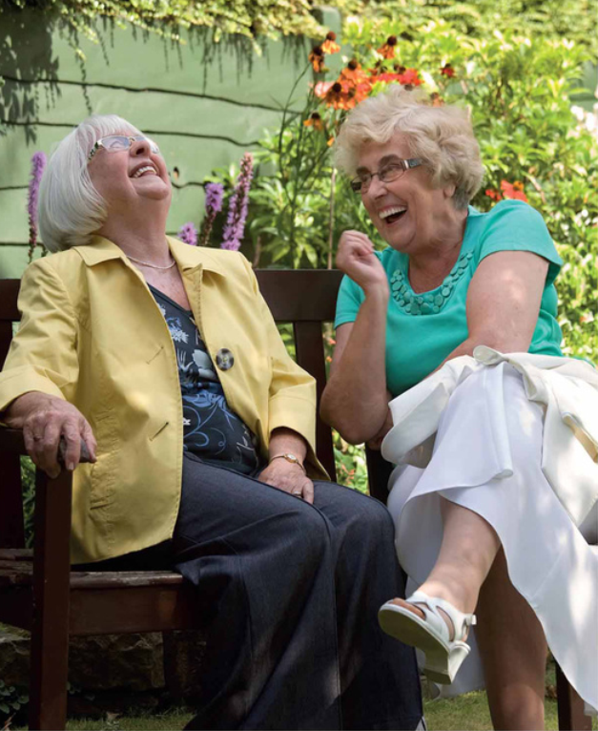



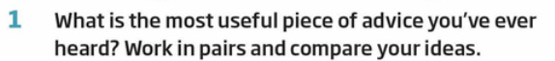

|  |
| --- |

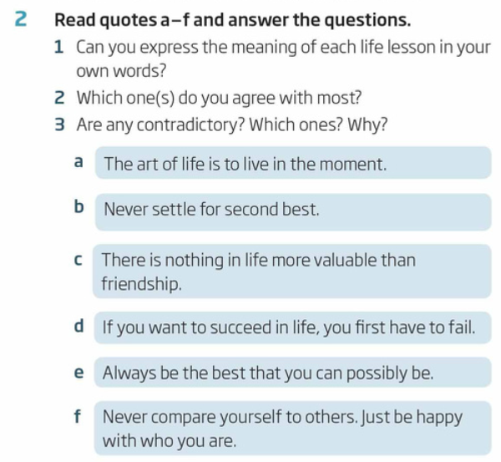

|  |
| --- |
|  |
|  |

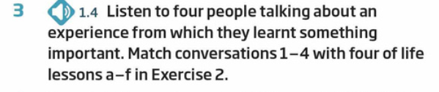

|  |  |  |  |
| --- | --- | --- | --- |
|  |  |  |  |

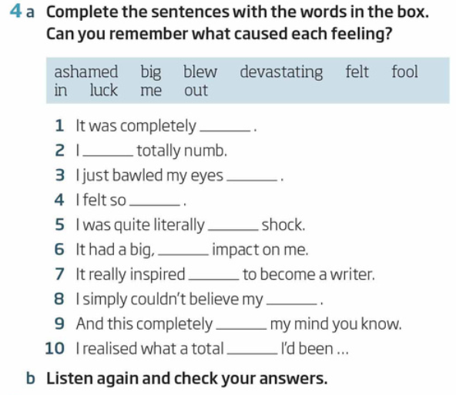

|  |  |  |  |  |  |  |  |  |  |
| --- | --- | --- | --- | --- | --- | --- | --- | --- | --- |

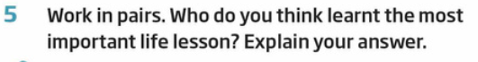

|  |
| --- |

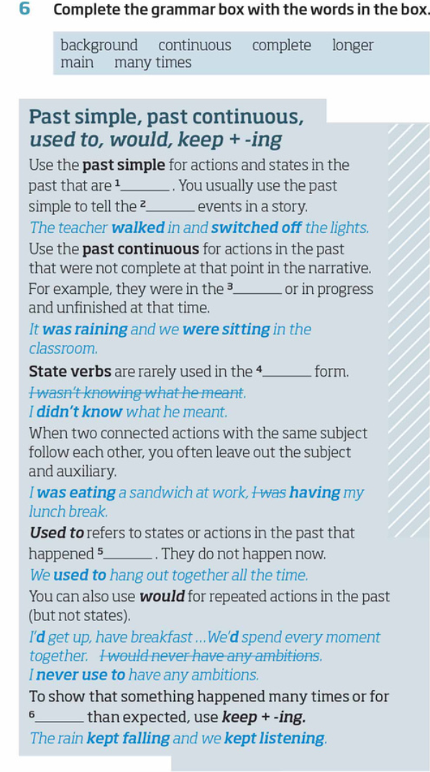

|  |  |  |  |  |  |
| --- | --- | --- | --- | --- | --- |

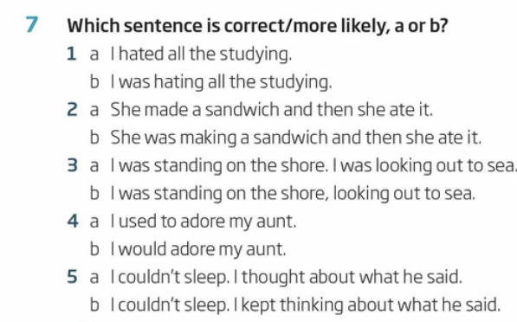

|  |  |  |  |  |
| --- | --- | --- | --- | --- |

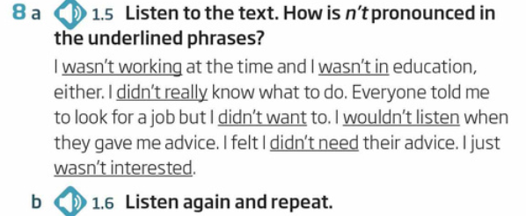

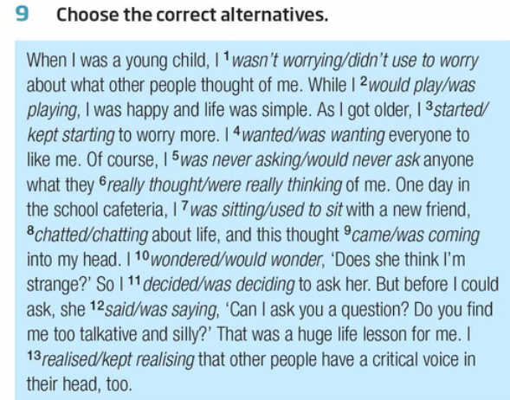

|  |  |  |  |  |  |  |  |  |  |  |  |  |
| --- | --- | --- | --- | --- | --- | --- | --- | --- | --- | --- | --- | --- |

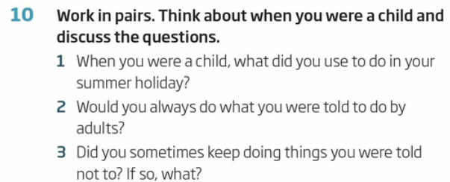

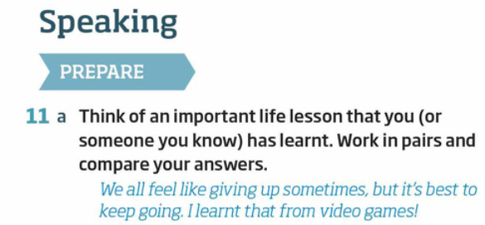

|  |
| --- |

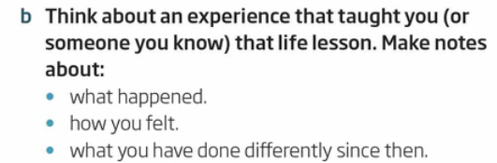

|  |
| --- |
|  |
|  |

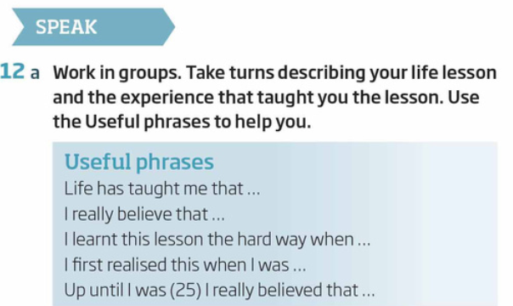

|  |
| --- |



|  |
| --- |

Extra writing tasks:

Write about your new hobbies .

Write a reflective essay about a new experience.