DEMO

Material taken from Business Partner B1, p.10

Lead-in

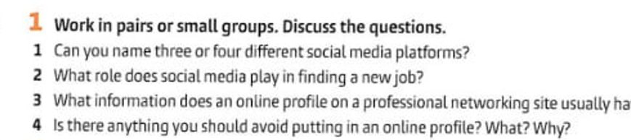

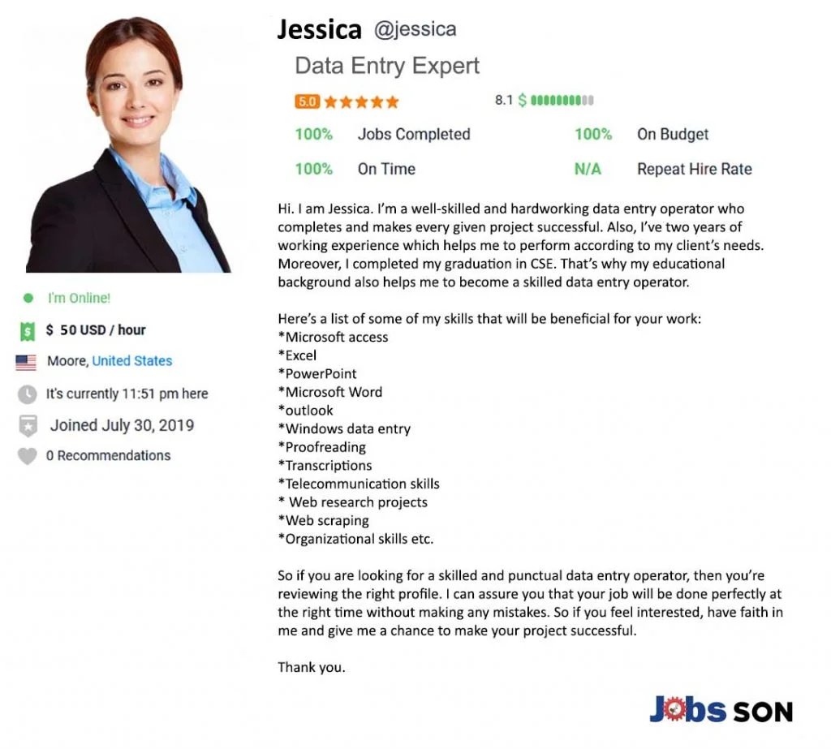

material taken from jobsson.com

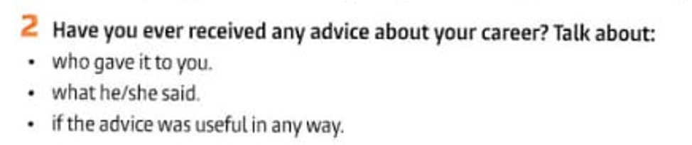

Task3

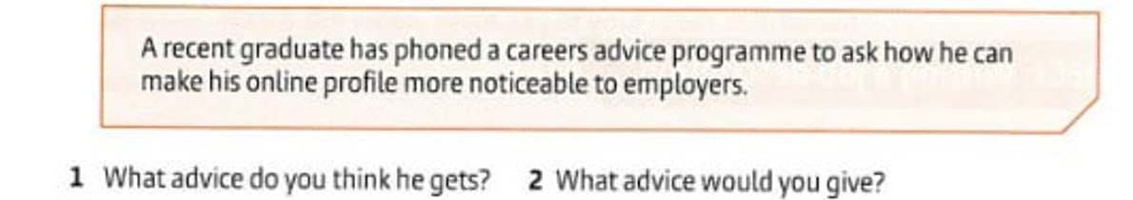

Task 4

Listening 1.



Task 2

Listening2

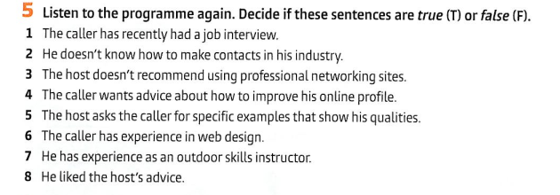

___

___

___

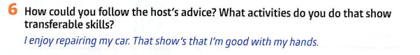___

___

___

Task 7 HOMETASK: Improve this profile:

