DEMO

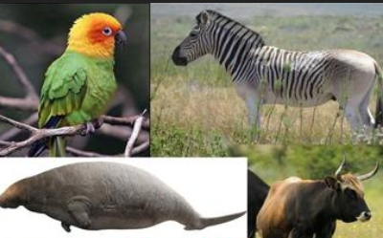

|  |  |  |  |  |
| --- | --- | --- | --- | --- |

Reasons

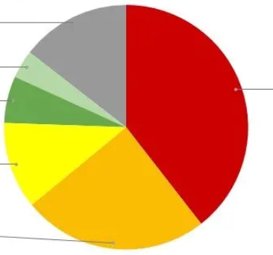

Check your answers:

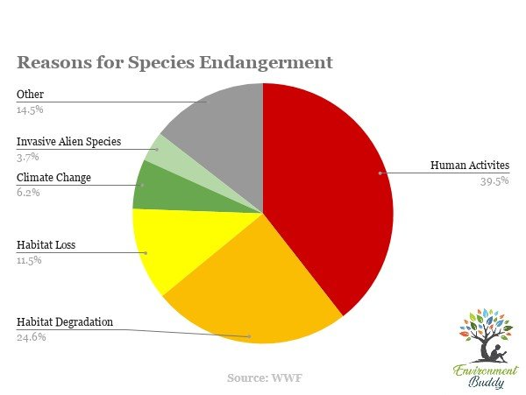

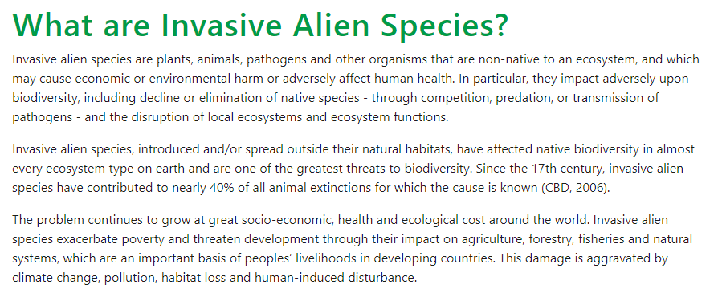

taken from: <https://www.cbd.int/idb/2009/about/examples>



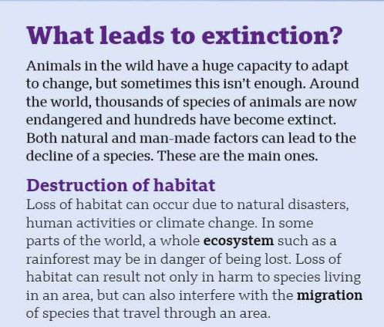

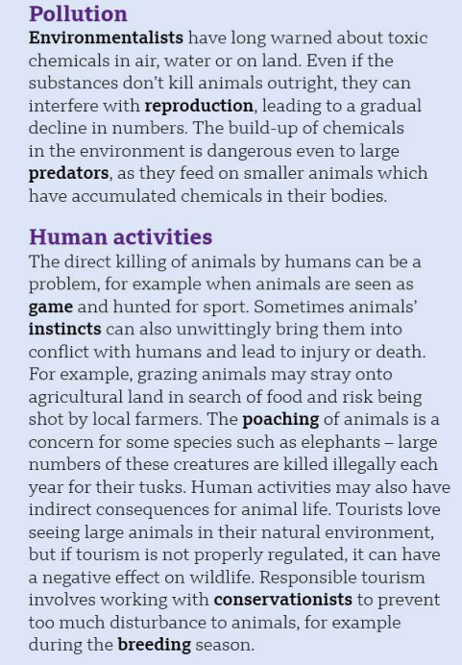

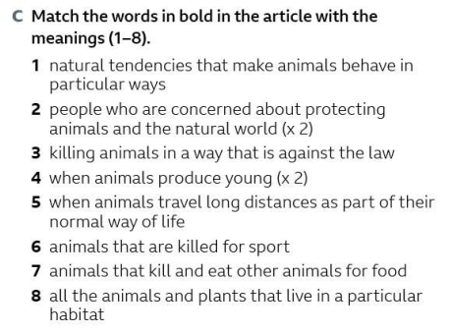

|  |  |
| --- | --- |
|  |  |
|  |  |
|  |  |
|  |  |
|  |  |
|  |  |
|  |  |

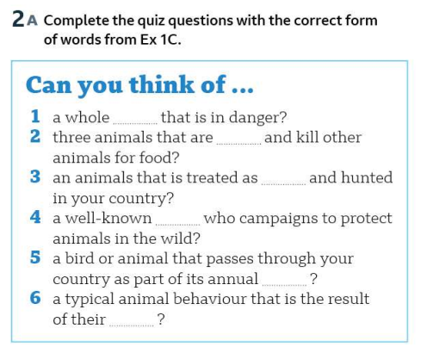

|  |
| --- |
|  |
|  |
|  |
|  |
|  |

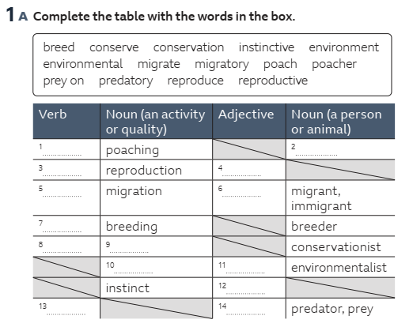

| verb | noun | adj | noun (person/animal) |
| --- | --- | --- | --- |
|  |  |  |  |
|  |  |  |  |
|  |  |  |  |
|  |  |  |  |
|  |  |  |  |
|  |  |  |  |
|  |  |  |  |
|  |  |  |  |

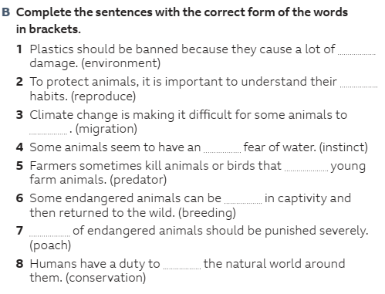

|  |
| --- |
|  |
|  |
|  |
|  |
|  |
|  |
|  |

Discussion

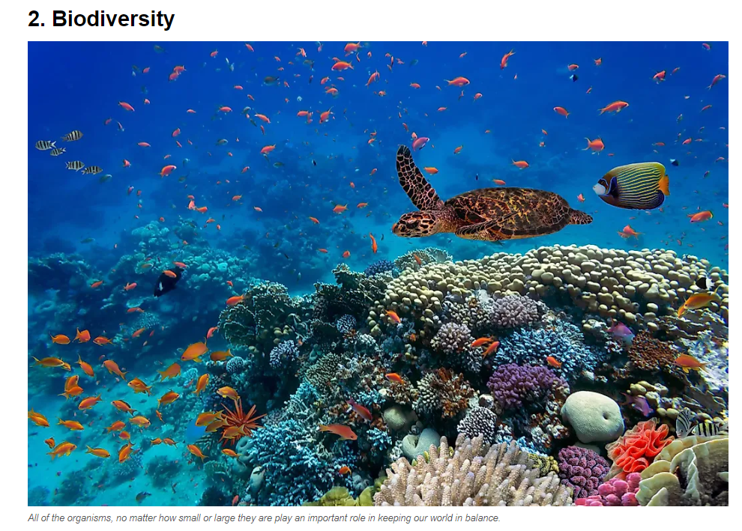

materials taken from SpeakOut B2+ p.59