DEMO

materials taken from Focus 3 SB, p48-53

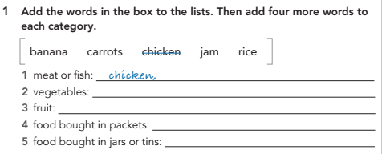

|  |
| --- |
|  |
|  |
|  |
|  |

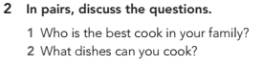

|  |
| --- |
|  |

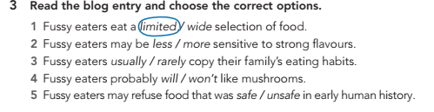

|  |
| --- |
|  |
|  |
|  |
|  |

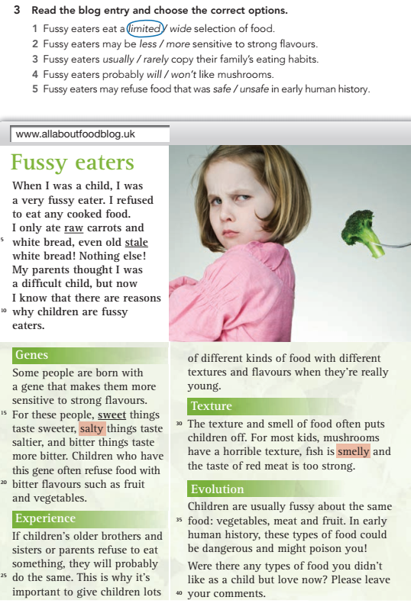

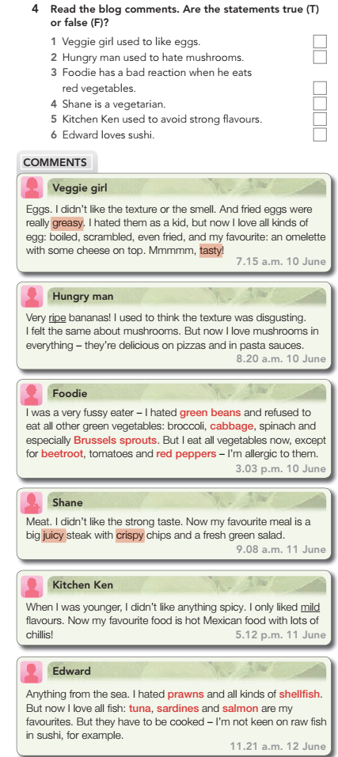

Complete the sentences and tick the ones that are true for you:

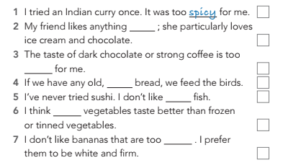

|  |
| --- |
|  |
|  |
|  |
|  |
|  |
|  |

# Hometask

# Read the text and do the tasks:

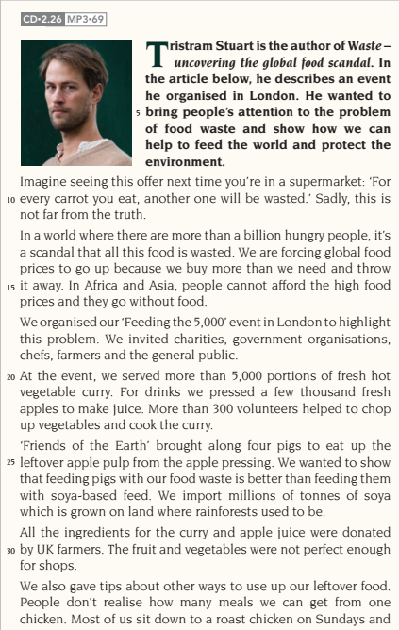

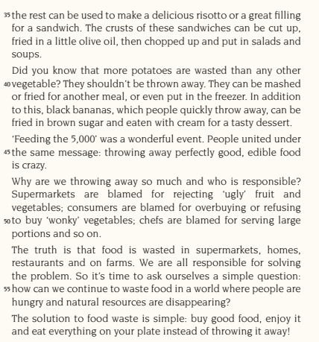

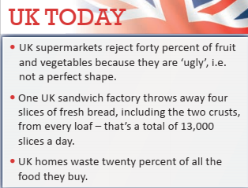

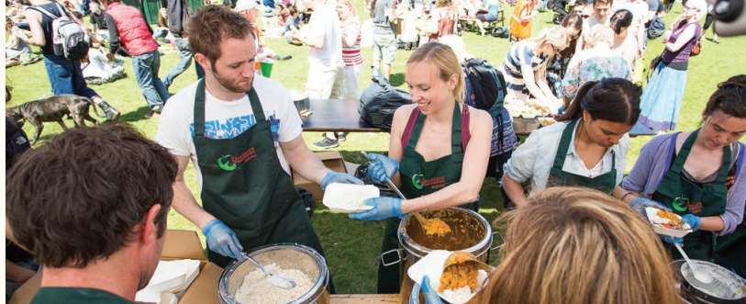

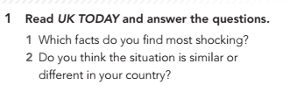

|  |
| --- |
|  |

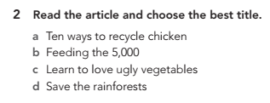

|  |
| --- |

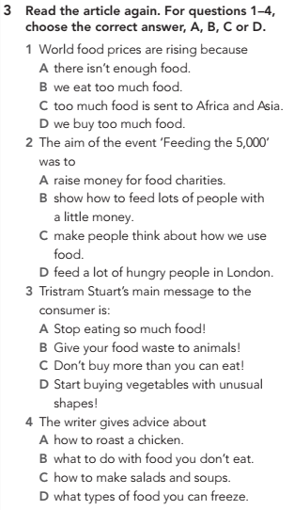

|  |  |  |  |
| --- | --- | --- | --- |

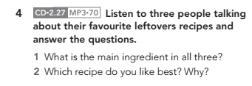

|  |
| --- |
|  |

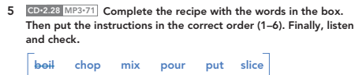

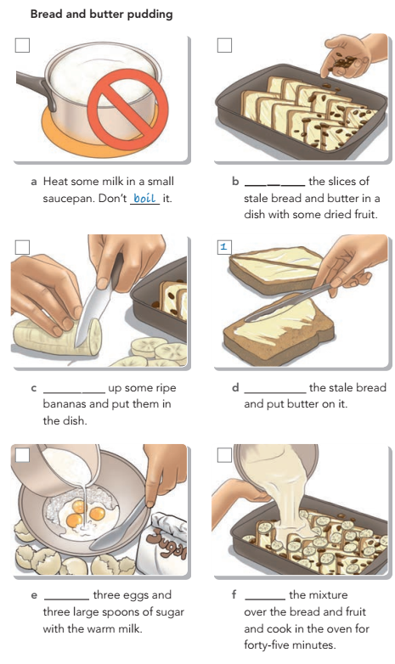

|  |  |  |  |  |  |
| --- | --- | --- | --- | --- | --- |

Write some ideas about things you could do to avoid wasting food.

|  |
| --- |