Learn Mobile Forensics
Write the first review
By William Oettinger

Schedule learning reminder
TIME TO COMPLETE:4h 50m
LEVEL:Intermediate to advanced
SKILLS:Mobile Forensics
PUBLISHED BY:Packt Publishing
PUBLICATION DATE:November 2024
PRINT LENGTH:295 pages

Learn Mobile Forensics: The Complete Guide from Extraction to Courtroom Testimony
Welcome to Packt Early Access. We’re giving you an exclusive preview of this book before it goes on sale. It can take many months to write a book, but our authors have cutting-edge information to share with you today. Early Access gives you an insight into the latest developments by making chapter drafts available. The chapters may be a little rough around the edges right now, but our authors will update them over time.
You can dip in and out of this book or follow along from start to finish; Early Access is designed to be flexible. We hope you enjoy getting to know more about the process of writing a Packt book.
- Chapter 1: Introduction to Mobile Devices
- Chapter 2: Wireless Networks and Connectivity
- Chapter 3: Mobile Forensics Analysis Process
- Chapter 4: Mobile Forensics Acquisition Process
- Chapter 5: Mobile vs. Computer Forensics
- Chapter 6: Understanding Mobile Databases
- Chapter 7: iOS Hardware and File Systems
- Chapter 8: Acquiring Evidence from iOS Devices
- Chapter 9: Analyzing Evidence from iOS Devices
- Chapter 10: Android Hardware and File Systems
- Chapter 11: Acquiring Evidence from Android Devices
- Chapter 12: Analyzing Evidence from Android Devices
- Chapter 13: Ethics for Mobile Forensic Experts
- Chapter 14: Creating Investigation Reports

1 Introduction to Mobile Devices
Join our book community on Discord
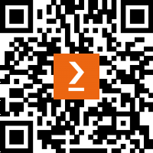
https://packt.link/SecNet
Mobile devices such as smartphones and tablets are integral to modern society. As technology advances, so does the need for mobile forensics capabilities to recover information from these devices. This chapter will be a foundation for understanding smartphone and tablet models, mobile operating systems (OSs), data acquisition methods, how to identify devices by their Unique Device Identifiers (UDIDs), and overarching standards relevant to mobile forensics.
Logical and physical methods offer two broad approaches to data extraction from mobile devices. The key differences between these categories will be explained. Then, we will explore unique identifiers employed across devices like International Mobile Equipment Identity (IMEI), Universal Unique Identifier (UUID), and UDID. The forensic value of these identifiers will be addressed. Finally, an introduction to relevant mobile forensics standards from accredited bodies like the National Institute of Standards and Technology (NIST) will familiarize readers with best practices endorsed by governing organizations.
This chapter covers the following topics:
- Origins of mobile devices
- First smart phones
- Common hardware
- OSs
- Research tools
- Mobile device identifiers
- Data acquisition
Upon completing this chapter, readers can compare the features and architectures of iOS and Android OSs. They will understand the crucial distinctions between logical and physical data acquisition in mobile forensics. You will recognize the importance of unique identifiers within forensic investigations.
Equipped with this foundation, we will continue building your knowledge about mobile device forensics throughout the following chapters

Origins of Mobile Devices
The introduction of the first handheld mobile phone in 1973 was a pivotal moment that transformed communication and connectivity worldwide. Early incarnations were large, heavy devices with little semblance to today's sleek smartphones. Over the past five decades, innovation centered on materials, display technology, and miniaturized components redefined perceptions of the optimal mobile form.
The bulky "brick" phones were barely portable by today's standards; contemporary devices boast expansive touchscreens with body dimensions rivaling credit cards. Premium builds are elegant glass-and-metal sandwiches no thicker than a pencil. Behind the scenes, this drastic form factor constantly balances consumer expectations, ergonomic considerations, and hardware capabilities.

Technological Advancements
Commercial mobile phones trace back to patented concepts from Bell Labs in the 1940s based around low-power small-cell networks rather than device design. The first prototype, resembling a portable phone, came from Motorola in 1973. It weighed over 2.5 pounds, had 30 minutes of battery life, and had a bulky antenna.
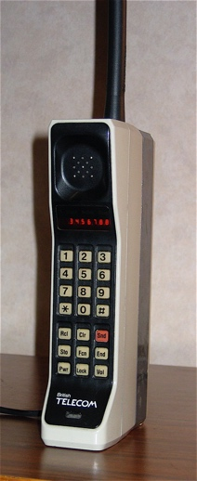Figure 1.1: This is an example of one of the first cell phones, the Motorola DynaTAC 8000X (by Redrum0486 CC BY-SA 3.0)
A decade passed before Motorola shrunk components for adequate portability, resulting in the popular DynaTAC 8000X in 1983. (As shown in Figure 1.1). Nicknamed "The Brick" phone, it managed a 10-ounce weight and briefcase-sized battery/electronics that comfortably fit large overcoat pockets. The limitations in technology heavily constrained the capabilities of mobile devices. High electrical current demands with immature battery chemistry created an exceptionally large form factor battery pack to achieve adequate mobile runtimes. Available display technologies relied upon primitive liquid crystal display (LCD) or light-emitting diode (LED) implementations. As you can see in Figure 1.1, considerable portions of the device were dedicated to power storage and visualization elements – modern smartphone-class lithium-ion batteries with a much superior energy density allowed for improvements and the creation of ultra-compact platforms.
Mobile phones swiftly spread among commercial audiences. Portability remained largely defined as "able to transport in vehicles" (Figure 1.2) rather than pocketable designs for average consumers. Given marginal internal radios, handsets relied on external antennae to maintain signal strength.
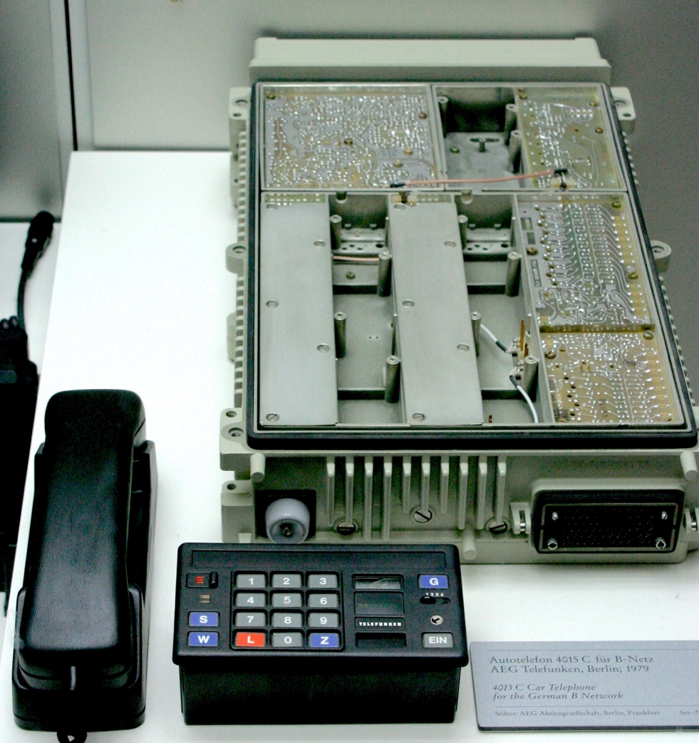Figure 1.2: Car phone for the German B network, circa 1979, on display at the Deutsches Museum in Munich, Germany (by Ben Franske, CC BY-SA 2.5)
By the mid-1990s, efficient power management electronics finally released phones from vehicular installation. Clamshell flip form factors also became popular, taking cues from Star Trek that protected keys and displays (as shown in Figure 1.3). Slimmer batteries powered improved radios, and antennas shrank in thickness as fingers became the primary tools for dial pads.
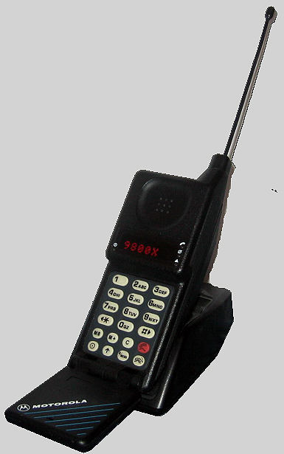Figure 1.3: The clamshell model type – Motorola MicroTAC 9800X

The Smartphone Revolution
The turn of the century ushered a drive toward miniaturization. Subscriber Identity Module (SIM) cards modularized user identity from hardware devices themselves. Screens used incremental LCD advancements, reaching usable resolutions at smaller dimensions. Mobile networks expanded globally. All foundations stood ready for unprecedented leaps in capabilities, triggering swift market adoption of internet-connected, versatile mobile computers termed "smartphones."
When Apple announced the iPhone in 2007, supporting infrastructure aligned with technology improvements to ignite a revolution. Power-sipping Advanced RISC Machines (ARM) processors handled digital workloads while balancing the battery limitations of thin devices. Capacitive multi-touch displays achieved smooth, responsive inputs. Cellular broadband networks enabled always-on internet connectivity. Combined behind a single glass face, traditional mobile phones effectively evolved into handheld computers overnight.
The hardware driving this user experience mandated compromises in physical design. Ballooning screen sizes tested maximum display area versus device footprint, seeking balance for media consumption. The shift from physical keypads to software-rendered GUIs justified sacrificing tactile feedback for expansive front glass expanses and the conveniences of software. The glass surfaces proved more durable yet appealing than plastic alternatives used on older devices. Maintaining network connectivity anywhere further meant dealing with bulge-inducing antennas and radios. Battery capacities also presented significant obstacles given current battery chemistry.
A market emerged almost overnight despite initial hardware immaturity. By 2019, over 5 billion individuals worldwide owned internet-connected smartphones as devices trended toward smaller dimensions with maximum display areas. The demand for better cameras, faster connectivity, longer runtimes, and higher processing power forced consumers to accept devices bulging from their pockets.
Display technology, battery chemistry, and fabrication techniques split the focus between opposing goals. While mainstream flagships consistently slimmed down, the other branch wanted wider girth but allowed for customization. Foldable phones draw clear inspiration from the iconic flip phones of the early mobile era, which revolutionized mobile communication with compact, clamshell designs that protected the keypad and screen while offering a satisfying tactile experience. This concept of a phone that could transform in size and functionality paved the way for today's foldable smartphones. These early innovations in phone design set the stage for modern foldable devices, which use flexible display technology to provide larger screens without sacrificing portability. Foldable displays are built around flexible plastic and glass offered in one vector, capturing consumers' imaginations despite durability challenges. Samsung pioneered concepts with the Galaxy Fold (as shown in Figure 1.4) before competitors like Motorola pursued similar options for large-screen portability. For average consumers, refinements targeting thinness and screen maximization dominate each fall's flashy new device announcements.
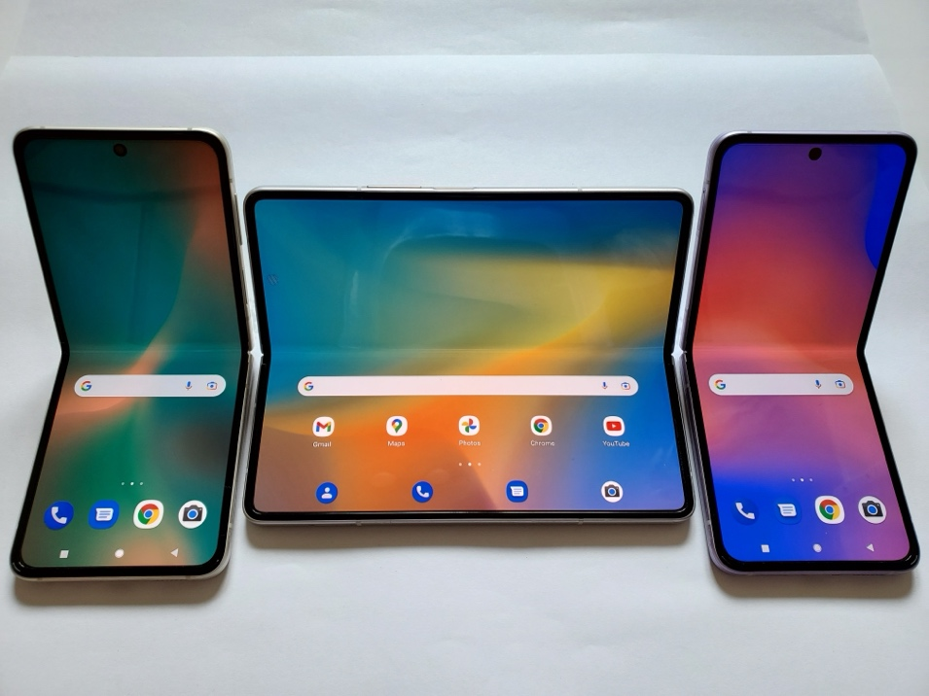Figure 1.4: The Samsung Galaxy Z Fold3 and Z Flip3 License (CC BY 3.0 Credit: Ka Kit Pang)
Modern smartphones currently equip over 5 billion global subscribers with high-performance computers connecting ideas across vast distances – a sci-fi dream mere decades ago.

The First Smart Phones
Announced in 1992, the IBM Simon Personal Communicator (Figure 1.5) claims to be the first smartphone – primitive by modern standards. Inspired by science fiction fantasies of portable communicators, IBM focused industrial design around a touchscreen with stylus input. The monochrome LCD displayed customizable app icons, arranging features from a calendar and contacts to email, fax, notepad, and world clock. While seemingly commonplace decades later, the touch interface marked uncharted territory.
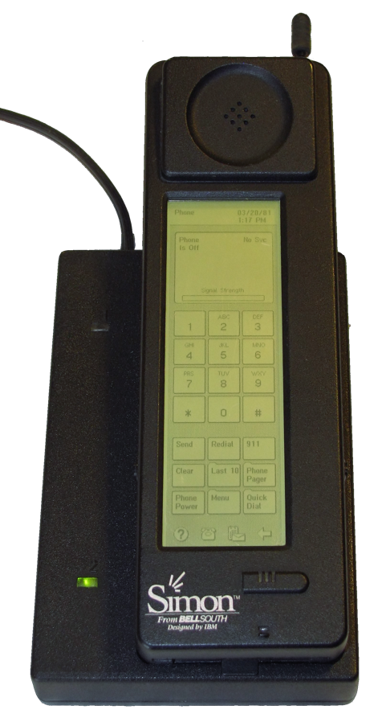Figure 1.5: IBM Simon Personal Communicator License (CC BY 2.0 Credit: textlad)
Simon centered a large screen flanked by a battery compartment and antenna. An extendable aerial and charging dock ensured connectivity. It relied on proprietary software and stylus input. Simon's feature set offered a glimpse into future smartphone capabilities through an early form factor. While Simon pioneered software, Nokia's Communicator series spearheaded smartphone functionality. Launching in 1996, the clamshell Nokia 9000 Communicator opened to reveal a monochrome LCD and physical keyboard, much like miniature laptops. The focus was mobile email and fax communications, and telephony functions.
Hinged forms afforded large screens unhampered by number pads when opened. This concept reemerged decades later with foldable Android devices. Through five successive generations over seven years, Nokia systematically refined its industrial design and enlarged displays, culminating in 640x200 resolution and 16-bit color. While it was niche and costly for average consumers, business users embraced the Communicator innovations (see Figure 1.6).
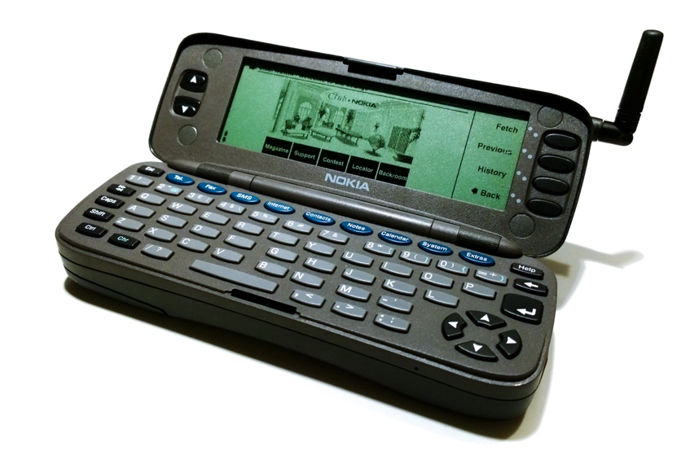Figure 1.6: Nokia Communicator 9000
As the Communicator series targeted enterprise consumers, Microsoft brought business smartphones to mainstream audiences in the early 2000s with the Windows Mobile OS. Handsets running Windows CE variants extended office software functions and email to simplified pocket devices with phone capabilities.
Designs like the Compaq iPAQ streamlined candybar forms and focused on an interface around a square display with circular navigation buttons centered underneath. Flanked volume rockers and slim rectangular shapes maximized screen real estate for the era while ensuring one-handed grips. The specifications seem meager alongside modern devices, but these early Windows phones boosted productivity through portability.
During the PDA era, Palm Computing was renowned for influential products like the Palm Pilot. Palm Computing sought smartphone consolidation through the PalmOS system software. The Handspring Visor phones offered promising PDA augmentations like Springboard hardware expansion slots. Even with advanced features, success remained limited to enterprise audiences until the 2004 Treo 600 brought the platform to consumers.
Following the footsteps of IBM Simon, Nokia's Communicators, and Palm Treos came the prolific BlackBerry smartphone line that soon dominated business users. Though initially focused purely on email, Blackberry OS rapidly evolved messaging features after the 1999 BlackBerry 850 pager, and subsequent models catered to productivity for millions worldwide through trademark hardware keyboards and secure communications.
Signature BlackBerry designs featured large displays with integrated shape-coded keypads for typing. Rounded curves, accent colors, and faux-leather/metallic plastic materials maintained a consistent aesthetic across model variations or the evolving wireless networks spanning the early days of 2G through 3.5G data transmission. The BlackBerry defined corporate smartphones for years until the touchscreen upended conventions.
While Palm, Windows Mobile, and BlackBerry smartphones achieved niche market permeation in the early 2000s, consumer-focused efforts remained sparse. Handset manufacturers or carriers occasionally produced low-cost touchscreen phones with custom software, but unreliable interfaces and limited app ecosystems curtailed enthusiasm. These early glimpses into these form factors hinted at alternatives to the phones of the era. Inconsistent user experiences and negligible app support hampered widespread touch development before the iPhone release.

iPhone
When Steve Jobs unveiled the original iPhone in January 2007, the landscape stood on the cusp of a seismic upheaval. The expectation was that mobile phones handled calls and messages while PDAs and some business smartphones provided personal organization functions. Apple suddenly proposed an all-touch slate without front facings, buttons, or switches. The 3.5-inch LCD went from edge to edge, accented only by a circular home button at the bottom center. Given the fragility perceptions of early touch implementations, such expansive glass on the phone was controversial.
Inside the iPhone, a browser and multimedia functions are augmented by a novel interface that relies on gestures called pinch, spread, and flick. Apple coined the term "multi-touch," promising a lag-free response and precision unachievable through older resistive touch layers employed by past devices. When the iPhone launched six months after the announcement, fanfare erupted. Stylish design, slick software, and usable touch mechanisms captured the imagination.
Apple's surprising success dispelled the stigma about touchscreen input viability. Competitors swiftly moved to emulate touch slabs, recognizing shifting preferences toward sleek styling and touch-focused interfaces free of small physical keys. Windows phones made radical reversals, as did BlackBerry, Palm, and Nokia – ultimately unsuccessfully, as Apple's formula dominated after being tested and refined across generations. The ultimate winner in Apple's wake was Google's accessible Android OS, which created an ecosystem spreading affordable iPhone-like touch smartphones through licensing partnerships. As slab phones saturated developed nations by the early 2010s, basic internet usage soared in emerging regions thanks to Android interfaces following the early iPhone designs.
Early smartphone forms explored many concepts while trying to find the ideal balance between portability, durability, and features. Clamshells, swivels, slides, modular components, and early foldable attempts all surfaced, seeking the perfect vessel for smartphone capabilities. But once Apple won over the public, few survived.
With the iPhone, the modern candy bar, typified by a single glass sheet, gave way to software fluidity, replacing mechanical options or moving parts. Minimalist face designs endure over a decade later despite internal technical advances. While pioneering models once boasted 2010s-era specifications sufficient at product launch, the same display size standards and credit card dimensions now contain exponentially superior computing hardware, battery life, and capabilities.
Tablet computers like the iPad also hit the consumer market in 2010, delivering larger touchscreens and portable access to apps and web services. Extensive app stores with millions of mobile apps then grew across smartphone platforms. Connection speeds accelerated further with 4G LTE networks, followed by the emergence of 5G networks in 2019, enabling faster downloads and high performance.

Mobile Devices – Global Impact and Forensic Use
In 2021, the Radicati Group reported that the number of mobile users worldwide stood at 7.1 billion, with forecasts suggesting this will rise to 7.26 billion by 2022. In 2025, the number of mobile users worldwide is projected to reach 7.49 billion. Figure 1.7 shows the evolution of mobile devices as their popularity soars.
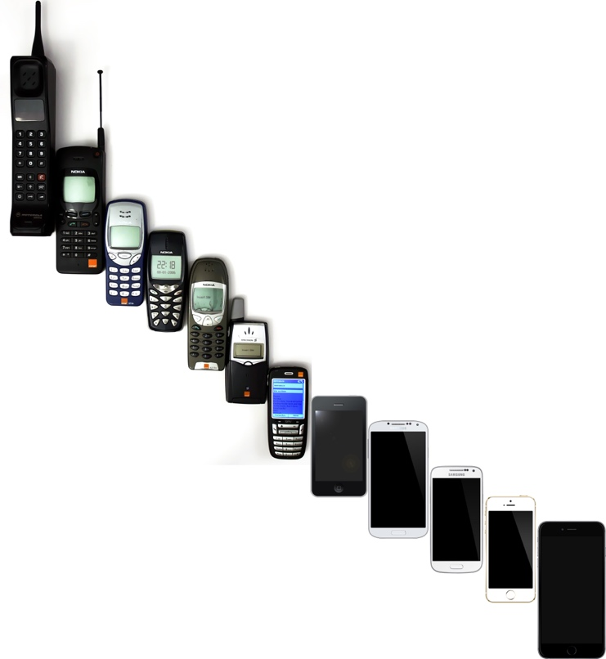Figure 1.7: Evolution of mobile phones, from 1995-2014
Mobile devices have achieved immense global penetration, with individuals in most nations using mobile technology. Understanding device access allows forensic investigators to identify which individuals are more likely to possess mobile devices. Recent statistics on worldwide mobile phone ownership reveal significant insights. In approximately half of the countries surveyed from 2018-2020, over 90 percent of the population owned a mobile phone. Additionally, another ten countries observed ownership levels ranging from 80 to 90 percent. Only three countries documented mobile phone ownership below 50 percent, with the lowest rate being 45 percent. These figures demonstrate the prevalence of mobile phones across diverse nations and cultures. As ownership intersects with gender, the data also shows progress toward gender equality in half of the 60 examined countries – both men and women maintained equivalent levels of device access.
Today's smartphones and tablets enable instant communication via email, messaging, video chat, and social platforms in the palm of one's hand virtually anywhere. Quad-core processors deliver computer-like performance for gaming, productivity, navigation, e-commerce transactions, multimedia streaming, and countless other applications. With versatile capabilities and continual enhancements in connectivity, display resolutions, camera quality, and processing power, mobile devices have revolutionized technology and granted users unprecedented immediacy and access to information across the globe.
Mobile devices generate expansive volumes of data – per Ericsson, global mobile traffic was over 130 exabytes per month in 2023 and is expected to grow to 403 EB by 2029.
An exabyte (EB) is a unit of digital information storage used to quantify large amounts of data. To help you understand better, here's a breakdown of how the data storage units scale:
- Byte (B): The basic unit of data storage
- Kilobyte (KB): 1,024 bytes
- Megabyte (MB): 1,024 kilobytes
- Gigabyte (GB): 1,024 megabytes
- Terabyte (TB): 1,024 gigabytes
- Petabyte (PB): 1,024 terabytes
- Exabyte (EB): 1,024 petabytes
One hundred thirty exabytes is a massive amount of data. It's estimated that all the words ever spoken by humans could be stored in about 5 exabytes of data, which would be 26 times that amount.
As compact yet powerful computers, smartphones facilitate communication and access to information. Mobile forensics allows for reconstructing smartphone events, movements, and activities based on the ever-growing digital traces these devices compile. Their personal nature offers intimate access to users' lives, making mobile devices highly useful for investigators.
Calls, texts, emails, documents, photos, GPS history, and more provide a comprehensive event timeline. Mobile devices keep near-constant records of user movements and activities. With society's integration of smart devices, they become increasingly central to investigations. This encompasses relevant digital artifacts like texts, photos, app data, and system logs. As devices evolve more features and applications, the extent of forensic evidence increases accordingly. The following case study shows how the information contained in a smartphone can be used.
The following case in point involves the investigation of a young boy's mother and her boyfriend. Law enforcement was investigating the death of the child. The primary subjects were the mother and her boyfriend. The primary digital evidence was comprised of mobile devices belonging to the subjects. The investigation uncovered internet search histories that included queries for "painful ways to die" and "torture techniques." GPS locations identified where the subject had traveled over the preceding weeks. This information was pivotal in the investigation and when questioning the subjects. When confronted with the digital evidence, both subjects ultimately confessed to causing the death of the child and identifying the location of the gravesite.
Let’s look at some common hardware you will find in most smartphones.

Common Hardware
While early models focused chiefly on wireless communication abilities, contemporary smartphones represent high-performance portable computers with multi-functional capabilities far exceeding those of previous phones. Mobile devices contain sophisticated integrated circuits and microprocessors that power their functionality.

Central Processing Unit (CPU)
The CPU constitutes the "brain" of a mobile device, handling essential computational tasks and executing software programs. Smartphone CPUs typically utilize ARM architectures, which balance processing power efficiency with the energy constraints intrinsic to battery-powered mobility. Common specifications involve octa-core configurations, allowing smooth system-wide functionality. CPU benchmarks continually expand as additional on-device artificial intelligence capabilities emerge on more advanced chipsets.

Data Storage
Two forms of data storage are used to deliver access to active information. Random access memory (RAM) temporarily caches running programs and data in devices. Flash-based storage contains persistent long-term files and system states using universal standards like eMMC or speedier UFS formats.

Sensors and Interfaces
Options like accelerometers enable automatic screen rotation when devices change orientations in space. Ambient light sensors adapt screen brightness optimal for current lighting scenarios. Proximity sensors turn off touch sensitivity during calls when held to ears. GPS and compass modules provide location and movement awareness critical for mapping applications.
The main interface involves touch displays augmented by buttons controlling power, volume, or launching assistants. Speakers offer auditory feedback, while microphones capture audio input. Expandable memory slots and charging ports like USB-C, provide wired peripheral connections otherwise handled wirelessly by Bluetooth, NFC, and WiFi antennas.

Battery and Charging
The time between charges requires efficient resource handling due to battery size and chemistry constraints. Current lithium-ion formulations provide 300-4000 mAh capacities on mainstream models. Recent ultra-fast charging technologies briefly accelerate input current to replenish batteries quicker when power outlets become available, mitigating capacity limitations through responsiveness. For some models, wireless and reverse charging options are also gaining traction as alternatives to wired power sources.

Cameras and Displays
Visual front-facing cameras facilitate selfies and video conferencing, leveraging 5–50-megapixel sensors. Rear multipurpose cameras offer focal lengths capturing wider scenes, macro photography, and augmented depth detection – upwards of 108 megapixels and folded optics providing optical zoom. OLED and LCDs span 5" to 7" across mainstream handsets, some trending closer to tablet dimensions. Higher density resolutions and pixel counts enhance clarity, contrast, and colors at levels up to 720p to Quad HD+ (1440p) on current generation screens.

Materials and Durability
While glass and aluminum are the current mainstream materials due to their durability, aesthetics, and handling, interest is growing in hardened devices for industrial use. Ruggedized phones with reinforced corners, rubber bumpers, and elevated waterproofing like IP68 ratings allow temporary submersion without damage. The use of sturdy panels and Gorilla Glass prevents screen cracking. At the same time, reinforced support structures with heat dissipation properties handle temperature spikes experienced by field personnel and other specialized use cases.
Next, we will explore the topic of OSs, examining their functions and significance in modern devices.

OSs
Two heavyweights – Android and iOS – have long defined the mobile OS domain. These rival platforms reflect different design philosophies and spawn distinct app ecosystems. Both share an obsession with optimizing the end-user experience.

The Rise of iOS and Android
Originally, carriers dictated features to vendors who controlled tightly integrated proprietary OS code, greatly limiting outsider contributions. This resulted in stunted ambition and user frustrations when carriers neglected platform updates. When the iPhone launched in early 2007, little doubt remained about software's significance in determining mobile experiences going forward. Android adapted Linux architecture instead while adding touch specialization. Sensing seismic shifts, a dual-pronged software modernization initiative began within Apple – iOS for phones and iPadOS for new tablet experiences.

Google’s Vision for Android
When Google acquired a small start-up, Android Inc., in 2005, few recognized the immense mobile potential hidden within. The Sidekick device inspired the Android development team to make mobile software development more accessible to a wider audience. Their goal was to stimulate innovation on a scale comparable to the web. They opened up the process of app creation to a diverse range of developers, fostering a vibrant and varied mobile app ecosystem. This approach aimed to mirror the growth experienced in web content but within the mobile space, promoting an environment enriched by creativity and technological progress. This initiative was crucial in reshaping the mobile software development landscape, highlighting the Android team's dedication to widespread innovation.

Divergent Development Paths of Apple and Android
In developing their OSs, Apple's iOS and Android took distinct paths. Apple set up strict rules for app developers, focusing heavily on security. This approach made iOS less flexible than other platforms, but it built a strong, reliable foundation. This solid base proved advantageous. iOS's consistency and focus on practicality kept it strong in the market. Android gives developers more freedom to tweak and innovate, contrasting iOS's more regulated environment. This difference balances the secure, tightly controlled iOS and the open, adaptable Android. Each has benefits and challenges: iOS's approach ensures security and reliability, while Android's openness fosters innovation and versatility.

User Experience and App Ecosystems
Apple delivered the first mass-market mobile platform, prioritizing consistent, simple, yet satisfying user experiences. iPhone hardware set benchmarks in responsiveness, fluidity, and multi-touch capabilities that awestruck consumers previously accustomed only to miniature desktop software or cumbersome phone keypads. Users used apps built for the touch interface hosted in a vetted App Store distribution, providing a secure environment for access and purchases.
Fans gravitated to their chosen mobile type based on priorities like affordability, hardware variety, user experience, or platform uniformity. Users became fiercely loyal as leaps were made in functionality and third-party apps. The open versus closed debate framed discussions but missed how purpose-built each OS is. iOS seamlessness attracts customers valuing convenience and consistency across Apple products. Android's flexibility suits buyers wanting more hardware choices and customizability. Both OSs enable sophisticated cloud connectivity, AI integration, high-grade cameras, and edge-to-edge displays. The central question remains – does a supremely responsive operation in a controlled environment or freedom to tinker gain a bigger following? Market share metrics suggest budget-friendly adaptability wins, but Apple still captures premium devotees.
iOS defined modern norms through consistency appreciated by average users, even given the tight control limitations. By contrast, Android rapidly welcomed alternate approaches both technically and business-wise. It delivered on its original ambition, opening development absent gatekeepers beyond individual device makers. As an inherently modular architecture, Android OS accommodated endless experimentations adapting the Linux underpinnings, with highly customizable home screen launchers, swappable keyboards, data transfer protocols, and device form factors flourished, attracting free-wheeling enthusiasts. The mass appeal came later through Samsung licensing deals infusing greater hardware variety. Android ultimately split the difference between iOS's cohesive yet confining environment and Windows Mobile's flexible but fragmented nature.
Understanding historical context explains current mobile realities with iOS largely retaining loyal audiences willing to operate inside walled gardens given trusted hardware-software integration and receiving a premium experience. Android's experimentation successfully fostered global penetration in the market thanks to broad development and distribution models at friendly price points. Customers reap the benefits on both platforms, enjoying smartphone and tablet devices that are more powerful than past room-sized mainframes.

Security and Forensics
Because Google allows more developer access to core OS functions, there can be more security vulnerabilities if device makers or users fail to patch properly. Android often yields extensive data in third-party app sandboxes. While beneficial for users, iOS security measures like hardware encryption make extracting forensic evidence more challenging. In most cases, device passcodes are required to access data. Android offers more versatility for end users, which comes at an occasional cost for security or stability. iOS prioritizes a more cohesive end-to-end experience, impeding forensic access.
I cannot say one platform is decisively "better" – ultimately, the user's specific app data proves more pivotal to cases than OS-level artifacts. Understanding platform differences helps guide effective evidence discovery. In Chapter 7, we will discuss iOS hardware and file systems; in Chapter 8, we will look at Android hardware and file systems. Now, let’s briefly go over some research tools you can use.

Research Tools
Not knowing a device's specific details can significantly affect any investigation. The more you know about the device, the better you can uncover its secrets. With mobile devices, these secrets are often hidden in plain sight in their internal and external components. Imagine that, during an investigation, you discover an external SD card that was not previously identified. This is not a trivial detail. To avoid such surprises, several online resources offer a wealth of information on millions of devices.

Phone Finder on Phone Scoop
Phone Scoop's device finder (https://www.phonescoop.com/phones/finder.php) provides detailed information about various mobile devices. This website allows you to search for specific devices based on model, make, or OS. You can quickly access the device's OS version, processor specifications, memory capacity, and the presence of a SIM card. This information is crucial in preparing for a forensic examination, as it helps understand the device's capabilities and potential data storage locations. It also links directly to the FCC database, where you can find summaries of internal components, original equipment designs, and label locations. Phone Scoop primarily covers devices in North America.
In the following screenshot, you can see the entry for a Google Pixel 7.
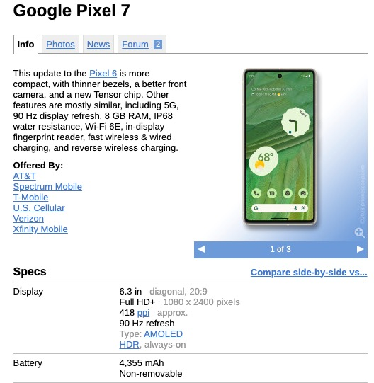Figure 1.8: Phone Scoop information about the Google Pixel 7
This allows you to identify the potential carrier of the device and access pictures of the device. In the next screenshot, you can see storage details, like 128 GB raw hardware and Not expandable storage status, indicating the amount of data a device can hold, which is vital during the data acquisition phases of an investigation. If a device comes with UFS 3.1 storage, for example, the DFE would know that the phone likely has faster data transfer speeds, which could affect how the user can quickly move data off the device.
Figure 1.9: Phone Scoop for the available storage of the Google Pixel 7
The OS version, such as Android version 13, can inform a DFE about the device's susceptibility to certain vulnerabilities or exploits known to affect that specific OS version. This information can guide you in assessing the device's security posture during an incident (as shown in the following screenshot).
Figure 1.10: Phone Scoop information about the OS of the Google Pixel 7
Details about network bands and frequencies, as shown in Figure 1.11, enable you to determine which networks the phone can operate on. This can be instrumental in determining the device's mobility and potential geographic location history. A device that supports multiple bands across various carriers indicates the phone's versatile connectivity capabilities, which can factor into understanding a subject's movement or network usage patterns.
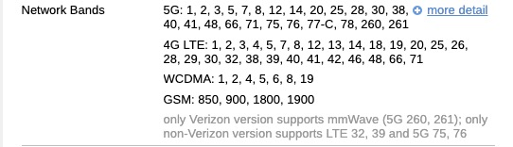Figure 1.11: Phone Scoop information about the network bands of the Google Pixel 7
The FCC IDs, as shown in Figure 1.12, provide unique identifiers for specific phone models. These can help confirm a device's legitimacy or track its import and export history. Clicking on the link will take you to the FCC website.
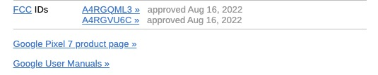Figure 1.12: Phone Scoop information about the FCC IDs of the Google Pixel 7

GSMArena
GSMArena (https://www.gsmarena.com/) is similar to Phone Scoop but focuses on GSM devices predominantly outside North America. GSMArena is also a valuable tool due to its comprehensive mobile phone specifications and features database. It also offers detailed device information, including hardware configurations, software versions, and connectivity options. The site's extensive data on phone models assists in determining device-specific attributes, which is essential for accurate data extraction and analysis in forensic scenarios.
The layout differs from what you will find on Phone Scoop. Let’s look at the differences using the Google Pixel 7 again, as shown in Figure 1.13.
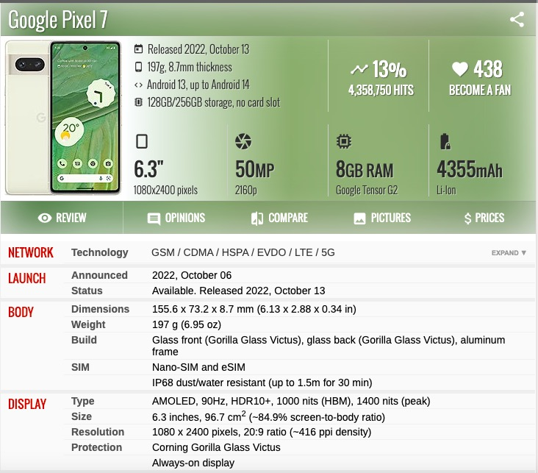Figure 1.13: GSMArena product page for the Google Pixel 7
As you can see, the presentation is different, but you still can access key aspects of the device. For example, you can access the memory details, such as internal storage capacity and RAM, which is crucial when seizing and imaging devices. Knowledge of the device's chipset, CPU, and GPU, as well as its processing power and security features, may also help you determine the necessary tools and techniques for data extraction.
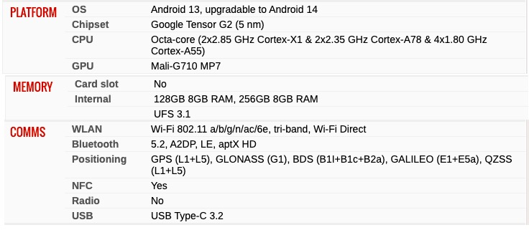Figure 1.14: GSMArena product page for the Google Pixel 7
Like in Phone Scoop, these platform details, such as the OS version, as shown in Figure 1.14, chipset type, and upgradeability, are key pieces of information. They can indicate the device's vulnerability to certain exploits or compatibility with forensic tools. In addition, battery capacity and charging capabilities might explain the device's power status during the incident.
Phone Scoop typically offers data on the North American market, including detailed phone specifications, news articles, and reviews. It also includes information about carrier availability and often provides FCC ID numbers, which are useful for regulatory information and determining whether a phone is approved.
GSMArena offers a more extensive database of phone specifications and is known for its global coverage. It includes detailed specs, photos, user reviews, news articles, and a comparison tool that compares different phone models. GSMArena also features a comprehensive guide on mobile technologies and an active forum for community discussions.
Both sites are useful as they provide detailed technical information about devices that can assist an investigation. Phone Scoop's FCC IDs can help track a device's certification and release details, which might be pertinent in an investigation. GSMArena's database may provide broader information on international models and a more comprehensive list of device features. Each site has strengths in different areas, so you might use both as resources to obtain a fuller picture of a device's capabilities or history.
Phone Scoop and GSMArena are rich information repositories, but they are just the beginning. Practical knowledge about software applications for particular devices, techniques, and processes is gained through experience. Participating in forums is an excellent way to interact with enthusiasts and pose specific questions about a device or software.

Forums

Android Developers Forum
The Android Developers forum (https://developer.android.com/) offers extensive information on the Android OS. This includes detailed Android architecture documentation, APIs, and security features. You can use this knowledge to understand how Android devices store data, manage applications, and handle user interactions. The site provides access to tools and software like the Android Emulator and SDK, which can be instrumental in simulating Android environments for forensic analysis. Understanding the OS from a developer's perspective enhances the ability to effectively extract and analyze data from Android devices.

XDA Developers
XDA Developers (https://www.xda-developers.com) is a good resource because of its comprehensive Android development and customization coverage. The site provides in-depth information on Android devices, including firmware updates, root methods, and custom ROMs. This knowledge is crucial for understanding the specific software configurations and modifications that could be present on an Android device under examination. This detailed technical information can aid in preparing for potential data extraction and analysis challenges.
Forums are great for casting a wide net and gathering insights and advice from a broad community. Think of them as a marketplace where you can exchange tips, stories, and experiences.
Moving from the wide-open spaces of forums, I have something more intimate and focused: a listserv. I have been a member of the International Association of Computer Investigative Specialists (IACIS) (https://iacis.com) for nearly twenty years. One of the best benefits for members is the IACIS listserv.
A listserv is a mailing list that manages and automates the distribution of email messages to subscribers on a list. The term "listserv" is often used generically to refer to any email-based mailing list service. Professional organizations use listservs for member communication, event announcements, and industry news.
It's like having a direct hotline to a group of professionals. I recently posted a message to the listserv about an issue I had observed with the Android version of the Whisper app. Within hours, I had responses with possible solutions, or if they didn't have a solution to my specific issue, they provided information about a similar incident and how they overcame that hurdle. Even better, I have saved almost twenty years of listserv messages to a Gmail account. I have access to those years of experience, problems, and solutions in an easily searchable format. While other organizations may have something similar, I am not sure they can compete with a listserv specifically created for law enforcement and civilian investigators.
Understanding mobile devices' features and specifications is the key to effectively researching them. This knowledge not only aids in technical analysis but also enhances the overall understanding of the technology. As the mobile landscape evolves, staying informed and adaptable is vital. Building expertise and enhancing your skill set in mobile forensics hinges on researching and gathering relevant insights before commencing the examination of a device. We now shift our focus towards the realm of mobile device identifiers.

Mobile Device Identifiers
Identifiers such as IMEI, IMSI, and serial numbers (SNs) are critical in distinguishing different mobile devices. This information can be used for tracking, evidence collection, and analysis. Understanding these identifiers not only aids in attributing the device to a specific individual but also in linking a particular device to activities of interest. Mobile device identifiers are essential for you to conduct an investigation in the ever-evolving landscape of mobile technology.
So, where do you start?
You can usually tell who made a phone by looking at the exterior. The full company name or a logo might be placed across the back. Motorola places its name across the rear panel. Samsung keeps logos subtler, tucked below the screen. Apple has the bitten fruit symbol shouting its pedigree to the world.
Identifying the mobile device carrier or network service provider is a basic skill and could be used to start another facet of the investigation. This distinction can often be blurred due to the branding and marketing strategies employed by manufacturers and network providers and the physical branding of the devices themselves.
The mobile device carrier, also known as the network service provider, is the company that provides cellular network connectivity that allows the device to make calls, send texts, and access data services. The relationship between the device and the carrier is more about service provision than the physical device itself. Much like manufacturers, carriers may also brand devices with their logos or names, often on the device's exterior or within the device's software, such as on the status bar at the top of the screen.
A common confusion arises when both the manufacturer's and the carrier's branding are present on the device. This dual branding can lead some to use vendor and carrier interchangeably. A useful tip for distinguishing between the two is to consider which entity sends the bill for network usage. This bill comes from the network service provider or the carrier, not the device manufacturer. This distinction is crucial if you send subpoenas or search warrants to the provider.
Be aware that multiple network carriers can support the same type of mobile device. This compatibility means that the same device type can operate on different networks, affecting your access to the data. This was an issue at the beginning of my career when we dealt with code-division multiple access (CDMA) and Global System for Mobile Communications (GSM) networks. We go into greater detail about network technologies in Chapter 2, Wireless Networks and Mobile Forensics.
As you saw in the preceding section, Research Tools, you can identify the network carriers that support a specific device model by using the GSMArena and Phone Scoop websites. This resource allows users to enter the mobile device and retrieve a list of common network carriers that support the given device. Looking at Figure 1.15, you can see the network providers for the Google Pixel 7.
Figure 1.15: Phone Scoop listing of network providers for Google Pixel 7
Identifying a mobile device is crucial in mobile forensics; if you have a search warrant to examine a device's content, you must be specific about the device you want to search. Using descriptive traits like color, manufacturer, seizure location, or network carrier can offer some identification, but they fall short of precisely distinguishing one device from another. A red Nokia bar-style phone or a gray Samsung Verizon flip phone could describe thousands of devices. The key to pinpointing a specific device lies in its unique identifiers.
All mobile devices have unique identifiers embedded in their hardware or displayed within the OS. These identifiers are crucial for authentication, tracking, and security purposes. However, the placement and accessibility of these identifiers can vary widely due to the absence of an industry-wide standard. Some devices might have this information readily available through a sticker or plate on the exterior, while others may only reveal it within the device's OS settings.
The most common unique identifiers found on mobile devices include the SN, IMEI, mobile equipment identifier (MEID), and electronic SN (ESN), along with its derivative, the pseudo ESN (pESN).
The SN is a unique identifier the manufacturer gives the device. Its location can be found on a sticker on the device's back or back panel or accessible through the OS settings.

International Mobile Equipment Identity (IMEI)
The IMEI can sometimes be printed within the phone's battery compartment; users can also retrieve it on their device. Users can access this vital information by dialing the MMI Supplementary Service code *#06# or navigating the device's settings menu.
The IMEI number is used to identify valid devices on the network, allowing the carrier to blacklist stolen devices from accessing the network. This action disables the phone across the network, rendering it inoperable even if the SIM card is replaced. Devices without a SIM card slot or eSIM will not have an IMEI code. Dual SIM technology introduced devices with two IMEI numbers, allowing dual-network access capability. The IMEI can also track the device within a few meters of its location.
The IMEI consists of 15 decimal digits – 14 digits followed by a single check digit – while the IMEI Software Version (IMEISV) extends to 16 decimal digits, including two additional digits to indicate the device's software version. The IMEI starts with the Type Allocation Code (TAC), an 8-digit sequence that encodes the device's model and origin. This ensures that each mobile device can be traced back to its manufacturing details.
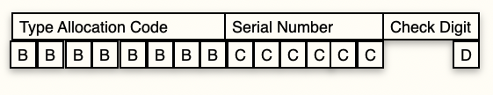Figure 1.16: IMEI format

The International Mobile Subscriber Identity (IMSI)
The IMSI is typically a 15-digit number stored on the SIM card; variations in length can occur depending on the region. The structure of an IMSI is divided, beginning with the first three digits designated as the mobile country code (MCC). This is immediately followed by the mobile network code (MNC), which can either be a 2-digit configuration (Europe) or a 3-digit format (North America). The corresponding MCC value influences the specific length of the MNC. The last portion of the IMSI is dedicated to the mobile subscription identification number (MSIN), which identifies a subscriber within a network's customer base. The MSIN is typically 9 to 10 digits, depending on the MNC's length.
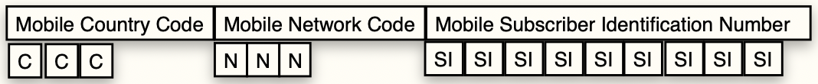Figure 1.17: IMSI format

Mobile Equipment Identifier (MEID)
MEID uniquely identifies CDMA2000 mobile devices. It is the CDMA equivalent of the IMEI number used in GSM phones but uses hexadecimal. Structurally, the MEID is crafted from 56 bits, translating to 14 hexadecimal digits. As shown in Figure 1.18, this unique identifier is split into three distinct parts: an 8-bit regional code that specifies the region of the device's origin, a 24-bit manufacturer code that identifies the maker of the device, and a 24-bit SN assigned by the manufacturer to the specific piece of equipment. The MEID does not consider the check digit as a part of its structure.
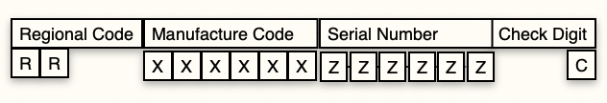Figure 1.18: MEID format
As the successor to the ESNs, which reached their issuance capacity in November 2008, the MEID emerged to accommodate the growing number of mobile devices. Although the ESN is phased out, compatibility requirements mandate that devices with a MEID generate a pESN.
This pESN uses a specific format: it starts with a manufacturer code of 0x80, followed by the least significant 24 bits of a SHA-1 hash of the MEID. This approach ensures backward compatibility with systems still requiring an ESN.
These unique identifiers are key for the precise identification of devices, evidence collection, and tracking. In Figure 1.19, you can see the output for an iPhone 12 Max Pro when entering the service code *#06#.
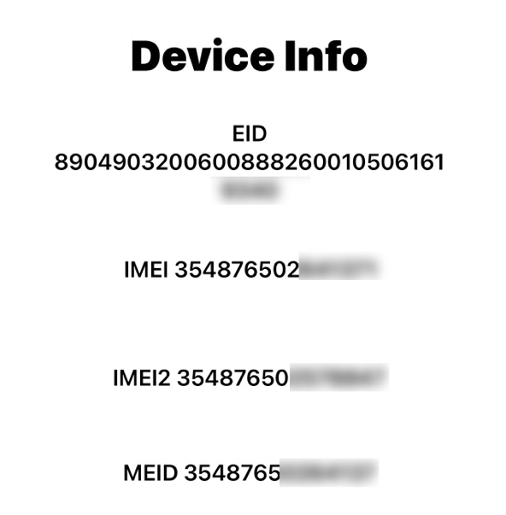Figure 1.19: Device Info screen from an iPhone 12 Pro Max
The iPhone 12 Pro Max features dual SIM capabilities, the traditional nano-SIM slot, and an embedded SIM (eSIM). Two SIM options allow the device to support two cellular plans simultaneously. As a result, the device is now assigned two IMEI numbers, IMEI1 and IMEI2, to uniquely identify each cellular connection.
The embedded SIM ID (EID) field is associated with eSIM technology. eSIM is a digital SIM that allows users to activate a cellular plan without needing a physical nano-SIM card. We will review eSIM in Chapter 2, Wireless Networks and Mobile Forensics.
Now, let’s discuss the different types of data acquisitions for mobile devices.

Data Acquisition
The acquisition of data from mobile devices represents a pivotal aspect of investigations. This process can encompass different methods to extract digital evidence from mobile devices. These techniques range from a physical acquisition, which aims to retrieve all data, including deleted files from the device's storage to a logical acquisition, which targets easily accessible files and settings. Understanding these methods is crucial, as each offers unique advantages and challenges, reflecting the intricate balance between technological advancement and forensic integrity.
As mobile devices become a bigger part of civil/criminal cases, learning how to get data from them is increasingly important for investigators. Whether you're trying to put together a timeline, figure out who owns a phone, or find messages that prove a crime, you must be able to access what's stored on the device. Getting around the different security features of different models can take creativity and a solid set of tech skills.
Investigators need to understand the methods – from manually looking at what's already open on the device to pulling data files off it and using advanced techniques to access the data. Which technique you use depends on how urgent the case is, the make and model of the device, and what tools and skills your lab has available. It's getting harder as device manufacturers add more security and encryption protections.
By matching the best acquisition method to the case and device, investigators can consistently beat those protections and get the needed evidence. Texts, call logs, app data, and more can prove a case – or clear someone falsely accused. Investigators must work harder to keep the upper hand as mobile devices evolve.
In the early days of my career in mobile forensics, the landscape was very different from today. In the early 2000s, the absence of smartphones and the presence of many different phone models presented many challenges. We often resorted to a basic method, such as positioning the device under a large magnifying glass and manually paging through each screen. When we found relevant information, we captured it the old-fashioned way – by photographing the screen with a digital camera. As you can imagine, this process was incredibly time consuming and laborious, but it is still a valid technique today.
Fast forward to the present, and the field of mobile device forensics has undergone a significant transformation. Forensic examiners can access a tool chest full of paid and open-source tools. The mobile device forensic acquisition and analysis process has evolved with sophisticated automated tools. The range of available tools is vast, each with strengths and limitations. Understanding that no single tool can cater to all forensic needs is crucial. I want to repeat this for the back row.

No single Tool can Cater to all Forensic Needs
When looking at the same make/model of a model device, the user experience may be the same, but the technological foundation beneath can vary significantly. For instance, the first iPhone 15 to come off the production line when compared to the last one manufactured. To the user, both devices appear identical in functionality and design. However, the technology powering each device beneath the surface could be vastly different.
Manufacturers often update a device's internal components or software throughout its production cycle without altering its external appearance or user interface. This practice means that the inner workings of mobile devices remain a closely guarded secret, with manufacturers releasing minimal information about the proprietary technologies used. Forensic tool vendors face the considerable challenge of reverse-engineering these devices to access and extract all relevant data in the forensic acquisition and analysis process. This is because each variation, no matter how slight, can affect the ability of forensic tools to retrieve and analyze the data, making mobile device forensics a complex and ever-evolving field. This is why you cannot rely on a single tool when examining mobile devices. You must understand the different types of mobile forensic tools, and understanding the limits of your tools is fundamental to being an effective examiner.

Mobile Device Tool Classification System
The mobile device forensic tool classification system that Sam Brothers developed for the NIST Special Publication 800-101 Revision 1 Guidelines on Mobile Device Forensics in 2014 is a valuable framework for forensic examiners (see Figure 1.20). It categorizes tools based on their examination methodology, laid out in a pyramid structure where complexity and technical sophistication increase from the bottom to the top. As you move up the pyramid, the techniques require more technical expertise and longer analysis times. Each level has pros and cons; examiners must understand these before applying any specific technique. Misuse of methods or tools, especially at higher levels of the pyramid, can lead to irreversible destruction of evidence. Therefore, adequate training is essential for effective and successful data extraction from mobile devices. This system allows each mobile forensic tool to be classified under one or more levels, providing a clear framework for understanding and selecting the appropriate tools for forensic acquisition and analysis of mobile phones.
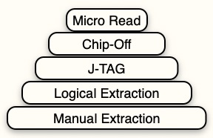Figure 1.20: Mobile device tool classification system

Manual extraction
Manual extraction, found at the bottom of the mobile device forensic tool classification pyramid, is the most rudimentary form of data acquisition (I am flashing back to the 2000s). This process entails physically navigating through a device's interface to access and document active data, such as messages, call logs, and photos. The investigator can use an external device like a digital camera to capture the screen's contents. While this approach is straightforward, it does not get deleted content and is limited to data immediately visible within the device's menus and apps.
Despite its limitations, manual extraction is a crucial step and can be used to verify more sophisticated forensic tools. By manually examining the device, investigators can confirm the accuracy of data using timestamps or other user activity records extracted through an automated method. This level of scrutiny can be pivotal, such as when the device presents physical challenges, a damaged screen or keyboard, or when the menu language is unfamiliar to the investigator.
Due to its labor-intensive nature, manual extraction is often time consuming. Although there may be more efficient approaches for comprehensive data recovery, it remains an indispensable technique, particularly with higher-level forensic tools. It can validate findings and strengthen the integrity of the investigative process.

Logical analysis
Logical analysis stands as a cornerstone technique for data extraction. This method uses inherent transfer methods within a device – USB, Wi-Fi, infrared, or Bluetooth – to establish a channel for data retrieval. Working with the device's operating protocols, the forensic software will use a series of commands that the device recognizes, responds to, and sends back data to the forensic tool. Logical analysis can access and extract a wide range of active user data while maintaining the integrity of the evidence. Less invasive than physical extraction techniques, it must continually adapt to the complexities of modern mobile devices. Using logical analysis is the most common form of extraction.

Joint Test Action Group (JTAG)
JTAG is a standardized technology that provides a way to communicate directly with the chips on a circuit board. It was originally used to test printed circuit boards during manufacturing.
For mobile device forensics, JTAG is a technique for data acquisition from locked, damaged devices or has some form of software protection that prevents traditional data extraction methods. JTAG allows forensic analysts to access the data stored in the device's memory chips directly, bypassing the need to interact with the OS.
Here's how it works:
- Physical access: The device is disassembled to access the main circuit board.
- Identifying points: The examiner locates the JTAG pins on the board, which serve as access points for data transfer. These can be specified in the device's documentation or found through schematics or manual inspection. (Remember GSMArena and Phone Scoop?)
- Connection: Once the JTAG pins are identified, they are connected to a JTAG interface box. The interface box then connects to a computer with specialized data extraction software.
- Extraction: The software sends instructions to the device's processor via the JTAG interface, allowing it to read the memory chips and extract a raw data image. This image contains all the data on the chip, including deleted files and system logs.
- Analysis: The extracted image is then analyzed using forensic tools to interpret the raw data.
JTAG extraction is non-intrusive in that it doesn't modify the device's software; it is physically intrusive since it often requires the device's disassembly. This method is also time consuming and requires a high level of expertise due to the technical knowledge needed. JTAG extraction is usually used when other methods are unavailable or have failed, making it a valuable tool in the forensic examiner's toolkit.

Chip-Off
The chip-off technique is highly invasive and can be used when traditional data extraction methods are unsuccessful. The process involves removing the physical memory chip from the mobile device to access the stored data. It can be used when devices are severely damaged or encrypted; this approach bypasses software-based extraction issues.
The examiner will disassemble the device to reach the internal components. Tools are used to desolder and remove the memory chip from the circuit board, which carries significant risks of damage to the chip and data loss. Once removed, the chip is ready for data extraction using a specialized reader to interpret and extract the raw data. The data will usually be in a raw binary format and requires forensic software for decoding and analyzing the file system.
The chip-off method is considered destructive, as the devices are now typically beyond repair. Chip-off techniques focus on data recovery rather than being able to restore the device to its original functioning state. Replacing the chip onto the source device is often impractical due to the challenges and risks involved.

Micro Read
The process involves using an electron microscope to scrutinize individual memory cells in a flash memory chip. The microscope would detect the presence or absence of electrons within each cell. The presence of electrons would signify a binary 1, while their absence would indicate a binary 0. This binary data, representing the fundamental building blocks of digital information, could then be reconstructed into a coherent data format. The practical challenges of such a method are immense. With device capacities of 1TB and growing, recreating the dataset in this method would be incredibly complex and time consuming. The sheer volume of data, combined with the intricate process of decoding and interpreting each binary bit, makes this approach impractical with current technology and understanding. While micro-reading presents a fascinating theoretical possibility, it remains beyond the scope of current standard forensic practices.
This groundwork sets the stage for the various acquisition methods used in mobile forensics, which we will discuss in Chapter 4, Mobile Forensics Acquisition Process.

Summary
This chapter dives into the world of mobile forensics. It starts by tracing the evolution of mobile devices and their growing importance as rich sources of digital evidence. You learned about data acquisition techniques for extracting that evidence and the importance of unique identifiers like IMEI and IMSI that link devices to individuals. Understanding mobile OSs, like iOS and Android, is also crucial since they determine how data is stored and accessed.
The next chapter takes your knowledge further by exploring wireless networks – the backbone of how mobile devices communicate. Analyzing wireless protocols can help pinpoint locations, track device movements, and expose the device's connections. Understanding how mobile devices interact with wireless networks is an essential tool for forensic investigators.

Questions
- True or false: Due to radio and display technology limitations, early mobile phones relied on large batteries to achieve sufficient runtimes.
- True or false: The iPhone developed the first software-based touchscreen interface on mobile devices.
- Mobile OSs Apple iOS and Google Android were designed with which ONE of the following as a priority from the beginning?
  - Customization options
  - Security features
  - User experience focus
  - Developer community feedback
- True or false: Android has allowed greater access to core OS functions than Apple.
- True or false: The IMEI identifier traces mobile devices back to details of their manufacturing origin.
- Logical data acquisition techniques for mobile devices involve the use of which of the following options?
  - JTAG
  - Infrared
  - Chip-off
  - Electron microscope
- True or false: Apple iOS security measures can complicate or restrict certain evidence extraction approaches.
- The Mobile Device Tool Classification Pyramid sorts acquisition methods according to what primary criteria?
  - Length of extraction time
  - Evidence integrity preservation
  - Complexity and skill level
  - Specificity of data recovered
- True or false: Multi-tool approaches for mobile data acquisition are always necessary, given variations that can affect forensic results.
- Which objective does chip-off data acquisition from mobile devices focus primarily on?
  - Data analysis for evidence
  - Full device functionality restoration
  - Memory chip removal and reading
  - Minimizing changes to the original phone

Answer Key
- True
- False
- C
- True
- True
- B
- True
- C
- True
- A

2 Wireless Networks and Mobile Forensics
Join our book community on Discord
https://packt.link/SecNet
Mobile devices are almost always linked to wireless networks, offering investigators a wealth of potential evidence. Whether through cellular connections, Wi-Fi, or Bluetooth, these wireless traces can often provide insights into a user's location, communications, and online activities. In this chapter, you will jump into the realm of wireless networks.
We will start by learning about the evolution of cellular networks, from 1G to 5G, and understanding how technological advancements have expanded capabilities and evidence trails. We will explore cellular network technologies, such as GSM, CDMA, and LTE.
We will then look into Wi-Fi and Bluetooth protocols, learning how they function and how to extract valuable evidence from them. Pinpointing access points, establishing connections, and recovering communications can be critical in investigations.
We will look at the critical role of Subscriber Identity Modules (SIMs) in mobile devices, focusing on their forensic value. SIM cards serve as a secure authentication method for cellular networks. We will discuss their data storage capabilities, which may contain contacts and text messages.
Let’s look at the following case study.
The Importance of Wireless Network Evidence
The Case
A prominent software development company discovered striking similarities between a new product recently launched by a competitor and a key internal project that had been in the works for years. Suspecting foul play, they initiated a lawsuit against the competitor, alleging the theft of valuable intellectual property. A key piece of suspicion revolved around a former employee, who had departed abruptly to join the competitor shortly before the rival product's release.
Wireless Networks as Evidence
While direct proof of IP theft remained elusive, forensic investigators focused on the former employee's company-issued mobile device. Examining wireless network logs provided a breakthrough:
- Unusual Home Network Activity: Records showed a spike in data uploads from the employee's device to their home Wi-Fi network during late hours, well outside of normal working patterns. This activity occurred in the weeks leading up to their resignation.
- Suspicious Cloud Storage Traces: Analysis revealed connections to a personal cloud storage service accessed by a user on the rival company's network. Network activity timestamps coincided with the upload patterns observed on the home Wi-Fi.
The Outcome
Although it did not definitively prove what specific files were transferred, the wireless network evidence established a suspicious pattern of behavior. It demonstrated unauthorized data movement outside of company systems and linked it to a likely storage destination used by the competitor. When presented with this evidence during the legal proceedings, the competitor agreed to a significant settlement, acknowledging the likelihood of wrongdoing and avoiding a protracted court battle.
Key Takeaways:
- Data Exfiltration: Unusual upload patterns on networks outside of company control can flag potential theft of company assets.
- Connection Points: Establishing links to networks or services associated with competitors can raise investigative red flags.
- Behavioral Indicators: Network activity at unusual hours or outside expected behavior patterns can warrant closer scrutiny.
Wireless network evidence is a cornerstone of mobile forensic investigations. By tracing network activity, investigators can:
- Establish location: Cellular records and Wi-Fi access point logs can help approximate a device's physical location over time.
- Uncover communications: Network logs might reveal connections with other devices or communication trails, via messaging apps that rely on Wi-Fi.
- Understand user behavior: Network history can unveil behavior patterns, visited websites, and online activities.
By the end of this chapter, you will understand how wireless networks interact with mobile devices, along with the techniques to collect and analyze crucial wireless network-related evidence for your mobile forensic investigations.

Cellular Network Technologies

What Is a Cellular Network?
Cellular networks are radio networks designed to provide coverage over expansive areas. They achieve this by dividing the land into smaller "cells," each containing a fixed-location transceiver known as a base station or cell tower. Each base station has several radios operating on different frequencies, providing the foundation for mobile voice and data connectivity. When these cells are linked, they create a blanket of radio coverage. This allows mobile phones, tablets, laptops with cellular modems, and other devices to communicate across the network. Network protocols allow seamless handoff of connections between towers to maintain uninterrupted service, even when moving. An advantage of this multi-cell system is that it avoids overwhelming a single transmitter, increasing the number of devices that can connect simultaneously.
Mobile devices benefit from lower power requirements when communicating with nearby cell towers, leading to extended battery life. Unlike traditional broadcast towers, cellular networks are easily scalable; network engineers can expand coverage by adding more towers without significant technical hurdles. Cellular network design also allows providers to utilize higher frequency signals within smaller areas, providing access to more available bandwidth and enabling faster data speeds.
As shown in Figure 2.1, you can see an illustration of a hexagonal grip map of cell sites. Each hexagon represents a specific area covered by a cell tower, indicated by a dot at the center of each hexagon. The grid displays various types of terrain, which might affect the coverage and performance of the cell sites. The uniform distribution of cell towers within the grid ensures that each hexagon, or cell, is adequately covered, facilitating continuous communication across the map. This pattern allows your mobile phone to switch seamlessly between cells while moving, maintaining a stable connection without interference from neighboring cells.
Figure 2.1: A hexagonal grid map depicting the distribution of cell towers across various terrains

The Impact on Mobile Forensics
The widespread prevalence of cellular networks dictates how society uses mobile devices. This creates trails of digital evidence that investigators can then use to create a picture of usage, emerging as devices connect to cellular towers or Wi-Fi networks linked back to those towers. Investigators can analyze cell tower records to approximate a device's location over time, uncover communications made via traditional calls and cellular data, and even track connections made by "smart" devices that have become commonplace in daily life. The frequently cited idea of "three cell sites/base stations" for triangulation is an oversimplification; modern cellular networks strategically use multiple overlapping cells for efficient coverage and seamless handoffs. While most people think of large telecommunication providers when envisioning a cellular network, smaller private networks also exist with a more limited scope and functionality, such as those used on company campuses or to manage emergency responder communications.

Cellular Network Origins
The origins of mobile communication began in the 1970s with 1G, the first analog cellular system focused solely on voice calls. Bulky handsets and limited mobility hampered early commercial networks. A decade later, 2G Global System for Mobile Communications (GSM) unlocked digital voice and Short Message Service (SMS) text messaging through improved radio interface standards. Instant popularity led to incremental 2.5G upgrades, like General Packet Radio Service (GPRS) and Enhanced Data Rates for GSM Evolution (EDGE) protocols, which boosted data speeds for limited internet access.
GSM represents the original 2G digital cellular standard developed by the European Telecommunications Standards Institute (ETSI). First commercially deployed by Radiolinja in Finland in 1991, GSM introduced mobile digital voice calls and text messaging across Europe and beyond.
GSM networks utilize varying cell tower sizes, depending on coverage needs. Channel access relies on Time Division Multiple Access (TDMA) schemes, regardless of deployed bands. TDMA divides each radio frame of approximately 4.615 milliseconds into 8 discrete time slots per frequency channel. Each channel maintains a throughput rate of around 270.8 kilobits per second. Cells dynamically allocate slots to users as needed upon network registration to avoid collisions.
The standardization of TDMA for channelized access, coupled with cell tower infrastructure buildouts, enabled the first large-scale mobile phone deployments. GSM lowered barriers across Europe, aligning frequency bands and roaming agreements, transforming mobile communication from a luxury to an everyday utility through affordable cellular connectivity. The open ecosystem model contributed enormously to global adoption rates in the 1990s, even as newer standards continued to push boundaries.
3G emerged in the early 2000s with vastly expanded data rates, enabling multimedia streaming, video calling, and mobile web browsing over Universal Mobile Telecommunications System (UMTS)/High-Speed Packet Access (HSPA) protocols. UMTS represents a 3G cellular standard that evolved from and improved upon the original 2G GSM networks. While GSM relies on TDMA for channelization, UMTS utilizes a Wideband Code Division Multiple Access (W-CDMA) transmission scheme. W-CDMA uses wider 5 MHz radio channels and spread spectrum processing gain for improved multi-path resilience and traffic capacity.
First launched commercially in 2001 by operators in Japan, UMTS offers theoretical peak rates that reach up to 42 Mbps downlink speeds per channel. Users typically experience modest throughput due to real-world constraints. The UMTS Terrestrial Radio Access Network (UTRAN) refers to infrastructure carrying data traffic between cell towers and core switching centers.
For security, UMTS specifies mutual authentication, encryption standards, and integrity checking, based on session keys negotiated between a user's Universal Subscriber Identity Module (USIM) card and the Authentication Center (AuC) within provider networks. Unique pre-shared keys and algorithms generate session cipher and integrity keys for user and message authentication. This protects the confidentiality and authenticity of 3G voice and data communication.
While GSM laid 2G foundations for the first generation of mass-market consumer cellular connectivity, UMTS strengthened protections and increased theoretical throughput rates. Practical speeds remained limited until HSPA and HSPA+ enhancements to the broader UMTS ecosystem.
Long-Term Evolution (LTE) represents the standard for high-speed 4G mobile data and network connectivity, reaching theoretically 1 Gigabits per second (Gbps) peak rates. Evolved from the mobile broadband foundations of 3G, enhancements in LTE security address user identity confidentiality, data integrity checking, and backhaul network protection mechanisms. Formal 4G requirements were fully achieved in LTE Advanced (LTE-A). Standardization was completed in 2010 to facilitate a smooth transition beyond early LTE networks. LTE propelled a mobile-first lifestyle across developed countries.
5G represents the latest fifth-generation cellular network communication standard, building on the capabilities of previous generations from 1G to 4G. Beginning commercial deployment in 2019, 5G delivers exponentially faster peak data speeds, enormous connection density, and reduced latency. The following figure, created by university professor Michel Bakni, shows a timeline for the network standards and generations.
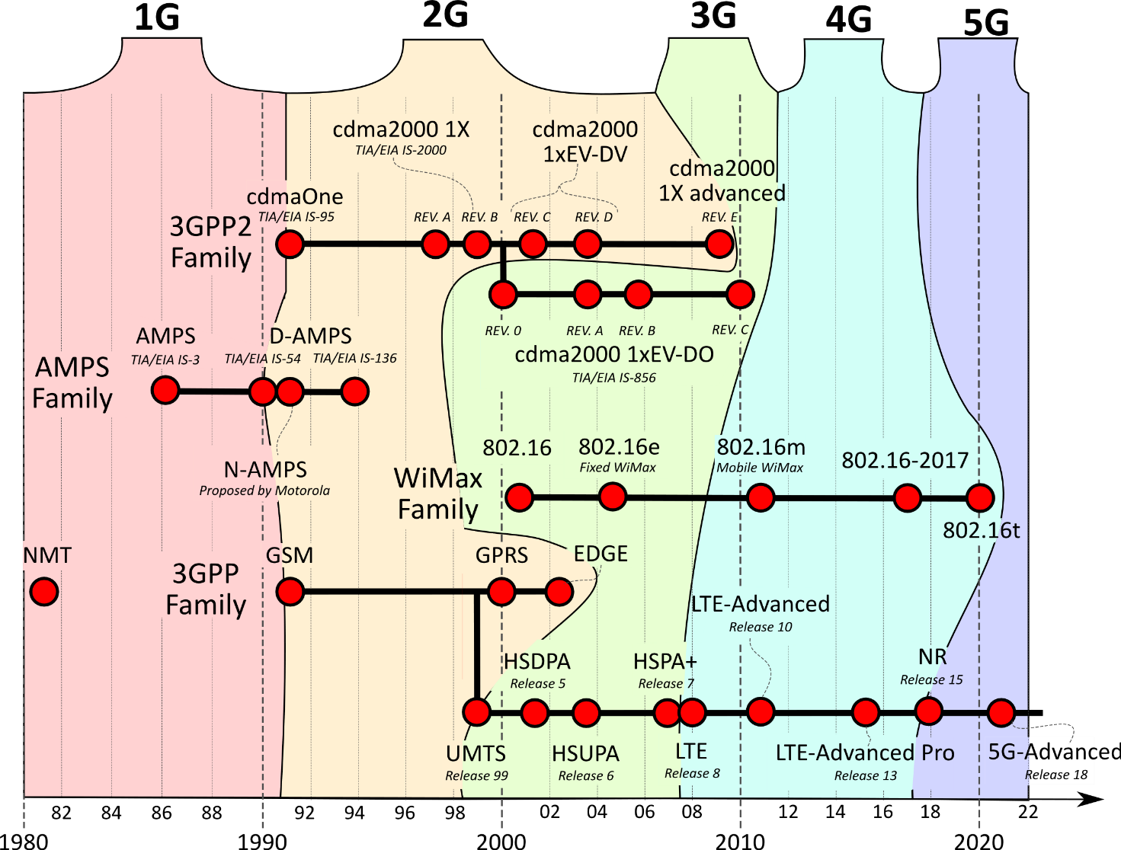Figure 2.2: Cellular network standards and generation timeline
Like existing mobile networks, 5G divides coverage regions into small cell areas, where devices connect to nearby towers using radio waves within designated frequency bands. Improvements allow 5G networks to achieve theoretical peak download rates of up to 10 Gbps under ideal conditions. Real-world speeds will depend on traffic load.
Increased data rates, seamless mobility, and low communication delays unlocked new mobile device use that was impossible in prior cellular generations. 5G could now serve as an alternative broadband delivery vector for consumers while creating an era of hyperconnectivity.
5G promises exponential capacity growth beyond consumers to connect smart cities, autonomous vehicles, and industrial Internet of Things (IoT) devices with sub-1 ms latency and speed measured in Gbps. It may bring us closer than ever to the possibilities of a truly wireless world.
Each generational shift demanded expanded infrastructure across radio access networks, core architectures, and device components. Companies invested billions in engineering higher frequencies, densified small cell networks, advanced antenna capabilities, and new Orthogonal Frequency-Division Multiplexing (OFDM) modulation schemes to reach ambitious throughput targets.
The mobile landscape evolved remarkably from crude analog beginnings, dependent on pedestrian movement, to streaming Ultra-High Definition (HD) content at near-fiber speeds on sophisticated edge devices today. Pushing boundaries to increase coverage, lower latency, and embed mobility into daily tasks will continue to unfold mobile possibilities.
Now, let's shift our focus to Wi-Fi networks and explore their role in the wireless ecosystem.

Wi-Fi Networks
Wi-Fi is a wireless networking technology that is fundamental to our digital lives. It allows various devices like computers, smartphones, and tablets to connect to the internet and each other without needing a physical connection. Radio waves transmit and receive data, offering remarkable convenience and mobility to the user. The Wi-Fi Alliance is the organization that owns the Wi-Fi trademark, and they are responsible for ensuring that compatible devices adhere to specific Wi-Fi standards, known as the 802.11 standards.
At the core of Wi-Fi networks are wireless access points or routers. These devices take a wired internet connection and broadcast it as Wi-Fi radio signals. Devices have built-in Wi-Fi adapters that listen for these signals and then communicate back to the router. Wi-Fi primarily uses 2.4 GHz and 5 GHz radio bands. The 5 GHz band is generally faster but has slightly less range than 2.4 GHz, while the 2.4 GHz band can easily penetrate obstacles like walls. Wi-Fi has revolutionized home networks and public spaces and powers the IoT, enabling connections between devices like smart lights and thermostats. This flexibility and wireless freedom are why Wi-Fi has become ever-present in society.
Wi-Fi networks hold a treasure trove of potential evidence for investigators. Devices maintain a history of past Wi-Fi networks, acting as digital footprints that indicate places a suspect might have been. Unlike pinpoint GPS coordinates, Wi-Fi alone generally gives investigators a zone of probability rather than a precise location. Correlating this Wi-Fi evidence with other information sources, such as cellular tower records or surveillance footage, is crucial for getting a clear picture of a device's whereabouts. Challenges arise when networks are password-protected, and investigators need proper authorization to access router logs. These logs may only be available for a short time, creating possible inconsistencies in evidence trails.
The explosion of connected devices with the IoT creates opportunities and challenges for investigations. From smart thermostats to fitness trackers, these devices collect copious amounts of data, recording usage patterns and preferences. They may even store videos and images. This dataset helps reveal the routines, connections, and lifestyles of the investigation subjects. IoT devices can also present serious security risks. If left unsecured, they become vulnerable points for unauthorized access or are used to facilitate attacks on a network.
When comparing Wi-Fi and cellular networks while trying to track a device's location in areas with many Wi-Fi access points, investigators can sometimes narrow down a device's location more precisely than using cell tower data alone. Cellular records can help investigators establish broader movement patterns, but Wi-Fi data can bring specific places into focus. The most comprehensive suspect activity map often emerges by combining insights from both network types.
A key difference between Wi-Fi and cellular technology lies in network ownership. Unlike telecommunication carriers that hold large amounts of subscriber data, Wi-Fi networks can be operated by businesses and individuals. This can lead to the issuance of search warrants or subpoenas for data. This data can be stored on a specific device, local router, or cloud. Additionally, investigators can sometimes gain helpful information through cooperation with the Wi-Fi network owner, although warrants and legal compliance remain crucial.
Wi-Fi and cellular technologies' update cycles add another layer of complexity. Investigators must continuously learn and adapt their methodologies to handle the latest standards and protocols while understanding the limitations and opportunities they present.

Wi-Fi Positioning Systems
Wi-Fi Positioning Systems (WPSes) are a valuable alternative to GPS when traditional satellite-based navigation doesn't suffice. Getting a solid GPS fix in dense urban environments where buildings create signal interference, inside structures where GPS penetration is weak, or when quick location determination is vital can be challenging. WPS addresses these scenarios by harnessing the widespread distribution of Wi-Fi access points (hotspots). With comprehensive databases mapping access points to known locations, WPS enables relatively accurate device positioning through signal strength analysis and other techniques.
Assisted GPS (A-GPS), used heavily in smartphones, benefits from WPS, providing an initial quick location estimate and helping the phone determine which GPS satellites are within reception range. In cities overflowing with Wi-Fi signals, WPS becomes a powerful method to offer users location-based navigation options, even with a lacking or spotty GPS service. For indoor use, WPS stands out – whether in museums, warehouses, or large retail stores, these systems empower real-time navigation, asset tracking, and location-specific experiences in spaces that GPS typically cannot service.
WPS functions revolve around a few core concepts. Signal strength, known as the Received Signal Strength Indicator (RSSI), offers one method for location determination. Devices measure how strong Wi-Fi signals are from multiple access points and generally associate a stronger signal with being closer to the source. It's essential to remember that these readings can fluctuate, due to obstacles, device orientation, and other types of interference. Fingerprinting involves a different approach, creating a map where certain locations possess a pattern of unique Wi-Fi signals, akin to landmarks. Proper access point identification through their Service Set Identifier (SSIDs) and unique MAC addresses is important for distinguishing various points in a database, guaranteeing accurate matching.
A Media Access Control (MAC) address is a unique identifier that the manufacturer assigns to a device's network interface controller (NIC). MAC addresses typically contain 48 bits and are displayed in hexadecimal format, with groups of two characters separated by either dashes or colons (for example, 00:1B:44:11:3A: B7). Manufacturers carefully coordinate during production to ensure that every NIC they create receives a globally unique MAC address.
Wi-Fi networks rely on MAC addresses to locate clients and facilitate the direct transmission of data packets. MAC addresses can track a device's physical location; network administrators can use "MAC filters" to dictate which devices have permission to join a network or are blocked outright.
iOS 14 and Android 10 have started to use Wi-Fi MAC address randomization, providing each Wi-Fi hotspot with a different Mac address.
Accuracy and reliability in WPS depend greatly on its context. Locations boasting numerous Wi-Fi networks usually see more accurate WPS results, due to more comprehensive data and unique "Wi-Fi signal landscapes." Understandably, rural areas may see less impressive WPS performance. It's important to recognize that signal fluctuations can easily mislead WPS location calculations.
WPS providers often combine tactics beyond a pure focus on high-precision accuracy. Utilizing geographic filtering by incorporating postal code-level knowledge can help guide the positioning calculation. It's also common to include temporal elements, analyzing signal patterns over time to compensate for individual anomalies and help create a more robust understanding of a device's probable location within a defined timeframe.
Techniques used in WPS systems include:
- Triangulation (which requires signal strength information from at least three known access points to estimate location).
- Trilateration (which improves upon triangulation by relying on time-of-flight measures for greater precision).
- Probabilistic methods, which involve statistical models and data mining approaches that consider history and other contextual factors.
WPS evolves rapidly, driven by the expansion of Wi-Fi networks and indoor connectivity initiatives. With database sophistication, increased Wi-Fi density, and more refined processing techniques, the role of Wi-Fi positioning is bound to become ever more prevalent both indoors and outdoors.

The IEEE 802.11 Standard: The Backbone of Wireless Networking
The world of Wi-Fi networking runs on the IEEE 802.11 standard. Let's explore the progression of this standard.

Building the Wireless Landscape
- 802.11a: While 802.11a arrived at the same time as 802.11b, its reliance on the 5 GHz band promises less interference from other devices. Its speed gains came at the price of a significantly decreased range, hindering its wide acceptance.
- 802.11b: 802.11b enjoyed rapid and extensive market success. This success came primarily at the cost of potential interference from other common consumer electronics devices.
- 802.11g: Attempting to combine the 802.11a speed advancements with the 802.11b range and compatibility, 802.11g delivered on those promises but brought no breakthrough changes. Its main weakness – interference on the widely occupied 2.4 GHz band – remained as technology evolved.

MIMO Revolutionizes Wi-Fi
- 802.11n: MIMO (Multiple Input Multiple Output) uses multiple antennas that transmit distinct data streams within the same channel, dramatically increasing throughput capacity and network reach. Operating in the 2.4 or 5 GHz band was an invaluable flexibility boost. With the increased data complexity, channel allocation became critical to avoid network conflicts.
- 802.11n 2009: Consolidating Progress
- 802.11n concentrated on refinement. Higher speeds remained attainable through expanded streams, leading to the foundation on which subsequent innovations would continue to be built.

802.11ax and Its Companions
The journey into the 802.11ax family highlights a shift in priorities:
- 802.11-2012, 802.11ac, 802.11ad, and 802.11af: This era marked an explosion of experimentation. We saw 802.11ac targeting increasingly crowded networks by pushing multi-gigabit speeds. 802.11ad, although focused on short-distance connections, shattered previous expectations by leveraging the less-populated 60 GHz band. Additionally, 802.11af explored unused TV spectrum (whitespace) for niche long-distance coverage.
- 802.11-2016, 802.11aj, 802.11ay, and 802.11ax (Wi-Fi 6): The 802.11-2016 revision was a foundation for consolidation. Alongside regional-specific 802.11aj developments, 802.11ax (Wi-Fi 6) took center stage. Aiming at dense, diverse networks rather than maximum speed, it exemplifies advanced optimization rather than solely pushing technological limits.
- 802.11ay (Future Standard): 802.11ay is envisioned as an enhanced expansion of 802.11ad, targeting higher sustained speeds and an increased effective range within the 60 GHz band.
An understanding of the ever-evolving 802.11 standards can't be overlooked for mobile forensic experts. Knowledge of past technology remains useful to extract and analyze information from older devices. Staying up to date on current and emergent 802.11 capabilities directly affects potential methods for data exfiltration or surveillance employed by perpetrators – and those very same techniques help an investigator unveil digital footprints that are often vital for piecing together evidence and reconstructing a suspect's activity.
Now, let's move on to discussing Bluetooth technology and its significance in wireless communication.

Bluetooth: A Brief History
Bluetooth technology has its roots in the late 1980s when Nils Rydbeck, CTO at Ericsson Mobile, began investigating short-link wireless connectivity options. The goal was to develop a way to eliminate the tangle of wires associated with headsets. By 1994, a project under the codename "Bluetooth" (a tribute to Danish King Harald Bluetooth, who united Scandinavian tribes) came to fruition. The Bluetooth Special Interest Group (SIG) was founded in 1998 by IBM, Intel, Ericsson, Nokia, and Toshiba to standardize and oversee the technology's development. The first Bluetooth device accessible to consumers appeared in 1999 – a hands-free mobile headset. Bluetooth 1.0, while groundbreaking, faced interoperability issues and suffered from slow speeds. Ongoing iterations saw those problems largely resolved, and in 2000, Bluetooth was embedded into millions of devices worldwide.

Bluetooth: Under the Hood
Bluetooth is a wireless radio communication protocol operating within the unlicensed 2.4 GHz ISM (Industrial, Scientific, and Medical) band. Devices using Bluetooth establish short-range, ad-hoc networks known as "piconets." A piconet is where a primary device can manage up to seven active secondary devices. Bluetooth devices find each other using an inquiry process. A discoverable device repeatedly broadcasts inquiry packets, and another device performing a scan listens for such signals. Bluetooth devices jump between 79 channels through frequency hopping techniques to minimize interference risks. Bluetooth has evolved through numerous versions, improving speed, security, range, and power efficiency.

Bluetooth Versions

The Foundation: Bluetooth 1.x
- Bluetooth 1.0 and 1.0B: Introduced in 1999 and 2000, these initial versions laid the groundwork for Bluetooth technology. Data rates maxed out at 721 Kbps, and they proved functionally unstable. Issues like device discovery problems and inconsistent manufacturer interoperability plagued these early iterations.
- Bluetooth 1.1 (2001): This update tackled many flaws of 1.0. It introduced received signal strength indication (RSSI) to help gauge connection quality and addressed various bug fixes for improved stability.
- Bluetooth 1.2 (2003): A significant step, 1.2 brought faster connection times and discovery. The introduction of Adaptive Frequency-Hopping Spread Spectrum (AFH) technology helped mitigate interference in the crowded 2.4 GHz band. The enhanced data rate (EDR) also brought the potential for speeds of up to 3 Mbps, although real-world rates were often lower.

Bluetooth 2.x: The Rise of EDR
- Bluetooth 2.0 + EDR (2004): While not fundamentally changing the core specifications, this release cemented the significance of the EDR. This was the key selling point, enabling higher bandwidth applications like music streaming. Actual data rates still often remained below the theoretical maximum, due to practical limitations.
- Bluetooth 2.1 + EDR (2007): Further refinements focused on simplifying the pairing process and boosting security. Secure Simple Pairing (SSP) was introduced to make connecting devices easier for users while enhancing protection against man-in-the-middle attacks.

Bluetooth 3.0 + HS: High Speed Arrives
- Bluetooth 3.0 + HS (2009): A major leap, version 3.0 adopted the 802.11 (Wi-Fi) protocol for high-speed file transfers. Theoretical speeds reached up to 24 Mbps, though actual Bluetooth data exchange still occurred at classic Bluetooth rates. The "HS" part was primarily intended for rapid bulk transfers when a Wi-Fi link was established.

Bluetooth 4.x: The Low Energy Revolution
- Bluetooth 4.0 (2010): This version introduced Bluetooth Low Energy (BLE) or Bluetooth Smart, designed for small, power-conscious devices like fitness trackers, beacons, and wearables. BLE functions differently from Classic Bluetooth, emphasizing short bursts of data and long sleep periods for remarkable power efficiency.
- Bluetooth 4.1 (2013): Improvements focused on coexistence with LTE cellular networks to minimize interference. It also enabled devices to act simultaneously as BLE peripherals and hubs.
- Bluetooth 4.2 (2014): Privacy got a boost, as devices could better control what data is exposed during connections. IP connectivity support allowed BLE devices to access the internet directly. Speed and packet capacity also increased.

Bluetooth 5.x: Range, Speed, and Broadcasting
- Bluetooth 5.0 (2016): Version 5.0 doubled the theoretical speed of BLE (to 2 Mbps), quadrupled the range (up to 800 feet), and introduced substantial improvements to broadcasting capabilities. These enhancements enabled better location-based services, beacons, and mesh networking potential.
- Bluetooth 5.1 (2019): Direction-finding was refined, enabling devices to pinpoint the direction of a Bluetooth signal with centimeter-level accuracy, benefiting use cases like real-time indoor location tracking.
- Bluetooth 5.2 (2020): Support for the new LE Audio Codec (LC3) was added, promising higher quality audio even at lower bitrates and improving power efficiency. Isochronous channels enable audio streaming to multiple devices simultaneously, which is useful for true wireless earbud setups.
- Bluetooth 5.3, released in July 2021: Enhancements focused on power efficiency, connection optimization, and improved security. It introduced connection subrating (for dynamic data rate adjustments), finer control over periodic advertisement intervals, channel classification improvements for better coexistence in crowded radio environments, and upgrades to encryption key size enforcement.
- Bluetooth 5.4, released in February 2023: New features included Periodic Advertising with Responses (PAwR), offering bidirectional communication in previously connectionless scenarios. Encrypted Advertising Data ensures increased security for broadcast information. BLE Generic Attribute Profile (GATT) Security Levels allow distinct security configurations within a device's services, providing more granular customization. Advertising Coding Selection makes it easier to tailor transmission methods for either robustness or range.

The Future and Beyond
Bluetooth continues to evolve rapidly. Ongoing refinements to security, new features within BLE, and mesh networking expansion remain areas of active development. While challenges like the potential for interference persist, the enduring ubiquity of Bluetooth ensures advancements will continue to push the technology further in the realms of connectivity, convenience, and smart device integration.
For mobile forensic investigators, Bluetooth offers a rich tapestry of potential evidence. Since countless modern devices use the technology, understanding its usage patterns and associated artifacts provides valuable information. Mobile phones store detailed Bluetooth pairing histories, allowing investigators to retrace a user's interaction with other devices. This can include connections to wireless speakers, car audio systems, fitness trackers, or other smartphones. Each pairing record often possesses timestamps, device names, and unique Bluetooth MAC addresses. This data can assist in building a timeline of movements and associations. Repeated connections to a Bluetooth device associated with a vehicle can indicate that the device traveled within that vehicle.
Beyond pairings, Bluetooth-related data within system logs or databases sometimes yields additional leads. Some devices keep logs of connection times, durations, and data transfer quantities. When pieced together, this information paints a more complete picture of the device's activities. Depending on the device type, it may be possible to determine if files were shared over Bluetooth, which is relevant in cases involving the distribution of illicit material.
Shifting our focus, let's examine Ultra-Wideband technology and its applications in modern wireless communication.

Ultra-Wideband: The Future of Precision Wireless
Ultra-Wideband (UWB) technology represents a significant advancement in wireless communication, offering a unique combination of high bandwidth, low power consumption, and the ability to accurately determine spatial and temporal information. Originating from military and radar technologies, UWB has found its way into consumer electronics, industrial applications, personal tracking, and IoT devices.
Unlike traditional wireless technologies that operate on narrowband, UWB spreads its signals over a wide range of frequencies, typically exceeding 500 MHz. At the heart of UWB lies the transmission of very short radio pulses. These short pulses spread their energy across the radio spectrum, leading to its ultra-wideband designation. This makes UWB signals very noise-resistant, allowing them to coexist with other wireless technologies without causing interference. The short pulse duration also results in superb time resolution, which is the key ingredient for UWB's hallmark feature – location and tracking accuracy. UWB's accuracy doesn't just stop at location—it can also sense relative movement precisely.
UWB technology excels in precise positioning and tracking applications because it can accurately measure a signal's time of flight (ToF). ToF measurement is the time it takes for a radio wave to travel from a transmitter to a receiver, which is used to calculate the distance between the two. This capability is enhanced in UWB because its wide bandwidth enables the transmission of very short pulses. These short pulses are easily distinguished from reflections and other environmental noise, allowing for accurate positioning even in cluttered or multipath environments. This makes UWB particularly well-suited for applications such as indoor navigation, asset tracking, and smart home systems, where precise location information is paramount.
UWB's power extends beyond just precision. Because the energy of a UWB signal is spread broadly, it operates at extremely low power levels. This low power consumption makes for long battery life in UWB devices. The ability of UWB to "see" through walls and other obstacles is another advantage, making it valuable in various situations where line-of-sight cannot be guaranteed.
Using UWB with smartphones and smart tags allows users to pinpoint the location of lost items with unprecedented accuracy. Imagine being able to locate your misplaced keys not just within your house but within the specific room, or even the couch they may have slipped under. UWB enables truly hands-free access control; your smartphone can seamlessly unlock your car or your front door as you approach it, without you having to fumble in your pocket for a key.
UWB also has the potential to redefine the world of indoor navigation. In settings where GPS signals fail to penetrate, such as large malls, airports, or underground facilities, UWB can create highly accurate indoor maps and guide users to their desired destinations with turn-by-turn precision. This technology could open up opportunities for highly customized marketing and targeted customer experiences in retail environments.
The automotive industry is also a sector that may see UWB transformation. As mentioned, keyless entry systems powered by UWB are more secure than their predecessors, relying on precise distance measurements and directional capabilities to thwart potential relay attacks. UWB radar inside vehicles may enable enhanced safety features, such as child presence detection and advanced driver assistance systems that can "see" through fog or heavy rain.
UWB offers precision in close proximity, while Bluetooth provides the widespread network needed to locate devices at much greater distances.
While the advantages of UWB are significant, the technology is still in its relative infancy. As UWB gains traction, we'll likely witness rapid innovation and the development of even more creative applications that use its potential. UWB represents a significant leap forward in wireless communication. Its unique combination of high precision, low power consumption, robust interference resistance, and spatial awareness sets it apart from traditional technologies and positions it to enable transformative solutions across domains. The next few years will undoubtedly see UWB-powered innovations as this technology unlocks new frontiers in location tracking, smart home experiences, and industrial automation.

Wireless Security Considerations

Find My
Apple's U1 chip is an example of UWB used in the consumer world. It uses multiple antennas to determine the direction of the signal, establishing spatial awareness. One example of the U1's use is enhanced AirDrop. When both devices have the U1 chip, AirDrop can display the direction of another compatible device. Point your iPhone at the user you want to share with and their device gets priority. AirTags also use the U1 chip by providing precise directions (think of it like a high-tech game of "hot and cold") to lead you straight to your lost item.
Apple's Find My network uses UWB technology and Bluetooth to locate lost devices. UWB plays a role in short-range precision tracking. When you're close to the AirTag, the U1 chip inside allows your iPhone to provide accurate location information – including distance and direction – pinpointing its location.
Find My network's reach extends beyond short-range tracking. This is where Bluetooth comes into play. The vast network of Apple devices (iPhones, iPads, Macs, etc.) worldwide is a crowdsourced mesh network. If a lost device comes within Bluetooth range of any Apple device with Find My enabled, it can anonymously and securely relay its approximate location back to the owner. This Bluetooth network significantly expands the potential of finding lost items even when they're far away.
Josh Hickman (https://thebinaryhick.blog/) has done some research in his articles “Apple’s Find My & iCloud’s Throne of Lies” and “iOS 15 Powered-Off Tracking & Remote Bombs”. Josh uncovered some interesting findings:
- Before 2019, the Find My app could only locate devices with an active internet connection over cell or Wi-Fi.
- With the release of iOS 13 and macOS Catalina, Bluetooth was added to the connections to track Apple devices. Bluetooth tracking could be used when Wi-Fi and cellular settings were disabled.
- Airplane disables Wi-Fi and cellular settings, not Bluetooth.
- iCloud or the Find My app can be used to track a device (when the user has enrolled in the Find My network, the default is opt-in)
- Using the web browser to access icloud.com and using the Find My function did not show the current device location.
- Using the Find My app on another device with the same user account did show the correct location.
- Devices using the U1 chip can be tracked when they are powered off.
- Devices cannot be remotely wiped unless powered on and connected via cellular or Wi-Fi to the network.
- If a device is not contained within a Faraday container, then you will encounter some operational security issues where the owner of the seized device can track its location. This will also apply to anyone with whom the owner has shared their location via the app.
In Figure 2.3, you can see how the Find My application in macOS shows the devices it is tracking. You can see my iPhone and devices, as well as the devices linked to my wife’s account but shared with me.
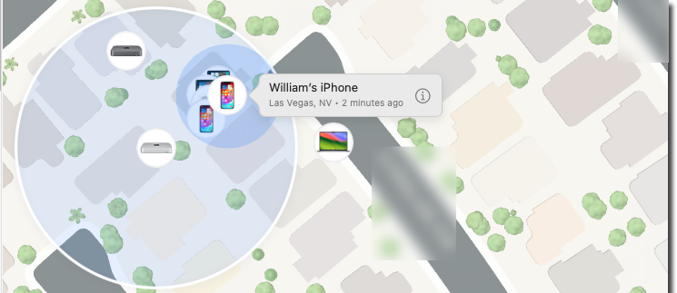Figure 2.3 – Device view for the Find My application
After the safety of the examiner, the foremost rule when handling a device suspected of holding valuable Bluetooth evidence is evidence preservation. The device should be placed in a Faraday bag or container to isolate it from external wireless signals that might overwrite potentially important data. Documenting the scene environment is crucial – noting other Bluetooth-enabled devices nearby helps set the scene and may give the examiner additional clues about the context of the device seizure. Investigators should avoid powering on and interacting with the device whenever possible.
Let’s now move on to the topic of SIM cards and their importance in enabling mobile connectivity.

SIM Cards
The SIM card is a small yet significant component within mobile devices and can have value for forensic investigators. Understanding this tiny device's functions is key to unlocking its potential as an evidence source.
A SIM card is a removable smart card with a built-in integrated circuit. This circuit securely stores the crucial information and cryptographic keys that a mobile device needs to authenticate with its cellular network. It is the gatekeeper that allows your phone to connect to the carrier's voice and data services.
Initially designed for GSM and iDEN networks, SIM cards have become ubiquitous in the mobile world. Their fundamental role—to securely authenticate a device to its carrier—has remained constant even as different cellular technologies have emerged. Interestingly, CDMA networks, such as those of Verizon and Sprint, adopted SIM cards specifically to enable access to faster 4G LTE speeds, demonstrating the SIM's adaptability.
SIM cards exist for several vital reasons. The IMSI (International Mobile Subscriber Identity) is the unique identifier housed on the SIM that ties your phone to your cellular account. This is used to bill and track usage and enables the carrier to provide services. SIM cards contain the secrets that facilitate secure communication with cellular networks for authentication. This process verifies that your device can receive service while preventing unauthorized access. The portability of SIM cards offers flexibility. You can easily move your phone number and service to a compatible device, crucial for upgrading phones or using local SIMs for international travel. SIM cards can store limited user data, such as contacts, sometimes text messages, or even bits of call history. The practice of directly storing call logs and SMS messages on the SIM card itself was more prevalent in older devices. It is much less common today.
SIM cards incorporate security features to counteract misuse. For instance, some SIMs are programmed to trigger a data wipe or a complete device lock if moved between handsets without proper authorization. This is a vital consideration for forensic examiners to avoid accidental data destruction during analysis. Internationally, the PIN and PUK system is widespread. The PIN (Personal Identification Number) prevents casual SIM card use on a different device. Entering the PIN incorrectly three times will lock the SIM, requiring the PUK (Personal Unblocking Key), a unique code provided by the carrier. Misentering the PUK too many times can permanently disable the SIM, a failsafe against brute-force attacks.

SIM Physical Structure
A SIM card's physical structure starts with the noticeable metallic gold contacts. These create an electrical interface between the card and the device's SIM card reader, allowing for power and data exchange. The integrated circuit (IC) is the SIM's brain. Within it lies a processor that manages communication protocols, security operations, and memory (read-only and non-volatile types) that stores the core operating system and subscriber data. This inner structure is enveloped in a plastic body, offering protection and ease of handling.
SIM cards, vital for mobile device identification, have undergone a remarkable transformation in physical size. The ever-shrinking form factors of mobile phones and other connected devices drive this evolution. The original full-size SIM (1FF), resembling a credit card, paved the way but is now entirely obsolete. It was replaced by the mini-SIM (2FF), commonly called the "standard SIM" due to its widespread use. While smaller, the mini-SIM retains the same contact arrangement as its predecessor, ensuring compatibility with older devices.
The desire for even more compact devices led to the creation of micro-SIM (3FF). This format significantly reduced both length and width compared to the mini-SIM. A key feature of the micro-SIM is that it is often supplied within a larger carrier, with break-away sections allowing it to be used in devices requiring either a mini-SIM or a full-size SIM. Finally, the nano-SIM (4FF) takes miniaturization to its current limit. It consists primarily of the chip contact area, drastically reducing the surrounding plastic. Due to their tiny size, nano-SIMs frequently require adapters to function in handsets designed for larger SIM formats. Figure 2.4 provides a visual reference of the current SIM sizes.
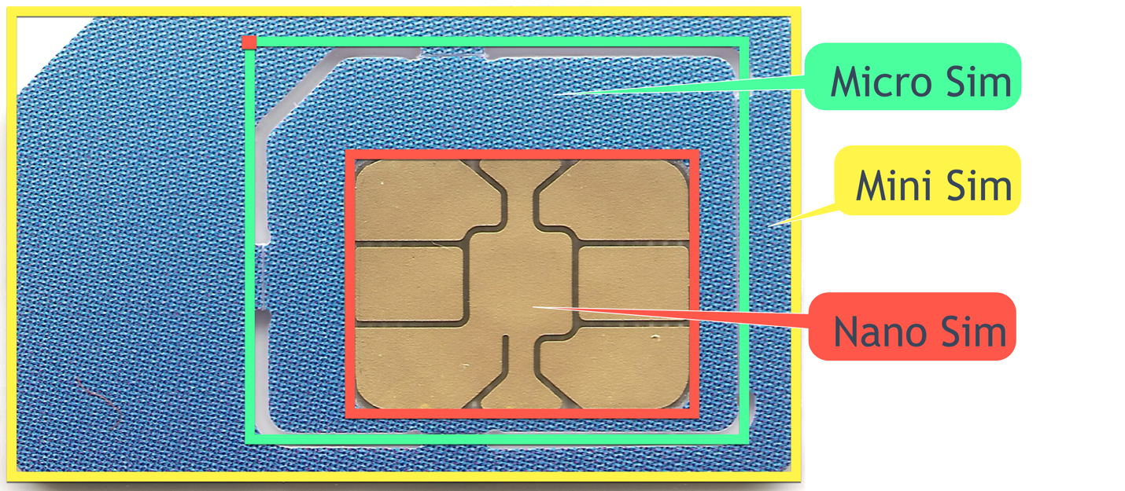Figure 2.4: Different SIM sizes
Throughout these physical changes, the arrangement of the electrical contacts on the SIM chip has remained constant. This deliberate design choice by standards bodies ensures that newer, smaller SIM cards remain compatible with a wide range of devices, making transitions smooth for manufacturers and consumers.

Integrated Circuit Card Identifier (ICCID)
The ICCID is a globally unique, typically 19–22 digit code that is an unchangeable serial number for each SIM card. Think of it as your SIM card's social security number! It is engraved into the SIM during manufacturing and remains a permanent, unalterable identifier. While the long string of numbers might seem complex, the ICCID follows a precise format, revealing vital information about the SIM itself.
Let’s dissect the ICCID's code. The initial digits are the Industry Identifier, confirming its use within the telecommunication sector. Following this comes the country code, specifying the nation where the SIM was issued. Next, we have the issuer identifier, pinpointing the specific mobile network operator that manages this SIM card. The remaining, often sizeable, chunk of digits forms a unique account number assigned exclusively to that SIM, as shown in Figure 2.5.
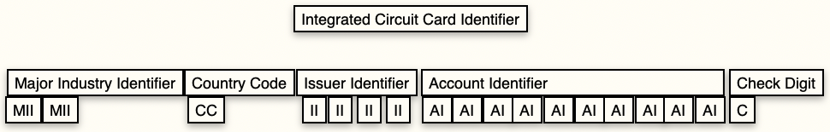Figure 2.5: ICCID breakdown
Figure 2.6 shows three nano SIMs, each with its ICCID embedded into the face. The SIMs are from the Mint Mobile, Hutchison 3G UK Limited, and Google Fi providers, respectively.
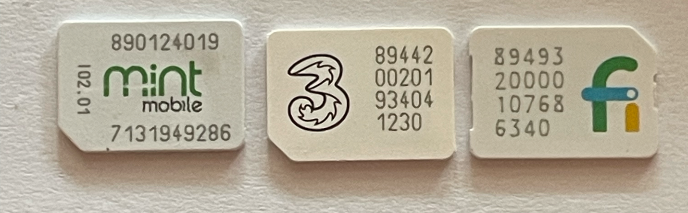Figure 2.6: <Insert Caption here>
Looking at the Mint Mobile SIM, we can see the ICCID of 8901240197131949286:
- Major Industry Identifier (MII): 89 – Telecom – Private agency
- International Calling Region: 01 – United States
- Issuer: 240 – T-Mobile USA
- Account Number: 19713194928
- Checksum: 6
That is interesting; Mint Mobile has a SIM for the T-Mobile Network. That does make sense, since Mint Mobile is a Mobile Virtual Network Operator (MVNO) that uses the T-Mobile network.
An MVNO is a wireless communications services provider that doesn't own the cellular network infrastructure it uses to deliver service. Instead, it partners with one of the major network operators (like AT&T, Verizon, or T-Mobile) and essentially leases bandwidth in bulk.
Let’s look at the 3 SIMs from the UK with the ICCID of 8944200201934041230:
- MII: 89 –Telecom – Private agency
- International Calling Region: 44 – United Kingdom
- Issuer: 20 – Hutchison 3G UK Limited
- Account Number: 020193404123
- Checksum: 0
No surprises there. Let’s look at the final SIM – Google Fi. Fi is also an MVNO. The ICCID is 8949320000107686340:
- MII: 89 – Telecom – Private agency
- International Calling Region: 49 – Germany
- Issuer: 32 – Giesecke & Devrient GmbH
- Account Number: 000010768634
- Checksum: 0
The SIM was issued out of Germany by Giesecke & Devrient GmbH; after a little research, I discovered that they are a German company that prints banknotes and securities, smart cards, and cash handling systems. I decoded this information using the Phone FYI Center, which can be found at http://phone.fyicenter.com/1155_ICCID_SIM_Card_Number_Checker_Decoder.html.
The ICCID holds a key role in the operation of mobile networks. Upon connecting to a carrier's network, your phone provides the ICCID. This identifies your SIM card and allows the carrier to verify it against your account profile. Think of it as linking you to your phone number and mobile services. The ICCID is also useful beyond the network itself. Often, it can be found within your device's settings or even printed on the physical SIM card, aiding in customer support scenarios or if you need to report a lost or stolen SIM.
From a forensic perspective, the ICCID offers tremendous value. As a unique, device-specific identifier, it can help investigators establish a definitive link between a seized SIM card, a specific phone, and potentially, the person under investigation. Law enforcement can often use carrier records and the ICCID to pinpoint device usage history, which can be crucial in various investigations.

eSIM
An eSIM (embedded SIM) is a digital SIM card built directly into a device's hardware, signaling a shift in how we manage mobile connectivity. Gone are the days of needing a physical, removable card. Instead, eSIMs offer significant advantages. Their integrated nature saves precious space within increasingly compact devices, like smartwatches or small IoT gadgets. Changing mobile network providers with an eSIM becomes incredibly convenient – simply download a new carrier's provisioning information remotely, eliminating the hassle of physically switching SIM cards. This is a bonus for frequent travelers or those wanting to easily compare the services of different carriers. eSIMs can even store multiple carrier profiles, allowing you to switch between personal and work lines or utilize local networks while traveling abroad. Device manufacturers also benefit, as eSIMs free them from needing to include physical SIM card slots and related mechanisms within their designs. An eSIM is inherently more secure than a removable SIM card because it is embedded within the device, reducing the risk of loss or tampering.
The eSIM format was introduced in 2016 through GSMA specifications and has been making its way into smart wearables, tablets, and premium phone models from manufacturers like Apple and Google. Adoption is still in early phases globally but is likely to accelerate, with eSIM phones projected to constitute over a third of US device shipments by 2025.
For mobile forensics practitioners, key artifacts to examine on phones with eSIM support include the embedded Integrated Circuit Card Identifier (ICCID) representing the chip's unique identity, onboard carrier profile settings, and recent network connection details that can reveal locations, subscriber information, and more.

Dual SIM
Dual SIM brings remarkable flexibility to mobile devices using two separate SIM cards simultaneously. This means two distinct phone numbers, potentially from different carriers, can be active and reachable within a single device. Most commonly found in smartphones, Dual SIM technology comes in two primary variations. The first is called Dual SIM Dual Standby (DSDS). Although you can have two SIMs in a phone, only one can be actively used for calls or data at a time – the other becomes temporarily inactive. The second, a more advanced but less widespread type, is Dual SIM Dual Active (DSDA). This allows both SIMs to remain active simultaneously for calls and potentially data, although this often depends on individual carrier support and limitations.
Dual SIM capabilities let someone utilize separate lines for personal and business needs or connect across multiple carriers. For example, a local provider SIM can make domestic calls, while a separate international SIM handles roaming when traveling abroad.
On Android phones, dual SIM settings allow the selective allocation of apps or contacts to specific SIM lines. This provides more control over which number is used to make calls or send messages versus everything automatically routing over the primary default SIM.
iPhones with dual SIM use one physical nano-SIM card and one integrated eSIM profile, so users can pair a physical SIM from their current carrier with a secondary eSIM-based plan, activated digitally without physically inserting another card. iPhone 13 and above phones support two active eSIMs.
For forensic examiners, linking calls, messages, and data from a range of apps to a specific SIM line can be invaluable for separating evidence trails. Understanding dual SIM artifacts can reconstruct a complete picture of a suspect's communications across the different numbers and associated identifier records.
Extracting multiple concurrent IMSI/ICCID combinations, along with individual call logs or address books per detected SIM, helps untangle data that could otherwise seem irrelevant when overlooking dual SIM status on a device. As with most mobile forensics, awareness of device features is key.

Mobile Subscriber International Subscriber Directory Number
The Mobile Subscriber International Subscriber Directory Number (MSISDN) is the globally distinct phone number identifying your mobile device on a cellular network. It functions like your phone's permanent address within the telecommunications system. You'll easily recognize the MSISDN format; the country code indicates your service origin, followed by your familiar local phone number. This number isn't just what people dial; the MSISDN plays a crucial role behind the scenes, enabling the seamless routing of calls and text messages to your device. It also acts as your unique identifier, linked to your account with your carrier, managing billing, applying the correct service plan, and other subscriber-specific processes. For travelers, your MSISDN helps international cellular networks identify your home network, ensuring calls or messages can still find their way to you, even far from home. Figure 2.7 shows a breakdown of the MSISDN.
Figure 2.7 – MSISDN breakdown
To break it down, the MSISDN = CC + NDC/MNC + SN:
- Country Code (CC): This is the international country calling code. For example, “1” is for the United States and Canada, “44” is for the United Kingdom, and “91” is for India.
- National Destination Code (NDC) or Mobile Network Code (MNC): This code specifies the mobile phone operator within a country. It can vary in length depending on the country.
- Subscriber Number (SN): The individual number assigned to a subscriber. It is unique within the mobile operator network.
From a forensic perspective, the MSISDN has the potential to unlock potential leads. When law enforcement works with carriers and obtains subscriber records, the MSISDN can help connect a seized device and its SIM card to a specific user. Detailed analysis of call records tied to the MSISDN will offer a window into the communication pattern of the user – a timeline of incoming and outgoing calls with other numbers can help establish relationships between individuals. MSISDN, cell tower records, and other network data may provide location clues regarding a suspect or victim's device usage.

Summary
This chapter explored key aspects of wireless networks and their relevance to mobile forensic investigations. We covered cellular network generations from 1G to 5G, Wi-Fi protocols and standards, Bluetooth technologies, overviews of UWB, and wireless security considerations relating to Apple's Find My network and Faraday shielding best practices.
The chapter also provided extensive details on SIM cards – their physical form factors, unique identifiers like ICCID, associated technologies like eSIM and dual SIM capabilities, and MSISDN numbers and security aspects. Understanding SIM evidence sources aids mobile network forensics.
The next chapter, Mobile Forensics Analysis Process, will guide you through a systematic approach to analyzing mobile devices in a forensic context. It will cover the legalities and preparations and provide an overview of tools to acquire data from mobile devices. It will ensure that evidence is handled correctly and analysis is conducted efficiently—foundations to empower informed analysis and a courtroom defense.

Questions
- What technology helped enable the first widespread mobile phone deployments by providing affordable connectivity across Europe?
  - A. 3G
  - B. GSM
  - C. LTE
  - D. 5G
- Which wireless technology uses a wideband transmission scheme for improved resilience and capacity?
  - A. GSM
  - B. UMTS
  - C. LTE
  - D. Bluetooth
- What connectivity enhancement specifically caters to small IoT devices and emphasizes extreme power efficiency?
  - A. Wi-Fi HaLow
  - B. Classic Bluetooth
  - C. Bluetooth LE
  - D. 5G NR
- Which wireless standard revolutionized throughput and coverage using multiple spatial streams?
  - A. 802.11b
  - B. 802.11n
  - C. 802.11ac
  - D. 802.11ax
- What technology leverages precise ToF measurements to accurately track a location within a few centimeters?
  - A. Wi-Fi
  - B. Bluetooth
  - C. RFID
  - D. UWB
- What unique SIM identifier is generated during manufacturing and does NOT change throughout the lifecycle?
  - A. IMSI
  - B. ICCID
  - C. IMEI
  - D. MEID
- What technology allows cellular network authentication without physical SIM card insertion/removal?
  - A. UWB
  - B. eSIM
  - C. iSIM
  - D. Dual SIM
- What wireless tracking network established by Apple combines short-range UWB and long-range crowdsourced Bluetooth detections?
  - A. AppleLink
  - B. AppleWay
  - C. iDetect
  - D. Find My
- What accessory helps safely transport seized mobile devices to prevent alteration of wireless evidence?
  - A. Signal amplifier
  - B. Wireless debugger
  - C. Faraday bag
  - D. Mesh network hub
- What mobile network technology uses CDMA with SIM card support for voice and 4G/5G authentication?
  - A. Verizon
  - B. AT&T
  - C. T-Mobile
  - D. Sprint

Answer Key:
- B
- B
- C
- B
- D
- B
- B
- D
- C
- A

3 Mobile Forensics Analysis Process
Join our book community on Discord
https://packt.link/SecNet
The mobile forensics analysis process prepares you for the process of identifying, extracting, preserving, and analyzing data from mobile devices. This process begins with the appropriate authority for conducting the examination, including compliance with your jurisdiction’s laws and regulations.
Since I am based in the United States (US), most of my experience will be US-based. You should always check and adhere to your jurisdiction's laws and regulations as they may differ from the US.
Once authorization is obtained, you can start the pre-analysis preparations, which can involve setting up a controlled environment to ensure the integrity of the evidence.
At this point, you will select forensic tools based on the characteristics of the mobile device, such as brand, model, and operating system. You may look to extract a wide array of data, from basic call logs and text messages to more complex data, such as application information and location tracking details. You must adhere to evidence management protocols to keep the evidence chain of custody intact for judicial or administrative proceedings.
After the acquisition, you will analyze the data for investigative leads and evidence. Your findings are documented in a report that includes the methods used, the data recovered, and any conclusions you have drawn from the analysis.
The mobile forensics analysis process involves a blend of technical skills, legal knowledge, and attention to detail, all essential to conducting a thorough and legally defensible investigation into mobile devices. This chapter provides the knowledge needed to set up an analysis environment, select and deploy forensic tools, and master the end-to-end acquisition of mobile evidence.
This chapter covers the following topics:
- Mobile forensics analysis process
- Standards and best practices
- Legal guidelines and evidence integrity
- Mobile forensic tools overview
By the end of this chapter, you will be equipped to confidently follow evidence integrity protocols, comprehend and apply relevant laws, prepare for analysis, select forensic tools, and execute evidence acquisition.

Starting the Process
Forensic examiners have been inundated with requests to analyze data from cell phones and other mobile devices in recent years. The task itself is not easy, and it is only getting harder. Smartphones and tablets dominate the market, and every model brings unique challenges. It is a jungle out there, wherein proprietary operating systems, custom file structures, numerous apps, and specialized services create additional hurdles. Forensic tools struggle to keep up, often failing to fully support these devices, especially newer models. Examiners face a constant delay before their tools fully catch up.
Mobile internet connectivity has improved, and many services have shifted primary storage to remote cloud servers, with minimal datasets being retained on the device. Accessing app-specific cloud data often requires account credentials and proper legal or administrative approval and relies on provider log retention policies. Locating the access tokens and assessing the importance of remote data has become a critical artifact.
Smart devices have also evolved into rich sensor platforms. GPS receivers plot detailed location histories, while wearables monitor health data and fitness metrics. Infotainment systems sync media preferences and travel habits, and smart home devices track living patterns and voice commands. Determining which sensors a subject uses develops a context for the acquired dataset. The following case study shows how valuable sensor data can be during an investigation.
Case study—mobile device forensics (MDF) in stalking investigation
Scenario: A woman reports ongoing stalking by her ex-fiancé. She alleges physical surveillance and suspects he was using technology to track her movements.
The role of mobile device forensics: In this case, forensic examination of mobile devices played a critical role.
Forensic examination of suspect's device: Investigators obtained a search warrant for the suspect's mobile phone. The data revealed the following:
- A spike in his heart rate aligns with the time he was observed near the victim's home.
- Connection to the victim's Wi-Fi network during the incident.
- Google searches related to the victim and potential attempts to contact her reveal an ongoing obsession.
Outcome: The collected evidence, witness accounts, surveillance recordings, and the comprehensive forensic analysis of the suspect's mobile device led to his arrest.
Key takeaways:
- Digital evidence: Heart rate data, Wi-Fi connections, search history, and location data were all crucial in painting a detailed picture of the suspect's actions.
- The interplay of evidence types: Digital data was strengthened by physical evidence (shoe comparison) and traditional investigative methods (witnesses, surveillance).
The problem compounds exponentially as the types of data stored on these devices explode, and how we use them changes in the blink of an eye. Forget just looking at contacts and call logs. Smartphones are pocket-sized computers overflowing with potential evidence. Large amounts of crucial data live within the apps, and it is often not automatically decoded by standard forensic tools. Countless third-party apps create valuable data that may not fit neatly into structured extraction formats. Understanding the underlying file system and directory paths allows investigators to manually recover relevant databases, SQLite records, configuration files, and cache storage. Manual analysis plugs the gaps left by automated tools for the newest data sources. This means traditional digital forensic skills, the ability to dig deeper and interpret data, are increasingly vital for mobile device examinations.
The motivations for extracting mobile device data span as widely as the techniques available. Rapid field acquisitions enable time-sensitive intelligence gathering or triage decisions. Selective collection may suffice for narrow specific case questions. Full physical extractions preserve the most complete evidence when recovery stakes are high.
The field will undoubtedly keep maturing as smartphones and consumer devices continue to permeate every aspect of modern life. You must embrace continuous learning and collaborate through knowledge sharing. Balancing sound forensic principles with practical technology adaptations will continue to deliver reliable results amid accelerating changes.
Mobile forensics demands a fine balance of structured processes to uphold evidence integrity alongside flexibility for solving novel problems. By developing extensible frameworks and exchanging lessons learned, practitioners can chart resilient courses through the certain uncertainties ahead.
I have seen several process trees dealing with the examination of mobile devices. Detective Cynthia Murphy created a detailed process tree, as shown in Figure 3.1.
Detective Murphy has dedicated over three decades to law enforcement and has a distinguished 25-year tenure at the Madison Police Department (MPD). At MPD, she specialized as a detective and attained certification as a digital forensic examiner, roles she held for more than 17 years. Throughout her investigative career, Detective Murphy witnessed the evolution of mobile devices into the predominant source of evidence in criminal investigations. This shift in the evidentiary landscape propelled her to develop extensive expertise in mobile forensics, establishing her as a leading authority in the field.
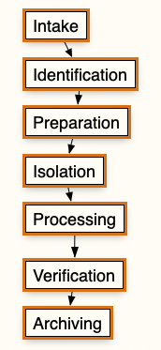Figure 3.1: 004Dobile device evidence extraction process
The National Institute of Standards and Technology (NIST) has recommended a four-step process, as shown in Figure 3.2.
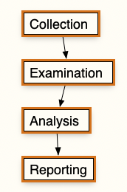Figure 3.2: NIST digital forensics process steps
NIST, founded in 1901 and part of the US Department of Commerce, is dedicated to driving innovation and industrial competitiveness. It achieves this by developing measurement science, standards, and technology to boost economic security and enhance quality of life. In digital forensics, NIST plays a crucial role by developing guidelines, best practices, and standards that help ensure digital evidence's reliability, consistency, and legal admissibility. Their recommendations, such as the four-step process for conducting digital forensics, provide a framework for practitioners to follow and help to establish a common language and methodology across the field.
While they seem to cover the same steps, I like Detective Murphy’s version, as it provides a granularity that allows you to focus more on the process. Does that mean you would be “wrong” using the NIST steps? No, use what works for you as the examiner and workplace and document your steps.
Let’s look at the steps in the mobile device evidence extraction process, starting with the evidence intake phase.

Evidence Intake Phase
The evidence intake phase sets the stage for the mobile device examination. The groundwork is laid, expectations are set, and critical information is gathered. This phase is all about communication and documentation.
Before seizing a mobile device, you must understand your jurisdiction's laws. Failure to follow proper procedures could render the seized evidence inadmissible in court. Legal requirements may differ depending on whether you act as a government agent or a private party. For example, the Fourth Amendment in the US protects against unreasonable searches and seizures by government agents. A valid search warrant is usually required to seize and search the mobile device.
When the request comes in, it is not just about taking possession of the device. It is about understanding the device's context and what the requester hopes to gain from the examination. Standardized request forms and intake paperwork play a vital role here.
These forms serve multiple purposes. They document the chain of custody, establishing a clear record of who has handled the device and when. They capture ownership information and provide a space for the requester to outline the type of incident involving the mobile device, giving you valuable context.
The chain of custody refers to the documentation and handling process that tracks mobile device possession, transfer, analysis, and storage and extractions. This process ensures that the evidence remains intact, unaltered, and secure from the point of collection to its presentation in a legal or administrative proceeding, preserving its integrity and admissibility. This will include detailed records of who handled the evidence, when, and for what purpose, safeguarding against unauthorized access or changes.
The intake process is where the requester communicates the information they seek from the examination. This moment sets the direction for the entire examination process.
With this information, you can develop specific objectives for the examination. These objectives serve as a roadmap, clarifying the goals and focusing your efforts. They can also assist in triaging examinations, helping prioritize cases, and allocating resources.
Documenting the objectives starts the paper trail for the examination process. Documentation is everything; it allows the examination process to be scrutinized, validated, and defended.
Many agencies and organizations have recreated standardized forms to ensure consistency in the intake process. These forms ensure that no critical information is overlooked and that each examination starts on a solid footing.
The evidence intake phase sets the stage for a successful examination. It is where information is gathered, objectives are set, and the foundation for the examination process is laid. Getting this phase right is critical to the overall success of the mobile device forensic process.

Identification Phase
The identification phase is a crucial step in examining any mobile device. It sets the stage for the entire forensic process and ensures that you understand the scope and legal boundaries of the examination.
You must establish the legal authority for examining the device. If the search is being conducted under a warrant, you must adhere strictly to the limitations outlined in the warrant. If the search is based on consent, you must be aware of any limitations on that consent, such as permission to examine only certain types of data, such as text messages or photos. You will also be defining the goals of the examination at this stage. These goals can vary significantly from case to case. It may be a targeted extraction of specific datasets, such as text messages or photos, or the goal may be a full extraction.
You will catalog the device's specifications, including make, model, and identifiers such as ICCID, MSISDN, IMEI, or MEID. This inventory guides the selection of examination tools and techniques. Record the phone's lock status and screen content. For locked devices, note the security mechanism (if known) (PIN, pattern, biometric). For unlocked devices, capture visible apps and content without interaction. Inventory any external storage like microSD cards.
Document through forms and photography. Photograph the device from multiple angles, capturing its condition, screen display, and identifiers. These images serve as visual references and protect against damage claims. This documentation establishes a forensic baseline, ensuring a defensible examination process. It preserves the evidence's integrity and provides a comprehensive starting point for analysis.
Addressing these issues lays the foundation for the rest of the examination. The initial investment of time and effort can pay dividends in efficiency and effectiveness as the examination proceeds. By establishing the legal authority, defining the goals, and documenting the device's physical and technical specifics, you ensure that the following stages are focused, legally sound, and technically appropriate. This is essential in the complex and ever-changing world of MDF.

Preparation Phase
In the preparation phase, you start researching the mobile device to be examined. You will want to gather as much information as possible about the device's model and operating system. These details will dictate the methods and tools used for data acquisition and examination. This is where resources like phonescoop.com and gsmarena.com (we discussed these sorts of resources in Chapter 1) come into play. These platforms offer a wealth of information about different cellular phones, but you must always verify that the information is valid for your specific make and model, as manufacturing specifications may change.
The preparation phase isn't just about research. It's also about getting ready to go hands-on and ensuring the examination machine is fully prepped and ready to go. This means ensuring all the necessary equipment, cables, software, and drivers are in place. It's like a surgeon ensuring all instruments are sterilized and set up before beginning a procedure.
By the end of the preparation phase, you should feel confident and fully equipped to proceed with the examination. You should understand the device, have a clear plan of action, and have all the necessary tools. With this groundwork, you will be ready to start extracting and analyzing data.

Isolation Phase
Mobile devices are designed with network connectivity in mind—cellular, Bluetooth, NFC, and Wi-Fi. Isolation serves multiple purposes and prevents new calls, texts, or app data from overwriting existing evidence. It safeguards against accidental or intentional remote wiping of data. Isolation also helps you stay within the legal bounds of search warrants or consent, avoiding access to data residing with cloud providers.
Faraday bags or radio frequency shielding cloths are common isolation methods. Informal solutions like aluminum foil or "arson cans" may offer some protection but also obscure the device screen and controls. If you use an “informal” method, you should always test it beforehand, as it is not 100% guaranteed to work. You can also use Faraday tents, cabinets, or rooms. An alternative is combining airplane mode with radio frequency shielding. Airplane mode disables the device's cellular and Wi-Fi but not Bluetooth. Remember, we discussed in Chapter 2 that iOS devices and the Find My application allow communication if the device is shut down.

Processing Phase
The processing phase can begin once a phone has been successfully isolated from communication networks. This phase presents its own set of challenges, particularly in terms of tool selection. Unlike computer forensics, where a single tool may suffice, mobile forensics often requires multiple tools.
MDF frequently requires a multi-tool approach due to the many different vendors of devices and the dynamic nature of the field. Manufacturers roll out new models with unique operating systems, file structures, and encryption methods, which means a single tool that works flawlessly on one device may be ineffective on another.
On the surface, a mobile device model's first and last device to roll off the assembly line may seem identical. Beneath the user interface, significant differences can exist. These could be tweaks to the file system, variations in how data is stored, or even how the device communicates with the network, all of which are proprietary information. Mobile device forensic tools must go below the user experience, reverse-engineering these underlying mechanics to identify and extract the artifacts you need. Due to the sheer volume of devices and the potential for these hidden changes, it's almost impossible for any single forensic tool to be a comprehensive solution.
Keeping multiple tools in the arsenal increases the chance of success across different device and software scenarios. Using multiple tools aids in validating your tools. Cross-referencing results between tools adds extra rigor to the process, boosting the findings' trustworthiness and potential for admissibility in legal or administrative proceedings.
Several factors, including cost, ease of use, and applicability to the specific device and situation, will influence your choice of tools. Given the high cost of mobile forensic software, this decision should not be taken lightly. When evaluating tools, ensure they have built-in features to maintain forensic integrity. This means that the tool should package collected data in a format that cannot be easily modified or altered, preserving the authenticity of the evidence.
The acquisition of a mobile device should follow a tested, repeatable method that is as forensically sound as possible.
Android versions before 6 limited SD cards to auxiliary storage. Android 6 (Marshmallow) introduced Adoptable Storage, integrating SD cards as internal storage. Adoptable Storage encrypts SD cards with AES-128, restricting content access to the adopting device. Data extraction from adopted SD cards requires logical extraction through the mobile device. In this state, physical imaging of the SD card alone produces encrypted data, which is unusable without the device's decryption. (iOS does not support the use of SD cards.)
Using different tools and creating multiple extractions from the same device can also be beneficial. Each extraction method may provide pieces of the puzzle that, when combined, give a more complete picture of the device's contents and usage.
The processing phase of MDF is a complex dance of tool selection, acquisition methods, and strategic sequencing. Every decision in this phase can have significant implications for the integrity of the evidence. You must approach this phase with an understanding of your tools, a commitment to forensic best practices, and a clear vision of the examination's goals. Documentation at every step is essential, as it provides a roadmap of the process to withstand legal scrutiny and validate the findings.

Verification Phase
After processing a mobile device, you must verify the accuracy of the extracted data. This verification phase is critical to validate your results. Remember, not all tools will get all of the data. You can compare the extracted data directly with what is displayed on the device. This allows you to ensure that the tools accurately report the information. Handling the original device in this manner will change the evidence.
As I write this chapter, I am working on a matter involving data not being presented properly on a mobile device's screen. The discrepancy was noted where screenshots showed chat messages in a non-chronological order. This anomaly was observed one day after the chat interaction, with User 2's responses appearing before User 1's questions. This situation shows that onscreen content might not always reflect the actual sequence of events, thereby complicating the accuracy of evidence derived from such interactions. I have not been able to determine why this is occurring, but after conversations with other examiners, the thought process is that it may be due to the app itself. The vendor has not been responsive to questions.
If you have a physical or file system extraction, you can use traditional computer forensic tools to examine the raw Hex data. By decoding this data manually, you can cross-verify the results reported by the mobile forensic tools. Another approach to ensure accuracy is to use multiple tools to extract data from the same device and then compare the results. Inconsistencies between tools can highlight potential inaccuracies.
You can also use hash values for verification. You create a baseline by extracting the file system and computing hashes for the extracted files. When individual files are extracted, their hashes can be calculated and checked against the original values to verify integrity. Any discrepancy in hash values must be explainable, such as whether the device was powered on and then acquired again, leading to different hash values.
Think of a hash as a unique digital fingerprint for a specific file or even an entire storage device. The algorithms are complex mathematical formulas that take the input (a file) and generate a fixed-length output of a string of characters. The slightest change to the original file will result in a completely different hash. No matter where you calculate its hash, the same file will always produce an identical result. You cannot reverse the process and create a file from its hash value.
Hashes are crucial in digital forensics. When you first acquire evidence, generating a hash of the original is standard practice. You can recalculate this hash to verify that the file has been modified, guaranteeing the integrity of your evidence. Law enforcement agencies and non-governmental organizations (NGOs) maintain vast "hash set databases." These contain hashes of known files, including operating system files and illegal content like Child Sexual Abuse Material (CSAM). By comparing hashes from a seized device to a hash set, you can quickly identify relevant files or filter out known ones, saving time and focusing your investigation.
Using multiple verification methods is crucial for confirming the integrity of the extracted data. The verification phase ensures the accuracy and reliability of the evidence. It provides a means to detect and explain any inconsistencies or changes in the data.

Documentation and Reporting Phase
The mobile device examination documentation should be an ongoing process, not just a final step. You should maintain contemporaneous notes detailing each action taken throughout the examination. Examination worksheets can be useful for ensuring that basic information is consistently recorded. Just be aware that if you create an "all-in-one" worksheet, there may be questions asked about why "this" or "that" wasn't completed or recorded.
As you document your examination, you must record specific details. Start by noting the exact date and time you began the examination. Pay attention to the device's physical condition and take photographs of the device and its components, such as the SIM card and memory card, ensuring any labels with identifying information are visible. Record whether the device was turned on or off when you received it, and include the make, model, and other identifying details and what information is being presented on the screen. List the tools you used throughout the examination and detail the data you documented. Remember, while many mobile forensic tools offer reporting functions, they might not always capture the necessary information or present it in the manner you want. I prefer to use the reporting function as a baseline and then complete the report using Microsoft Word. You must document the correct information, especially after the data verification phase. I have read many reports and prefer those created by the Army CID and Defense Cyber Crime Center (DC3).
Document the process used to extract data from the device, the types of data extracted, and any pertinent findings. Even if you successfully extract the desired data using the available tools, additional documentation through photographs can be invaluable, particularly for presentation in a judicial or administrative proceeding.
Pay close attention to date and time stamps when using mobile forensic tools. These tools might record times in Coordinated Universal Time (UTC) while your device might be on local time. Keep in mind any changes due to time zones and daylight savings and disclose these adjustments in your report.
UTC is the primary time standard by which the world regulates clocks and time. It is a highly precise atomic time scale that is the basis for time zones worldwide. UTC is expressed using a 24-hour clock system and is the reference point from which all other time zones are calculated.
Neglecting this step could confuse or make it seem like there are inconsistencies between the evidence on the device and your reports. Including a note in your report about whether you've made these time zone adjustments could avoid confusing the reader of the report.
The documentation and reporting phase is not just about recording findings but about creating a clear, accurate record of the examination process. This record is essential for the examination's transparency and reproducibility, which are key factors in the admissibility and credibility of the evidence in judicial or administrative proceedings. This documentation also allows other examiners or investigators to understand and verify the work done, even if they were not directly involved in the original examination.

Presentation Phase
Throughout the mobile device examination process, you should remember how the extracted and documented information can be presented to various audiences. The audience can include non-technical people, such as investigators, attorneys, and participants in a judicial or administrative proceeding. The presentation of the evidence is a critical aspect of the forensic process, as it can significantly impact the understanding of the findings. This means you may be required to make multiple reports depending on the audience.
Some of your report's recipients may want a paper report, some want an electronic copy, and others want both formats. Electronic formats allow for further analysis, such as sorting call history data. Paper formats provide a physical record and may be easier to reference during judicial/administrative proceedings.
You should also provide reference information to help the reader understand the data. This could include date and time stamps and EXIF data. Remember, your reader may not have the same understanding of the technical term or may not understand why that artifact in your report is important.
Visual aids are effective in judicial/administrative proceedings. Using pictures of text messages and call history logs is a powerful way to show the progression of communications. This approach is also useful when multiple devices are involved in a case, as it helps to clarify the sequence of events and the interactions between the parties involved.
The presentation phase is more than just displaying the evidence; it's about communicating the findings to the intended audience. You must put yourself in the shoes of the target audience. An effective presentation can distinguish between admissible and truly impactful evidence. It can help the audience grasp the significance of the findings and see the connections you have uncovered. In this field, presenting findings clearly and compellingly is critical. It's about telling the story of the evidence in an accurate, clear, and persuasive way.

Archiving Phase
This phase involves preserving the extracted dataset for ongoing and future use. Legal proceedings can take many years before reaching a final resolution, so the extracted evidence must remain accessible and usable throughout this period. Your jurisdiction may have regulatory or judicial requirements for retaining data for a specific length of time.
To mitigate these risks, consider storing the extracted data in proprietary and non-proprietary formats. This allows you to access the data if the original forensic tool is unavailable. For example, storing call logs or text messages in a CSV format, in addition to the tool's proprietary format, can provide a backup option for future access. Another good practice is retaining a copy of the tool with the extracted data. The software used to extract and analyze the data may become outdated or unsupported over time, making accessing the data in its original format difficult or impossible.
The phase is also about maintaining the chain of custody of the evidence. The archived data must be stored securely, with access controls and audit trails to prevent tampering or unauthorized access. The hash values we discussed earlier will come into play at this stage. These cryptographic fingerprints serve as a tool for verifying the integrity of the archived data. By comparing the hash values of the stored evidence with those calculated at the time of collection, investigators can detect any alterations or corruptions in the data. Proper documentation, access logs, and storage procedures further strengthen the chain of custody and demonstrate the reliability of the archived digital evidence.
You are preserving the usability and integrity of the evidence over time. This will require planning to ensure the evidence remains accessible and admissible, regardless of technological changes. The ability to future-proof the evidence is critical. What works today may not work tomorrow, and the archiving phase is about anticipating and mitigating this risk.
As you can see, this process can be a complex undertaking that requires a meticulous approach to ensure the integrity and admissibility of evidence. Its success relies on more than your skills and diligence; it also depends on standards that provide a framework for best practices.
These standards guide you as you navigate the complex landscape of MDF. Organizations like NIST and the Scientific Working Group on Digital Evidence (SWGDE) have created standards for MDF. These standards address evidence handling, data acquisition, tool validation, reporting, and archiving.
Adherence to these standards is not just a matter of professional best practice; it's also a key factor in the admissibility of evidence in legal proceedings. Courts increasingly expect digital evidence to be handled following recognized standards.
In the next section, we will explore some key standard-creating bodies in MDF, exploring how they guide and shape your work. By understanding and applying standards, you can ensure that your work stands up to scrutiny by the judicial and administrative systems.

Standards
In MDF, standards ensure digital evidence's consistency, reliability, and admissibility. As mobile devices become increasingly central to criminal investigations and legal proceedings, forensic examiners must have a clear framework to guide their work and ensure that their methods and conclusions can withstand the scrutiny of the legal system.

Importance of Standards
Standards in MDF serve several key purposes. They provide a set of best practices and guidelines that help ensure the soundness of examinations. By adhering to these standards, examiners can demonstrate that they have followed accepted procedures and methodologies, which can be critical in establishing the credibility of their findings.
Standards also promote consistency. With the vast diversity of mobile devices and rapid technological change, examiners have a common set of principles and approaches to guide their work. Standards help to ensure that, regardless of the specific device or the individual examiner, the fundamental processes of evidence handling, data acquisition, and reporting remain consistent. This is important in the context of legal proceedings. Courts have high expectations for handling digital evidence, and adhering to recognized standards can be a key factor in determining the admissibility of your evidence. By following these standards, examiners can help to ensure that their work will be accepted in any judicial or administrative proceeding.
Standards also serve an important educational role. For new examiners entering the field, standards provide a roadmap for acquiring the skills and knowledge needed to conduct mobile device examinations. For an experienced examiner, standards are a benchmark for ongoing professional development and to keep up with current best practices. Standards help demonstrate the integrity and professionalism of the field by setting a high bar for the conduct of examinations and the handling of evidence. This is crucial in maintaining the confidence of the legal system, the public, and other stakeholders in the work of forensic examiners. Examiners must also stay informed of the latest best practices emerging from the forensic community's collective wisdom and experience.
Standards and best practices are guidelines for conducting activities or achieving objectives, but they differ in origin, specificity, and level of obligation.
Standards are as follows:
- Standards are developed by recognized authorities or governing bodies
- They undergo a formal, consensus-driven process involving various stakeholders
- They are prescriptive, detailing specific requirements to be met
- They often have a legal or regulatory basis, making compliance mandatory
- They are regularly reviewed and updated through a structured revision process
- They provide a benchmark against which practices can be audited or certified
- Examples include ISO standards, NIST guidelines, SWGDE protocols
Best practices are as follows:
- They emerge from the collective wisdom and experience of practitioners
- They represent techniques or methodologies proven effective through practical application
- They are descriptive, offering general principles or recommendations
- They serve as advisories or suggested approaches, but not legally binding
- They evolve organically as the field adapts to new challenges and technologies
- They provide a reference point for continuous improvement and professional development
- Examples include industry whitepapers, professional association guidelines, community forums
While standards provide a formal framework for ensuring consistency and minimum quality, best practices offer the flexibility to adapt to context-specific needs. Standards are often broad in scope, setting the overall parameters within which best practices operate.
In the field of mobile forensics, an example of a standard would be the NIST Guidelines on Mobile Device Forensics (SP 800-101), which outlines specific procedures for evidence collection, examination, and reporting. A related best practice might be a specific technique for bypassing a lock screen or extracting data from a particular app, as shared by experienced examiners.
Both standards and best practices guide forensic examiners' work. Standards ensure a baseline of reliability and admissibility, while best practices drive innovation and adaptation in the ever-changing landscape of mobile devices. The most effective approach often involves a combination of both, using standards as the foundation upon which to build and refine best practices.

Governing Bodies
Several organizations and governing bodies lead the development of standards in MDF. Bringing together experts from academia, industry, and government to create best practices and consensus-based guidelines for the field.
NIST is part of the US Department of Commerce. It has a long history of developing standards and guidelines for computer and digital forensics. NIST's Computer Forensic Tool Testing (CFTT) program has been influential in setting standards for validating and testing mobile device forensic tools.
Another group shaping digital forensics is the SWGDE. This collaborative body unites law enforcement, academic, and private-sector experts, creating guidelines and best practices for dealing with digital evidence, including mobile device examinations. SWGDE documents address evidence collection, data recovery, and forensic analysis.
The International Organization for Standardization (ISO) represents the international stage. This independent NGO acts as a global hub for collaboration, working with national standards bodies to create and promote international standards. Several ISO standards, such as ISO 27037, which focuses on “Guidelines for The Identification, Collection, Acquisition, and Preservation of Digital Evidence,” are highly relevant to MDF. The ISO collaborates with organizations like SWGDE and NIST and helps in establishing a unified approach to digital forensics globally.
Many countries have their own organizations focused on standards in digital forensics. The United Kingdom has the Forensic Science Regulator, which sets standards for forensic science providers, which includes digital forensics.
There are also professional organizations that contribute to the creation of standards. Groups like the International Association of Computer Investigative Specialists (IACIS) and the SysAdmin, Audit, Network, and Security (SANS) Institute provide training and certification programs that help ensure that forensic examiners have the necessary skills and knowledge to conduct examinations per established standards and best practices.
These entities do not just create standards; they also promote the adoption and implementation. They educate forensic examiners, engage with the legal system and policymakers, and foster stakeholder cooperation and information sharing, all of which help to keep everyone up to date. These organizations help ensure that the standards and best practices are widely disseminated, allowing the field of MDF to continue to evolve in a manner that serves the interests of justice.
The role of standards and governing bodies in MDF cannot be overstated. The stakes are high in this field, and technology is always changing. Standards provide the foundation for digital evidence's reliability, consistency, and admissibility. Mobile devices will play an increasingly central role in our lives and investigations, and organizations like NIST, SWGDE, and ISO will only become more important in guiding forensic examiners' work and upholding the process's integrity.

NIST
NIST (https://www.nist.gov/) is a federal agency in the US Department of Commerce. Established in 1901, NIST's mission is to fuel innovation and industrial competitiveness by pushing innovation to bolster economic security and improve the quality of life. In digital forensics, NIST develops guidelines, best practices, and standards that help maintain digital evidence's reliability, consistency, and legal admissibility.
NIST's involvement in mobile forensics is part of its focus on cybersecurity and digital forensics. The CFTT project (www.cftt.nist.gov) was initiated in 1999. This was one of the first efforts to establish a methodology for testing and validating forensic software tools.
In 2007, NIST published the first version of its "Guidelines on Cell Phone Forensics" (Special Publication 800-101). This document addressed the growing use of mobile phones in criminal activities and the need for law enforcement to properly seize, examine, and analyze these devices. The guidelines covered various aspects of mobile forensics, including evidence collection, data recovery, and reporting. NIST has updated the document to keep pace with the evolution of mobile technology. The most recent version, "Guidelines on Mobile Device Forensics" (SP 800-101 Revision 1), was released in 2014. This update expanded the scope to include smartphones and tablets and guided topics such as on-device versus cloud storage, GPS and location data, and application analysis.
The Mobile Device Tool Specification (MDTS) is a standard developed by NIST as part of the CFTT project. The specification defines the capabilities, tests, and protocols for forensic tools to extract and report 45 categories of potential evidence from smartphones, tablets, feature phones, and UICCs. The specification recognizes that mobile devices hold a treasure trove of investigative data, establishing requirements for mobile forensic data acquisition tools. These requirements form the basis for test assertions and specific claims about a tool's capabilities. Each test assertion is backed by test cases consisting of step-by-step instructions and the anticipated results. This thorough framework ensures that tools are evaluated for their ability to recover evidence from a wide range of mobile devices.
One of the challenges that NIST faces in its mobile forensics work is the sheer diversity and rapid evolution of mobile devices and operating systems. With new smartphones and tablets constantly being released and mobile operating systems regularly updated, it can be difficult for guidelines and standards to keep up. NIST addresses this through ongoing research and engagement with the mobile forensics community.
Encryption is also challenging due to its increasing use as a security feature in mobile devices. Mobile device manufacturers emphasize user privacy and data protection, making it more difficult for forensic examiners to extract and analyze data. NIST is actively researching methods for dealing with encrypted devices by working with device manufacturers and operating system developers to find ways to balance user privacy with the needs of law enforcement.
Despite these challenges, NIST's work has significantly impacted the field. The agency's guidelines and standards have helped promote consistency and reliability in mobile forensic examinations and have contributed to the admissibility of mobile device evidence in court. NIST's research has advanced the capabilities of mobile forensic tools and techniques, which have helped to ensure that examiners have the skills and knowledge needed to conduct effective examinations.
NIST's role in mobile forensics will become even more important as mobile devices evolve and become even more embedded in our daily lives. 5G networks, the internet of things (IoT), and the increasing use of mobile devices in business will present new challenges and opportunities for mobile forensics. NIST must continue developing guidelines, standards, and research to address these emerging issues.
Through its development of guidelines, standards, specifications, research on mobile forensic challenges, and education, NIST helps ensure the reliability, consistency, and legal admissibility of mobile device evidence. As mobile devices become increasingly central to criminal investigations and legal proceedings, NIST's work in setting standards and promoting best practices will ensure that the truth can be uncovered from the vast trove of data stored on devices.

ISO
The ISO (https://www.iso.org) is an independent NGO that develops and publishes international standards across many industries, including digital forensics.
The ISO has developed several standards for mobile forensics:
- ISO/IEC 27037:2012—Guidelines for identification, collection, acquisition, and preservation of digital evidence: This standard provides guidelines for handling digital evidence, including mobile devices, and maintaining its integrity and admissibility in legal proceedings.
- ISO/IEC 27041:2015—Guidance on assuring suitability and adequacy of incident investigative method: This standard guides organizations in ensuring the suitability of the techniques used in incident investigations, including mobile forensics. It establishes a structured process for selecting, implementing, and evaluating investigative methods.
- ISO/IEC 27042:2015—Guidelines for the analysis and interpretation of digital evidence: This standard guides the analysis and interpretation of digital evidence, including that obtained from mobile devices. It covers the processes involved in examining and interpreting digital evidence, the principles of evidence analysis, and the role of the forensic analyst.
- ISO/IEC 27043:2015—Incident investigation principles and processes: This standard provides guidelines for investigating information security incidents, including those involving mobile devices. It covers the principles and methods of conducting incident investigations, from initial response to final reporting.
Following ISO standards can benefit forensic examiners and organizations that conduct mobile forensic investigations. These standards help ensure that the evidence collected and analyzed is admissible in court.
ISO standards play a role in mobile forensics by creating guidelines and best practices for mobile devices. These standards help ensure that mobile forensic processes are conducted consistently and reliably, are legally admissible, and provide a framework for organizations to establish best practices and procedures in mobile forensic investigations.

SWGDE
The SWGDE (https://www.swgde.org) was established in 1998. It brings together members from a wide array of sectors, including federal, state, and local law enforcement, academia, and legal and commercial entities worldwide. The mission of the SWGDE is to develop guidelines, standards, and best practices for collecting, preserving, and analyzing digital evidence.
The SWGDE was originally named the Technical Working Group (TWG) on Digital Evidence. In 1999, TWGs were renamed to Scientific Working Groups (SWGs) to distinguish the long-term, FBI-supported groups from the short-term groups supported by the National Institute of Justice. The initial members of the SWGDE included federal forensic laboratories and agencies performing digital forensics outside traditional lab settings. Membership was expanded to include state and local agencies, academic institutions, and commercial organizations. In 2014, the SWGDE was placed under the umbrella of NIST.
The SWGDE has an executive board and eight standing committees:
- Audio forensics
- Computer forensics
- Imaging
- Photography
- Quality standards
- Video
- Membership
- Outreach
The SWGDE initially defined digital evidence as "any information of probative value that is stored or transmitted in a binary form," but this concept was broadened to include any data in "digital" form, such as text, numbers, audio, images, and video. In 1999, the SWGDE worked with the International Organization on Computer Evidence (IOCE) to craft guidelines and definitions for digital forensics. In 2001, the Group of Eight (G8) adopted the SWGDE recommendations.
The SWGDE's primary function is to guide the digital forensics community by publishing standards, guidelines, and best practices. These documents are freely available on the SWGDE website. The SWGDE encourages standard-developing organizations to use its published documents to create national and international digital and multimedia evidence standards. The "Best Practices for Mobile Phone Forensics" document, first published in 2013 and regularly updated, provides comprehensive guidance for forensic examiners handling mobile devices. It covers evidence intake, data extraction, analysis, and reporting, emphasizing legal compliance, integrity, and thorough documentation.
Another key contribution is the "Best Practices for Mobile Device Evidence Collection & Preservation, Handling, and Acquisition" document, which focuses on the initial stages of mobile forensics, providing guidance on properly seizing, securing, and transporting mobile devices to maintain evidence integrity.
One area where the SWGDE's work will be important in the coming years is addressing the challenges posed by mobile device encryption and other security features. As manufacturers emphasize user privacy and data protection, it will become increasingly difficult for forensic examiners to extract and analyze data from these devices. Despite these challenges, the SWGDE's work in mobile forensics has already impacted the field. The organization's best practice guides and technical documents (found at https://www.swgde.org/documents/) have become the go-to resources for mobile forensic examiners worldwide.
As our reliance on mobile devices continues to grow, and as these devices become more complex and secure, the need for reliable, consistent, and legally defensible methods for extracting and analyzing mobile device data will only increase. By continuing to bring in experts from across the digital forensics community to develop and update best practices and standards, the SWGDE will ensure that mobile forensic examiners are well equipped to meet the challenges of this rapidly evolving field. This organization will play a vital role in ensuring that the truth can be uncovered from the digital traces left behind on our mobile devices and that justice can be served in an increasingly digital world.

IACIS
The IACIS (https://iacis.com) was founded in 1990 and is a non-profit organization dedicated to advancing digital forensics and cyber investigations. With a primary focus on law enforcement, the IACIS welcomes members from academia, the private sector, and government agencies. The IACIS distinguishes itself by emphasizing the training and certification of computer forensic and mobile device examiners. Their most well-known offering is the Certified Forensic Computer Examiner (CFCE) designation, an industry-recognized credential that signifies a strong foundation in digital forensic principles and techniques. To become certified, candidates must demonstrate their knowledge and experience through an exam process.
Their MDF course is a five-day course designed for practitioners with some foundational knowledge. This program goes beyond the basics, focusing on advanced techniques for detecting, decoding, decrypting, and analyzing data extracted from mobile devices. The course employs a combination of instructor-led exercises and hands-on practical exercises, enabling students to acquire the skills needed to understand and navigate the automated processes of popular mobile forensic tools.
The IACIS Certified Mobile Device Examiner (ICMDE) program is based on competencies approved by the IACIS board of directors. This certification program consists of two stages: written and practical examinations. The structure ensures a thorough assessment of candidates' abilities, finding a balance between theoretical and practical expertise. This approach helps maintain the standards of the ICMDE certification, ensuring that certified professionals possess the necessary knowledge and skills to conduct MDF examinations.
The IACIS promotes a sense of community and facilitates networking through conferences and events, where practitioners can connect, collaborate, and stay up to date on the latest advancements.

The SANS Institute
The SANS Institute (https://www.sans.org/) plays a vital role in mobile forensics. It offers in-depth training, respected certifications, cutting-edge research, and a wealth of resources, which are an asset for professionals in this field. It’s emphasis is on practical learning and staying ahead of technology trends.
One of their most popular mobile forensics courses is FOR585: Smartphone Forensic Analysis In-Depth. This course isn't just about data extraction; students learn to use mobile forensic tools and explore iOS, Android, and other platforms. The SANS Institute offers the GIAC Mobile Device Security Analyst (GMOB) certification to validate their expertise.
The SANS team actively researches new challenges in mobile forensics, such as tougher encryption and cloud evidence. Sharing this research benefits the entire field, not just its students. The SANS DFIR Summit is another way to foster the community—here, mobile forensic examiners network and learn from each other to stay on the cutting edge.
Their free resources are also impressive: whitepapers, blogs, and podcasts. Many of them have practical value for examiners. For those wanting a more formal education, the SANS Institute offers programs ranging from a master's degree in information security engineering to specialized certificates.
In a landscape where mobile devices hold more evidence than ever, the SANS Institute helps forensic practitioners keep pace. As mobile technology gets more complex, the SANS Institute will keep pushing the field forward, ensuring examiners have every tool needed to unlock those digital secrets.
While organizations like NIST, the SWGDE, and the ISO provide methodologies and best practices, MDF operates within a complex legal landscape. To ensure that digital evidence can withstand scrutiny in a judicial or administrative proceeding, you need a firm grasp of the legal guidelines and the steps necessary to maintain its integrity. Let's explore some of the key considerations.

Legal Guidelines and Evidence Integrity
As a digital forensic examiner, I always prioritize understanding case details and legal considerations before diving into the evidence. That means gathering information from whoever has requested my services. Here are some key points that are important to understand:
- Asking about the nature of the investigation helps you understand the context and plan your approach accordingly. Different types of cases may require different forensic techniques and prioritize different types of evidence. For example, a narcotics case might focus on communication records and financial transactions, while a homicide investigation may prioritize location data and digital media related to the crime.
- It's best to be prepared to handle multiple devices and various types. Experience has taught me that things might change when arriving on-site. If an investigator expects only one mobile device, there will usually be more. Being prepared for unexpected devices or data sources is crucial. This is where your experience and adaptability as a digital forensic examiner come into play.
- Another critical aspect is the legal justification for the search. Whether it's based on consent or a search warrant, you must understand the limits and scope of the search authority. Reading and interpreting the consent form or search warrant is essential for ensuring that you stay within the legal boundaries. Overstepping these limits can make evidence inadmissible and have potential legal consequences for you as the examiner.
- In government and corporate investigations, additional limitations may exist on what you can search for or view on mobile devices. These restrictions might be based on privacy policies, employee agreements, or legal and regulatory considerations. Being aware of and adhering to these limitations is crucial to maintaining the investigation's integrity and avoiding any sanctions.
- Depending on my role, I might or might not directly interact with the subject of the investigation. If possible, I like to have a conversation with them. I have found that having a calm discussion with the subject can yield additional information about the digital devices and data involved.
Before collecting evidence, ensuring that the crime scene has been properly documented and secured is essential. This includes removing unnecessary personnel, restricting access to the scene, and having someone record the scene. Recording the scene is a crucial step in crime scene investigation and involves creating a comprehensive visual and written record of the crime scene as it was initially found. This process typically employs a combination of photographs, videos, and written sketches or notes. Photographs should capture wide-angle views of the entire scene and mid-range and close-up shots of individual pieces of evidence or areas of interest. Video recordings can provide a dynamic, 360-degree view of the scene, capturing spatial relationships that might be missed in still photos. Written sketches or diagrams complement visual records by providing measurements, noting the precise locations of evidence, and detailing the overall layout of the scene. This thorough documentation serves multiple purposes: it preserves the original state of the scene for future reference, aids in the reconstruction of events, and helps establish the chain of custody for evidence. Proper recording of the scene also supports the admissibility of evidence in court proceedings and allows investigators to revisit the scene virtually during later stages of the investigation. These steps help maintain the integrity of the evidence and prevent any potential contamination or tampering.
Imagine you're called to investigate suspected corporate espionage at a cutting-edge electronics firm. Someone's been leaking details about unreleased products to a competitor. The prime suspect is a disgruntled engineer with high-level access to design files. A security guard finds a smartphone in the hallway outside the secure engineering lab.
This is where well-intentioned actions can ruin the investigation:
- The guard, thinking it belongs to someone inside, takes it to the lab's breakroom for when the owner comes looking.
- A few curious engineers picked up the phone and wondered who it belonged to. They checked recent calls and tried to identify a contact to alert. One scrolled through the photo gallery, hoping to find a clue.
- The suspicion grew that this might be the leak device. A team leader took the phone, brought it to his desk, and connected it to his computer to see whether he could find any suspicious files.
By the time you arrive, multiple employees have handled the phone. Every swipe, scroll, and file access alters timestamps and potentially overwrites evidence. Organizations need clear guidelines: find a suspicious device, power it down immediately, isolate it, and summon a forensics expert.
Your task in this scenario might involve the following:
- Interviewing those who interacted with the phone to get clues on who left it.
- Placing the phone in a Faraday bag to cut off network signals.
- Creating an extraction of the phone's data as soon as possible.
- Analyzing recent call logs, text messages, web browsing history, and installed apps for signs of communication with competitors or data transfer.
- Examining the team leader's computer for traces of the phone's connection.
Sometimes, you're handed a phone or tablet that has already been seized by someone else. It's easy to want to dive in, but hold on! Even without interviewing the original collector, you need crucial information.
You'll need to know the following:
- Why it was seized: Understanding the type of crime suspected will help guide your analysis.
- Type of evidence: Does the device potentially hold evidence of wrongdoing or something that might clear a suspect? Is the device itself evidence of a crime?
- Chain of custody: Is there a clear record of everyone who's handled the device? This is crucial for ensuring that the evidence is admissible.
- Past access: How many others have touched it? Knowing this helps establish a risk level for contamination.
- Location: Where was the device found? Was it found in a secure area or the open? This may impact the data you find.
- Timestamps: Are there dates and times noted in the reports that may need to align with your findings?
- Investigative focus: What specific data do the investigators need?
Thoroughly review the documentation before starting with the device itself. Examine any warrants to ensure the original seizure was authorized, and pay close attention to any limits set on what you can examine. Mistakes here can render evidence invalid!
Additionally, anticipate potential hurdles:
- Your expertise: Is there an aspect of this case (encryption, a specific app) where your experience might be lacking? Identify those areas so you can get support if needed.
- Resources: What tools, software, and expertise are available as you embark on this examination?
Once you've addressed the legal and practical considerations, you're ready for the next step—acquiring the data in the most forensically sound way possible.
Every situation, crime scene, and investigation will be different, so your actions will be based on the circumstances you encounter.
Now that we have the evidence, how do we control it? Let's discuss the chain of custody.

Chain of Custody
Maintaining the chain of custody is crucial for any mobile device you work on as a forensic examiner. This record will prove the evidence is authentic and hasn't been tampered with. It will show everyone who handled the evidence, when they had access, and exactly what they did with it.
NIST offers a template chain of custody form that you can download and tailor to your needs (https://www.nist.gov/document/sample-chain-custody-formdocx). This form tracks the device and any changes of possession:
- You fill out a new entry every time the device's control changes. This ensures complete transparency.
- Some fields might not apply in your situation. As a corporate investigator, you may not need a "Victim" section—feel free to adapt the form.
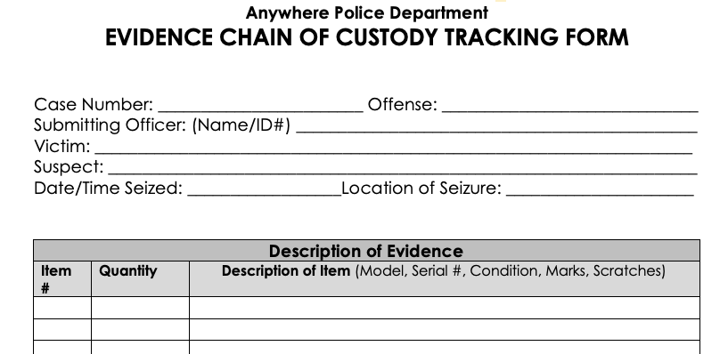Figure 3.3: Evidence form
The goal is to document the device's journey in detail. In the Description section, include everything about the device—make, model, serial number, damage, and accessories. This level of detail allows you to authenticate the evidence and prove it's the same one collected from the scene. In the following figure, you can see the Description of Evidence section. The Item number is a sequential numbering system used to help track the items. Quantity is the physical number of items, and the Description of Item field is self-explanatory:
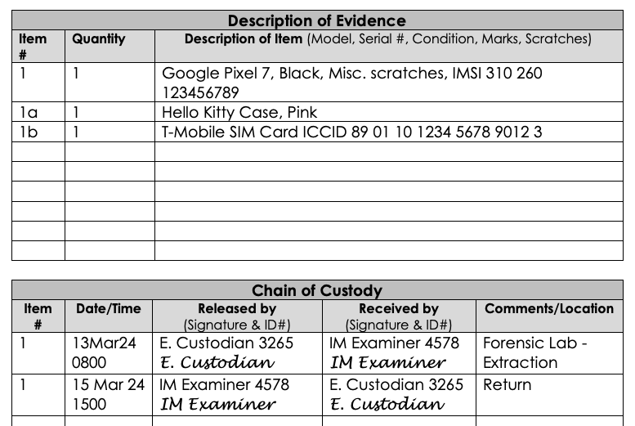Figure 3.4: A completed evidence form
In the example, a Google Pixel 7 is listed as Item 1; since the device was in a Pink Hello Kitty case, that will be Item 1A. The SIM card is listed as Item 1B. You want to keep all of the associated items together; it helps track all the related evidence. In some cases, the associated items may also help you link a device to the primary user.
Maintaining a detailed chain of custody is essential, but it's only the first step. To unlock the secrets held within a mobile device, you'll need specialized tools to extract and analyze the data they store. Let's dive into an overview of some of the most common mobile forensic tools.

Mobile Forensic Tools Overview
Once you've carefully collected and documented a mobile device, it's time to unlock the data. A multi-tool approach to mobile forensics is necessary because of the cost involved in licensing multiple software solutions, the sheer diversity of devices and operating systems, and the need for a deep understanding of how your tools work so you can confidently defend your findings. While open-source options exist, no single tool will be the perfect solution for every scenario. The world of mobile technology evolves rapidly, and your toolkit needs to be adaptable.
To make the most of the tools available, you must fully understand the limitations of your current software while continuously researching new solutions. Most examiners/agencies/organizations can't afford to purchase every tool. Prioritize those that will address the most common devices, operating systems, and data types you will likely encounter in your work. This strategic approach ensures you're well prepared for the challenges of analyzing mobile device data.
Choosing the right mobile forensic tools can be a complex process. Factors like cost, ease of use, and what your colleagues are using all come into play. Take the time to consider each option carefully—the most popular one isn't always the best fit for your needs. Commercial mobile forensic tools can be incredibly expensive. Don't assume a higher price tag automatically means a more comprehensive or capable tool. Before investing in anything, research to ensure the features align with your needs.
If less-experienced personnel will be performing some collections, consider how user friendly (or not) your tools are. Will they be able to extract data without compromising its integrity? Look for tools that perform hashing to protect the collected data and help verify that it hasn't been altered. To ensure your findings are defensible, your tools must be reliable and allow for repeatable processes. This includes creating the “digital fingerprints” (hashes) of individual files and the collected dataset.
Think about the types of cases you'll need to handle. Will you be examining devices directly, as well as backups? Don't spend money on capabilities you won't use! Investing in tools that stay up to date with the latest mobile technology is also crucial. Don't let the fact that "everyone else" is using a particular tool blind you to its potential shortcomings. Popularity doesn't always equal ideal. Thoroughly research the available options, focusing on features, how they handle data, and what support the company provides. Most software vendors offer demos, letting you try before you buy.
Once you've assembled your toolkit, take the time to truly master each tool before deploying it in real cases. Understand its strengths, limitations, and how it works. Seek out training if needed. Remember, technology changes fast, and what worked perfectly yesterday might not be the best method today.
Once you have determined your tools, validate them and their output before starting the examination process. Validating a tool determines whether the tool performs, and the results are consistent. You should verify the following:
- The tool does not alter the data in any way.
- The data represented by the tool is consistent with what you find in the source file of that particular piece of data.
- The results are consistent among different forensic tools.
Validation is increasingly important when dealing with unsupported third-party applications. Some tools have built-in features that attempt data extraction from these artifacts. Be aware that the results can be incomplete or inconsistent, so you have to manually examine the unsupported artifact.
Although forensic tools will greatly aid you by speeding up the entire process, this software should not fully replace the manual viewing and assessing of the files extracted in the acquisition process.
One of the best ways to truly understand your forensic tools and ensure the accuracy of their results is to test them on a known dataset. Use resources like DigitalCorpora.org and the NIST CFTED portal (https://cfreds.nist.gov/). These sites offer free mobile device extraction datasets, giving you a wide array of scenarios and data types. Many of these datasets come with descriptions and guides, making it easy to understand what artifacts you should look for and how to test your tools against them.
Several commercial tools are available when you need to perform forensic acquisition and analysis of mobile devices. Some of the most popular vendors include the following:
- Belkasoft
- Cellebrite
- Magnet Forensics
- MSAB
- Oxygen Forensics
Research these carefully to determine which best fits your needs and budget! I will provide an overview of their tools.

Belkasoft
With Belkasoft Evidence Center X (https://belkasoft.com/), you can analyze artifacts such as chat applications, web browsers, email, multimedia files, system files, mobile and payment apps, cloud storage, and peer-to-peer networks. Belkasoft Evidence Center X has functionalities like File System Explorer, Artifacts Viewer, Plist, SQLite, Registry Viewer, and the comprehensive Timeline Viewer. For in-depth analysis, you have hash set analysis, a connection graph for visualizing links between data points, and cross-case analysis for comparing evidence across files.
After you've examined the data, you can generate customizable reports in multiple formats to share your findings. Belkasoft Evidence Center X also offers a free portable case viewer, which allows you to easily share your case with others.
Belkasoft Evidence Center X supports agent-based and Checkm8 mobile device acquisition.
Checkm8 is a jailbreak exploit for iOS devices that uses a boot ROM vulnerability. This security flaw is hardware-based, meaning it can't be patched through iOS updates. It grants you access to the operating system's core, bypassing restrictions and installing software not sanctioned by Apple.
The Checkm8 exploit is compatible with several Apple devices. It affects devices with chipsets A5 to A11, including iPhones from the 4S to the X, several iPad models, several Apple TV iterations, and some iPod touch models.

Cellebrite
With Cellebrite Universal Forensics Extraction Device (UFED) (https://cellebrite.com), you gain access to a vast array of mobile devices. This tool lets you gather digital evidence from smartphones, SIM cards, and SD cards. Throughout the acquisition process, the integrity of the data is preserved. There are several methods for data acquisition, such as full file system (FFS) and physical extractions, which ensure that you have the flexibility and resources needed.
UFED software is available on multiple devices:
- UFED 4PC is software that is installed on the user’s existing PC or laptop.
- UFED Touch3 gives you access to the UFED software installed on a tablet designed for lab or field extractions.
- UFED Ruggedized Laptop is the UFED software installed on a ruggedized Getac laptop.

Physical Analyzer
Cellebrite Physical Analyzer allows you to analyze mobile device extraction from various devices, applications, and the cloud. The tool decodes data and can facilitate collaboration across your organization. It supports data from multiple extraction tools, including Cellebrite UFED, and can handle data from over 11,000 apps.
It has advanced decoding tools like SQLite Wizard, Python scripting, and Hex highlighting, along with the ability to emulate Android applications for a more user-friendly view of the data. You can access and review cloud data from major social platforms and backup services.
The tool can analyze content in over 40 languages, offering on-demand translation to streamline the analysis process. Cellebrite Physical Analyzer creates clear, customized reports through Cellebrite Reader. The software requires a Windows-compatible PC environment. For optimal performance, 32 GB of RAM and a substantial amount of free disk space for installation and database functionalities are recommended.

Magnet Forensics
Magnet AXIOM (https://www.magnetforensics.com) is a digital forensics tool that allows you to recover, process, and analyze digital evidence from various sources. You can process and analyze iOS and Android extractions with direct Graykey integration and support for third-party tools like UFED, Oxygen, and more. For computers, you can recover evidence from Windows, Mac, Chrome, and Linux devices, enabling you to analyze RAM, browser history, deleted files, and other important artifacts.
Magnet AXIOM also supports analyzing cloud data from warrant returns, user-generated archives, live cloud services, and open sources, providing artifact support for the most popular and relevant sources.
- The Media Explorer allows you to filter out icons and non-relevant images with Magnet.AI, stack similar images, add hash sets, and automatically grade and blur CSAM.
- The Connections feature helps you identify how artifacts, people, or even devices relate, enabling you to find and visualize data across the digital evidence.
- The Timeline tool allows you to learn and validate what happened before or after an incident.
- Cloud Insights Dashboard automatically identifies cloud account information, helping you uncover new sources of evidence.
Magnet AXIOM also offers reporting and case-sharing features. It provides flexible export options, including portable cases, enabling you to choose and share the relevant data for your case.

Graykey
Graykey is only available by verified law enforcement or government agencies and is not made available to the public. (Verakey is a consent-based option for non-law enforcement/government organizations.) Every account request from a potential customer is validated to confirm that it originated from a valid law enforcement agency in a supported country.
Graykey is a mobile data extraction tool for the iOS platform, offering full file and same-day data extraction. Magnet Graykey extracts data from locked and encrypted mobile devices and integrates it with existing forensic analysis products. The tool provides brute-force access to iOS and Android devices. Integrated with Magnet AXIOM, you can access and extract evidence from mobile devices irrespective of device state and access credential stores like Keychain and Keystore, decrypting encrypted content.

MSAB
XRY (https://www.msab.com) is MSAB's flagship product family, extracting digital evidence from mobile devices. With XRY, you can access over 42,000 device profiles. The tool also offers passcode and bypass features, allowing you to access over 4,500 new devices. XRY supports Apple devices and Chinese chipsets in many popular low-cost feature phones.
With XRY, you can pull data from over 4,200 app versions, covering major platforms like Facebook, WhatsApp, Viber, and Instagram. It also has WebKit support to analyze browsing histories across browsers. Its location reporting feature allows you to draw connections between datasets. XRY has a pre-indexation feature that prepares extracted files for searches in XAMN Spotlight.
- XRY Logical is used to access and recover the device at the crime scene.
- XRY Physical allows you to bypass the operating system to extract all the raw data from a device. This capability grants access to system-protected and deleted data, overcoming security measures and encryption on locked devices.
- XRY PinPoint allows you to acquire extractions from non-standard mobile devices.
- XRY Cloud helps you recover data from cloud-based storage.
- XRY Express is a locked-down workflow that enables non-expert users to create their own mobile device extractions.

XAMN
XAMN offers user-friendly tools that enhance your analytical efficiency. Two variants of XAMN are provided to cater to different needs within the mobile forensics community: XAMN Pro and XAMN Viewer.
With XAMN Pro, you can acquire and analyze data from XRY and third-party extraction tools. You can refine your investigations by applying filters based on content category, time, file size, location, deleted data, and Project VIC.
Project VIC is a coalition focused on rescuing child exploitation victims. It revolutionizes how law enforcement handles child exploitation cases by standardizing how digital forensic tools handle images and videos containing CSAM. This is done using algorithms and hashing technologies to categorize and share information about digital media. Integrating Project VIC's resources into mobile forensic tools enhances the ability to sift through massive amounts of data, prioritize investigative leads, and protect child victims.
With XAMN Pro, you can connect phone numbers and chat names directly to individuals and categorize images by weapons, drugs, people, and other categories. This tool includes specialized viewers for Plist, XML, and SQLite files.
With XAMN Pro, you can explore data from various angles. The Geographic and Maps views reveal the locations of calls and where photos were snapped. For conversations, it tracks chat threads across popular messaging apps, while the Connection view uncovers the interactions between the user accounts and their contacts. You can also export data in PDF, Word, Excel, XML, GPX, and VICS formats.

Oxygen Forensics
Oxygen Forensic® Detective (https://oxygenforensics.com) is a comprehensive tool that simplifies the extraction, analysis, and reporting of digital evidence across a variety of platforms. This solution empowers you to gather data from mobile devices, cloud services, drones, computers, IoT devices, and wearables with ease.
You can acquire data from multiple devices simultaneously, circumvent screen locks on a wide array of mobile devices, and discover passwords for encrypted backups and images.
The integrated Cloud Extractor can access cloud services and acquire data using either account credentials or tokens, which can be sourced directly from the device.
The KeyScout utility finds and decrypts credentials, system files, and user data across Windows, macOS, or Linux platforms. All extracted data can then be incorporated with artifacts from mobile devices within Oxygen Forensic® Detective for comprehensive analysis.
The software's data analysis capabilities include a unified Timeline view, which displays all device events in a single list, and a Maps module that visualizes geo-coordinates from various sources. You can also use the built-in OCR functionality to convert text within images to machine-encoded text and utilize the Social Graph to explore connections between device owners and their contacts.
Advanced features allow you to categorize images and facial data and classify images into predefined categories. The Key Evidence section lets you bookmark and tag important evidence across single or multiple devices, streamlining your analysis process.
Oxygen Forensic® Detective includes built-in tools like the Plist Viewer and SQLite Viewer, which provide advanced analysis capabilities for their respective file types. You can export data from any software section to various formats, such as PDF, RTF, XLS, XML, and HTML, and create customizable reports to share your findings.

Summary
In this chapter, you explored the mobile forensics analysis process, a procedure for extracting, preserving, and analyzing data from mobile devices.
The chapter also went into the importance of standards in mobile forensics, emphasizing how they ensure the consistency, reliability, and admissibility of digital evidence. You learned about the role of governing bodies such as NIST, the SWGDE, the ISO, the IACIS, and the SANS Institute in developing guidelines, standards, and best practices.
Legal guidelines and evidence integrity were highlighted as crucial aspects of mobile forensics. We discussed the importance of gathering case information, establishing legal authority, and maintaining a chain of custody to ensure the admissibility of evidence in legal proceedings.
You were introduced to an overview of mobile forensic tools, including Belkasoft Evidence Center X, Cellebrite UFED and Physical Analyzer, Magnet AXIOM and Graykey, and MSAB XRY and XAMN. You learned about the need for a multi-tool approach due to the diversity of devices and operating systems.
The next chapter, Mobile Forensics Acquisition Process, will guide you through the different methods for acquiring evidence from mobile devices, including logical, physical, and cloud acquisitions. You will compare the capabilities, pros and cons, and use cases of each acquisition method, providing you with a comprehensive understanding of how to effectively acquire evidence from mobile devices while maintaining the integrity of the data.

Questions
- What is the purpose of the mobile forensics analysis process?
  - To extract and preserve data from mobile devices.
  - To analyze data from mobile devices.
  - To extract, preserve, and analyze data from mobile devices.
  - To ensure compliance with laws and regulations.
- Which of the following is not considered when selecting forensic tools during the analysis phase?
  - The brand of the mobile device.
  - The model of the mobile device.
  - The operating system of the mobile device.
  - The color of the mobile device.
- What should be included in the report documenting the findings of the mobile forensics analysis?
  - The methods used.
  - The data recovered.
  - The conclusions drawn from the analysis.
  - All of the above.
- Which organization develops mobile forensics guidelines, standards, and best practices?
  - NIST.
  - SWGDE.
  - ISO.
  - All of the above.
- What is the purpose of maintaining a chain of custody in mobile forensics?
  - To ensure the admissibility of evidence in legal proceedings.
  - To keep track of who has handled the evidence.
  - To document the transfer of evidence.
  - All of the above.
- Why is a multi-tool approach often necessary in mobile forensics?
  - Due to the diversity of devices.
  - Due to the diversity of operating systems.
  - To ensure a comprehensive understanding of how the tools work.
  - All of the above.
- What is not a mobile forensic tool mentioned in the chapter?
  - Belkasoft Evidence Center X.
  - Cellebrite UFED.
  - Magnet EnCase.
  - MSAB XRY.
- What does the Cellebrite Physical Analyzer allow you to do?
  - Analyze mobile device extractions.
  - Decode data.
  - Facilitate collaboration across your organization.
  - All of the above.
- What is the purpose of Magnet AXIOM in mobile forensics?
  - To recover digital evidence from various sources.
  - To process digital evidence from various sources.
  - To analyze digital evidence from various sources.
  - All of the above.
- What does the XRY PinPoint tool allow you to do?
  - Extract data from non-standard mobile devices.
  - Decode data from non-standard mobile devices.
  - Analyze data from non-standard mobile devices.
  - Both A and B.

Answer Key
- C
- D
- D
- D
- D
- D
- C
- D
- D
- D

4 Mobile Forensics Acquisition Process
Join our book community on Discord
https://packt.link/SecNet
Mobile device forensics is one of the fastest-evolving fields within digital forensics. This is largely due to the constant evolution of mobile device technology. Operating systems are becoming increasingly sophisticated, and the storage capacity of modern devices is staggering. These devices now serve as personal powerful computing platforms, but extracting data from them poses unique challenges.
As a Mobile Forensic Investigator, you'll encounter unique challenges when approaching the data acquisition phase when compared to investigating desktop computers. While you have a consolidated workflow for forensically sound acquisition on desktop computers, you won't find a single, one-size-fits-all procedure that works for every mobile device.
You will encounter a wide variety of mobile device models and operating system combinations, which means the procedure you use for a satisfactory acquisition may vary depending on the specific device you are working with. Tools, exploits, or vendor solutions may stop working when a device is updated to a new OS release. This is common with jailbreaks that rely on publicly disclosed vulnerabilities that the manufacturer later patches. You'll face an additional challenge when dealing with locked devices, as they significantly limit your ability to extract useful information.
Jailbreaking removes the restrictions and limitations the device manufacturer or carrier imposes on your mobile device's operating system. It allows you to gain root access to your device's file system, modify system settings, install unauthorized applications, and customize your device beyond what is normally permitted.
When you jailbreak your iOS device, you exploit vulnerabilities in the iOS operating system to bypass Apple's security measures and gain access to the root file system. This enables you to install apps from sources other than the official App Store, apply system tweaks, and access otherwise unavailable features.
The latest version of iOS that can be jailbroken is iOS 17.4.1 using the Palera1n jailbreak tool. This tool is compatible with macOS and Linux and works on devices with the A11 chip or older, such as the iPhone X series. The official release date of iOS 17 was September 18, 2023, and the iPhone X was released on November 3, 2017
If you have an Android device, the equivalent process is called "rooting." When you root your Android device, you grant yourself superuser privileges, allowing you to modify system files, remove pre-installed applications, and install specialized root-only apps. Rooting a device to gain access to its operating system for examination carries substantial risks, including the potential for significant data loss. This process can destabilize the device and compromise security, making it vulnerable to data corruption or loss. Rooting should only be performed by a trained mobile device examiner for a digital forensic examination. Their expertise ensures the process is conducted correctly, minimizing the risks and maintaining the integrity of the data under investigation.
Data acquisition is often the most challenging aspect of the mobile forensic workflow. In this chapter, you'll explore some of the possible solutions, beginning with an overview of different acquisition methods and their limitations.
In this chapter, you will cover the following topics:
- Understand logical acquisition capabilities and use cases
- Learn how to perform a logical acquisition on a mobile device
- Understand physical acquisition capabilities and use cases
- Explore techniques for performing physical acquisitions on mobile devices
- Learn methods for acquiring cloud app data associated with mobile devices
- Discuss the importance of cloud data in mobile forensic investigations
- Compare the pros and cons of each acquisition type
- Understand the appropriate use cases for logical, physical, and cloud acquisitions
By the end of this chapter, you will have gained an understanding of the acquisition methods available for mobile devices, their respective capabilities, and how to apply them in real-world scenarios. This knowledge will serve as a foundation for the subsequent chapters, where you will dive deeper into analyzing and interpreting the acquired data.

Logical Acquisitions
We discussed the Mobile Device Tools Classification System in Chapter 1, so let’s quickly review it. In Figure 4.1, you can see the different levels in the pyramid.
Figure 4.1: Mobile Device Tools Classification System
Manual extraction is a basic form of data collection from a mobile device. You navigate the device's interface, documenting visible data like messages, call logs, and photos. This method, while simple, doesn't retrieve deleted data and can become time-consuming. Despite these limitations, it's valuable for verifying data obtained through automated tools. By manually cross-checking timestamps and activity logs, you ensure accuracy and bolster the credibility of your findings.
Logical extraction transfers data using the device's built-in communication protocols (USB, Wi-Fi, etc.). Your forensic software interacts with the device's operating system, extracting a wide range of active user data. It's a common and less invasive approach, and the key to its success lies in the software's ability to communicate effectively with the specific device.
As an investigator, you may encounter Android more often than Apple, as it is the leading phone operating system worldwide. According to Statista (https://www.statista.com/statistics/272698/global-market-share-held-by-mobile-operating-systems-since-2009/), Android has the largest market share of mobile operating systems worldwide, at 70.1% in the fourth quarter of 2023. Apple's iOS has a 29.2% market share during the same period. iOS leads the way in security, which can be problematic when trying to access content on a device on a non-consent basis. Without the passcode, you won’t get very far on a modern iOS device (GREYKEY is a special situation).
Apple's USB Restricted Mode (introduced in iOS 11.4.1) is designed to protect user privacy, but as a forensic examiner, it creates a major obstacle. After one hour of the phone being locked, USB data transfer is blocked, hindering your ability to extract data. There are a few potential methods for bypassing it. On older iOS devices, jailbreaking might still be an avenue to gain full system access, but this is increasingly difficult with modern iPhones and will change the state of the device. GREYKEY can access data on old iPhones, but success rates with new security features are unreliable, and the tool is very expensive. Hardware-based exploits, while powerful, are rare, likely to be patched quickly, and often only work on specific iOS versions. The easiest way to deal with USB Restricted Mode is to have the device's passcode and unlock it before the one-hour timeout resets the restriction.
When bypass isn't possible, think strategically. Speed is of the essence since you have limited time. Consider alternative data sources like cloud backups or data synchronized with the user's computer.
When comparing iOS and Android, Apple pushes updates directly to its users, while Android users rely on the manufacturer and carrier to provide updates. This means that you'll often encounter Android phones running old operating system versions, allowing different types of extraction to be available. Because of the different versions of operating systems and different types of hardware, you have more options to acquire the data.
Encryption and other security measures are hurdles you face daily. As device security gets stronger, cracking even basic passcode protection becomes less guaranteed, and that's on top of the huge variety of manufacturers and models.
The sheer amount of data we now find on mobile devices and the ever-changing technical landscape make things incredibly complex. It's more than just pulling data – understanding your tools' access level is crucial.

Terminology
The terms "logical" and "physical" acquisition come from computer forensics and can be confusing when used in mobile device forensics. In 2013, SWGDE defined logical acquisition as "A process that provides access to the user-accessible files. This process will not generally provide access to deleted data." In 2014, NIST defined it as "capturing a copy of logical storage objects (e.g., directories and files) that reside on a logical store (e.g., a file system partition)." SWGDE further updated its definition in 2020 as "Logical acquisitions of mobile device data may result in the limited recovery of application and user data." and "A process that extracts individual files or objects."
So, let us briefly forget "logical" vs. "physical” descriptors. Here's a simpler breakdown: think of a basic logical extraction as using the phone's operating system to ask for data it understands—calls, texts, etc. A more accurate description of a logical collection might be getting user data from the device without looking at the entire file system. This process uses specific protocols and queries to retrieve data that may be in a database, which is then displayed through forensic software. In contrast, a file system collection is more like speaking the phone's file system language. You can see how files are organized, find deleted data, and get deeper insights. The key takeaway is that those official terms aren't always a perfect fit, and the capabilities of "logical" tools evolve alongside the phones themselves. In Figure 4.2, you can see the data types associated with the different acquisition methods.
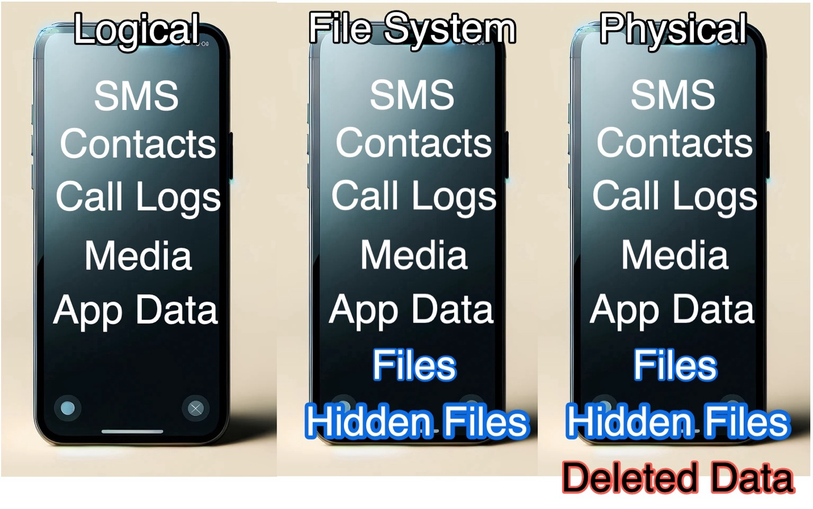Figure 4.2: Acquisition types and the data associated with each extraction type

File System Acquisition
When examining a mobile device, a file system collection gives you more data than a logical collection. A file system collection is better than a logical collection as it contains files and folders that make up the apps, settings, user info, and storage on the device.
When dealing with mobile devices, you may encounter different "points of storage." This means you may need to access multiple storage locations when performing a file system collection on a mobile device. One area is typically user-accessible; you will find images, videos, and audio files. A different storage location is often internal and not directly accessible to the user and contains application data, system log files, and documents. Let’s look at the Media Transfer Protocol next.

Media Transfer Protocol
Media Transfer Protocol (MTP) is a method used to transfer files between devices and computers. It's an extension of the Picture Transfer Protocol (PTP), developed by Microsoft to allow modern devices like smartphones, tablets, and digital cameras to communicate with a computer system for file management. Unlike its predecessor, the USB Mass Storage (MSC) protocol, MTP allows you to transfer files without giving the computer full control over the device's storage. MTP operates at the file level rather than the storage (block) level. This approach allows a more controlled interaction with the device, enabling operations like transferring photos, music, and other files without needing the device's storage to be unmounted from the device itself. It also prevents file system compatibility issues, as MTP does not require the device's file system to be accessible by the computer's operating system.
One of MTP's main benefits is its support for arbitrary metadata. This allows the transfer of file metadata, such as album names for music files or image capture dates for photographs. This capability makes MTP particularly useful for media devices, where file organization and metadata are crucial for a good user experience.
Metadata is data that describes other data. In the context of mobile devices, metadata provides information about the data stored on the device, such as files, photos, messages, and app data. This information can include file names, creation dates, modification dates, file types, file sizes, camera settings for images, GPS coordinates for photos and videos, etc.
Metadata can be a valuable source of information for your investigation. It can help you establish a timeline of events, determine the origin or ownership of a particular file, or even reveal the user's location at a specific time.
For example, when you analyze a photo taken with a smartphone, the metadata embedded within the image file (called EXIF data) can tell you the date and time the photo was captured, the device model used, the camera settings, and even the GPS coordinates of where the photo was taken, if the user enabled location services, as shown in Figure 4.3.
When investigating a document found on a mobile device, metadata can provide insights into when the file was created, last modified, and by whom. This information can be crucial in establishing the document's authenticity and provenance.
In addition to file-specific metadata, mobile devices also store system-level metadata, such as call logs, message timestamps, app usage data, and network connection records. This metadata can help you understand the user's behavior, communication patterns, and device usage habits.
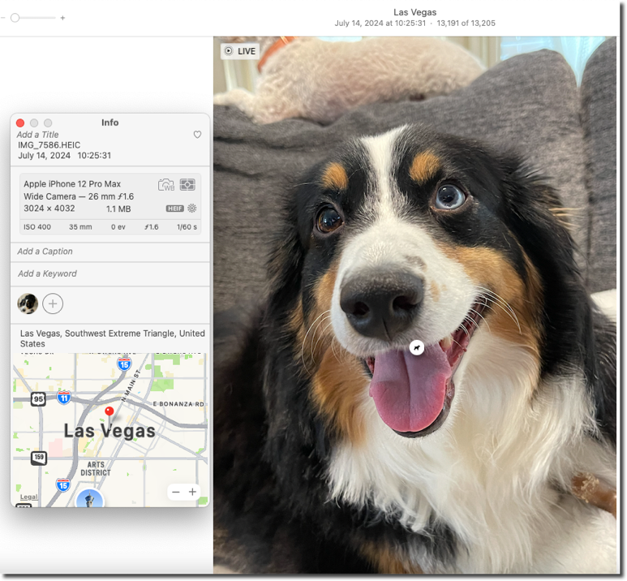Figure 4.3: Detailed metadata and image view of a dog
The image depicts a happy, black, brown, and white dog. The metadata panel to the left provides comprehensive details about the photo, including the file name (IMG_7586.HEIC), capture date and time (July 14, 2024, at 10:25:31 AM), and location (Las Vegas, Southwest Extreme Triangle, United States). The camera is an Apple iPhone 12 Pro Max, with specific camera settings like a 26 mm wide camera lens, f/1.6 aperture, and 3024 x 4032 resolution. The image size is 1.1 MB. The map at the bottom also pinpoints the exact location where the photo was taken (a user can alter this.)
While MTP provides flexibility and maintains device usability during file transfers, it can be slower than MSC. Also, be aware that some devices may require specific drivers and software. The next protocol is the Picture Transfer Protocol.

Picture Transfer Protocol
Picture Transfer Protocol (PTP) was developed by the International Imaging Industry Association (I3A) to allow direct communication between devices and hosts for transferring photos. PTP uses USB to transfer photos and videos without needing a separate device driver. When you connect a PTP-enabled device to a computer, the computer recognizes it as a digital camera, and you can use the operating system's built-in photo transfer software to import the images.
A key difference between PTP and MTP is that PTP is focused on transferring photos and videos. MTP is designed to handle a wider range of files, including music and documents. Many modern mobile devices support both protocols; some even use PTP to implement MTP.
When you encounter a device using PTP during a mobile forensic investigation, you can use the protocol to transfer photos and videos from the device to your examination computer. This can be useful for previewing and triaging the device's media content before deciding whether a more comprehensive file system extraction is necessary.
While PTP provides access to the device's photos and videos, it may not allow you to access other files or system data. Depending on the device and the specifics of your investigation, you may need to use other methods, such as MTP or physical acquisition techniques, for a more complete extraction.

Physical Acquisition
You have two main options for physically extracting a mobile device: non-invasive and invasive methods. These methods allow you to access unallocated space on the device, which can be valuable for your investigation, although more devices are using encryption to protect user data.

Non-Invasive Physical Extraction
Non-invasive physical extraction, also known as physical (non-intrusive), does not require disassembling the phone to acquire a full physical download of the phone's data. Several tools, such as Cellebrite UFED, Oxygen Forensic, and MSAB XRY, are available for physical extractions.
When conducting a non-invasive physical extraction, you communicate with the device through a client that can access and export a forensic image of the flash storage media. You may need to install software on the device to gain root permissions or access the media. Remember that installing software can overwrite deleted data in unallocated space. This may be a necessary sacrifice to obtain the dataset as a whole, and it will not create or alter historical user activity stored on the device.
Another non-invasive method involves replacing the device's Bootloader or system firmware with custom versions that allow direct access to the storage media. Since user data is not stored in these file system areas, no user data is altered during this process. Some forensic tools can upload the Bootloader directly into the phone's RAM to gain the appropriate access. This should only be performed by a trained mobile device examiner in a digital forensic examination. Their expertise ensures the process is conducted correctly, minimizing the risks and maintaining the integrity of the data under investigation.

Invasive Physical Extraction
Invasive physical extraction requires disassembling the device to access the Printed Circuit Board (PCB). This method has two primary extraction types: JTAG and ISP. JTAG (Joint Test Action Group) is a diagnostic connector method present on the main PCB of many mobile devices. Although designed for the PCB manufacturer to conduct file transfer testing, examiners can use this connection system. JTAG is designed to transfer very small files, making the acquisition process very slow. Flasher boxes provide the interface for communication between the device and your computer.
A flasher box is used for communicating with the mobile device. It is a translator and command center that connects directly to the JTAG Test Access Port (TAP) on the phone's circuit board. The forensic software sends instructions, which the flasher box converts into signals the device's memory chip can understand. This allows you to read memory areas, make changes, or even erase data. These boxes work at a low level, so there's a risk of accidentally damaging data if they are used incorrectly.
In-System Programming (ISP) utilizes soldering to connect to points (pinouts) on the board, which are aligned to direct electrical pathways connecting to the memory chip. ISP acquires data faster than JTAG and is supported on mobile devices that use memory chips with an embedded flash controller (eMMC, eMCP, and UFS). During an ISP acquisition, power is provided directly to the flash memory chip, and commands are sent via the embedded flash controller.
JTAG and ISP extractions are more complex and demanding than other methods, requiring extensive training and experience. Many of the tools used for these extractions were not initially developed with forensic applications in mind, so only trained examiners should attempt to use them. An incorrect operation or misstep could potentially modify or delete data stored in the flash memory, compromising the integrity of the evidence. Data extracted through JTAG and ISP is typically in its stored state, meaning that if the data is encrypted, the forensic image will also be encrypted.

Cloud Acquisition
Mobile cloud computing integrates mobile networks with cloud technology, enabling apps and user data to be stored on remote servers instead of locally on mobile devices. This data can be distributed across servers in different countries, ignoring national and international boundaries.
Cloud storage opens up a world of opportunities for mobile app developers, enabling them to break free from the constraints imposed by mobile devices' limited memory capacity. With the evolution of mobile apps, users can now access their data seamlessly, blurring the line between data stored locally on the device and data hosted on remote cloud servers.
When investigating a mobile device, pay attention to the potential gold mine of cloud-based data that may be left behind. Artifacts like browser cache files can provide valuable clues about the user's activities, helping you reconstruct a timeline of events. These seemingly insignificant traces can be the key to unlocking the full story of what transpired on the device. Dropbox, Google Docs, OneDrive, and other file storage/saving services operate in the Cloud. If a file can be stored on a local device and in the Cloud, it's considered a cloud application or service. This concept also applies to apps such as Telegram, WhatsApp, Viber, and Messenger, which store and offer their services via remote servers (the Cloud) to users.
When discussing native and cloud mobile apps, you should recognize their differences. A native mobile app's environment is the mobile device, while a cloud mobile app uses a cloud server. The native app doesn't require a built-in browser to display its contents, while the cloud-built app relies on a built-in browser and a server-side code base.
To determine if an app uses cloud services, you can perform a simple test: if you install the app on another device or uninstall and reinstall it on the same device, is the app data, settings, and user information still visible? If so, the app uses the Cloud to store data. The data will likely be stored on the Cloud.
Consider the following scenario, where a suspect has used multiple mobile devices to commit their crimes and the devices are not available for physical examination. By identifying and accessing the suspect's cloud accounts linked to these devices, you can collect data from multiple sources, creating a comprehensive picture of their activities and helping to build a case. In this type of incident, you don't need a physical mobile device for the cloud-based investigation. When focusing on cloud investigations, the attention is on data being stored in cloud services, not the device itself.
As an investigator, you must stay informed about the security measures implemented by device manufacturers, cloud service providers, and app developers. With the advent of passwords, biometrics, PINs, and the exclusion of app databases from backups, obtaining a complete extraction of user data has become increasingly challenging.
One important aspect to consider when accessing cloud services is the notifications feature. Cloud services typically notify users about access attempts from unrecognized devices. As an investigator, you need to consider these notifications when using tools to access a cloud account, especially if you're attempting to covertly access a subject's account.
Cloud accounts employ security mechanisms such as username and password combinations, tokens, biometrics, and data encryption. To access the dataset, you'll need to authenticate yourself and, potentially, provide a second form of authentication (Two-Factor Authentication (2FA)). 2FA has become the standard authentication method for many mobile apps, requiring two forms of identification to verify the user's identity. The simplest form of 2FA with mobile devices typically involves receiving an SMS or a phone call on the device where the app is installed.
Authentication tokens represent another method of accessing cloud services. After a user on an authorized device successfully authenticates with an app or cloud server, the service issues a token, allowing the user to access the service without needing to re-enter their username and password. Most tokens expire after a set duration, which varies by app or cloud server. The advantage of using authentication tokens over usernames and passwords is that they do not trigger account owner notifications, and 2FA is bypassed.
As an investigator, keeping up with the latest security measures implemented by device manufacturers and app developers is crucial. Adapting your investigative techniques is essential for successfully extracting user data from mobile devices and cloud services.

Forensic Tool Choice
Your ability to extract cloud data may be crucial to the success or failure of your investigations. While you may have access to a number of different tools, it's important to understand that each tool will come with its own set of features and limitations. In some cases, performing a cloud extraction may require the purchase of an "add-on" feature for your forensic software.
You must understand each tool's particular nuances. For example, not every tool can handle two-factor or multi-factor authentication. When evaluating a tool, consider which cloud services it can access and how granular the data extraction can be. This level of detail can be important when the investigation is bound by data type or temporal restrictions. Filtering is one of the most valuable features a tool can offer. If you're only cleared to pull pictures or movies from the cloud storage or need to focus on a dataset from a specific timeframe, having a tool that allows you to apply these filters can improve your efficiency. The ability to filter out non-pertinent data types will also help avoid getting overwhelmed with data.
Choosing the right tool is more than just checking off a list of features. It's about understanding how the tool fits into the bigger picture of your investigation, meets legal requirements, and makes the best use of your time. Your choices regarding your tools can impact the success of your investigations.
When selecting a tool, consider the following factors:
- Compatibility with the different cloud services
- Ability to handle different authentication methods, including two-factor and multi-factor authentication
- The granularity of data extraction
- Filtering capabilities to narrow down data based on type or timeframe
- Ability to meet any requirements or restrictions
- Ease of use and integration with your existing workflow
- Cost and potential return on investment (for non-law-enforcement examiners)
You need to evaluate your options and select the tool that best fits your needs; this will enhance your effectiveness as a mobile forensics investigator and ensure that your cloud data extractions are thorough, efficient, and legally compliant. Let’s talk about Magnet AXIOM.

Magnet AXIOM
Let’s use AXIOM to perform a cloud acquisition. Magnet AXIOM is a commercial tool for acquiring and analyzing evidence from computers, mobile devices, and cloud data sources. AXIOM's mobile acquisition features support mobile operating systems, including iOS and Android, and services like iCloud, Google Drive, Dropbox, and Microsoft OneDrive. The software can acquire data from jailbroken and non-jailbroken iOS devices and Android devices with or without root access.
AXIOM's cloud acquisition relies on having the correct credentials or tokens for the target account. It can recover various data types, including documents, photos, videos, etc. AXIOM's ability to access cloud-based data sets may prove vital if the physical device is unavailable or damaged. AXIOM categorizes and organizes the extracted data, making it easier to locate and analyze. It also provides the ability to search and filter, so you can sift through large volumes of data and focus on the information that matters most to your investigation—using the built-in analytics tools to help you uncover patterns, relationships, and hidden connections within the data. The timeline feature allows you to visualize the chronology of events based on mobile and cloud data, giving you the context of the user's activity for the recovered artifacts.
AXIOM uses separate programs, one for acquiring data and one for processing, called AXIOM Process and AXIOM Examine. When you start AXIOM Process, it will ask you for the standard information about the case, such as name, investigator, evidence paths, etc. Then it will ask you for the evidence source, as shown in Figure 4.4.
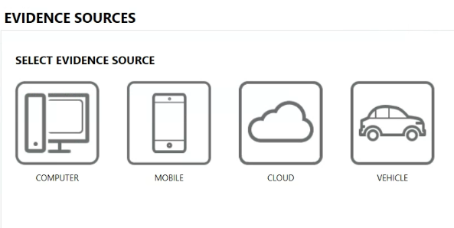Figure 4.4: AXIOM Process evidence source menu
AXIOM Process will process different source types, which I like as it gives me greater functionality as an investigator. For our purposes, we will select the CLOUD icon. The next screen, as shown in Figure 4.5, gives the option of acquiring evidence or loading evidence that has already been collected.
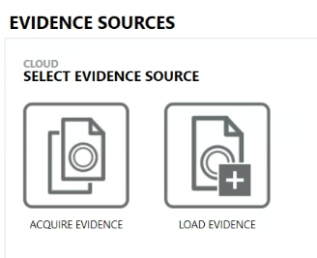Figure 4.5: AXIOM Process SELECT EVIDENCE SOURCE menu
In Figure 4.6, you will select the specific cloud evidence sources you wish to access. You can choose from a variety of cloud platforms: Apple, Box.com, Dropbox, Facebook, Google, IMAP/POP Email, Instagram, Lyft, MEGA, Microsoft Account, Twitter, Uber, and WhatsApp.
To proceed, you must indicate that you have a proper search authorization. This is indicated by the checkbox at the top of the screen, which states, "I have proper search authorization to access the target's information stored in the cloud."
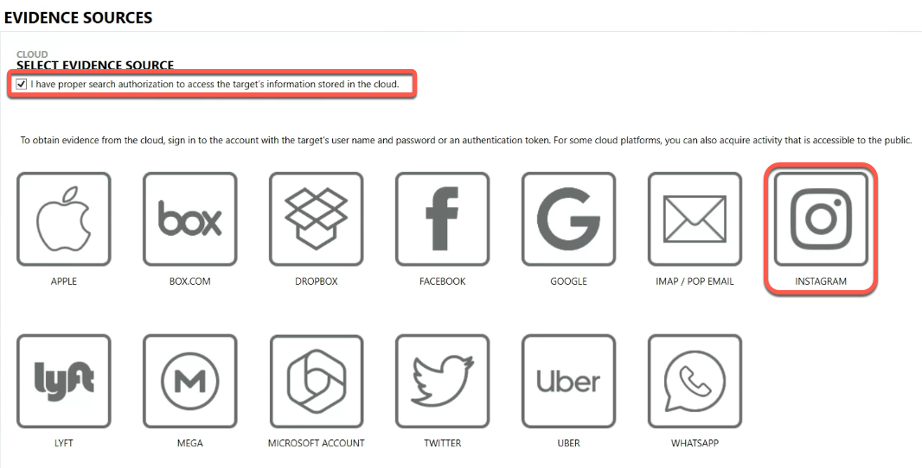Figure 4.6: AXIOM Process cloud service provider screen
I have selected Instagram as the source of the cloud dataset. After selecting Instagram as the cloud evidence source in AXIOM Process, you are presented with the SELECT INSTAGRAM ACQUISITION METHOD screen (shown in Figure 4.7). This step requires you to choose between two acquisition methods for Instagram data: PUBLIC ACTIVITY or USER ACCOUNT.
The PUBLIC ACTIVITY option allows you to acquire Instagram activity that is accessible to the public without the need for account credentials. This method is useful when gathering publicly available information from a target's Instagram profile, such as their posts, comments, and likes. It's important to remember that this option will not provide access to private or restricted content.
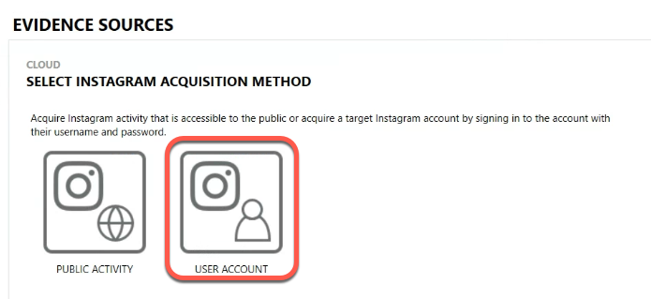Figure 4.7: AXIOM Process Instagram acquisition method menu
The USER ACCOUNT option allows you to acquire data from the target's Instagram account by signing in with their credentials (username and password). This method allows you to collect private messages, stories, and other account-specific information that may not be publicly accessible. Since we have the target's credentials, I have selected the USER ACCOUNT option.
The next screen is the Instagram login screen, as shown in Figure 4.8.
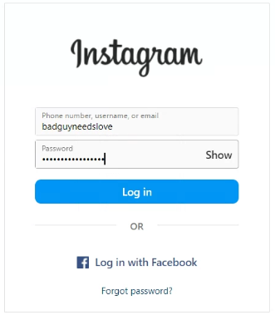Figure 4.8: Instagram login screen
After selecting the USER ACCOUNT acquisition method for Instagram, you will be presented with a login screen that requires entering the target's Instagram credentials. The screenshot shows the Instagram login page, where you need to provide two key pieces of information:
- Username, email, or phone number: In the first field, you should enter the target's Instagram username, email address, or phone number associated with their Instagram account.
- Password: Enter the target's Instagram password in the second field.
The login screen also has the Log in with Facebook option. You may choose this option if the target's Instagram account is linked to their Facebook account. You will be required to provide the target's Facebook login credentials.
Once you have entered the correct Instagram username (or email) and password, click the Log in button to proceed with the acquisition. AXIOM Process will then use these credentials to access the target's Instagram account and acquire the available data.
After successfully logging into the target's Instagram account, you will be presented with the SELECT INSTAGRAM USER ACCOUNT SERVICES screen, shown in Figure 4.9. This screen lets you choose the acquisition's specific data types and date ranges.
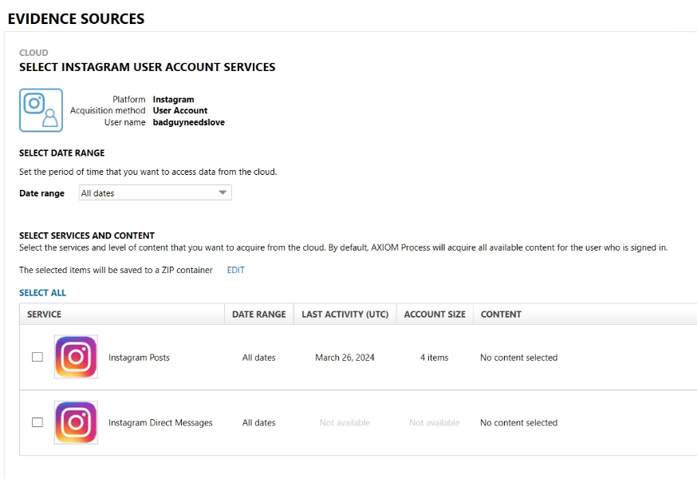Figure 4.9: AXIOM Process SELECT INSTAGRAM USER ACCOUNTS SERVICES screen
At the top of the screen, you will see the selected platform (Instagram), acquisition method (User Account), and the target's Instagram username (badguyneedslove).
The next section is the SELECT DATE RANGE section, which lets you set the period for the data you want to acquire. By default, All dates is selected, meaning AXIOM Process will obtain all available data from the target's Instagram account. You can customize the date range by choosing a specific start and end date if you wish to narrow down the scope of the acquisition.
Below the date range selection, you will find the SELECT SERVICES and CONTENT section. You can specify which types of Instagram data you wish to acquire. By default, AXIOM Process will acquire all available content for the signed-in user. The selected items will be saved to a ZIP container.
In the screenshot, there are two Instagram data types available for selection:
- Instagram Posts: This option will acquire the target's Instagram posts for the specified date range. The last activity, March 26, 2024, indicates the most recent date when the target made a post. The account size, displayed as four items, represents the total number of posts available for acquisition.
- Instagram Direct Messages: This option will acquire the target's Instagram direct messages for the specified date range. The screenshot does not show the last activity and account size, suggesting there may be no direct messages to acquire.
Select the desired data types to acquire by checking the boxes next to each item. To acquire all available data types, ensure that both Instagram Posts and Instagram Direct Messages are selected. Click the Next button to proceed with the acquisition process. AXIOM Process will then acquire the selected Instagram data based on your chosen date range and data types.
After selecting the desired Instagram data types and specifying the date range, you will be directed to the EVIDENCE SOURCES screen in AXIOM Process. This screen, shown in Figure 4.10, provides an overview of the evidence sources that will be added to your case.
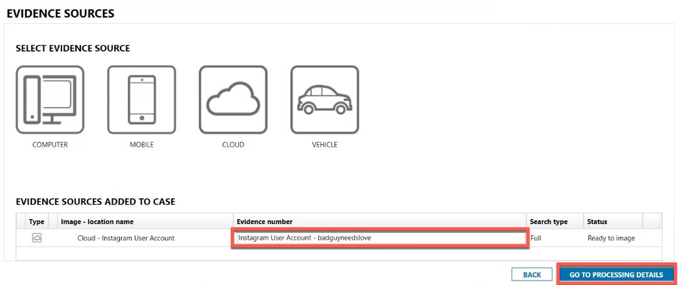Figure 4.10: AXIOM Process EVIDENCE SOURCES screen
In the EVIDENCE SOURCES ADDED TO CASE section, you will find the Instagram user account you selected for acquisition. The evidence source is listed as Cloud - Instagram User Account, with the Evidence number field displaying Instagram User Account - badguyneedslove. This confirms that you have chosen to acquire data from the Instagram account associated with the username badguyneedslove.
The search type for this evidence source is set to Full, meaning that AXIOM Process will perform a full acquisition of the selected Instagram data types within the specified date range. The status of the evidence source is shown as Ready to image, confirming that the Instagram user account has been successfully added to the case and is prepared for the imaging process.
At this point, you have two options:
- If you need to modify the selected evidence sources or settings, click the BACK button to return to the previous screen.
- To proceed with the acquisition and configure additional processing options, click the GO TO PROCESSING DETAILS button. This will take you to the next step in the acquisition workflow, where you can customize the processing settings and initiate the imaging of the selected Instagram account.
- After confirming the selected evidence sources on the previous EVIDENCE SOURCES screen, you will proceed to the PROCESSING DETAILS screen in AXIOM Process. This screen allows you to customize the processing options for your case and use advanced features to enhance your investigation (shown in Figure 4.11)
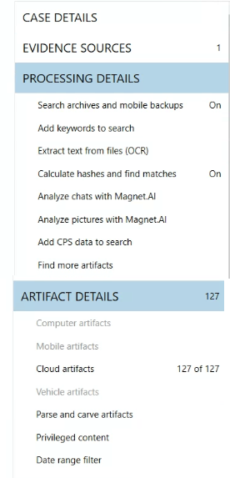Figure 4.11: AXIOM Process Screen for Processing and Artifact Details
The PROCESSING DETAILS section provides several options that you can enable or disable based on your requirements:
- Search archives and mobile backups: This option allows AXIOM Process to search within archived files and mobile backup data.
- Add keywords to search: You can specify keywords that AXIOM Process will search for within the acquired data.
- Extract text from files (OCR): Enabling this option will perform Optical Character Recognition (OCR) on image files to extract text content.
- Calculate hashes and find matches: AXIOM Process will calculate hash values for the acquired files and attempt to find matches against known hash databases.
- Analyze chats with Magnet.AI: This feature uses artificial intelligence to analyze chat conversations and identify potentially relevant information.
- Analyze pictures with Magnet.AI: Like chat analysis, this option employs AI techniques to analyze pictures and detect significant content.
- Adding CPS Data to Search: To help protect children targeted by suspects using the internet, the Child Rescue Coalition's Child Protection System (CPS) collects online data tracking person-to-person activity, such as IP addresses, file hashes, user GUIDs, and more. You can include CPS evidence in your search within AXIOM Process or add evidence from CPS to your case in AXIOM Examine.
- Find more artifacts: To search for artifacts that Magnet AXIOM doesn't currently support.
Below the processing options, you will find the ARTIFACT DETAILS section, which provides an overview of the number of artifacts found in the different categories. The focus is on the Cloud artifacts category, showing that 127 artifacts have been selected. Figure 4.12 shows the SELECT ARTIFACTS TO INCLUDE IN CASE screen in AXIOM Process, focusing on the Cloud Artifacts section. This screen allows you to choose which specific cloud artifacts you want to include in your case.
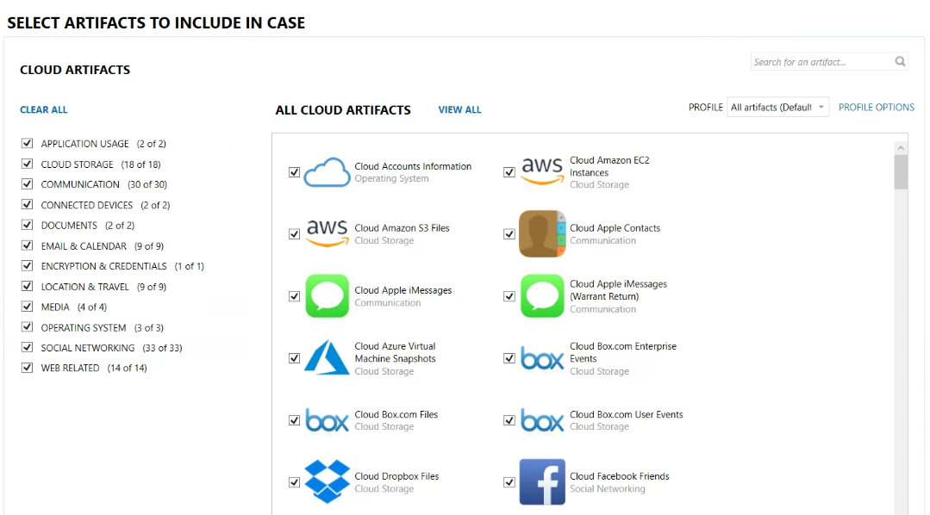Figure 4.12: AXIOM Process cloud artifacts selection menu
The left side of the screen displays various categories of cloud artifacts:
- APPLICATION USAGE
- CLOUD STORAGE
- COMMUNICATION
- CONNECTED DEVICES
- DOCUMENTS
- EMAIL & CALENDAR
- ENCRYPTION & CREDENTIALS
- LOCATION & TRAVEL
- MEDIA
- OPERATING SYSTEM
- SOCIAL NETWORKING
- WEB RELATED
Each category has a checkbox that you can select or deselect to include or exclude all artifacts within that category. The right side of the screen shows an example of the specific cloud artifacts from different cloud services. Each cloud artifact has a checkbox next to it, allowing you to select which artifacts you want to include in your case. While including every available artifact is tempting, it can lead to longer processing times. Consider the specific needs of your investigation and select the artifacts most likely to contain pertinent information.
Figure 4.13 shows the next three options when going through the workflow. The following sections are separate, but I have combined them for readability.
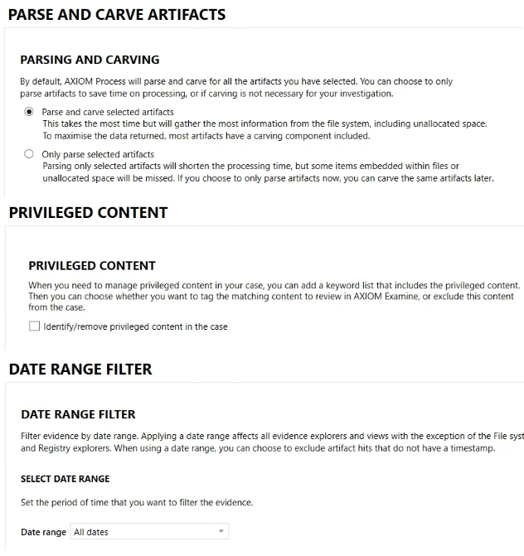Figure 4.13: AXIOM Process screens for PARSING and CARVING, PRIVILEGED CONTENT, and DATE RANGE FILTER
PARSING and CARVING:
AXIOM Process offers two options for parsing and carving artifacts:
- The Parse and carve selected artifacts option is the most thorough and time-consuming. It will dig deep into the file system, including unallocated space, to extract as much information as possible from the selected artifacts.
- Only parse selected artifacts: This option will parse only the selected artifacts, shortening the processing time. However, some items embedded within files or unallocated space will be missed.
You can choose the appropriate option based on your investigation requirements and time constraints.
PRIVILEGED CONTENT:
When managing privileged content in a case, you can add a keyword list that includes the privileged content. You can choose whether to tag the matching content to review it in AXIOM Examine or exclude this content from the case entirely.
DATE RANGE FILTER:
The date range filter allows you to filter evidence by date range, affecting all evidence explorers and views except the File System and Registry explorers. When using a date range, you can exclude artifacts without a timestamp.
To set the date range, you can select the desired period to filter the evidence.
The next figure (4.14) shows the ANALYZE EVIDENCE screen in AXIOM Process, the final screen before the program begins processing the selected evidence sources.
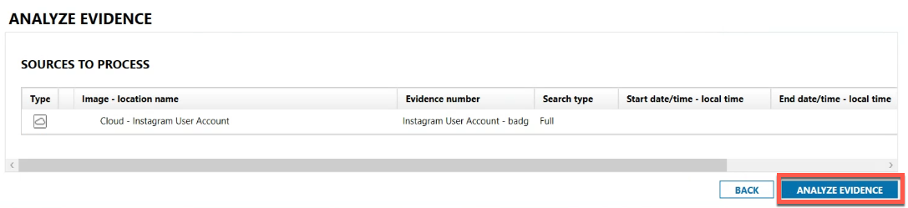Figure 4.14: AXIOM Process final step before processing screen
The SOURCES TO PROCESS section displays a summary of the evidence sources that have been selected for processing. In this case, one evidence source is mentioned:
- Type: Cloud - Instagram User Account
- Image - location name: Cloud - Instagram User Account
- Evidence number: Instagram User Account - badguyneedslove
- Search type: Full
- Start date/time - :local time:
- End date/time - local time:
This information confirms that the user has selected to process a cloud acquisition of an Instagram user account belonging to the user badguyneedslove. The search type is set to Full, indicating that all available data from the account will be processed.
At this stage, you have two options:
- Click the BACK button to return to the previous screens and modify the selected evidence sources, processing details, or other settings.
- Click the ANALYZE EVIDENCE button to process the selected evidence source(s) with the chosen settings.
The next figure (4.15) shows the Case Dashboard view of the Magnet AXIOM Examine user interface. This screen appears automatically when evidence processing is initiated in AXIOM Process. The Case Dashboard provides an overview of the case and the evidence that has been processed.
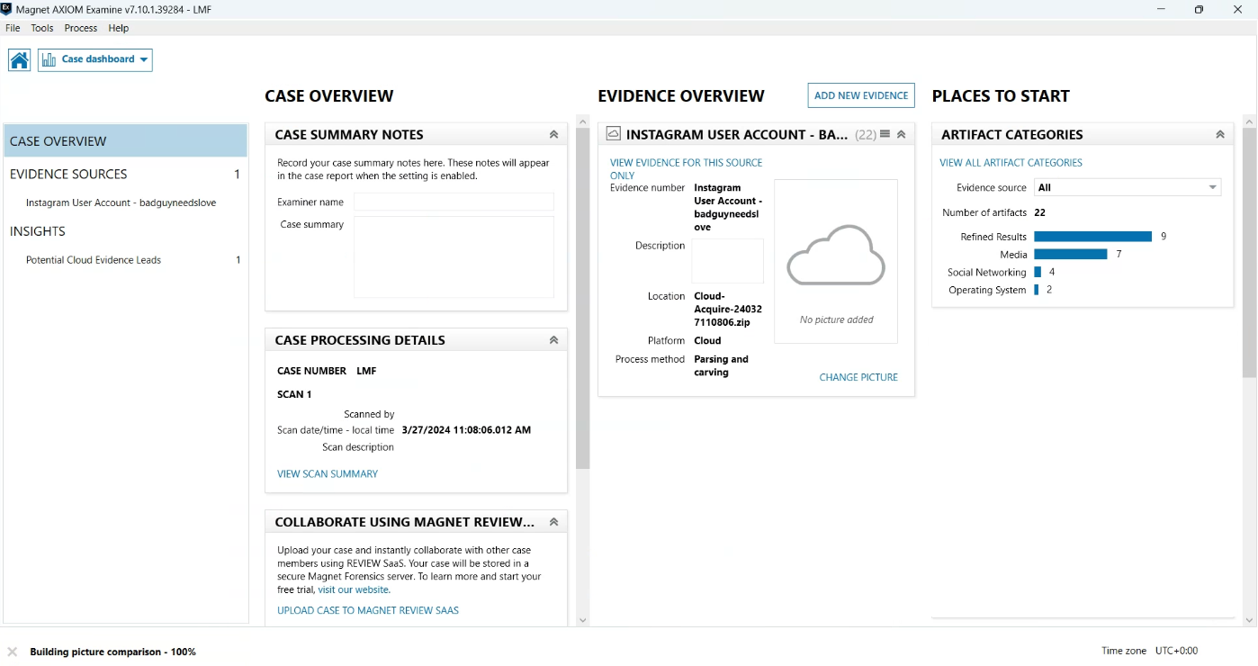Figure 4.15: AXIOM Examine Case Dashboard screen
It is divided into several sections:
- CASE OVERVIEW: This section displays the number of evidence sources (1 in this case) and potential cloud evidence leads (1).
- CASE SUMMARY NOTES: This area allows users to record case summary notes that appear in the case report when the setting is enabled.
- EVIDENCE OVERVIEW: This section lists the sources of evidence that were processed, in this case, an Instagram user account belonging to badguyneedslove. The location, platform, and process method (parsing and carving) are also displayed.
- INSIGHTS: The INSIGHTS section shows the number of artifacts found in various categories, such as Media (7), Social Networking (4), and Operating System (2). The total number of artifacts is 22, with 9 refined results.
- CASE PROCESSING DETAILS: This section provides information about the case, including the case number (LMF), scan date/time, and scan description.
The Case Dashboard is the central hub for navigating and managing the processed evidence. You can access the various tools and features to analyze the evidence and generate insights relevant to your investigation.
Figure 4.16, a screenshot from Magnet AXIOM Examine, displays the evidence artifacts recovered from a cloud acquisition, the Instagram user account belonging to badguyneedslove.
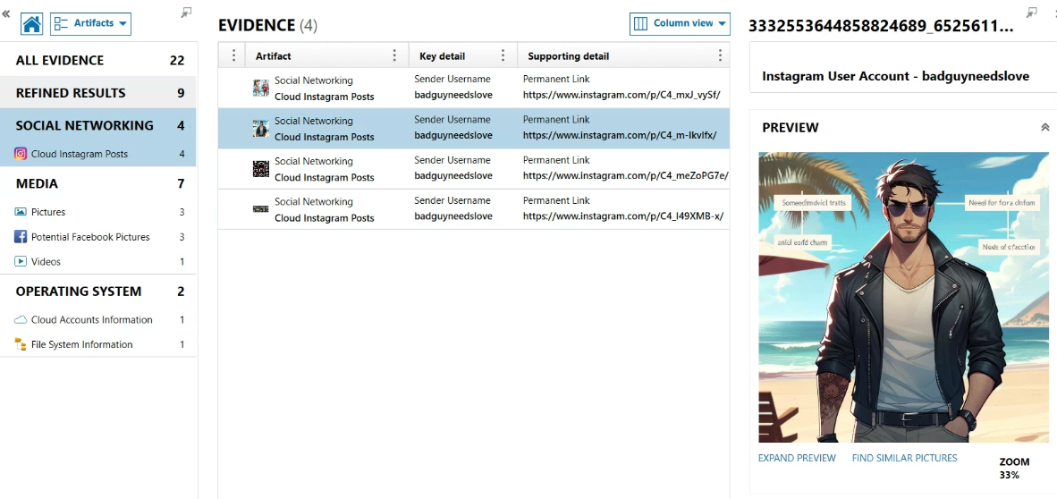Figure 4.16 AXIOM Examine Artifact Screen
The left panel of the interface shows the artifact categories and the number of artifacts found in each category. The SOCIAL NETWORKING category has been expanded to reveal 4 Cloud Instagram Posts artifacts.
The main panel provides a detailed view of the recovered evidence. It lists the individual artifacts, their key details, and supporting information. In this case, the artifacts are Instagram posts, and the key details are:
- Artifact type: Social Networking
- Key detail: Sender Username (badguyneedslove)
- Supporting detail: Permanent Link (URLs to the specific Instagram posts)
The right panel displays a preview of the selected artifact. It shows a picture used by the user in an Instagram post that features a picture of a man in a leather jacket standing on a beach. The panel provides options to expand the preview, find similar pictures, and zoom in on the image. That is a lot to go through. Let’s summarize what you have learned in this chapter!

Summary
In this chapter, you explored the various methods for acquiring data from mobile devices, including logical, file system, physical, and cloud acquisitions. You learned about each acquisition type's capabilities, limitations, and use cases. Logical acquisitions allow you to extract user-accessible data without accessing deleted data, while file system acquisitions provide a more comprehensive view of the device's artifacts. Physical acquisitions enable you to access all data on the device, including unallocated space, but may require you to use more advanced techniques such as JTAG or ISP.
You discovered that cloud acquisitions have become increasingly important as mobile apps rely heavily on cloud storage. You examined the challenges of accessing cloud data, such as security measures and authentication methods, and the importance of using appropriate tools to handle these obstacles. You also followed a step-by-step guide on performing a cloud acquisition using Magnet AXIOM, using the tool's ability to acquire and analyze data from an Instagram account.
Understanding the strengths and limitations of each acquisition method is crucial for an investigator when gathering relevant evidence. Choosing the right tools and techniques based on the specific case requirements is essential for mobile forensic investigations.
While this chapter focused on the acquisition process with mobile devices, you need to recognize that mobile forensics presents distinct challenges compared to traditional computer forensics. In the next chapter, Chapter 5, Mobile vs. Computer Devices, you will explore the key differences between these two domains.

Questions
- What is the most basic form of data collection from a mobile device?
  - Logical acquisition
  - File system acquisition
  - Physical acquisition
  - Manual extraction
- Which acquisition method allows you to access deleted data on a mobile device?
  - Logical acquisition
  - File system acquisition
  - Physical acquisition
  - Cloud acquisition
- Which protocol transfers files between mobile devices and computers, allowing users to transfer files without giving the computer full control over the device's storage?
  - USB Mass Storage (MSC)
  - Media Transfer Protocol (MTP)
  - Picture Transfer Protocol (PTP)
  - File Transfer Protocol (FTP)
- What does JTAG stand for in the context of physical acquisition?
  - Joint Test Action Group
  - Java Tool for Android Forensics
  - Joint Tactical Acquisition Gateway
  - JavaScript Testing and Analysis Group
- Which physical acquisition method utilizes advanced soldering to directly connect to points on the device's circuit board?
  - JTAG
  - ISP
  - Chip-off
  - Micro Read
- What is the main difference between a native mobile app and a cloud mobile app?
  - Native apps don't require a login, while cloud apps do
  - Native apps run on the mobile device, while cloud apps use a cloud server
  - Native apps are always faster than cloud apps
  - Cloud apps don't store any data on the mobile device
- What is a potential issue to consider when accessing a subject's cloud account using forensic tools?
  - The cloud service may notify the account owner about access attempts
  - Cloud services don't employ any security mechanisms
  - Cloud services do not use 2FA
  - Cloud services do not support authentication tokens
- In Magnet AXIOM, which option allows you to acquire Instagram activity that is accessible to the public without the need for account credentials?
  - User Account
  - Private Activity
  - Public Activity
  - Open Source
- What does the Parse and carve selected artifacts option do in AXIOM Process?
  - It parses only the selected artifacts, reducing processing time
  - It extracts the most information, including data from unallocated space
  - It ignores deleted data and focuses only on active files
  - It doesn't extract any data from the file system
- What information does the Insights section in the AXIOM Examine Case Dashboard provide?
  - The number of evidence sources and cloud evidence leads
  - The number of artifacts found in various categories
  - Detailed information about the case, such as case number and scan time
  - Case summary notes entered by the investigator

Answer Key
- d
- c
- b
- a
- b
- b
- a
- c
- b
- b

5 Mobile versus Computer Devices
Join our book community on Discord
https://packt.link/SecNet
You are moving into the specialized and sometimes frustrating world of mobile device forensics. If you have experience as a computer forensic examiner moving to this field, you'll quickly see that it's a new game with different rules and expectations.
With computers and traditional storage devices, you have common file system formats and well-documented operating systems (OSs). Understanding the current file and OS artifacts is pretty straightforward. With mobile devices, you may face a legacy device running a unique OS without official documentation. How do you go about conducting the examination with little to no information about the device?
While writing this chapter, the following request was made on a listserv I monitor:
I am looking for information on a Nokia / Tracfone N139DL by HMD. The device is running an unknown version of KaiOS. It has a 4-digit passcode and is not supported by Cellebrite UFED. The generic KaiOS requires ADB access. You get 5-6 attempts at the passcode. I am looking for information about a profile that might get through the passcode and/or get some data.
After two months, the issues still haven’t been resolved.
Mobile device storage media may look like the typical solid-state drives (SSDs) found in modern computers, but the file system formats and methods for accessing this data are very different. The ability to make a physical image of a mobile device is not as simple as imaging a traditional storage device.
When you get a physical image of a traditional storage device, you capture every bit and byte from the first sector to the last. Getting an exact copy of the storage device's contents is the gold standard in computer forensics. The ability to get a full physical image of a mobile device's internal storage is, in most cases, impossible in today's environment.
The term "mobile device extraction" or “digital forensic extraction” is now commonly used instead of forensic image or copy when creating a copy of the contents of a mobile device. As the world embraces mobility and mobile devices become tiny computers, the forensic process is even more critical for mobile device exams than traditional computer forensics. The many differences and challenges unique to these devices make the process extremely important.
The biggest hurdle is protecting the integrity of mobile device evidence. When corners are cut, training is lacking, or the process is reduced to pushing a button, issues that may snowball into case law can arise.
By staying current with the latest techniques and understanding the ins and outs of mobile devices, you'll be well prepared to uncover critical evidence and make a meaningful impact in your investigations.
The chapter will cover the following topics:
- Understanding the unique challenges and differences between mobile device forensics and traditional computer forensics
- Discovering the challenges faced by computer forensic examiners transitioning to mobile device forensics
- Understanding the importance of having a firm understanding of a mobile device's software and hardware, as well as the limitations and functions of forensic tools
By the end of this chapter, you will understand the unique challenges and considerations in mobile device forensics compared to traditional computer forensics. You will recognize the importance of having a well-defined process and procedure and the need for specialized training and knowledge in the field. You will be equipped with the knowledge to create a comprehensive standard operating procedure document and workflow to guide mobile device investigations from seizure to examination.

Defining Digital Forensics
Digital forensics involves identifying, preserving, examining, and analyzing digital evidence. This evidence may be found on various digital devices such as computers, smartphones, tablets, and storage media. The main goal is to recover, authenticate, and present digital evidence in a way that is legally admissible in court. This process demands an approach that combines your technical expertise with an understanding of legal standards and procedures. You might be called upon to investigate cases involving cybercrime, data breaches, intellectual property theft, or any incident connected to mobile devices. The scope of digital forensics extends across multiple domains, including criminal investigations, corporate inquiries, and civil disputes. Each investigation will require you to tailor your approach to reflect the unique characteristics of the devices and data involved.
Digital forensics is broadly categorized into several subfields, each focusing on different devices and data types. These subfields include computer forensics, network forensics, and mobile device forensics. While the fundamental principles remain consistent across these subfields, your methodologies and tools will vary. Understanding different subfields helps you choose the appropriate investigation tools and techniques. Each device and data storage type presents unique challenges; a one-size-fits-all approach rarely works. Specializing in a particular subfield can help develop the deep technical knowledge required to navigate these challenges.
In many cases, digital evidence spans multiple devices and platforms. A bank robbery investigation, a stalking investigation, or a child abuse investigation may involve data from computers, mobile devices, or cloud storage services. Understanding the different subfields can be critical for ensuring the legal admissibility of digital evidence. Each device and data storage type is subject to specific legal standards and regulations. Understanding different subfields allows you to proactively anticipate and address potential legal challenges. Let's turn our attention to mobile device evidence. You'll find that handling data from mobile devices requires the navigation of a complex legal landscape to ensure your findings stand up in court.

Mobile Devices and Evidence Handling
Handling digital evidence from mobile devices involves navigating complex legal frameworks to ensure the integrity and admissibility of the evidence in court. As a mobile device examiner, you must understand key legal precedents and rules (the following are US-based requirements; your jurisdiction may have differing requirements), including Frye v. United States, Daubert v. Merrell Dow Pharmaceuticals, Inc., and Federal Rule of Evidence 702. These legal standards govern the admissibility of expert testimony and the handling of digital evidence.

Frye v. United States
The Frye standard is from the 1923 case, Frye v. United States, which established a standard for determining the admissibility of scientific evidence. Under this standard, for the evidence to be admissible, it must be based on scientific methods that are generally accepted by the scientific community. This principle ensures that only widely accepted methods and technologies are used in forensic investigations, maintaining the credibility and reliability of the evidence presented.
In the context of mobile device forensics, applying the Frye standard means that the digital forensics community must generally accept the tools and techniques you use. If you use a specific software tool to extract data from a mobile device, that tool should be recognized and validated by other experts in the field. Adhering to this standard helps ensure that the evidence will be considered reliable and admissible in court.
The Frye standard does have some limitations, particularly in the rapidly evolving field of digital forensics, where new tools and techniques frequently emerge. While a method you use might not yet be widely accepted, it could still be scientifically valid and useful. This limitation led to the development of a more comprehensive standard in the Daubert case.

Daubert v. Merrell Dow Pharmaceuticals, Inc.
The 1993 Supreme Court case, Daubert v. Merrell Dow Pharmaceuticals, Inc., refined the criteria for admissibility of expert testimony, shifting the focus from general acceptance to a more flexible reliability standard. The Daubert standard outlines several factors for courts to consider when determining the admissibility of scientific evidence:
- Testability: The technique or theory can be tested and has been tested.
- Peer review and publication: The technique or theory has been subjected to peer review and publication.
- Known or potential error rate: The error rate of the technique or theory is known and acceptable.
- Existence of standards: There are standards controlling the technique's operation.
- General acceptance: The technique or theory is generally accepted in the relevant scientific community.
Applying the Daubert standard to mobile device forensics determines whether the tools and methods you use can withstand scrutiny based on these factors. When presenting data extracted from a mobile device, you should be prepared to demonstrate that the extraction method has been tested, subjected to peer review, has a known error rate, and follows industry standards. This comprehensive approach helps ensure that your evidence is scientifically valid and legally defensible.

Federal Rule of Evidence 702
Federal Rule of Evidence 702 builds on the principles established in Frye and Daubert, providing a detailed framework for the admissibility of expert testimony. Rule 702 states that an expert witness may testify if:
- The expert's knowledge will help the trier of fact understand the evidence or determine a fact in issue.
- The testimony is based on sufficient facts or data.
- The testimony is the product of reliable principles and methods.
- The expert has reliably applied the principles and methods to the facts of the case.
In mobile device forensics, Rule 702 requires you to demonstrate that your expertise, methods, and application of those methods are reliable and relevant to the case. This means you must have a solid foundation of knowledge in mobile device forensics and use established, reliable methods to handle and analyze digital evidence. Your testimony should clearly explain how you applied these methods to the investigation's specific set of facts, ensuring that the court understands and trusts your findings.

Practical Application in Mobile Device Forensics
To meet the legal requirements that Frye, Daubert, and Rule 702 set forth, you should follow best practices in handling mobile device evidence. Here are key steps to ensure compliance:
- Use validated tools and techniques: Ensure that the tools and methods you use for data extraction and analysis are validated and generally accepted by the digital forensics community. This validation can come from peer-reviewed research, certification by recognized bodies, or widespread use by other experts in the field.
- Document your process: Thoroughly document your evidence-handling procedures, from the initial collection to the final analysis. This documentation should include details about the tools and methods used, the steps you took to preserve the integrity of the evidence, and any challenges you encountered. Comprehensive documentation supports the reliability and reproducibility of your findings.
- Maintain chain of custody: Establish and maintain a clear chain of custody for all digital evidence. This involves keeping detailed records of who handled the evidence, when and where it was collected, and how it was stored and transferred. A well-maintained chain of custody helps prevent tampering and ensures the integrity of the evidence.
- Stay informed and updated: Continuously update your knowledge and skills in mobile device forensics. Stay informed about new tools, techniques, and legal developments. Regular training and professional development help you remain proficient and ensure your methods align with current best practices.
- Prepare for testimony: When preparing to testify, be ready to explain your methods and findings clearly and confidently. Understand the scientific principles underlying your techniques and articulate how you applied them to the case. This preparation will help you meet the standards of Daubert and Rule 702, ensuring that your testimony is credible and persuasive.
Understanding and adhering to your jurisdiction's legal requirements is essential for handling mobile device evidence. By using validated tools and techniques, documenting your process, maintaining the chain of custody, staying informed, and preparing for testimony, you can ensure that your findings are reliable, scientifically sound, and legally admissible. Let's compare mobile and computer forensics. While both fields intersect, they diverge in key aspects and present unique challenges.

Overview of Mobile Device Forensics versus Traditional Computer Forensics
While both mobile device forensics and traditional computer forensics are integral components of digital forensics, they differ significantly in their methodologies and challenges. Mobile device forensics focuses on extracting, preserving, and analyzing data from mobile devices such as smartphones, tablets, and wearables. These devices have become ubiquitous, serving as personal communication tools, entertainment hubs, and productivity aids. The data stored on mobile devices is often highly personal and context-rich, including but not limited to text messages, call logs, GPS data, and app usage history.
One of the primary challenges in mobile device forensics is the diversity of OSs and device architectures. Unlike traditional computers, which predominantly run on a few standardized OSs (Windows, macOS, Linux), mobile devices operate on a wide range of platforms, including iOS, Android, and proprietary systems for specific manufacturers. Each platform has its security features, data storage mechanisms, and application structures, requiring you to possess specialized knowledge and tools tailored to each system.
Another challenge in mobile device forensics is the rapid evolution of technology. Mobile devices frequently receive updates, and new models are released regularly, introducing new features and security measures. For instance, modern smartphones often have advanced security features like encryption enabled by default, which protects data at rest, making extracting information without credentials or sophisticated decryption techniques difficult.
Traditional computer forensics focuses on analyzing data from desktop and laptop computers. These devices typically have established and standardized forensic tools and methodologies, reflecting their longer history and more stable technological landscape. Traditional computer forensics involves examining a broad range of data types, including documents, emails, databases, software applications, and system logs.
Data acquisition methods differ between mobile device forensics and traditional computer forensics. In mobile device forensics, data acquisition often relies on logical acquisition, where data is extracted through the device's OS using standard application programming interfaces (APIs), local and cloud backups, or software and hardware exploits. These methods are hindered by security measures such as passwords, PINs, and biometric locks. Traditional computer forensics typically involves imaging the hard drive or storage media to create a forensic copy, which can be analyzed using any number of forensic tools. While the possibility of advanced security features being encountered, such as BitLocker encryption, is still present, they are not enabled by default in most cases, which is a major difference from mobile devices. The physical size and complexity of storage devices in traditional computers also allow for data recovery techniques, including recovering deleted files and analyzing slack space.
Legal and procedural considerations also vary between mobile device forensics and traditional computer forensics. Mobile devices can be subject to stricter privacy regulations and laws, reflecting their highly personal nature.
Riley v. California (2014) is a United States Supreme Court case in which the court ruled that the warrantless search and seizure of the digital contents of a cell phone during an arrest is unconstitutional under the Fourth Amendment.
You must navigate these legal frameworks carefully to ensure evidence collection is lawful and admissible in court. Understanding the legal landscape for each type of device is essential for ensuring the integrity and admissibility of your findings.
Mobile devices and traditional computer forensics present unique challenges and require distinct approaches. Mobile device forensics demands specialized knowledge of diverse OSs, rapid technological advancements, and robust security features. Traditional computer forensics benefits from more standardized tools and methodologies but involves a broader range of data types and storage mechanisms.
By defining digital forensics, emphasizing the importance of understanding different subfields, and providing an overview of the unique challenges and methodologies of mobile device forensics versus traditional computer forensics, you are better prepared to jump into the specifics of each area. As you proceed through this book, you will explore the techniques, tools, and case studies that will equip you with the knowledge and skills needed to excel in this dynamic and essential field.

Technological Landscape
Understanding the technological landscape is fundamental for investigations and analysis in digital forensics. The diversity of OSs in mobile devices presents one of the most significant challenges in mobile device forensics. Unlike traditional computers, which are predominantly dominated by a few major OSs, mobile devices run on a wide array of platforms, each with its architecture, security features, and data storage methods.

iOS
Apple's iOS represents a significant portion of the mobile device market. Its closed ecosystem, stringent security measures, and regular updates create unique challenges and opportunities for you.
iOS is built on a Unix-based architecture derived from macOS, which stems from NeXTSTEP and BSD Unix. This foundation creates a stable environment with some of the complexities associated with Unix systems. Understanding this architecture is crucial for you as it influences how data is stored, managed, and accessed on iOS devices. The architecture of iOS can be broadly categorized into several key layers, as shown in Figure 5.1:
- The Core OS layer
- The Core Services layer
- The Media layer
- The Cocoa Touch layer
Each layer serves specific functions and interacts with the others to provide a seamless user experience.
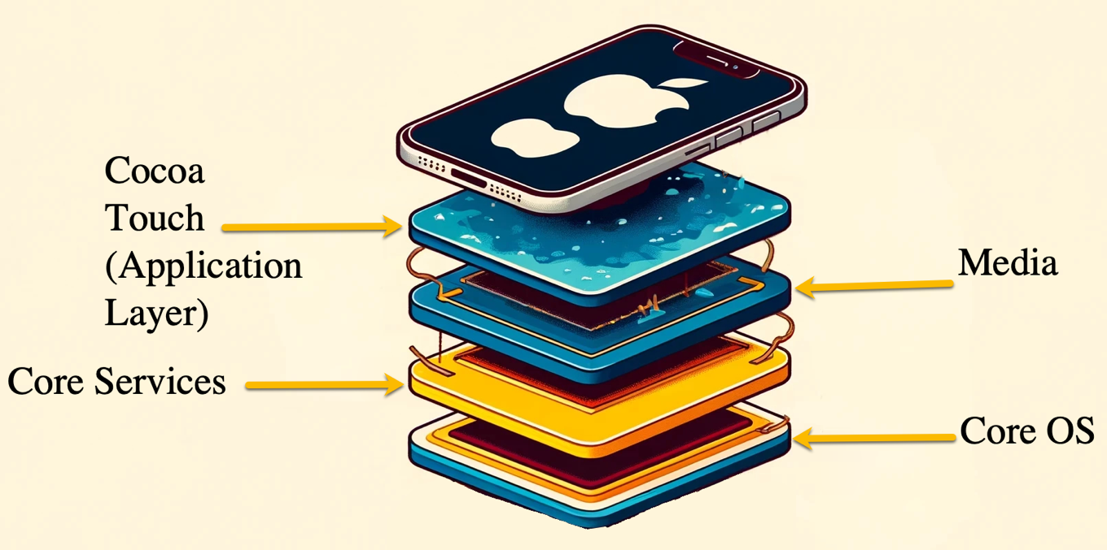Figure 5.1: iOS architecture

Core OS Layer
At the foundation of iOS lies the Core OS layer, which is responsible for the fundamental operations of the device. This layer includes the kernel, device drivers, and low-level system interfaces. Key components of the Core OS layer include:
- Kernel: The iOS kernel is based on the XNU kernel, which combines elements of the Mach kernel and components from FreeBSD. The kernel manages system resources, including memory, processes, and hardware devices. It also handles security features such as sandboxing and address space layout randomization (ASLR), which protect the system from malicious code execution.
- Device drivers: These are specialized software modules that allow the OS to communicate with the hardware components of the device, such as the touchscreen, cameras, and sensors.
- System management: This includes power management, which optimizes battery usage by controlling the power state of the device components, and file system management, which handles data storage and retrieval.
- Security features: The Core OS layer implements key security features, such as secure boot, which ensures that only Apple-signed code can run during the device's boot process, and the Secure Enclave. This secure subsystem handles sensitive tasks like encryption and biometric data processing.

Core Services Layer
The Core Services layer provides essential services and frameworks that support higher-level functionalities. It bridges the Core OS's low-level operations and the system's more user-visible aspects. This is the layer that interacts with iOS apps.
A framework is a reusable, pre-built code library that provides classes, methods, and resources designed to perform specific tasks and simplify development. Frameworks encapsulate functionality related to particular aspects of the OS, such as user interfaces (UIs), graphics, data management, and networking.
They allow developers to leverage existing, well-tested components rather than writing code from scratch, thus promoting efficiency and consistency in app development. Each framework serves a specific purpose and interacts with other frameworks to provide a seamless and integrated environment for app development.
By using frameworks, developers can ensure that their apps are consistent with the overall iOS ecosystem, follow best practices, and leverage the OS's full capabilities. This modular approach enhances development efficiency and improves app performance, security, and maintainability. Some of the frameworks you will encounter are:
- Foundation framework: This framework provides fundamental data types and collections, file handling, networking, and threading capabilities. It forms the backbone for building most iOS applications.
- Core data: This is a powerful framework for managing object graphs and persistent data storage. It allows developers to store data in a relational database, XML, or binary format, making it easier to manage complex data models.
- Core location: This framework provides services for determining the device's geographic location and heading and tracking location changes. Location-based applications and services use this framework.
- Networking: iOS includes networking capabilities, supporting standard protocols (e.g., TCP/IP, HTTP/HTTPS), and higher-level services like Bonjour for zero-configuration networking and Multipeer Connectivity for peer-to-peer communication.

Media Layer
The Media layer handles all multimedia-related tasks, including audio, video, graphics, and animations. This layer provides the frameworks and services to create rich, interactive media experiences. Some key components of the Media layer include:
- Core graphics: This framework provides 2D graphics rendering and image manipulation capabilities. It supports drawing, path-based rendering, transparency, and transformations.
- AVFoundation: This framework handles audio and video playback, recording, and processing. It supports a wide range of multimedia formats and provides advanced features like time-based media manipulation and metadata handling.
- Core animation: This animation framework enables developers to create smooth, high-performance animations and transitions.
- OpenGL ES and Metal: These frameworks provide low-level access to the device's GPU for high-performance 3D graphics rendering. OpenGL ES is a cross-platform API, while Metal is Apple's proprietary graphics API, offering improved performance and efficiency.

Cocoa Touch Layer
The Cocoa Touch layer sits at the top of the iOS architecture and provides the frameworks and services that enable developers to create UIs and interact with device features. This layer includes:
- UIKit: The UIKit framework is the primary interface for building and managing the UI of an iOS application. It provides the classes and infrastructure needed to construct windows, views, controls, and manage touch-based input. UIKit also supports UI elements such as buttons, labels, text fields, and navigation controllers.
- Event handling: This component manages user interactions, including touch, gestures, and motion events. It ensures that user inputs are captured and processed accurately, providing a responsive user experience.
- Multitasking: iOS supports various multitasking modes, allowing apps to run in the background, receive updates, and handle tasks while not in the foreground. This includes background fetch, push notifications, and task completion.
- Other frameworks: The Cocoa Touch layer also includes several other frameworks that provide specialized functionalities, such as the GameKit framework for game development, the HealthKit framework for health and fitness data, and the HomeKit framework for home automation.

Interactions Between Layers
The interaction between these layers is seamless and integral to iOS's functioning. When a user interacts with an app, the touch events are captured by the Cocoa Touch layer and passed down to the appropriate framework for processing. The Core Services layer may handle data storage or networking requests, while the Media layer manages audio or video playback. The Core OS layer ensures that these operations are executed securely and efficiently.
Understanding iOS architecture can be important for you because it dictates how data is stored, managed, and accessed. Knowing that the Secure Enclave handles sensitive information like biometric data can help understand why certain data might be challenging to access. Familiarity with the sandboxing mechanism in the Cocoa Touch layer helps you know how app data is isolated, which can be important for data extraction and analysis.
The closed nature of iOS means that Apple tightly controls hardware and software. This control extends to the App Store, where every application must undergo a rigorous review process before being made available to users. For you, this closed ecosystem implies that standard forensic tools may not always work seamlessly, and specialized knowledge of Apple's development and security practices is necessary.

Security Features
Apple's iOS has security features to protect user data and maintain the system's integrity. These security measures are integral to the OS and present challenges and opportunities for you.

Secure Enclave
The Secure Enclave is a key component of Apple's security architecture, designed to protect sensitive data and perform critical security functions on iOS devices. When you work with devices starting with the A7 chip and newer models, you will find that the Secure Enclave operates independently of the main processor and runs its own microkernel, isolated from the rest of the system. This isolation ensures the Secure Enclave remains secure even if the main OS is compromised. The Secure Enclave generates and manages cryptographic keys used for encryption and decryption, handles the storage and processing of biometric data used in Touch ID and Face ID, and manages the encryption and decryption processes for data stored on the device. iOS relies on the Secure Enclave to authenticate users and authorize access to encrypted data. This ensures that sensitive operations, such as accessing encrypted files or making payments through Apple Pay, are securely authorized using the correct credentials.
The Secure Enclave uses hardware-based encryption to protect data, ensuring that even if an attacker gains physical access to the device, extracting encrypted data without the correct keys is virtually impossible. Each Secure Enclave generates unique keys tied to the device's specific hardware, which are not stored anywhere else and cannot be extracted. The encryption keys managed by the Secure Enclave are entangled with the user's passcode, meaning that even if an attacker obtains the device's hardware, they still need the correct passcode to decrypt the data. The Secure Enclave ensures that only trusted software can run during the device's boot process, verifying the integrity of the OS and preventing unauthorized modifications.
When conducting forensic investigations, you will face significant challenges due to the Secure Enclave. Accessing data protected by the Secure Enclave requires sophisticated tools and techniques. The encryption keys managed by the Secure Enclave are inaccessible, making it difficult to decrypt data without the correct authentication credentials. You will need specialized forensic tools to bypass or exploit vulnerabilities in the Secure Enclave. Since biometric data is stored within the Secure Enclave and is never exposed to the main OS, you cannot access this data, which directly complicates investigations where biometric authentication is involved. The connection of the encryption keys to the user's passcode means that you often need the correct passcode to access encrypted data, and without it, bypassing the Secure Enclave's protections will be extremely challenging.
The Secure Enclave is a key part of iOS security, providing protection for sensitive data and critical security functions. Its advanced features, such as hardware-based encryption, unique device keys, and biometric data protection, ensure the privacy and integrity of user data. These features pose significant challenges for forensic investigators requiring specialized tools and techniques to extract and analyze data.

File Data Protection
When working with iOS devices, one aspect you need to understand is File Data Protection. This ensures that the data remains secure through encryption. In iOS, every file is encrypted using a unique key, and these keys are further protected by a hierarchy of encryption keys stored in the device's Secure Enclave. This layered approach to encryption ensures that even if one layer is compromised, the underlying data remains protected, making it difficult for unauthorized users to access sensitive information.
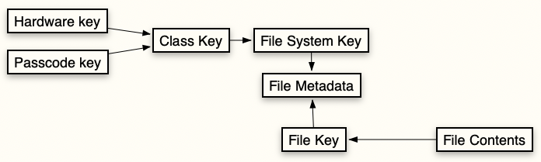Figure 5.2: Encryption flow in iOS file protection
Figure 5.2 illustrates the encryption hierarchy and process used by iOS to protect file data on a device. This multi-layered approach ensures that files are encrypted and can be accessed by authorized users. Here's a breakdown of each component and its role in the process.
The hardware key is derived from the device's unique hardware and ensures that data remains secure even if the device is physically tampered with. This key is integral to the device and cannot be extracted or transferred to another device. The passcode key is generated from the user's passcode, adding a layer of security by ensuring that data remains inaccessible without the correct passcode.
The class key is created using the hardware key and the passcode key. It manages the encryption and decryption of different data classes on the device, ensuring that only authorized users can access specific data. The file system key, derived from the class key, encrypts the overall file system.
Metadata is information about the file, such as its name, creation date, modification date, and other attributes, but not content. The flow of encryption begins with the hardware key and passcode key combining to generate the class key. The class key is then used to create the file system key, which encrypts the file metadata. The file metadata contains the file key, which encrypts the file contents. This hierarchical structure provides security for data stored on iOS devices. Each layer of encryption depends on the previous one, providing multiple layers of protection against unauthorized access. This multi-layered encryption mechanism is critical to iOS security, ensuring user data remains private and secure.
Data Protection categorizes files into four distinct classes, each offering different levels of protection based on the device's lock state and user authentication:
- Complete Protection: This ensures that files are encrypted when locked and can only be accessed when the device is unlocked. This means the data remains inaccessible until the user enters their passcode or uses biometric authentication (such as Face ID or Touch ID). This class is for the most sensitive information, providing a security measure that prevents unauthorized access even if the device is physically compromised.
- Protected Unless Unlocked: This ensures that files are encrypted while the device is locked but remain accessible once the user unlocks the device until the next restart. This balances security and usability, allowing for essential functions without compromising data protection. It enables applications to perform background tasks while the device is locked yet maintains security by requiring user authentication after each restart.
- Protected Until First User Authentication: This is another class where files are inaccessible upon device restart until the user unlocks the device for the first time. After this initial authentication, the files remain accessible even if the device is subsequently locked. This class provides security against attacks immediately after a restart but prioritizes usability once the device is in regular use. This means that while the initial barrier to access is high, regular usage allows functionality without repeatedly prompting the user for authentication.
- No Protection: This class is typically used for files requiring minimal security, such as temporary data or files that do not contain sensitive information. These files are not encrypted, making them accessible regardless of the device's lock state. While this class offers the least security, it is designed for data that does not pose a significant risk if accessed by unauthorized users. It enables the system to operate efficiently without unnecessary encryption overhead for non-critical data.
As a forensic examiner, you frequently encounter these encryption classes when extracting data from iOS devices. Accessing data under Complete Protection usually requires the device to be unlocked, so having the passcode or biometric authentication is essential. Without it, most forensic tools will struggle to decrypt these files. For data in the Protected Unless Unlocked class, timing your forensic acquisition is crucial. Extracting data immediately after the user has unlocked the device can provide access to these files until the next restart.
For data in the Protected Until First User Authentication class, when the device transitions from a locked state (Before First Unlock (BFU)) to an unlocked state (After First Unlock (AFU)), the class keys used for protection are decrypted and stored in memory. These decrypted class keys persist in memory even when the device is subsequently locked again. Once the user has unlocked the device after a restart, the data becomes accessible, allowing you to proceed with your extraction.
Data in the No Protection class can be extracted without any specific authentication. This might include system logs, crash reports, and other non-sensitive information that can provide valuable insights during your investigation.
The encryption employed by Data Protection presents both challenges and opportunities. User cooperation is often essential for accessing encrypted data, which might involve obtaining the passcode or using biometric authentication methods provided by the user. Using advanced forensic tools that specialize in iOS data extraction can be crucial. Magnet Graykey can aid in bypassing security measures and is restricted to law enforcement only. When extracting data from locked devices or decrypting protected files, ensuring the integrity of the extracted data is paramount. You must follow best practices and minimize any alteration of the original data.
Data Protection in iOS provides a framework for securing user data through encryption. As a forensic examiner, understanding the different encryption classes and their implications is essential for accessing and analyzing data on iOS devices. By staying informed about the latest forensic tools and methodologies, you can navigate the challenges presented by these security features and ensure that your investigations are thorough and legally compliant.
BFU and AFU:
When working with iOS security, you need to understand the concepts of BFU and AFU. These states impact how data protection mechanisms operate on an iOS device (and Android device). Your ability to understand these states will determine how you can access encrypted data and tackle the challenges involved in extracting the data.
BFU:
When an iOS device is in the BFU state, the user hasn't unlocked it with the passcode or biometric authentication since the last reboot. In this state, the device's security measures are at their highest level of data protection. The keys used for decrypting most of the data on the device are still encrypted and inaccessible until you unlock the device.
In the BFU state, only a minimal set of data is accessible. This includes some system-level information that needs to be available for basic device functionality, such as receiving calls or displaying alarms. Most user data remains encrypted and inaccessible, including messages, emails, photos, and application data. You will face significant challenges when dealing with devices in the BFU state, as traditional data extraction methods often fail to retrieve meaningful information without the user's cooperation to unlock the device.
From a security perspective, the BFU state is designed to protect user data when the device is lost, stolen, or seized by unauthorized individuals. The encryption ensures that even if someone gains physical possession of the device, they cannot access sensitive data without the correct passcode or biometric authentication.
AFU:
Once you unlock the device with the passcode or biometric authentication, it transitions to the AFU state. In this state, the keys required to decrypt the device's data are loaded into memory and available, making most of the data on the device accessible.
In the AFU state, you can access and extract data from the device. Since the encryption keys are in memory, various forensic tools can use this state to retrieve data, including messages, photos, app data, and so on. The level of access can still depend on the device's specific security features and configurations and the forensic tools being used. The AFU state is used for normal device operations, allowing applications to function smoothly without repeatedly asking for the user's credentials. It balances security and usability by ensuring that once the user has authenticated, the device can provide a seamless experience while protecting data when it is locked.
The BFU and AFU states directly affect your forensic analysis of iOS devices. Understanding these states helps you plan your data extraction strategies and choose the appropriate tools and techniques. When a device is in the BFU state, you have limited options for data extraction. Accessing encrypted data is challenging without a passcode or biometric authentication. The distinction between BFU and AFU states also underscores the importance of timing in forensic investigations. Extracting data immediately after the user has unlocked the device can maximize your access to the dataset, as the device remains in the AFU state until the next reboot. You must be prepared to act quickly to take advantage of this window of opportunity. I mentioned USB Restricted Mode in Chapter 4; this is where USB Restricted Mode could cause issues for you.

App Sandbox
App Sandbox in iOS represents one of the most critical security features you must understand when working with mobile forensics. This mechanism ensures that each application operates in a confined environment, limiting its ability to interact with other apps and system resources. This isolation maintains the security and integrity of the OS and the user's data.
With App Sandbox, you encounter a protective barrier that Apple has designed to prevent apps from harming the system or other apps. Each app runs in its sandbox, meaning it only has access to its files and a limited set of system resources. This isolation prevents malicious apps from accessing other apps' data or modifying critical system files.
For instance, if you install a messaging app, it will store its data—such as chat logs, contacts, and media—within its sandbox. This data is not accessible to other apps on the device unless the user grants explicit permissions. This segregation ensures that even if one app is compromised, the potential damage is contained within that app's sandbox.
Understanding App Sandbox helps you identify where an app's data resides and how it is protected. Each app's sandbox is in a specific directory on the device, and you will need appropriate tools and techniques to access this data.
App Sandbox incorporates strict rules about what resources an app can access. I am sure you have experienced an app requesting permission to access the camera, microphone, or location services on your device. These permissions are managed through the iOS settings and can be reviewed and modified by the user at any time. You might need to review these permissions to understand the scope of an app's capabilities and any potential privacy implications.
When analyzing app data, you should be aware of the different data types that might be stored within the sandbox. User-generated content, cached data, settings, and temporary files may be found, which can provide valuable insights during your investigation. Cached data may reveal previously viewed content, while user-generated content can include messages, photos, or documents.
Frequent updates to iOS and its security features mean that the methods and tools you use for accessing sandboxed data must continuously evolve. Staying up to date with the latest forensic techniques and tools is essential for effective iOS forensic analysis.

Android
Android is an open source OS developed by Google and is the most widely used mobile platform. You will frequently encounter devices running on Android, coupled with its adaptability, which has led to its adoption by a myriad of manufacturers, resulting in a diverse and complex ecosystem. This diversity presents unique challenges and opportunities in forensic investigations, requiring you to possess in-depth knowledge of the Android platform, its security features, and data storage mechanisms.
Android's open source nature is a double-edged sword in mobile forensics. It allows for a high degree of customization by device manufacturers, leading to a rich diversity of devices in the market. This customization results in different devices running various versions of Android, often with manufacturer-specific modifications. This poses a unique challenge for you, who must be adept at handling a multitude of device configurations and OS versions. Manufacturers like Samsung, Huawei, and Google often introduce UIs and features on top of the base Android OS. These modifications can affect how data is stored and accessed. Samsung's One UI and Huawei's EMUI have distinct file structures and security enhancements that differ from Google's stock Android. These variations mean that a one-size-fits-all approach does not work in Android forensics; you must tailor your methods to the specific device and OS version you are examining.
The Android OS is built on a layered architecture, which includes the Linux kernel, the Android runtime, the application framework, and the applications themselves.
Figure 5.3: Hierarchical representation of Android architecture
Figure 5.3 illustrates the four main layers of Android architecture, which form the backbone of the Android OS. These layers are arranged hierarchically, each building upon the one below it to provide a framework for running applications on Android devices. Let's break down each layer:
- Linux kernel: At the base of the Android architecture is the Linux kernel. This is the foundational layer that interacts directly with the device's hardware. It manages core functions such as memory management, process management, and device drivers (which allow the OS to communicate with hardware components like the CPU, camera, and touch screen). Think of the Linux kernel as the underlying engine that keeps everything running smoothly. The Linux kernel's role in security mechanisms, such as enforcing permissions and access controls, is particularly interesting.
- Android runtime: Above the Linux kernel is the Android runtime (ART). This layer includes the core libraries and the Dalvik virtual machine (for older versions of Android) or the ART (for newer versions). The ART translates the application's code into machine code that the hardware can execute. This layer is responsible for executing applications and managing memory.
- Application framework: The third layer is the application framework. Developers use this set of higher-level services and APIs to build applications. It provides essential services like activity management, resource management, and UI controls. The application framework allows developers to create complex apps without handling low-level details. It includes APIs for accessing device hardware, data storage, and system services.
- Applications: At the top of the hierarchy are the applications. These are the programs that users interact with directly, such as the phone app, messaging app, web browser, and games. They can include everything from pre-installed apps to third-party applications downloaded by the user. Data from both system and user applications can store a wealth of information pertinent to an investigation. Applications are built using the tools and services the application framework provides and run within the ART.
The Android architecture is structured to ensure performance and security. The Linux kernel provides the foundational services, the ART executes application code, the application framework offers the tools needed for app development, and the applications layer is where users interact with the device. Understanding this layered structure helps one appreciate how Android is powerful and user friendly.

Android Security
Android's security features are designed to protect user data and ensure the integrity of the OS. These features also present significant challenges for forensic analysis.

Full-Disk Encryption (FDE) for Android
FDE is a cornerstone of mobile device security. Introduced as an optional feature in Android 3.0 Honeycomb and later made mandatory for devices running Android 6.0 Marshmallow and above, FDE ensures that all user data on the device is encrypted at rest. FDE works by encrypting all data stored on the device's internal storage using cryptographic algorithms. This includes user, application, and even OS files. The primary goal of FDE is to protect data from unauthorized access, particularly in scenarios where the device is lost or stolen.
Encryption transforms readable data (plaintext) into an unreadable format (ciphertext) using an encryption key. To access the encrypted data, the correct decryption key must be provided. Android devices typically derive this decryption key from the user's PIN, password, or pattern lock. This means that without the user's authentication credentials, the data on the device remains inaccessible. Android primarily uses the Advanced Encryption Standard (AES) for FDE. AES is a symmetric encryption algorithm, meaning the same key is used for encryption and decryption. Android devices typically use AES-128 or AES-256, depending on the hardware capabilities and security requirements.
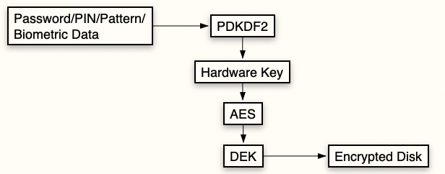Figure 5.4: The FDE process on Android devices
Figure 5.4 is a flow chart illustrating an Android device's FDE process. It depicts the steps and components of securing data stored on the device. Here is an explanation of each element shown in the flow chart:
- Password/PIN/pattern/biometric data: These user authentication methods can unlock the device and access the encrypted data. The user provides this input to initiate the decryption process.
- Password-Based Key Derivation Function 2 (PBKDF2): This cryptographic function takes the user's password, PIN, pattern, or biometric data and derives a cryptographic key. PBKDF2 strengthens the security of user-provided input by making it more resistant to brute-force attacks.
- Hardware key: A unique key tied to the device's hardware. This key adds a layer of security, ensuring that the encryption keys are specific to the device and cannot be easily extracted or used on another device.
- AES: This widely used encryption standard encrypts the disk encryption key (DEK). The combination of the PBKDF2-derived key and the hardware key is used as an input to AES to produce the encrypted DEK.
- DEK: This is the key used to encrypt and decrypt the data stored on the device. It is encrypted using the AES algorithm and the derived key from the previous steps.
- Encrypted disk: This represents the data storage on the device (e.g., internal storage) where all data is encrypted using the DEK. This ensures that data remains secure and inaccessible without the correct decryption key.
Process flow:
- The user provides authentication data (password/PIN/pattern/biometric data), which PBKDF2 processes to derive a cryptographic key.
- The derived key is combined with the hardware key and input into the AES encryption algorithm.
- AES uses this combination to encrypt the DEK.
- The encrypted DEK is then used to encrypt the entire disk, ensuring the protection of all data on the device.
Starting with Android 5.0 Lollipop, Google introduced support for hardware-backed encryption. This involves using dedicated hardware components, such as a trusted execution environment (TEE) or the Secure Enclave, to handle cryptographic operations. Hardware-backed encryption enhances security by isolating encryption keys and cryptographic processes from the main OS, making it more difficult for attackers to access or tamper with the keys.
With the release of Android 7.0 Nougat, Google introduced file-based encryption (FBE) as an alternative to FDE. Unlike FDE, which encrypts the entire storage volume, FBE allows individual files to be encrypted with different keys. This provides more granular control over data access and improves performance by enabling the device to decrypt only the files needed at any given time. In FBE, each file is encrypted with its file encryption key (FEK). These FEKs are then encrypted with a master key protected by the user's credentials. FBE also supports Direct Boot, allowing certain essential services and apps to run even before the user has unlocked the device, thereby improving usability without compromising security.
While FDE significantly enhances the security of Android devices, it also poses substantial challenges for forensic analysis. Accessing encrypted data without the user's credentials requires sophisticated techniques. One of your primary challenges is bypassing the encryption to access the data. Several approaches can be used, depending on the device model, OS version, and security features:
- Brute-force attacks: Attempting all possible combinations of the user's PIN, password, or pattern to unlock the device. This method is time-consuming and often impractical due to rate-limiting mechanisms and account lockout policies that prevent rapid guessing.
- Exploiting vulnerabilities: Identifying and exploiting software vulnerabilities or flaws in the encryption implementation to gain access to the data. This approach requires up-to-date knowledge of the latest exploits and may not be feasible for newer devices.
- Collaboration with manufacturers: You may need to collaborate with device manufacturers to obtain assistance in decrypting the data. This often involves legal processes such as securing court orders or search warrants to compel manufacturers to provide support.

Secure Boot for Android
Secure Boot is a security feature in modern Android devices designed to ensure that only trusted software can run during startup. It forms a part of the broader security architecture aimed at protecting user data and maintaining the integrity of the OS. Secure Boot is a security protocol that verifies the software loaded during the boot process, ensuring it originates from a trusted source and has not been tampered with. This verification process begins at the hardware level and extends through the OS, creating a trusted boot chain. Each component in the boot sequence verifies the integrity and authenticity of the next element before execution, establishing a secure environment from the moment the device powers on.
The implementation of Secure Boot in Android devices involves several critical components. The initial bootloader, the first code executed when an Android device is powered on, is responsible for loading the OS kernel and starting the boot process. It is split into multiple stages, each performing specific tasks and verifying the next stage's integrity. This staged approach ensures that each step in the boot process is secure before moving on to the next. Verified Boot, also known as Android Verified Boot (AVB), is another component. It ensures the integrity of the entire Android OS using cryptographic verification to confirm that all executed code comes from a trusted source. AVB is divided into three key phases: bootloader verification, partition verification, and error handling, each playing a role in maintaining system security.
The TEE is a secure area of the main processor that runs a separate OS. It securely stores and processes sensitive data, such as cryptographic keys used in the boot verification process. The TEE ensures that these keys remain protected even if the main OS is compromised, adding an extra layer of security. The hardware root of trust, often implemented as a Trusted Platform Module (TPM) or equivalent, stores cryptographic keys used to verify the bootloader. It serves as the foundation upon which the trust chain is built, ensuring that the boot process starts from a secure state.
Implementing Secure Boot involves several steps. When the device is powered on, the initial bootloader stage verifies the integrity of the next stage bootloader using cryptographic signatures stored in the hardware root of trust. If verification fails, the device will not proceed with the boot process. Once the initial bootloader stage is verified, the secondary bootloader stage is loaded, which is responsible for verifying the integrity of the OS kernel and other components using cryptographic hashes and signatures. AVB maintains the integrity of the OS partition, including the kernel and system partitions. If any part of the OS fails verification, the boot process halts, and the device may enter a recovery mode to prevent untrusted code execution. If any stage of the Secure Boot process fails, the device enters a secure recovery mode, providing limited functionality and allowing the user or administrator to repair or reset the device. This behavior varies depending on the device manufacturer and security policies.
Many Android devices ship with locked bootloaders, which prevent unauthorized modifications to the boot process. Unlocking the bootloader requires explicit user consent and is easily accomplished, but it may result in the wiping of the device's data. The device usually warns about the data wipe and requires the user to confirm the action, ensuring that the user knows the consequences. The trusted boot chain established by Secure Boot ensures that any changes to the boot process are detected and prevented.
Rooting an Android device refers to gaining administrative (root) access to the device's OS. This allows users to bypass restrictions imposed by the manufacturer or carrier, enabling them to modify system settings, install specialized apps, and access system files that are typically inaccessible. Rooting gives the user full control over the device, similar to administrator privileges on a computer. While it offers enhanced customization and functionality, rooting also comes with risks, including voiding warranties, compromising security, and potentially bricking the device if not done correctly.
Mobile device security continues to evolve, and so will Secure Boot implementations. Future developments in Secure Boot may include more advanced cryptographic techniques, enhanced integration with hardware security modules, and improved user authentication methods. Enhanced integration with hardware security modules, such as TPMs and Secure Elements, will provide stronger protection for cryptographic keys and bootloader verification processes.
TPMs are hardware-based security chips that provide secure storage and cryptographic operations. A TPM securely stores artifacts such as encryption keys, passwords, and certificates, which are used for authentication and maintaining platform integrity. TPMs ensure that sensitive information remains isolated from potentially hostile components, including the OS. TPMs (or equivalent technologies like Android's Trusty TEE and Knox for Samsung devices) enhance security by ensuring that operations are performed in a secure environment. These modules implement security measures such as verifying device integrity, secure user authentication, and encrypted storage.
TPMs are a component of modern mobile security architecture. They provide a hardware-based root of trust that enhances the security of Android devices by protecting cryptographic keys and ensuring the integrity of the device and its data.
You will need to understand these integrations and develop methods to work with or around these security features. User authentication methods, such as biometric verification, are becoming tightly integrated with Secure Boot processes, ensuring only authorized users can modify the bootloader or access recovery modes.
In the United States, users generally do not expect privacy when using biometrics, such as fingerprints or facial recognition, to secure their mobile devices. Courts have ruled that biometrics are not protected under the Fifth Amendment, which protects against self-incrimination. Unlike passcodes or PINs, which are considered "testimonial" and therefore protected, biometrics are viewed as physical evidence, akin to providing a DNA sample or a handwriting exemplar. This distinction means law enforcement can compel individuals to unlock their devices using biometric methods without violating constitutional rights.
Secure Boot is a cornerstone of Android device security. It protects against unauthorized modifications and ensures the OS's integrity. Secure Boot's evolving nature requires continuous learning and adaptation. Stay informed about these advancements so you can adapt your techniques and tools accordingly.

Application Sandbox for Android
The Application Sandbox in Android secures user data and maintains system integrity. Each application on an Android device runs in its isolated environment, ensuring that one app cannot access another app's data without proper authorization. The Android Application Sandbox concept is rooted in the Linux OS's security model. Each Android application operates within its own unique user ID (UID) and Group ID (GID), enforced by the Linux kernel. This separation ensures that apps cannot directly interfere with each other's data or processes.
- Isolation and permissions: When an app is installed on an Android device, the system assigns it a unique UID. The app's files are stored in a directory accessible only to that specific UID. This directory includes the app's internal storage, databases, shared preferences, and other data files. The sandbox ensures that only the app with the matching UID can read or write to this directory unless explicit permissions are granted.
- Inter-process communication (IPC): Android provides several IPC mechanisms, such as intents, content providers, and Binder, to facilitate controlled data exchange between apps. These mechanisms allow apps to share data without breaking the sandbox isolation.
- Role of Security-Enhanced Linux (SELinux): SELinux is integrated into Android to enforce mandatory access control (MAC). SELinux policies define which resources apps can access and enforce restrictions at the kernel level. This adds an extra layer of security, making it more challenging for malicious apps to exploit vulnerabilities.
- App permissions: Android's permission model is another critical aspect of the sandbox. Apps must request permission to access sensitive resources such as the camera, microphone, contacts, and location. Users grant these permissions at runtime, providing granular control over what data apps can access.
While both Android and iOS implement app sandboxing to enhance security, their approaches differ significantly:
- Underlying OS architecture: Android's app sandboxing is based on the Linux kernel's user and group permissions and SELinux policies. iOS relies on the XNU kernel, which combines elements from Mach and BSD kernels. iOS implements sandboxing using a combination of MAC policies and entitlements defining the resources an app can access.
- Permission models: Android uses a permission model where users grant permissions at runtime. These permissions are more granular, allowing users to control access to specific resources like the camera or location. iOS uses a similar permission model but focuses on protecting user privacy. iOS permissions are typically more restrictive, and apps are required to justify their need for access to sensitive data more rigorously.
- IPC mechanisms: Android and iOS provide mechanisms for IPC, but they differ in implementation. Android's IPC mechanisms include intents, content providers, and Binder, while iOS uses URL schemes, app extensions, and services like AirDrop for IPC.
- Encryption practices: Android and iOS employ encryption, but their practices differ. Android's FDE and FBE protect data at rest, and individual apps may implement additional encryption. iOS uses a comprehensive encryption framework that ties data protection classes to the device's hardware and user passcode. iOS's approach to encryption is often more integrated with the file system.
The app sandbox in Android is a fundamental security feature that ensures data isolation and integrity, presenting challenges and opportunities for forensic investigators. Comparing Android's approach to iOS highlights the unique aspects of each platform and underscores the importance of platform-specific knowledge in mobile forensics. Staying abreast of these changes will be essential to conducting forensic investigations as mobile OSs evolve.

SELinux for Android
SELinux is a security module integrated into the Linux kernel, which provides a mechanism for supporting access control security policies. SELinux enhances the security framework by enforcing MACs that limit the actions of processes based on defined policies. This integration is part of Android's security architecture, ensuring that even if an application or process is compromised, its actions remain restricted by the security policies.
SELinux was originally developed by the United States National Security Agency (NSA) as a series of patches to the Linux kernel aimed at adding access control mechanisms. The primary goal of SELinux is to enforce the principle of least privilege, ensuring that processes and users have only the permissions necessary to perform their functions. This is achieved through policies defining what resources processes can access and what operations they can perform on those resources. SELinux was first introduced in Android 4.3 Jelly Bean, where violations of policies were logged but not enforced. Starting from Android 5.0 Lollipop, SELinux will block any actions violating the defined policies.
SELinux operates on the principle of MAC, which differs from the more traditional discretionary access control (DAC), where users have control over the permissions of their files. In SELinux, policies are defined by the system administrators and are enforced by the kernel, leaving no room for end-user modifications. These policies specify the interactions between processes, files, and other resources. The SELinux policies in Android are written in a specific policy language and compiled into a binary policy file that the kernel can interpret. These policies are defined using three primary components: types, attributes, and roles:
- Types: These are labels assigned to objects such as files, directories, and sockets and subjects such as processes. They form the basis of SELinux's type enforcement (TE) model, where policies define how types can interact.
- Attributes: These are labels that group types with similar properties. All types representing executables might share a common attribute, allowing policies to apply to a broad category of types.
- Users: These are assigned roles, and the processes they can run are defined. This adds another layer of access control by limiting what users can do based on their roles. When a process attempts to perform an operation, the SELinux security server checks the policy rules to determine whether the operation is allowed. SELinux will block the operation and log the violation if it violates any policy.
SELinux policies in Android define interactions for system services, applications, and user data, ensuring strict control over what each component can do. These policies are maintained by Google and device manufacturers, who may customize them to suit their specific hardware and software configurations. Android's SELinux policies are divided into several key domains:
- Domain transitions define how processes transition from one domain to another. When an app starts, it transitions from the untrusted app domain to its specific app domain with restricted permissions.
- File contexts specify the types assigned to files and directories, ensuring that only authorized processes can access sensitive files.
- System services run in tightly controlled domains with limited permissions. The media server runs in the media server domain, restricting its access to only the needed resources. Policies control access to device hardware and network resources, preventing unauthorized processes from accessing sensitive components like the camera or network interfaces.
SELinux can operate in two modes: permissive and enforcing. In permissive mode, SELinux policies are not enforced, but violations are logged. This mode is useful for debugging and policy development, as it allows administrators to see what actions would be blocked without actually enforcing the restrictions. In enforcing mode, SELinux policies are strictly enforced. Any operation that violates the policies is blocked, and the violation is logged. This is the default mode for production Android devices.
SELinux logs policy violations, providing a detailed record of attempts to perform unauthorized actions. These logs can be invaluable in forensic investigations, helping to identify malicious activities and understand how an attacker may have tried to compromise the device. Device manufacturers can customize SELinux policies, leading to variations between devices. Shifting focus, let's survey the computer realm.

Computers
When examining traditional computer forensics, you'll encounter three primary OSs: Windows, macOS, and Linux. Each system has unique characteristics, forensic methodologies, and tools you need to understand and utilize effectively. This knowledge contrasts sharply with mobile device forensics, where the landscape is dominated by the rapid development and diversity of OSs and manufacturers, each with its own set of challenges.
Windows, the most widely used OS globally, presents a familiar environment for forensic analysis. The prevalence of Windows in both personal and corporate settings means that a significant amount of digital forensic work will involve this OS. Windows systems are typically analyzed using tools like EnCase, X-Ways, AXIOM, Belkasoft X Forensic, and several open source utilities. These tools allow you to image hard drives, recover deleted files, and parse system logs, providing a comprehensive view of user activity and system events. One of the critical components of Windows forensics is the Windows Registry—this hierarchical database stores configuration settings and options for the OS and installed applications. Analyzing the Registry can reveal a wealth of information, including user preferences, system configurations, and evidence of software installations or usage patterns. This information depth is generally unavailable in mobile device forensics, where data is often more fragmented, less detailed, or simply unavailable due to restrictions on what you can access.
macOS, the OS for Apple's desktop and laptop computers, presents a different set of forensic challenges. The Unix-based architecture of macOS means that many of the principles and tools used in Linux forensics can be applied here, though with certain Apple-specific nuances. Forensic tools like SUMURI RECON LAB and PALADIN are designed specifically for macOS, allowing you to navigate the HFS+ and APFS file systems, analyze system logs, and extract user data. One distinctive feature of macOS is the inder's metadata, which provides additional context about file creation, modification, and access times. This metadata can be used to build a timeline of user activity. Another aspect is Time Machine, macOS's built-in backup solution, which can offer snapshots of the entire system at different points in time. These snapshots will be invaluable in understanding changes to the system over time and recovering deleted data. While you might have backups in mobile device forensics, they are often less detailed and more challenging to access due to security profiles, encryption, and cloud storage policies.
While less common on personal desktops, Linux is ubiquitous in server environments. The open source nature of Linux means that an array of forensic tools and techniques are available, many of which can be customized to suit specific investigative needs. Tools like EnCase, X-Ways, AXIOM, Belkasoft X Forensic Autopsy, and various command-line utilities allow for detailed analysis of Linux systems, including examining different file systems like ext4 and XFS. Understanding Linux forensics requires a solid grasp of its permissions model, file system structure, and logging mechanisms. Unlike Windows and macOS, Linux offers a more modular approach to forensic analysis, where you can often script and automate tasks to a high degree. The diversity of Linux distributions means that you need to be adaptable and knowledgeable about the specific characteristics of the distribution in question. Similar to mobile forensics, while you may encounter variations in Android due to manufacturer customizations, the core OS remains relatively consistent.
One of the significant differences between traditional computer forensics and mobile device forensics lies in the stability and standardization of the OSs. Windows, macOS, and Linux have well-documented forensic methodologies and a wealth of tools. This stability allows for a more predictable and systematic approach to forensic investigations. You can follow established protocols for imaging drives, recovering data, and analyzing system artifacts. This predictability is beneficial when presenting evidence in court, as the forensic community widely recognizes and accepts the methods and tools. Mobile device forensics is often at the mercy of rapid technological advancements and changes in security features. New models of mobile devices with updated OSs and security patches are released frequently, requiring constant updates to forensic tools and techniques. This rapid development cycle can make mobile forensics feel like a moving target, where staying current with the latest methods is a continual challenge.
Another area where traditional computer forensics differs from mobile device forensics is data storage and retrieval. On traditional computers, with disk-based storage, you deal with structured file systems and often have the luxury of recovering deleted files and examining unallocated space on drives. SSDs pose a unique challenge in data recovery, particularly for retrieving data from unallocated space. Unlike hard disk drives (HDDs), which store data on magnetic platters, SSDs use NAND flash memory cells. SSDs use garbage collection, a process that manages and maintains performance by reorganizing data, consolidating free space, and eliminating data fragments. SSDs also support TRIM, which commands the drive to zero out data blocks when marked as available for new writes. TRIM enhances performance and longevity but makes data recovery techniques ineffective. Once TRIM processes the block containing a deleted file, recovering that file from unallocated space is highly unlikely.
Tools can perform in-depth analysis of disk images, allowing you to recover fragmented files and analyze slack space for hidden data. The file systems used in Windows (NTFS), macOS (APFS), and Linux (ext4, XFS) provide frameworks for data storage, which forensic tools can exploit to retrieve information. Mobile devices often use flash storage with wear-leveling algorithms, similar to TRIM and garbage collection, that can make data recovery more challenging. Integrating cloud storage in mobile devices means that data may be dispersed across multiple locations, requiring you also to have expertise in cloud forensics.
The security features inherent in mobile devices present additional hurdles. Features like FDE, secure boot, and biometric authentication are standard on modern smartphones and tablets. These security measures are designed to protect user data but also complicate forensic investigations. Accessing a locked iOS device, for example, may require legal intervention or collaboration with the manufacturer, and even then, decryption can be a formidable task. With their diversity of manufacturers, Android devices present a similar challenge, as each manufacturer may implement unique security features and encryption protocols. While employing security measures such as BitLocker on Windows or FileVault on macOS, traditional computers typically offer more straightforward solutions for bypassing or decrypting data with the appropriate forensic tools.
Legal and procedural considerations also vary significantly between mobile device forensics and traditional computer forensics. Due to their nature, mobile devices can be subject to stricter privacy regulations and laws. The data stored on mobile devices, such as text messages, call logs, and app data, is highly personal and sensitive. Obtaining data from a smartphone might require specific warrants or subpoenas that explicitly mention the types of data to be extracted. The procedures for collecting and analyzing data from computers are generally more established and standardized, reflecting the longer history of computer forensics compared to the field of mobile forensics.
The tools and software used in traditional computer forensics are also more mature and feature-rich than those available for mobile forensics. Established forensic suites offer comprehensive imaging solutions, analyzing, and reporting on digital evidence from computers. These tools have been refined over years of development and use in the field, providing features for forensic investigators. Mobile forensic tools, while advanced, often play catchup in terms of capabilities. Tools like Cellebrite and XRY continually evolve to keep up with new mobile device models and OS updates. The rapid pace of mobile technology means that these tools must constantly adapt to remain effective.
Traditional computer and mobile device forensics, critical components of digital investigations, present distinct challenges and require different skill sets and approaches. The stability and standardization of Windows, macOS, and Linux OSs provide a reliable foundation for forensic analysis with well-established tools and methodologies. Mobile OSs' rapid development and diversity necessitate continual adaptation and learning. Understanding these differences and staying current with the latest developments in both fields is essential for effective and thorough investigations. Let's examine storage architectures.

Differences between Computer Storage and Mobile Devices
Computer storage drives are designed with interoperability in mind, ensuring that data can be shared and accessed across different systems and platforms. This design philosophy is evident in the use of standardized file systems such as NTFS, HFS+, APFS, and ext4, which facilitate data exchange between OSs (In most cases). Seamlessly sharing information is a convenience for users and a significant advantage for forensic investigators. When examining traditional computers, you can utilize well-documented tools and methodologies to analyze data stored on these drives, benefiting from the standardized structures and documentation available for these file systems.
The standardized nature of computer storage drives allows you to perform forensic analysis with a high degree of reliability and consistency. NTFS, the primary file system used by Windows, provides a rich set of metadata and a detailed record of file creation, modification, and access times. This metadata can be used to construct timelines and understand user activity. macOS's HFS+ and APFS file systems also offer metadata and snapshots that provide forensic insights. The consistency of these file systems across different devices and versions allows forensic tools to function effectively, providing comprehensive analysis capabilities.
In stark contrast, the design and architecture of mobile devices prioritize the user experience above all else. Mobile OSs such as iOS and Android focus on creating a seamless, intuitive interface for users, often at the expense of accessibility for forensic analysis. The processes that underpin this user experience are typically proprietary and closely guarded by the manufacturers. This lack of transparency and documentation poses challenges for forensic investigators. Unlike the standardized and well-documented world of computer storage, mobile devices require a different approach due to the proprietary nature of their OSs and data storage methods.
The proprietary nature of mobile OSs means that forensic tools must often reverse engineer the underlying processes to access and analyze data. This reverse engineering is necessary because manufacturers frequently update their OSs, adding new features, security enhancements, and changes to data storage practices. Each update can introduce new obstacles for forensic analysis, requiring you to adapt and update your tools and techniques constantly. Android presents challenges due to the custom modifications made by different manufacturers. These modifications can affect how data is stored and protected, necessitating understanding each variant to perform forensic analysis.
The lack of documentation for the proprietary processes in mobile devices means you must rely heavily on specialized tools designed to handle these challenges. Tools like Cellebrite, XRY, and Oxygen Forensic Suite are continually updated to keep pace with the rapid development of mobile OSs and security features. These tools employ various methods to bypass security measures, extract data, and interpret the proprietary data structures used by mobile devices. The effectiveness of these tools can vary depending on the device model, OS version, and specific security measures in place.
The disparity between the standardized, accessible nature of computer storage drives and the proprietary, user-centric design of mobile devices highlights the unique challenges faced in mobile device forensics. While traditional computer forensics benefits from a wealth of documentation, standardized tools, and established methodologies, mobile forensics requires continuous learning and adaptation. To effectively extract and analyze data from mobile devices, you must stay abreast of the latest developments in mobile technology. The more advanced examiners may reverse engineer new features and security measures and share that information with colleagues.
The design philosophy of computer storage drives, emphasizing interoperability and standardization, provides a stable foundation for forensic analysis. Mobile devices' proprietary and user-centric design presents significant challenges that require specialized tools, reverse engineering, and constant adaptation. Understanding these differences is needed to perform forensic investigations, as each type of device demands a unique approach and expertise. As technology evolves, staying informed and adaptable is essential for successfully navigating the complexities of mobile device forensics.

Summary
In this chapter, you explored the differences between mobile device forensics and traditional computer forensics, focusing on their technological landscapes. Computer storage drives are designed with interoperability in mind, using standardized file systems like NTFS, HFS+, APFS, and ext4 to facilitate data sharing across different platforms. This standardization benefits forensic investigators by allowing the use of well-documented tools and methodologies, making data analysis reliable and consistent. In contrast, mobile devices prioritize user experience, often at the expense of forensic accessibility. The proprietary nature of mobile OSs like iOS and Android requires forensic tools to reverse engineer processes due to frequent updates and changes in security features, presenting ongoing challenges for investigators.
The lack of documentation for mobile OSs means that forensic tools like Cellebrite, XRY, Belkasoft X Forensic, and Oxygen Forensic Suite must constantly adapt to new developments. Their effectiveness can vary based on the device model, OS version, and specific security protocols. Mobile devices often contain highly personal and sensitive information, leading to stricter privacy regulations and legal requirements for data extraction.
While traditional computer forensics benefits from well-documented methodologies and standardized tools, mobile device forensics requires continuous adaptation and specialized knowledge. As you move forward to the next chapter, Understanding SQLite Databases and Plists, you will look into the data structures commonly encountered in mobile devices. This understanding will enhance your ability to navigate the complexities of mobile forensics and ensure the integrity and admissibility of digital evidence in your investigations.

Questions
- What is the primary file system used by Windows OSs?
  - HFS+
  - ext4
  - APFS
  - NTFS
- What is one of the primary benefits of using standardized file systems in traditional computer forensics?
  - Enhanced user experience
  - Facilitated data sharing across different platforms
  - Faster data access speeds
  - Increased device security
- What is a significant challenge in mobile device forensics compared to traditional computer forensics?
  - Lack of data
  - Standardized tools
  - Proprietary OSs
  - Uniform legal frameworks
- What does the term “reverse engineering” refer to in the context of mobile device forensics?
  - Creating new software
  - Analyzing existing systems to understand their design and functionality
  - Writing documentation
  - Developing hardware
- Which of the following is a key feature of Android's security model?
  - Secure Enclave
  - HFS+
  - Application Sandbox
  - APFS
- Why is creating a physical image of a mobile device's storage often difficult?
  - Mobile devices use NTFS file systems
  - Manufacturers restrict access to the storage
  - Lack of physical storage
  - Incompatibility with forensic tools
- What does the term “logical acquisition” refer to in mobile forensics?
  - Extracting a physical copy of the entire storage device
  - Retrieving user-accessible data without accessing deleted data
  - Bypassing all security features
  - Using specialized hardware to access internal components
- What does FDE stand for in the context of mobile device security?
  - File data encryption
  - Full disk encryption
  - File directory encryption
  - Full data extraction
- What is a common characteristic of cloud data that poses challenges for forensic investigators?
  - It is always encrypted
  - It is stored in a single location
  - It frequently changes and is dispersed across multiple locations
  - It is inaccessible without physical access to the device
- What is the primary purpose of the Secure Boot feature in Android devices?
  - To speed up the boot process
  - To ensure only trusted software runs during startup
  - To enhance battery life
  - To allow for easier software updates

Answer Key
- d) NTFS
- b) Facilitated data sharing across different platforms
- c) Proprietary OSs
- b) Analyzing existing systems to understand their design and functionality
- c) Application Sandbox
- b) Manufacturers restrict access to the storage
- c) Retrieving user-accessible data without accessing deleted data
- b) Full disk encryption
- c) It frequently changes and is dispersed across multiple locations
- b) To ensure only trusted software runs during startup

