DEMO

materials taken from Business partner B1 p.60

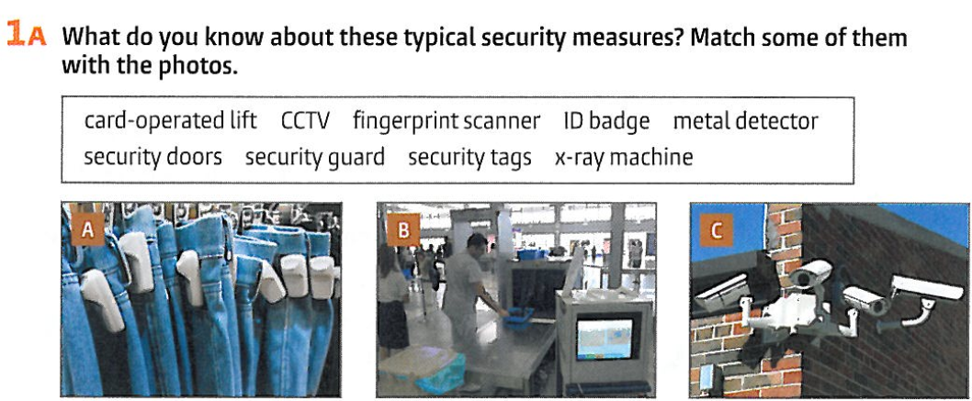

|  |  |  |
| --- | --- | --- |



|  |
| --- |

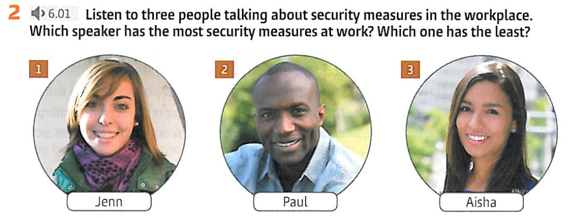

|  |  |  |
| --- | --- | --- |

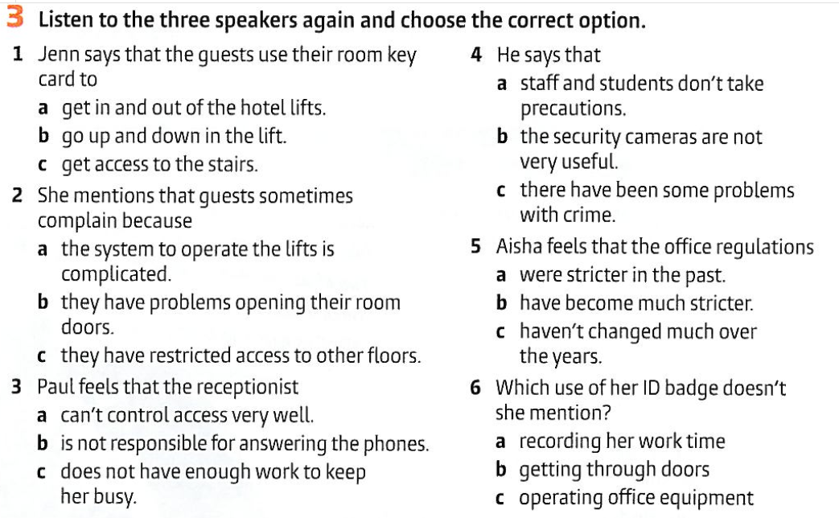

|  |  |  |  |  |  |
| --- | --- | --- | --- | --- | --- |

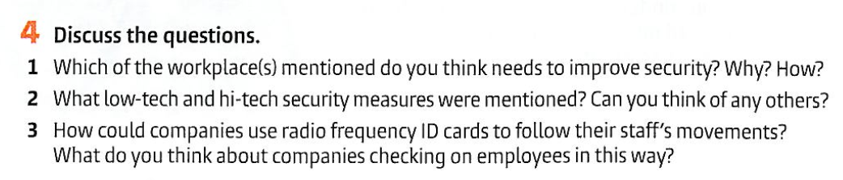

|  |
| --- |
|  |
|  |

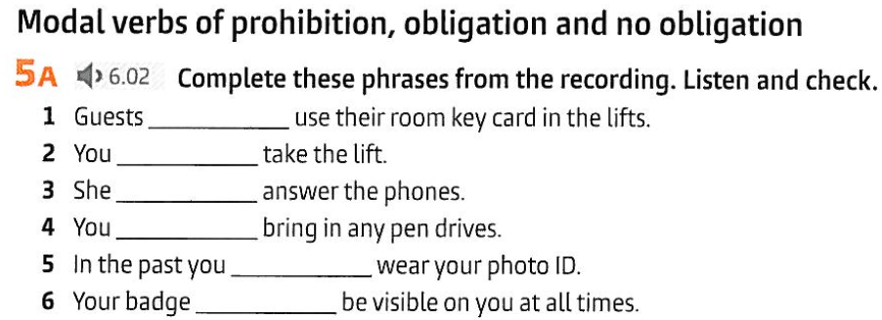

|  |  |  |  |  |  |
| --- | --- | --- | --- | --- | --- |

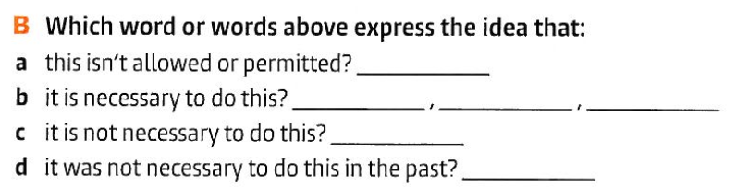

|  |  |  |  |
| --- | --- | --- | --- |

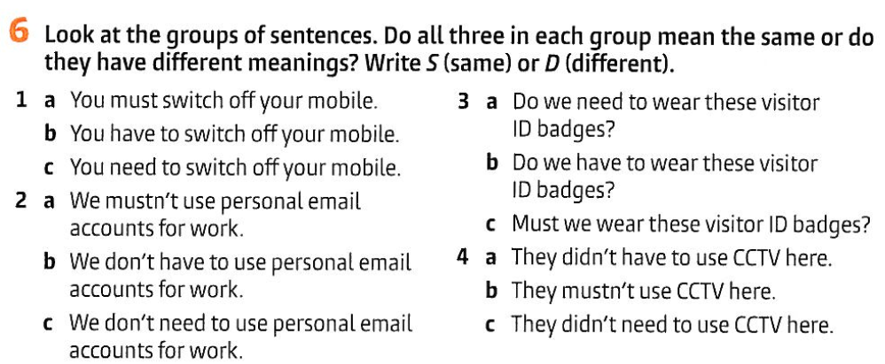

|  |  |  |  |
| --- | --- | --- | --- |

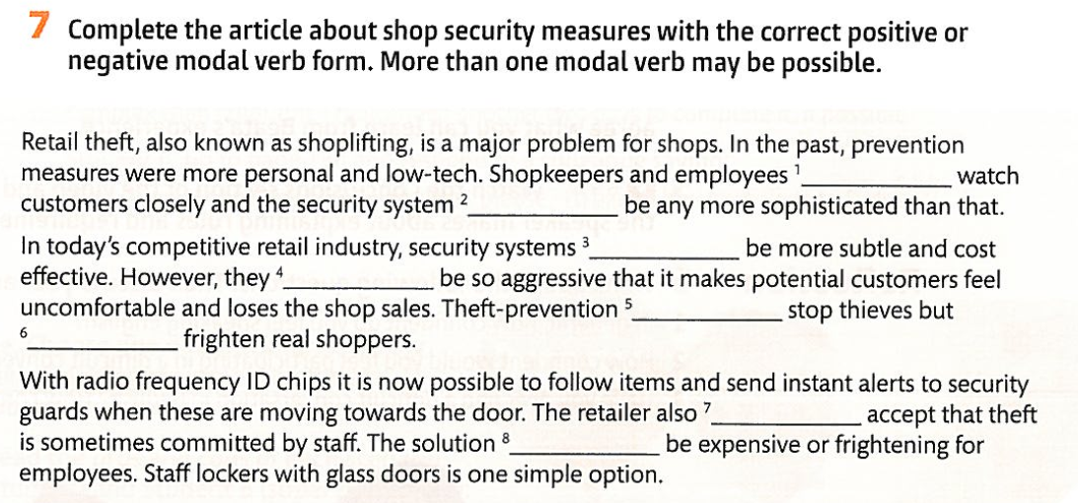

|  |  |  |  |  |  |  |  |
| --- | --- | --- | --- | --- | --- | --- | --- |

Audioscript

6.1

