DEMO
TASK 1
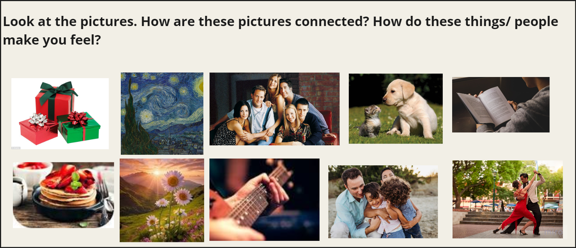

Task 2


Task 3
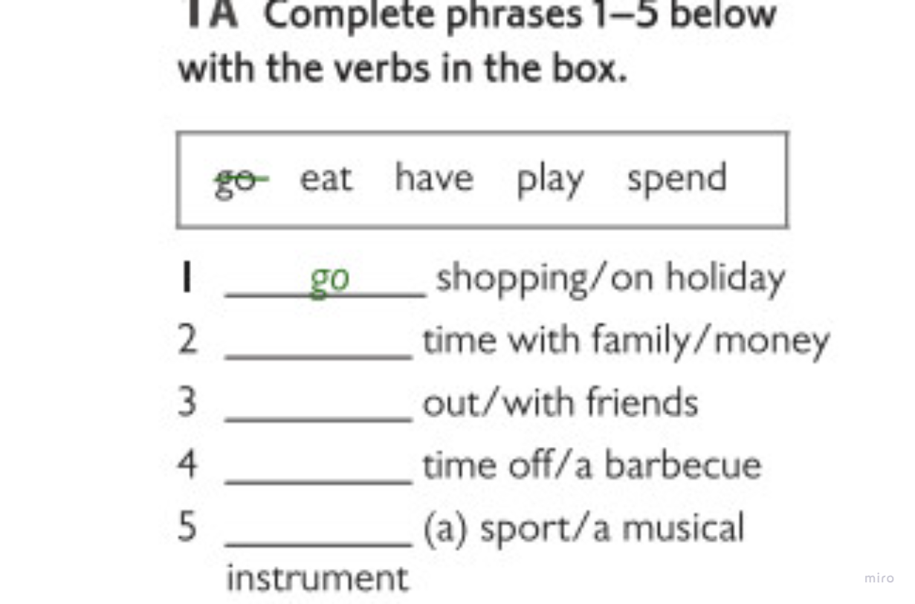
Task 4
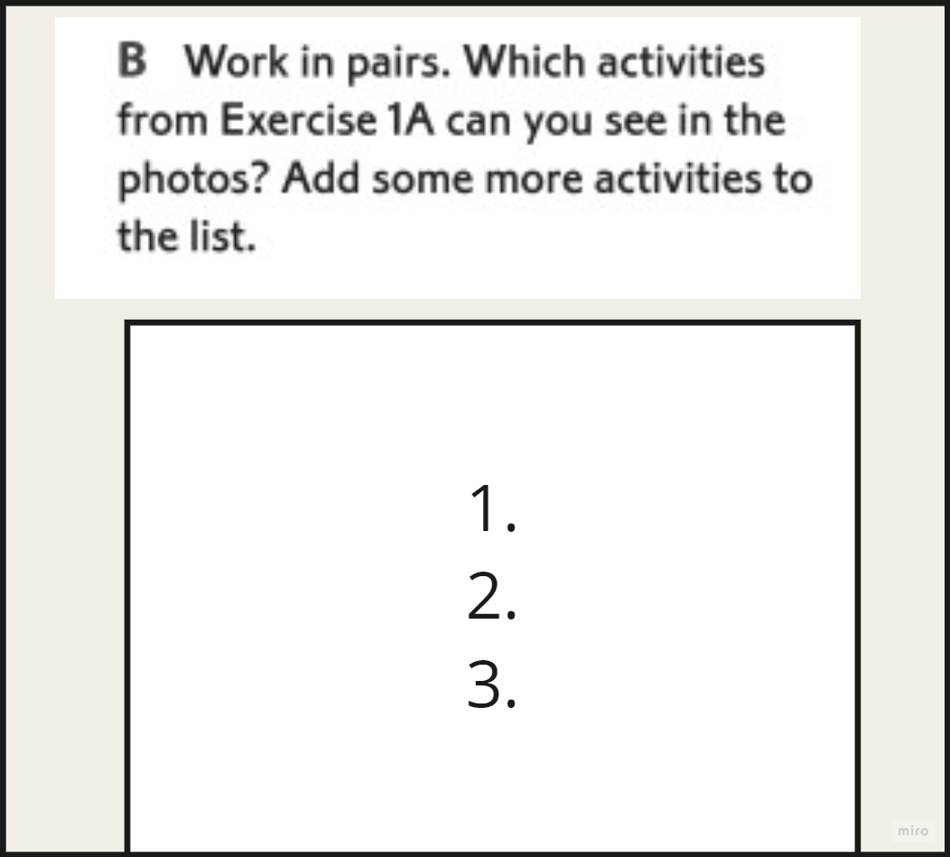

Task 5

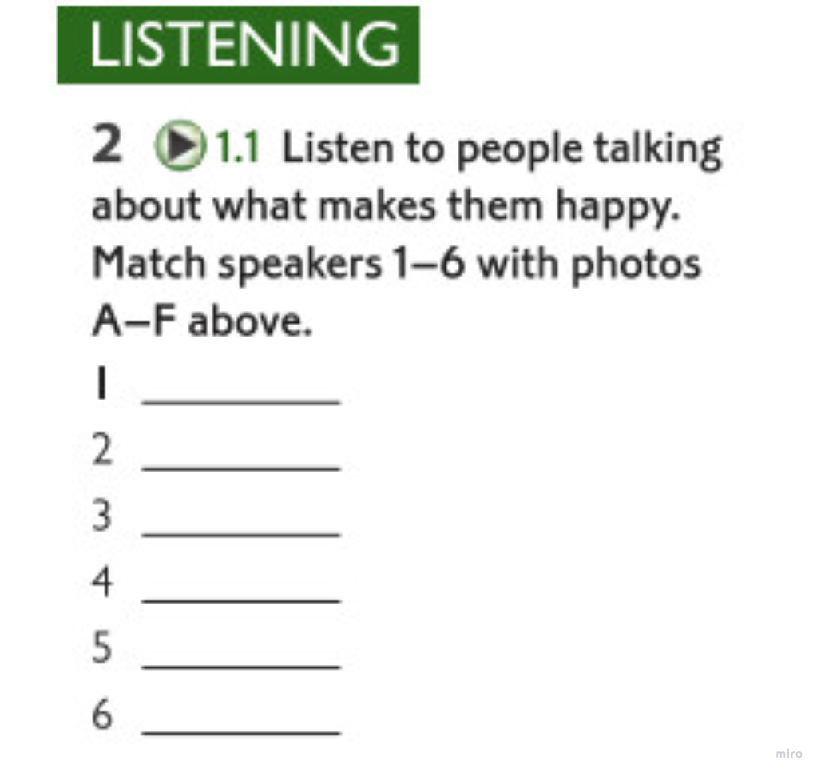

Task 6
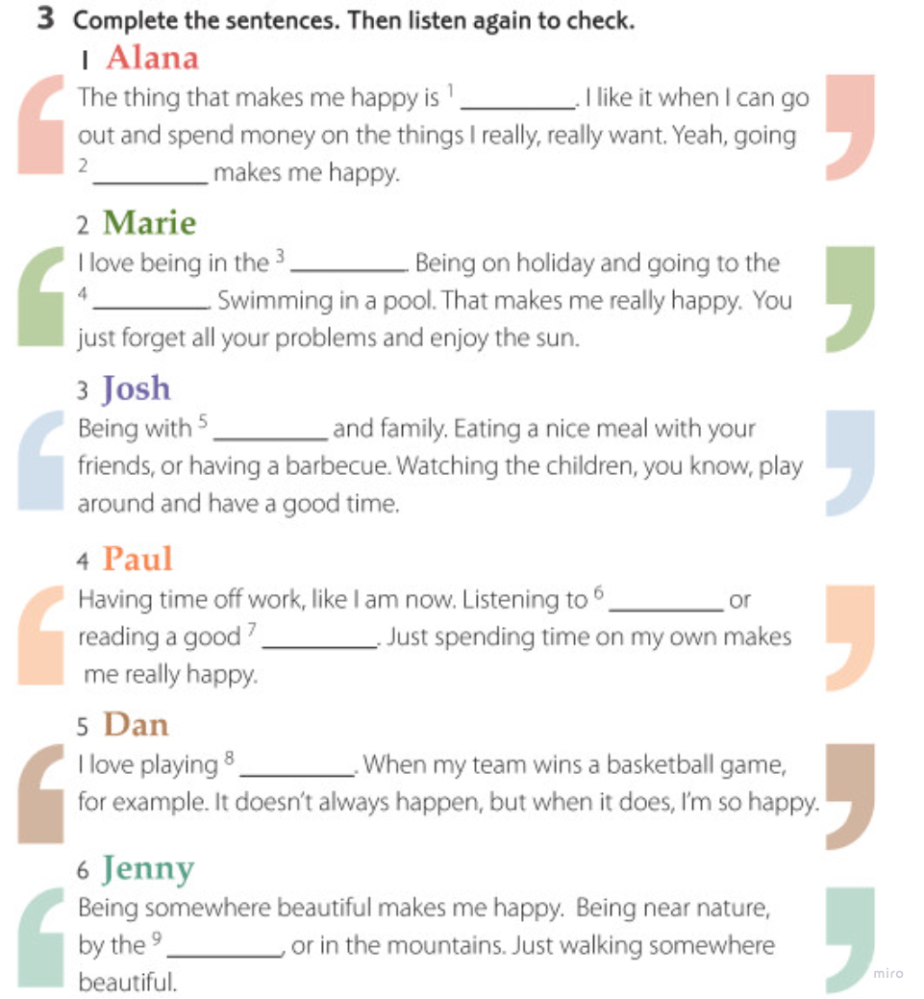
1
2
3
4
5
6

Task 7
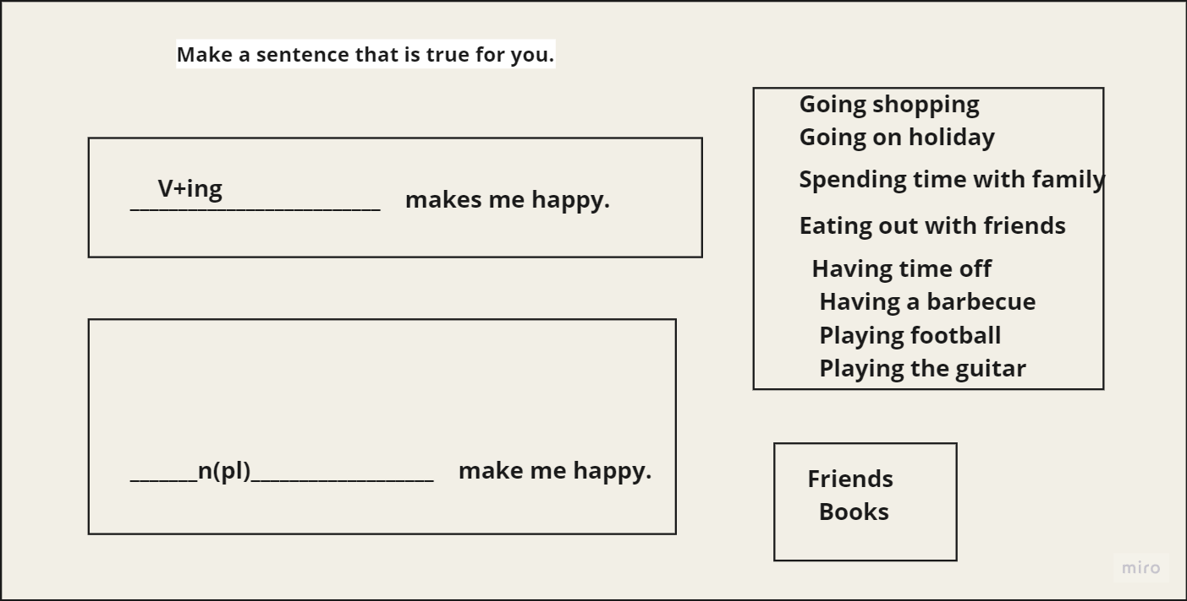

Task 8

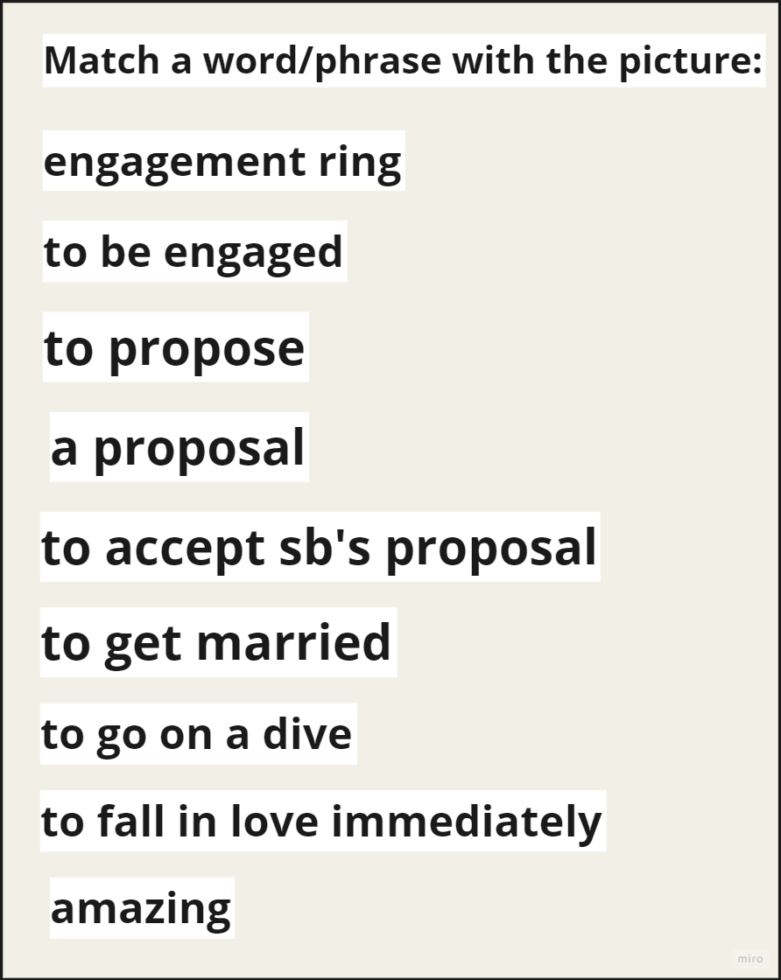

Task 9

1
2
3

Task 10
Listen to the three stories about marriage proposals. Decide if each statement is True (T) or False (F).
- ____ The first woman's boyfriend put the ring in her soup.
- ____ The first couple got married one month after the proposal.
- ____ The man in the second story proposed while they were on a boat.
- ____ The couple in the second story went on holiday to Egypt.
- ____ The man in the second story gave a speech underwater when proposing.
- ____ The couple in the third story met at work.
- ____ The man in the third story proposed through a YouTube video.
- ____ In the third story, the proposal video featured only the man proposing.
- ____ The woman in the third story accepted the proposal in a usual way.
Discussion
Discuss in pairs: Which proposal do you think was the most creative? Why? Do you know any unusual proposals?

Ahilbaev Danylo

TASK 1

Task 2
Task 3
Task 4

Task 5

Task 6
1
2
3
4
5
6

Task 7

Task 8

Task 9
1
2
3

Task 10
Listen to the three stories about marriage proposals. Decide if each statement is True (T) or False (F).
- ____ The first woman's boyfriend put the ring in her soup.
- ____ The first couple got married one month after the proposal.
- ____ The man in the second story proposed while they were on a boat.
- ____ The couple in the second story went on holiday to Egypt.
- ____ The man in the second story gave a speech underwater when proposing.
- ____ The couple in the third story met at work.
- ____ The man in the third story proposed through a YouTube video.
- ____ In the third story, the proposal video featured only the man proposing.
- ____ The woman in the third story accepted the proposal in a usual way.
Discussion
Discuss in pairs: Which proposal do you think was the most creative? Why? Do you know any unusual proposals?

Andrienko Valeriia

TASK 1

Task 2
Task 3
Task 4

Task 5

Task 6
1
2
3
4
5
6

Task 7

Task 8

Task 9
1
2
3

Task 10
Listen to the three stories about marriage proposals. Decide if each statement is True (T) or False (F).
- ____ The first woman's boyfriend put the ring in her soup.
- ____ The first couple got married one month after the proposal.
- ____ The man in the second story proposed while they were on a boat.
- ____ The couple in the second story went on holiday to Egypt.
- ____ The man in the second story gave a speech underwater when proposing.
- ____ The couple in the third story met at work.
- ____ The man in the third story proposed through a YouTube video.
- ____ In the third story, the proposal video featured only the man proposing.
- ____ The woman in the third story accepted the proposal in a usual way.
Discussion
Discuss in pairs: Which proposal do you think was the most creative? Why? Do you know any unusual proposals?

Baranov Oleksandr

TASK 1

Task 2
Task 3
Task 4

Task 5

Task 6
1
2
3
4
5
6

Task 7

Task 8

Task 9
1
2
3

Task 10
Listen to the three stories about marriage proposals. Decide if each statement is True (T) or False (F).
- ____ The first woman's boyfriend put the ring in her soup.
- ____ The first couple got married one month after the proposal.
- ____ The man in the second story proposed while they were on a boat.
- ____ The couple in the second story went on holiday to Egypt.
- ____ The man in the second story gave a speech underwater when proposing.
- ____ The couple in the third story met at work.
- ____ The man in the third story proposed through a YouTube video.
- ____ In the third story, the proposal video featured only the man proposing.
- ____ The woman in the third story accepted the proposal in a usual way.
Discussion
Discuss in pairs: Which proposal do you think was the most creative? Why? Do you know any unusual proposals?

Volkov Dmytro

TASK 1

Task 2
Task 3
Task 4

Task 5

Task 6
1
2
3
4
5
6

Task 7

Task 8

Task 9
1
2
3

Task 10
Listen to the three stories about marriage proposals. Decide if each statement is True (T) or False (F).
- ____ The first woman's boyfriend put the ring in her soup.
- ____ The first couple got married one month after the proposal.
- ____ The man in the second story proposed while they were on a boat.
- ____ The couple in the second story went on holiday to Egypt.
- ____ The man in the second story gave a speech underwater when proposing.
- ____ The couple in the third story met at work.
- ____ The man in the third story proposed through a YouTube video.
- ____ In the third story, the proposal video featured only the man proposing.
- ____ The woman in the third story accepted the proposal in a usual way.
Discussion
Discuss in pairs: Which proposal do you think was the most creative? Why? Do you know any unusual proposals?

Horai Vitalii

TASK 1

Task 2
Task 3
Task 4

Task 5

Task 6
1
2
3
4
5
6

Task 7

Task 8

Task 9
1
2
3

Task 10
Listen to the three stories about marriage proposals. Decide if each statement is True (T) or False (F).
- ____ The first woman's boyfriend put the ring in her soup.
- ____ The first couple got married one month after the proposal.
- ____ The man in the second story proposed while they were on a boat.
- ____ The couple in the second story went on holiday to Egypt.
- ____ The man in the second story gave a speech underwater when proposing.
- ____ The couple in the third story met at work.
- ____ The man in the third story proposed through a YouTube video.
- ____ In the third story, the proposal video featured only the man proposing.
- ____ The woman in the third story accepted the proposal in a usual way.
Discussion
Discuss in pairs: Which proposal do you think was the most creative? Why? Do you know any unusual proposals?

Horai Oleksandr

TASK 1

Task 2
Task 3
Task 4

Task 5

Task 6
1
2
3
4
5
6

Task 7

Task 8

Task 9
1
2
3

Task 10
Listen to the three stories about marriage proposals. Decide if each statement is True (T) or False (F).
- ____ The first woman's boyfriend put the ring in her soup.
- ____ The first couple got married one month after the proposal.
- ____ The man in the second story proposed while they were on a boat.
- ____ The couple in the second story went on holiday to Egypt.
- ____ The man in the second story gave a speech underwater when proposing.
- ____ The couple in the third story met at work.
- ____ The man in the third story proposed through a YouTube video.
- ____ In the third story, the proposal video featured only the man proposing.
- ____ The woman in the third story accepted the proposal in a usual way.
Discussion
Discuss in pairs: Which proposal do you think was the most creative? Why? Do you know any unusual proposals?

Dolhoniuk Bohdan

TASK 1

Task 2
Task 3
Task 4

Task 5

Task 6
1
2
3
4
5
6

Task 7

Task 8

Task 9
1
2
3

Task 10
Listen to the three stories about marriage proposals. Decide if each statement is True (T) or False (F).
- ____ The first woman's boyfriend put the ring in her soup.
- ____ The first couple got married one month after the proposal.
- ____ The man in the second story proposed while they were on a boat.
- ____ The couple in the second story went on holiday to Egypt.
- ____ The man in the second story gave a speech underwater when proposing.
- ____ The couple in the third story met at work.
- ____ The man in the third story proposed through a YouTube video.
- ____ In the third story, the proposal video featured only the man proposing.
- ____ The woman in the third story accepted the proposal in a usual way.
Discussion
Discuss in pairs: Which proposal do you think was the most creative? Why? Do you know any unusual proposals?

Drozdiuk Jurii

TASK 1

Task 2
Task 3
Task 4

Task 5

Task 6
1
2
3
4
5
6

Task 7

Task 8

Task 9
1
2
3

Task 10
Listen to the three stories about marriage proposals. Decide if each statement is True (T) or False (F).
- ____ The first woman's boyfriend put the ring in her soup.
- ____ The first couple got married one month after the proposal.
- ____ The man in the second story proposed while they were on a boat.
- ____ The couple in the second story went on holiday to Egypt.
- ____ The man in the second story gave a speech underwater when proposing.
- ____ The couple in the third story met at work.
- ____ The man in the third story proposed through a YouTube video.
- ____ In the third story, the proposal video featured only the man proposing.
- ____ The woman in the third story accepted the proposal in a usual way.
Discussion
Discuss in pairs: Which proposal do you think was the most creative? Why? Do you know any unusual proposals?

Zhvanko Pavlo
DEMO
TASK 1

Task 2
Task 3
Task 4

Task 5

Task 6
1
2
3
4
5
6

Task 7

Task 8

Task 9
1
2
3

Task 10
Listen to the three stories about marriage proposals. Decide if each statement is True (T) or False (F).
- ____ The first woman's boyfriend put the ring in her soup.
- ____ The first couple got married one month after the proposal.
- ____ The man in the second story proposed while they were on a boat.
- ____ The couple in the second story went on holiday to Egypt.
- ____ The man in the second story gave a speech underwater when proposing.
- ____ The couple in the third story met at work.
- ____ The man in the third story proposed through a YouTube video.
- ____ In the third story, the proposal video featured only the man proposing.
- ____ The woman in the third story accepted the proposal in a usual way.
Discussion
Discuss in pairs: Which proposal do you think was the most creative? Why? Do you know any unusual proposals?

Ilchyshyna Oksana
DEMO
TASK 1

Task 2
Task 3
Task 4

Task 5

Task 6
1
2
3
4
5
6

Task 7

Task 8

Task 9
1
2
3

Task 10
Listen to the three stories about marriage proposals. Decide if each statement is True (T) or False (F).
- ____ The first woman's boyfriend put the ring in her soup.
- ____ The first couple got married one month after the proposal.
- ____ The man in the second story proposed while they were on a boat.
- ____ The couple in the second story went on holiday to Egypt.
- ____ The man in the second story gave a speech underwater when proposing.
- ____ The couple in the third story met at work.
- ____ The man in the third story proposed through a YouTube video.
- ____ In the third story, the proposal video featured only the man proposing.
- ____ The woman in the third story accepted the proposal in a usual way.
Discussion
Discuss in pairs: Which proposal do you think was the most creative? Why? Do you know any unusual proposals?

Kordan Mykola
DEMO
TASK 1

Task 2
Task 3
Task 4

Task 5

Task 6
1
2
3
4
5
6

Task 7

Task 8

Task 9
1
2
3

Task 10
Listen to the three stories about marriage proposals. Decide if each statement is True (T) or False (F).
- ____ The first woman's boyfriend put the ring in her soup.
- ____ The first couple got married one month after the proposal.
- ____ The man in the second story proposed while they were on a boat.
- ____ The couple in the second story went on holiday to Egypt.
- ____ The man in the second story gave a speech underwater when proposing.
- ____ The couple in the third story met at work.
- ____ The man in the third story proposed through a YouTube video.
- ____ In the third story, the proposal video featured only the man proposing.
- ____ The woman in the third story accepted the proposal in a usual way.
Discussion
Discuss in pairs: Which proposal do you think was the most creative? Why? Do you know any unusual proposals?

Pavlenko Artem
DEMO
TASK 1

Task 2
Task 3
Task 4

Task 5

Task 6
1
2
3
4
5
6

Task 7

Task 8

Task 9
1
2
3

Task 10
Listen to the three stories about marriage proposals. Decide if each statement is True (T) or False (F).
- ____ The first woman's boyfriend put the ring in her soup.
- ____ The first couple got married one month after the proposal.
- ____ The man in the second story proposed while they were on a boat.
- ____ The couple in the second story went on holiday to Egypt.
- ____ The man in the second story gave a speech underwater when proposing.
- ____ The couple in the third story met at work.
- ____ The man in the third story proposed through a YouTube video.
- ____ In the third story, the proposal video featured only the man proposing.
- ____ The woman in the third story accepted the proposal in a usual way.
Discussion
Discuss in pairs: Which proposal do you think was the most creative? Why? Do you know any unusual proposals?

Pavlysyn Jurii
DEMO
TASK 1

Task 2
Task 3
Task 4

Task 5

Task 6
1
2
3
4
5
6

Task 7

Task 8

Task 9
1
2
3

Task 10
Listen to the three stories about marriage proposals. Decide if each statement is True (T) or False (F).
- ____ The first woman's boyfriend put the ring in her soup.
- ____ The first couple got married one month after the proposal.
- ____ The man in the second story proposed while they were on a boat.
- ____ The couple in the second story went on holiday to Egypt.
- ____ The man in the second story gave a speech underwater when proposing.
- ____ The couple in the third story met at work.
- ____ The man in the third story proposed through a YouTube video.
- ____ In the third story, the proposal video featured only the man proposing.
- ____ The woman in the third story accepted the proposal in a usual way.
Discussion
Discuss in pairs: Which proposal do you think was the most creative? Why? Do you know any unusual proposals?

Paiias’ Serhii
DEMO
TASK 1

Task 2
Task 3
Task 4

Task 5

Task 6
1
2
3
4
5
6

Task 7

Task 8

Task 9
1
2
3

Task 10
Listen to the three stories about marriage proposals. Decide if each statement is True (T) or False (F).
- ____ The first woman's boyfriend put the ring in her soup.
- ____ The first couple got married one month after the proposal.
- ____ The man in the second story proposed while they were on a boat.
- ____ The couple in the second story went on holiday to Egypt.
- ____ The man in the second story gave a speech underwater when proposing.
- ____ The couple in the third story met at work.
- ____ The man in the third story proposed through a YouTube video.
- ____ In the third story, the proposal video featured only the man proposing.
- ____ The woman in the third story accepted the proposal in a usual way.
Discussion
Discuss in pairs: Which proposal do you think was the most creative? Why? Do you know any unusual proposals?

Prysiazhniuk Jaroslav
DEMO
TASK 1

Task 2
Task 3
Task 4

Task 5

Task 6
1
2
3
4
5
6

Task 7

Task 8

Task 9
1
2
3

Task 10
Listen to the three stories about marriage proposals. Decide if each statement is True (T) or False (F).
- ____ The first woman's boyfriend put the ring in her soup.
- ____ The first couple got married one month after the proposal.
- ____ The man in the second story proposed while they were on a boat.
- ____ The couple in the second story went on holiday to Egypt.
- ____ The man in the second story gave a speech underwater when proposing.
- ____ The couple in the third story met at work.
- ____ The man in the third story proposed through a YouTube video.
- ____ In the third story, the proposal video featured only the man proposing.
- ____ The woman in the third story accepted the proposal in a usual way.
Discussion
Discuss in pairs: Which proposal do you think was the most creative? Why? Do you know any unusual proposals?

Serhiichuk Anastasiia
DEMO
TASK 1

Task 2
Task 3
Task 4

Task 5

Task 6
1
2
3
4
5
6

Task 7

Task 8

Task 9
1
2
3

Task 10
Listen to the three stories about marriage proposals. Decide if each statement is True (T) or False (F).
- ____ The first woman's boyfriend put the ring in her soup.
- ____ The first couple got married one month after the proposal.
- ____ The man in the second story proposed while they were on a boat.
- ____ The couple in the second story went on holiday to Egypt.
- ____ The man in the second story gave a speech underwater when proposing.
- ____ The couple in the third story met at work.
- ____ The man in the third story proposed through a YouTube video.
- ____ In the third story, the proposal video featured only the man proposing.
- ____ The woman in the third story accepted the proposal in a usual way.
Discussion
Discuss in pairs: Which proposal do you think was the most creative? Why? Do you know any unusual proposals?

Sladkovskii Oleh
DEMO
TASK 1

Task 2
Task 3
Task 4

Task 5

Task 6
1
2
3
4
5
6

Task 7

Task 8

Task 9
1
2
3

Task 10
Listen to the three stories about marriage proposals. Decide if each statement is True (T) or False (F).
- ____ The first woman's boyfriend put the ring in her soup.
- ____ The first couple got married one month after the proposal.
- ____ The man in the second story proposed while they were on a boat.
- ____ The couple in the second story went on holiday to Egypt.
- ____ The man in the second story gave a speech underwater when proposing.
- ____ The couple in the third story met at work.
- ____ The man in the third story proposed through a YouTube video.
- ____ In the third story, the proposal video featured only the man proposing.
- ____ The woman in the third story accepted the proposal in a usual way.
Discussion
Discuss in pairs: Which proposal do you think was the most creative? Why? Do you know any unusual proposals?

Sukhomud’ Serhii
DEMO
TASK 1

Task 2
Task 3
Task 4

Task 5

Task 6
1
2
3
4
5
6

Task 7

Task 8

Task 9
1
2
3

Task 10
Listen to the three stories about marriage proposals. Decide if each statement is True (T) or False (F).
- ____ The first woman's boyfriend put the ring in her soup.
- ____ The first couple got married one month after the proposal.
- ____ The man in the second story proposed while they were on a boat.
- ____ The couple in the second story went on holiday to Egypt.
- ____ The man in the second story gave a speech underwater when proposing.
- ____ The couple in the third story met at work.
- ____ The man in the third story proposed through a YouTube video.
- ____ In the third story, the proposal video featured only the man proposing.
- ____ The woman in the third story accepted the proposal in a usual way.
Discussion
Discuss in pairs: Which proposal do you think was the most creative? Why? Do you know any unusual proposals?

Usik Oleksandr
DEMO
TASK 1

Task 2
Task 3
Task 4

Task 5

Task 6
1
2
3
4
5
6

Task 7

Task 8

Task 9
1
2
3

Task 10
Listen to the three stories about marriage proposals. Decide if each statement is True (T) or False (F).
- ____ The first woman's boyfriend put the ring in her soup.
- ____ The first couple got married one month after the proposal.
- ____ The man in the second story proposed while they were on a boat.
- ____ The couple in the second story went on holiday to Egypt.
- ____ The man in the second story gave a speech underwater when proposing.
- ____ The couple in the third story met at work.
- ____ The man in the third story proposed through a YouTube video.
- ____ In the third story, the proposal video featured only the man proposing.
- ____ The woman in the third story accepted the proposal in a usual way.
Discussion
Discuss in pairs: Which proposal do you think was the most creative? Why? Do you know any unusual proposals?

Khodakivskii Vladyslav
DEMO
TASK 1

Task 2
Task 3
Task 4

Task 5

Task 6
1
2
3
4
5
6

Task 7

Task 8

Task 9
1
2
3

Task 10
Listen to the three stories about marriage proposals. Decide if each statement is True (T) or False (F).
- ____ The first woman's boyfriend put the ring in her soup.
- ____ The first couple got married one month after the proposal.
- ____ The man in the second story proposed while they were on a boat.
- ____ The couple in the second story went on holiday to Egypt.
- ____ The man in the second story gave a speech underwater when proposing.
- ____ The couple in the third story met at work.
- ____ The man in the third story proposed through a YouTube video.
- ____ In the third story, the proposal video featured only the man proposing.
- ____ The woman in the third story accepted the proposal in a usual way.
Discussion
Discuss in pairs: Which proposal do you think was the most creative? Why? Do you know any unusual proposals?

Sharlai Illia
DEMO
TASK 1

Task 2
Task 3
Task 4

Task 5

Task 6
1
2
3
4
5
6

Task 7

Task 8

Task 9
1
2
3

Task 10
Listen to the three stories about marriage proposals. Decide if each statement is True (T) or False (F).
- ____ The first woman's boyfriend put the ring in her soup.
- ____ The first couple got married one month after the proposal.
- ____ The man in the second story proposed while they were on a boat.
- ____ The couple in the second story went on holiday to Egypt.
- ____ The man in the second story gave a speech underwater when proposing.
- ____ The couple in the third story met at work.
- ____ The man in the third story proposed through a YouTube video.
- ____ In the third story, the proposal video featured only the man proposing.
- ____ The woman in the third story accepted the proposal in a usual way.
Discussion
Discuss in pairs: Which proposal do you think was the most creative? Why? Do you know any unusual proposals?

