DEMO

materials taken from Business Partner B1 p. 62-63

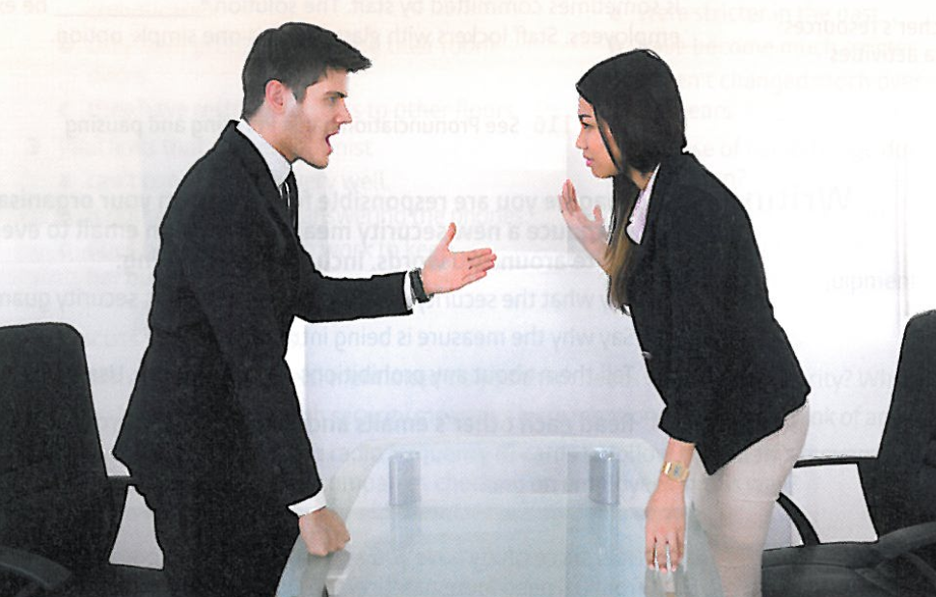

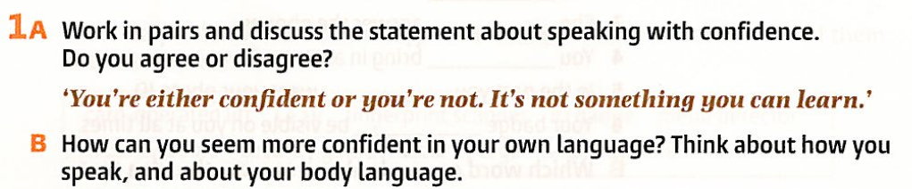

|  |
| --- |
|  |

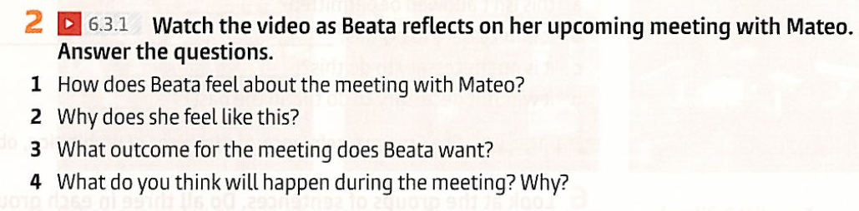

[Video 6.3.1](https://www.youtube.com/watch?v=oxyTXujgLQs&ab_channel=UniEnglish)

|  |
| --- |
|  |
|  |
|  |

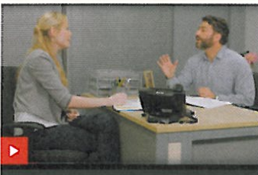

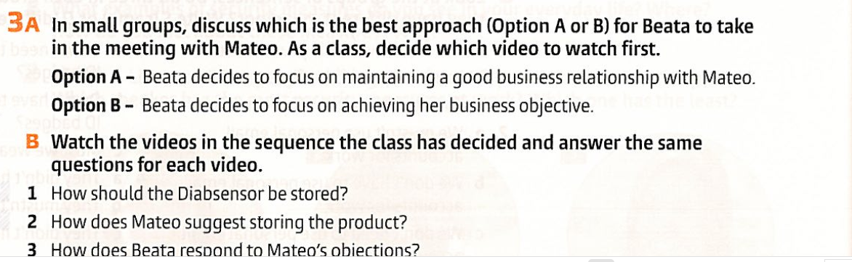

|  |
| --- |
|  |
|  |

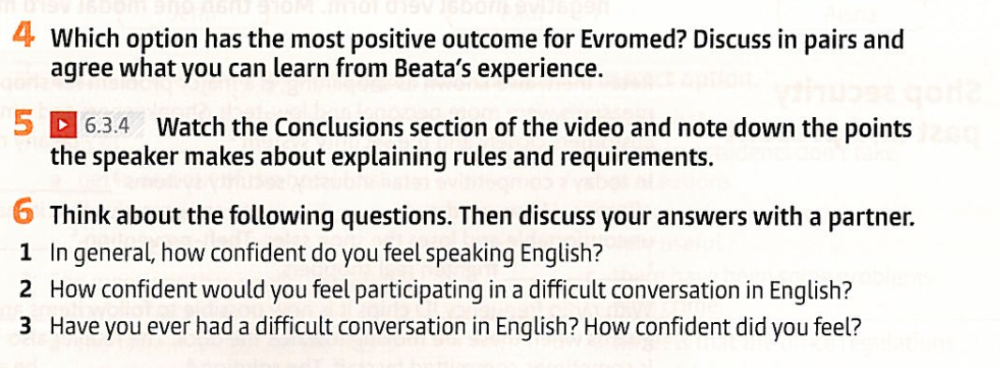

|  |
| --- |
|  |
|  |

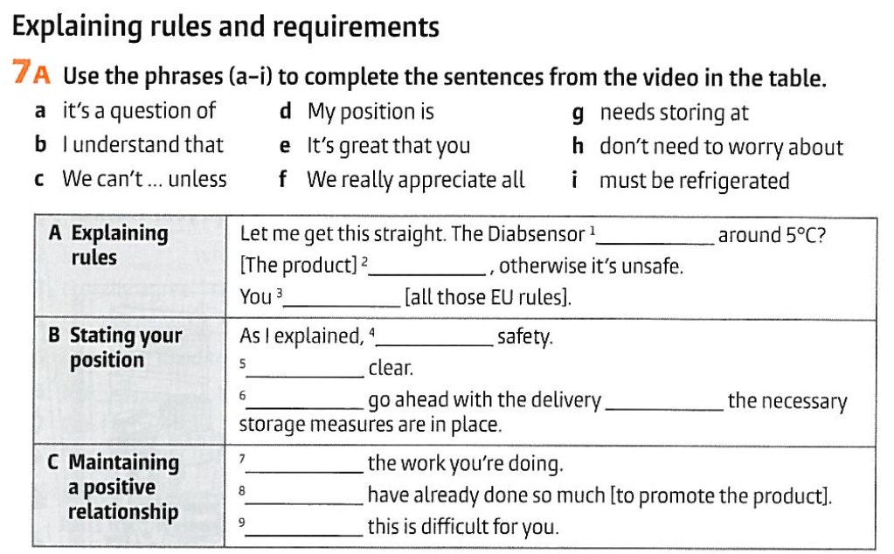

|  |
| --- |
|  |
|  |
|  |
|  |
|  |
|  |
|  |
|  |

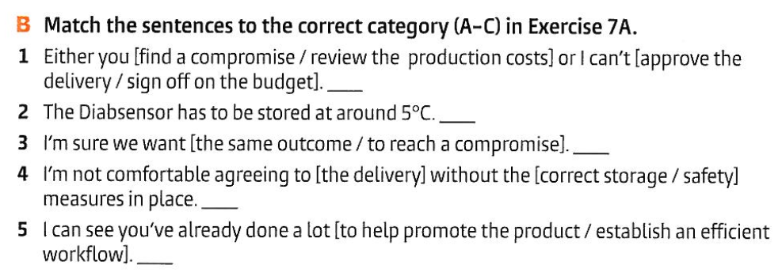

|  |  |  |  |  |
| --- | --- | --- | --- | --- |

Respond to a colleague with these ideas in mind:

Situation_A

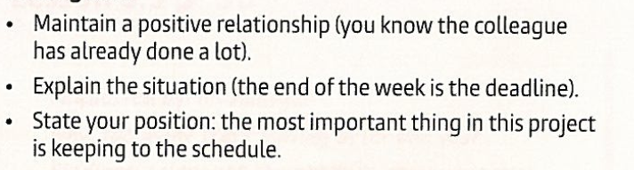

Your colleague said:



| You say: |
| --- |

Situation_B

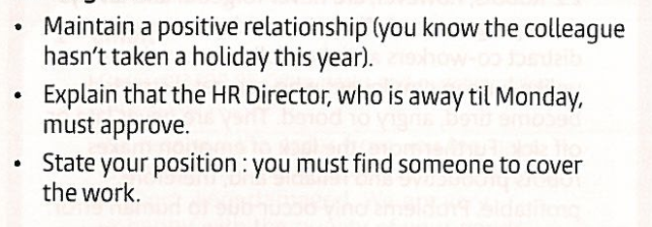

Your colleague said:



| You say: |
| --- |