DEMO

materials taken from Business Partner B1 SB p50-51

[What is Product Testing? Definition, Types and Process - Trymata](https://trymata.com/blog/what-is-product-testing/)

[product testing blog](https://asktheman.xyz/)

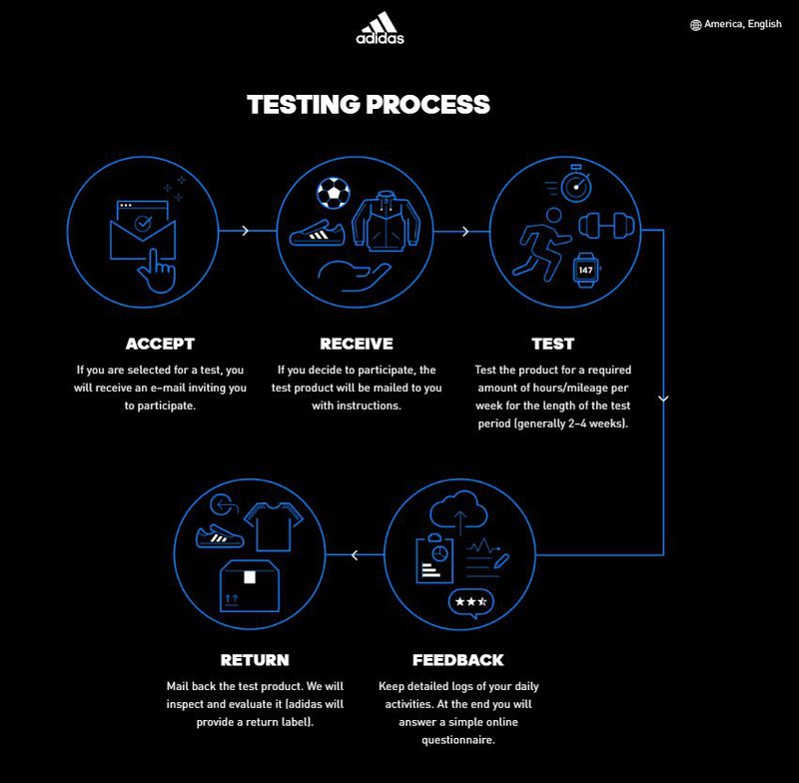

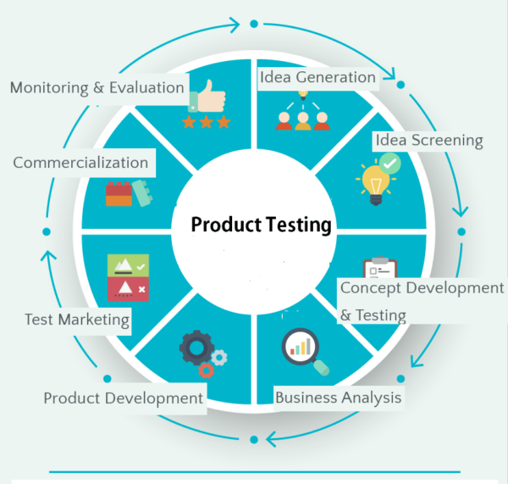

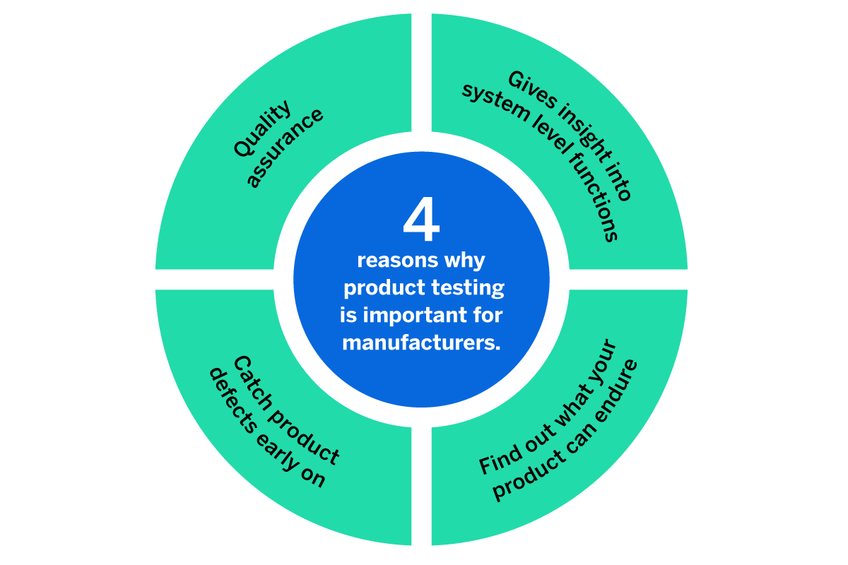

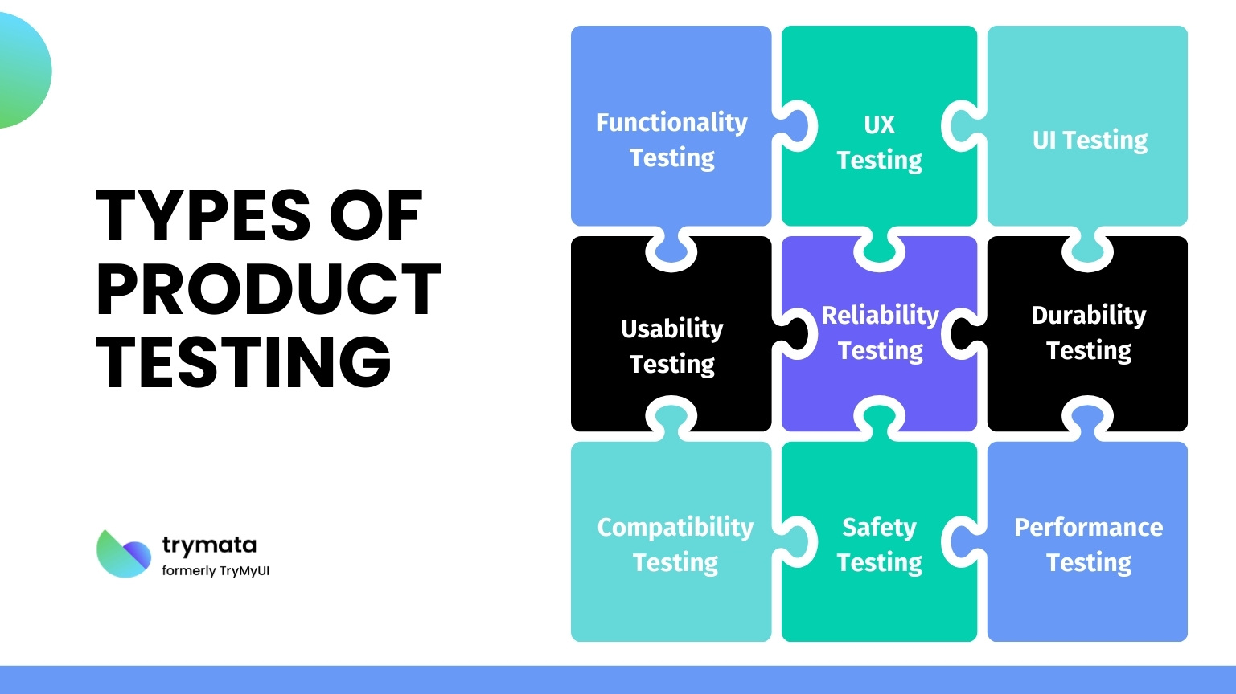

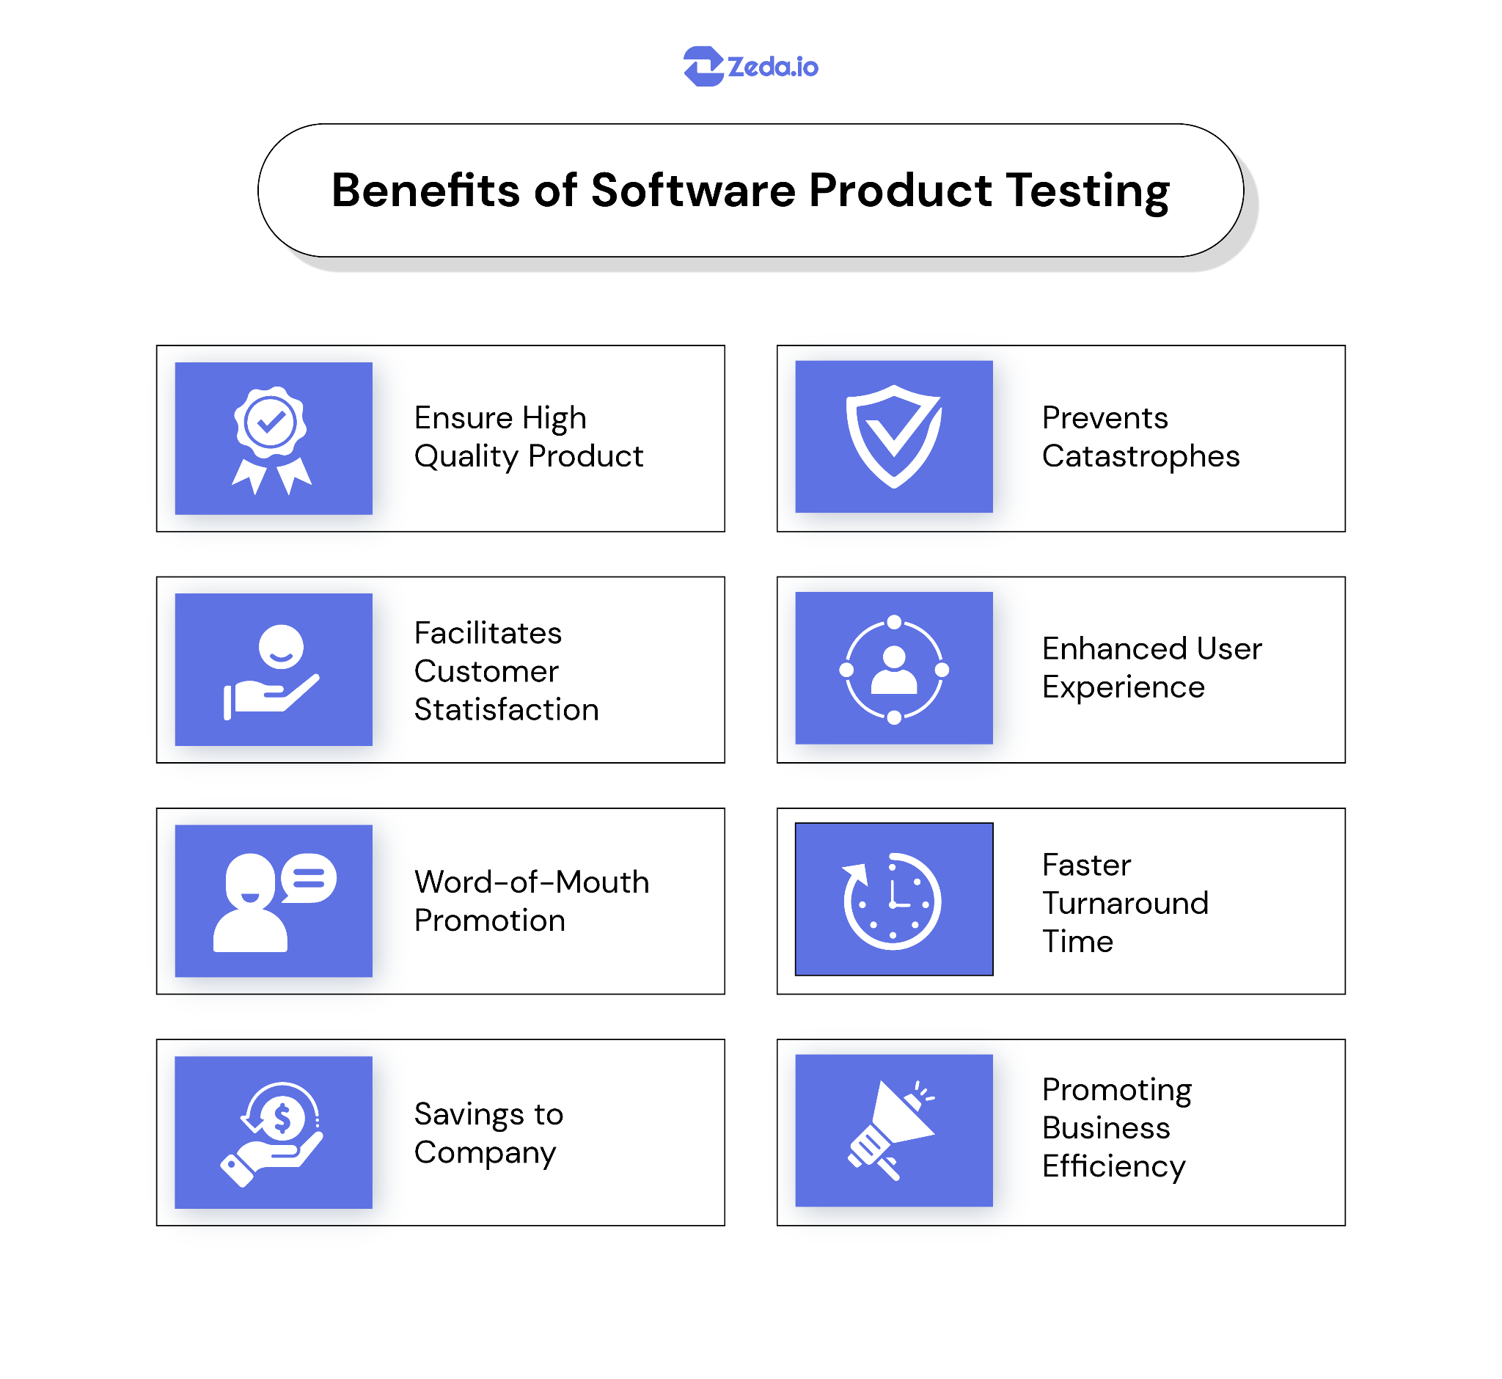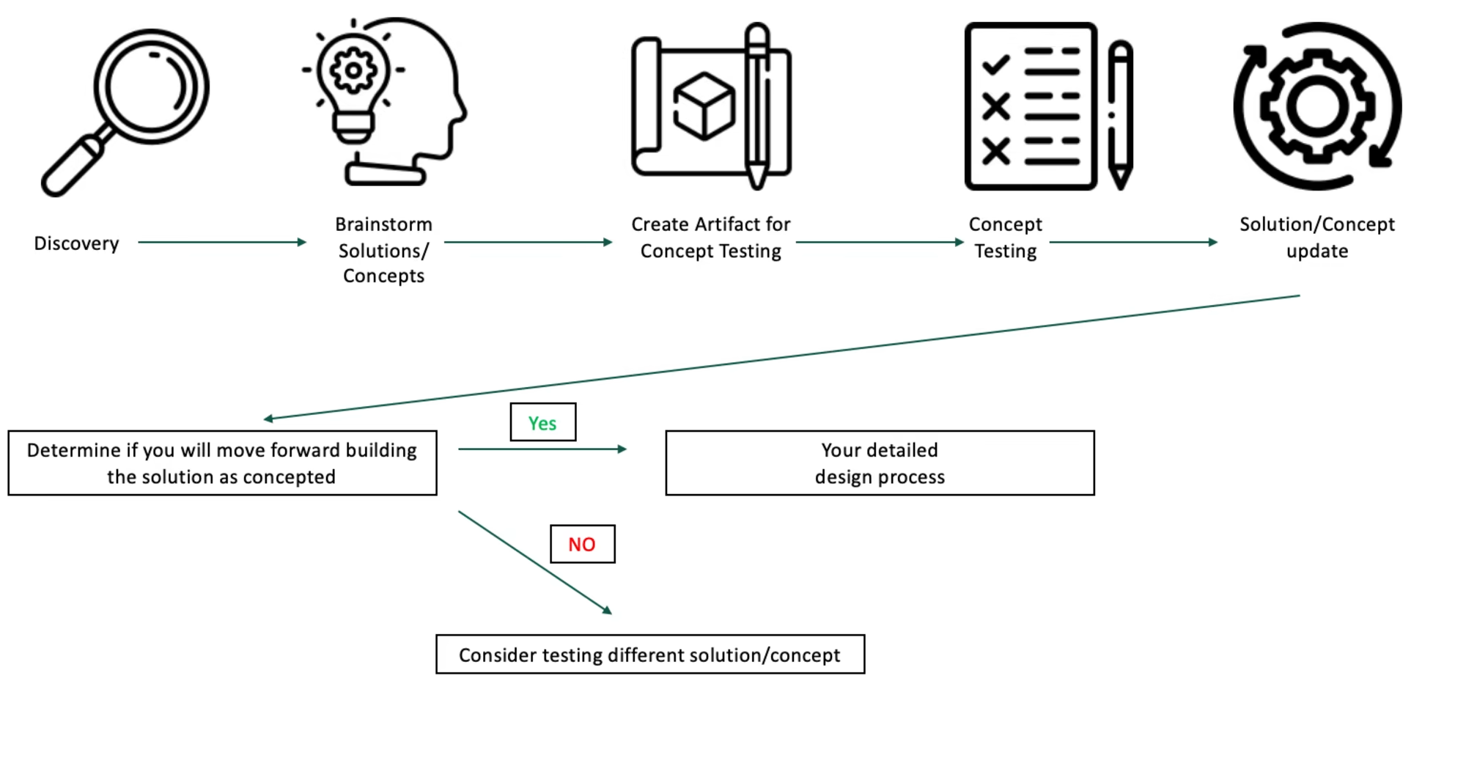

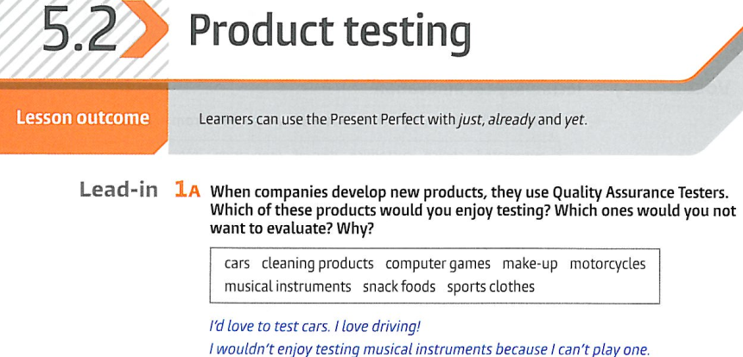

| + |
| --- |
| - |



|  |  |  |
| --- | --- | --- |



|  |  |
| --- | --- |



|  |
| --- |

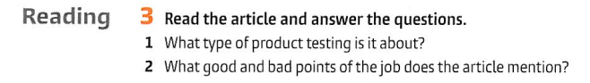

|  |  |  |
| --- | --- | --- |

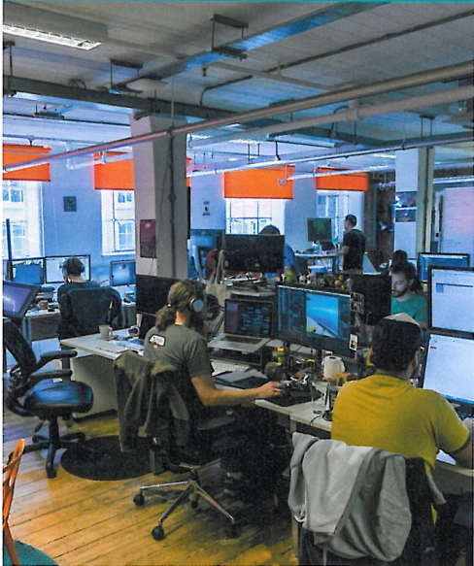1 2

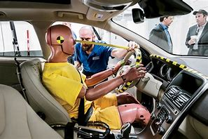3 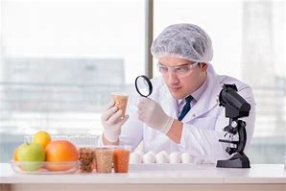4

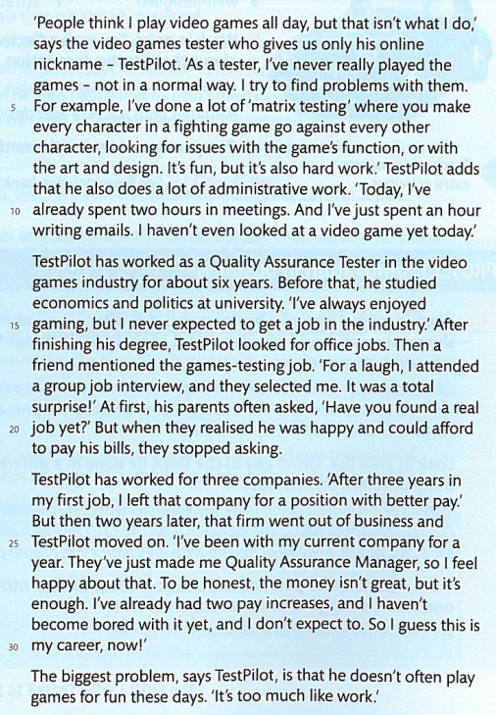

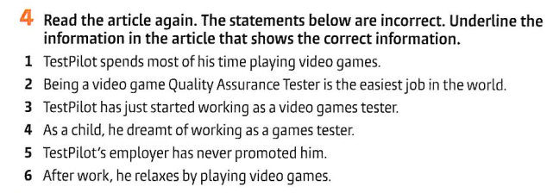

|  |
| --- |
|  |
|  |
|  |
|  |
|  |



|  |  |
| --- | --- |

|  |
| --- |

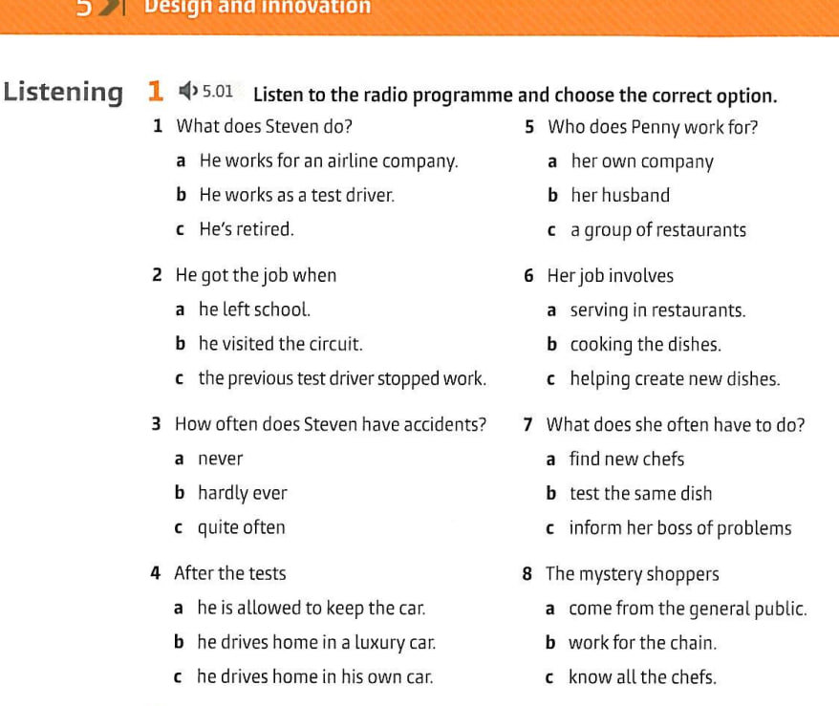

|  |  |  |  |  |  |  |  |
| --- | --- | --- | --- | --- | --- | --- | --- |

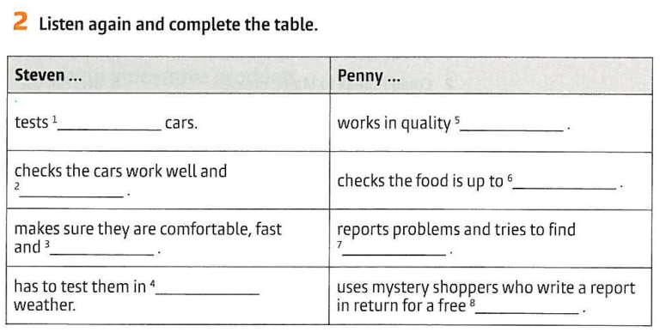

|  |  |  |  |  |  |  |  |
| --- | --- | --- | --- | --- | --- | --- | --- |

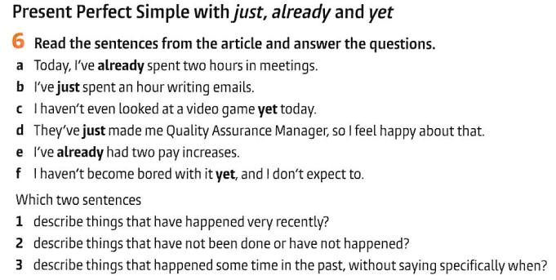

|  |  |
| --- | --- |
|  |  |
|  |  |

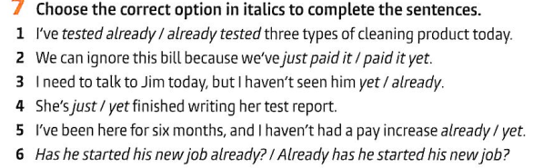

|  |  |  |  |  |  |
| --- | --- | --- | --- | --- | --- |

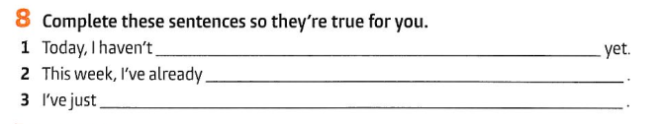

|  |
| --- |
|  |
|  |

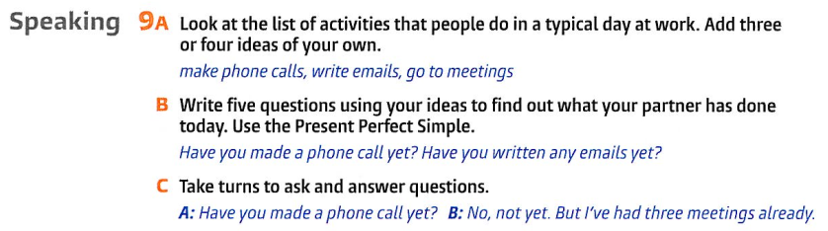

Appendix 1.

# 