DEMO
Lead in

Look at the pictures. What do you think this is about?

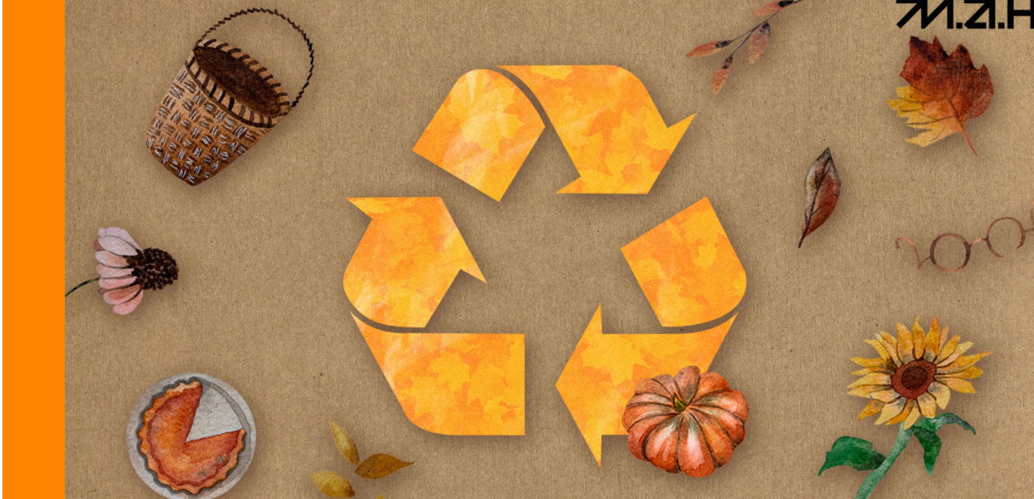

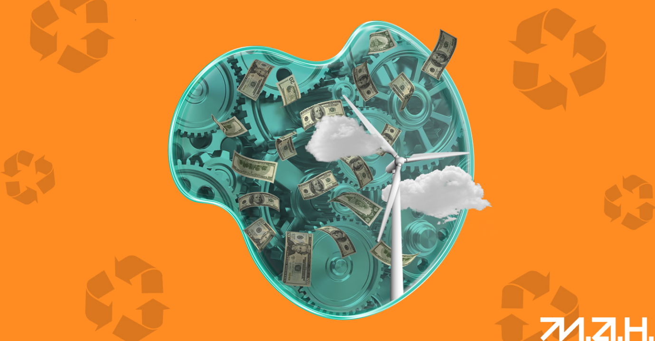

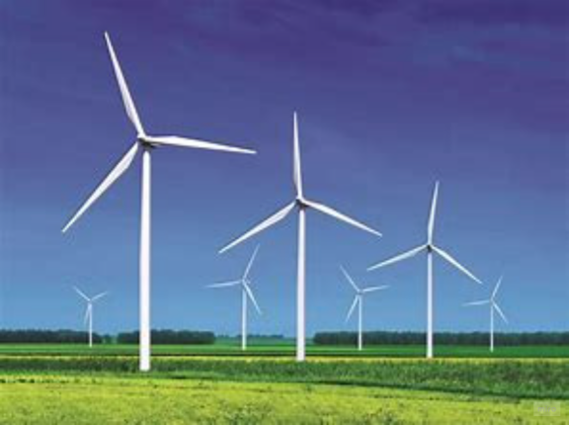

wind turbine

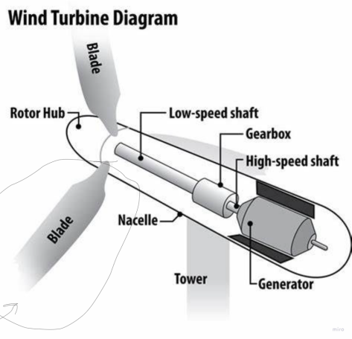

blade

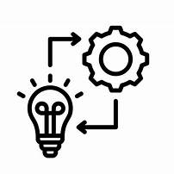
to implement

То

Quickly look through the article and match the next 3 pictures with inventions:
Ukrainian children continue to amaze with their achievements, and we continue to tell their stories. Today, we bring you the stories of four young Ukrainians, students of the Junior Academy of Sciences of Ukraine, who are sure to astonish you with their inventions and victories.
Yaroslava Polikarpova, a young entrepreneur from Kherson, who created the bladeless wind turbine project and continued to work on it even during the occupation.
Yaroslava Polikarpova, a graduate of the Junior Academy of Sciences and a resident of the "Ukrainian Future" business incubator, created the startup "WITERoK" last year, which focuses on a bladeless wind turbine project.
Despite finding herself in occupied territory with limited internet access, she did not give up on her project. She juggled her schedule between household chores, studying, and working on the project, sometimes even by candlelight. She recalls, "After our household chores, I would study and work on the project, sometimes by candlelight. Then I would go to sleep in multiple layers of pants, sweaters, socks, and wrap myself in a blanket because we had no heating. In such conditions, I developed a winning project."
Her project won international programs such as "Empowering Future Entrepreneurial Ukraine" and "Science&Business." These victories brought her two grants worth 5,000 euros or dollars each, which she is using to further develop her project, WITERoK.
"In the coming months," Yaroslava shares, "I want to make my wind turbine larger in size and improve its details. As for my global plans, I dream of conducting testing and implementing 'WITERoK' on a mass scale within Ukraine and Europe."
You can read Yaroslava's full story in an interview on JASmedia.

"Autumn" Scientific Projects by JAS Students
The autumn season inspires creativity not only among artists but also among young scientists, including participants of GENIUS Olympiad Ukraine 2023. Here are the stories of the competition winners who presented ecological ideas with an autumnal theme.
David Melnyk created eco-lovtsi (leaf collectors) and previously invented a method for making ink from oak leaves and acorns. His invention earned him a silver medal at the national stage of the "Genius Olympiad" in 2023.
Anastasia Shestopal developed a technology to transform dry leaves into briquettes for heating rooms and received an honorary award at the national stage of the "Genius Olympiad" in 2023. "Compressed leaf briquettes are an excellent alternative to firewood as a heating material," she explains. "This way, we save trees from being cut down and instead utilize a renewable resource - leaves."
Anna Kokhanenko wrote a short but highly practical story about eco-consciousness. In her work, she encouraged composting fallen leaves and provided detailed instructions on how to do it. She, too, received an honorary award at the national stage of the "Genius Olympiad" in 2023.
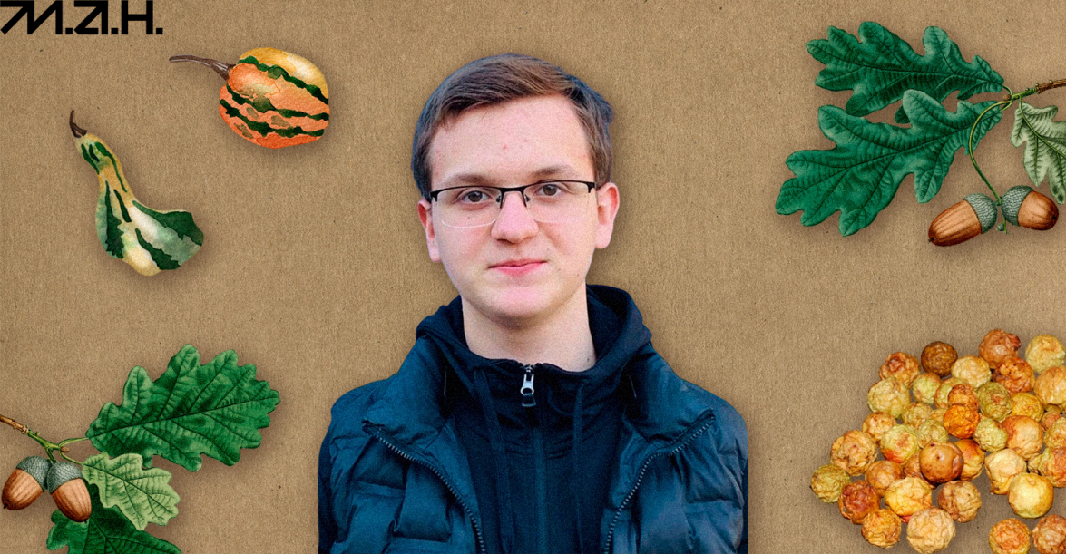
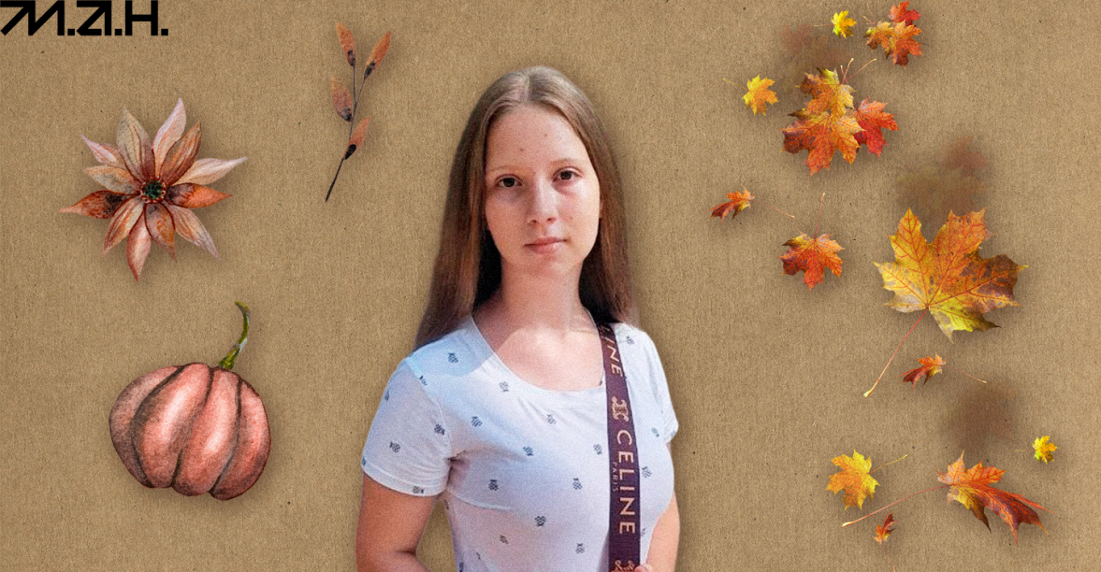
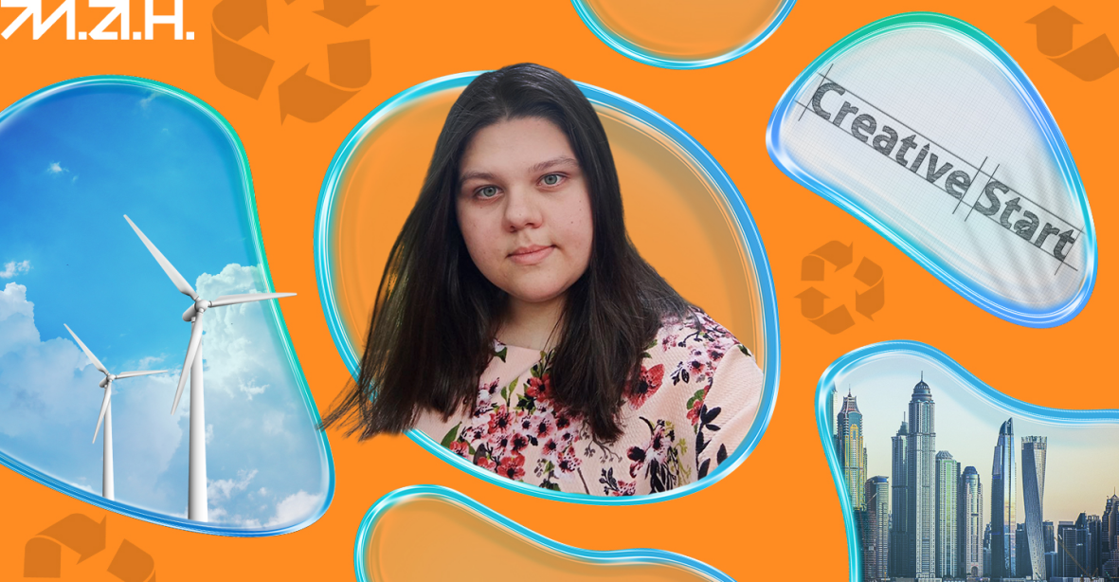

- transforming dry leaves into briquettes for heating rooms
- ink from oak leaves and acorns
- bladeless wind turbine

Read the text again and mark the statements True or False:

1. Yaroslava Polikarpova created a project for a bladeless wind turbine.

2. The "WITERoK" project won international programs and received two grants of 5,000 euros each.

3. Yaroslava plans to make her wind turbine smaller in the coming months.

4. David Melnyk invented a method for making ink from pine needles and cones.

5. Anastasia Shestopal developed a technology to transform dry leaves into pizza boxes

Materials are taken from
https://platform.man.gov.ua/media/5189a177-e151-40d0-aca4-5cc7f3a49b67

https://destinations.ua/social/Social/1178-eco-enthusiasts-leaf-briquettes-and-bladeless-wind-turbine-what-young-ukrainian-inventors-are-up-to

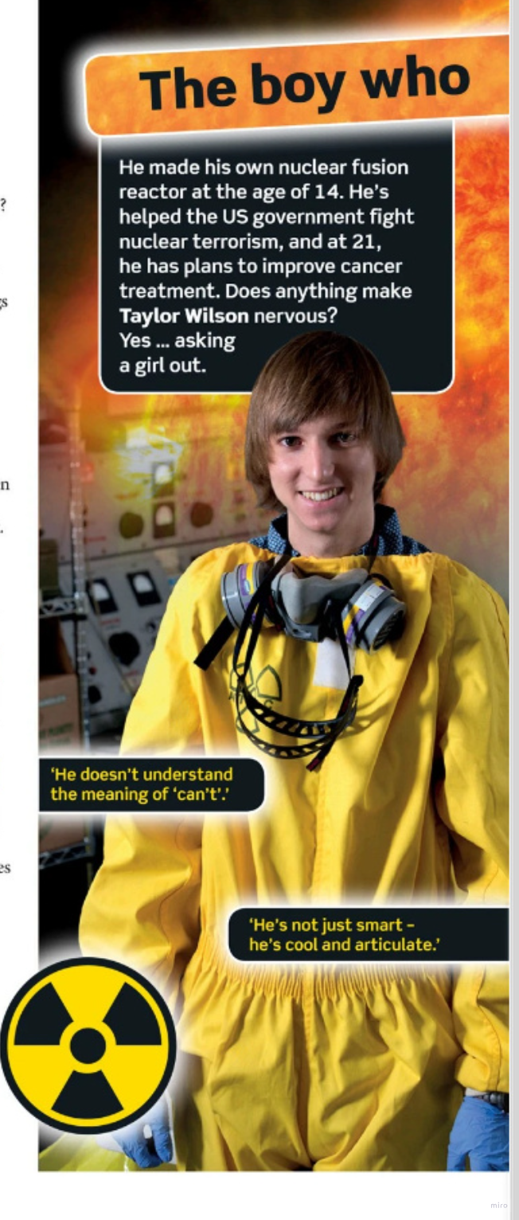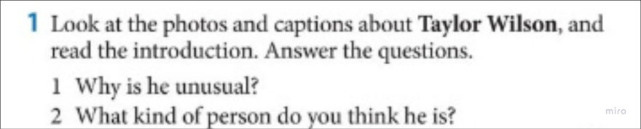
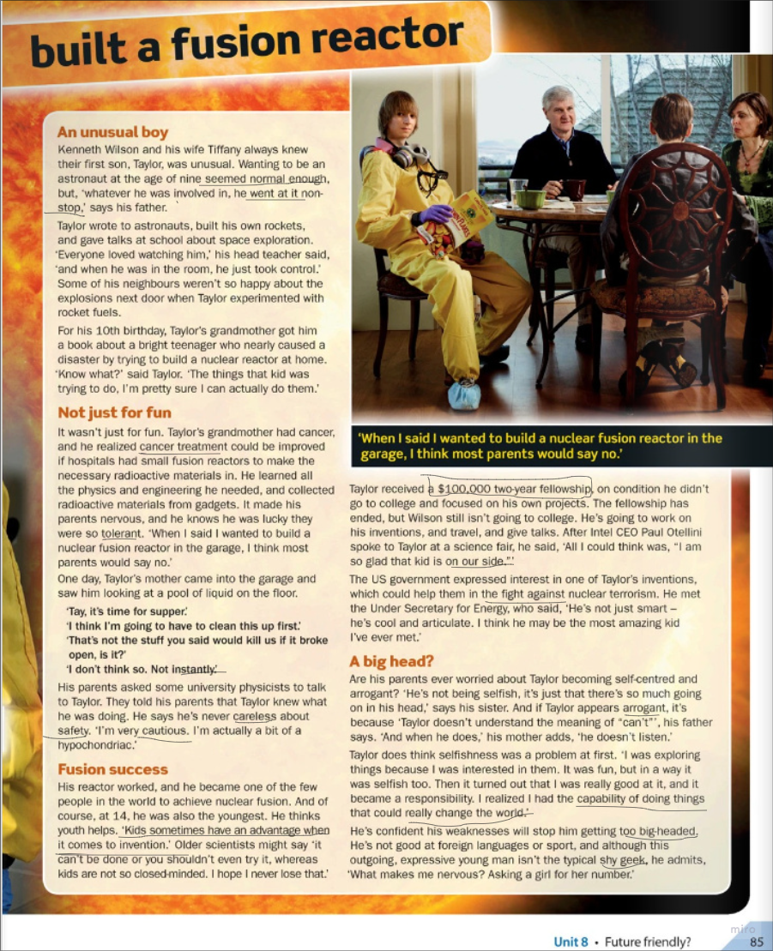

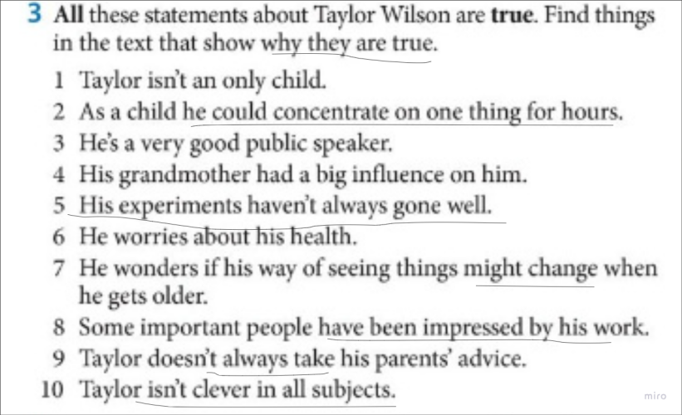

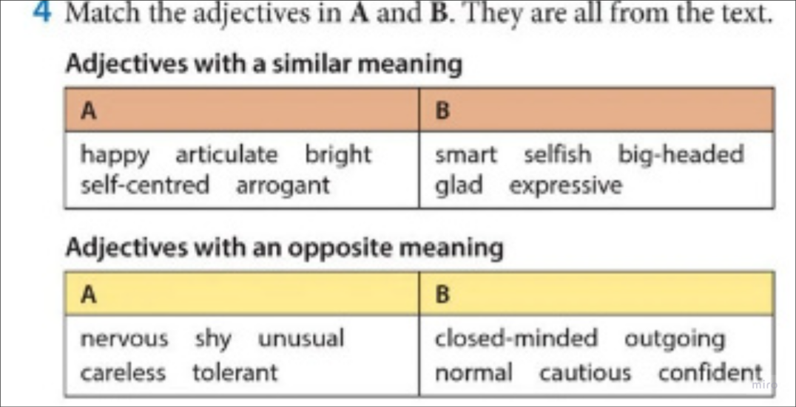

Hometask
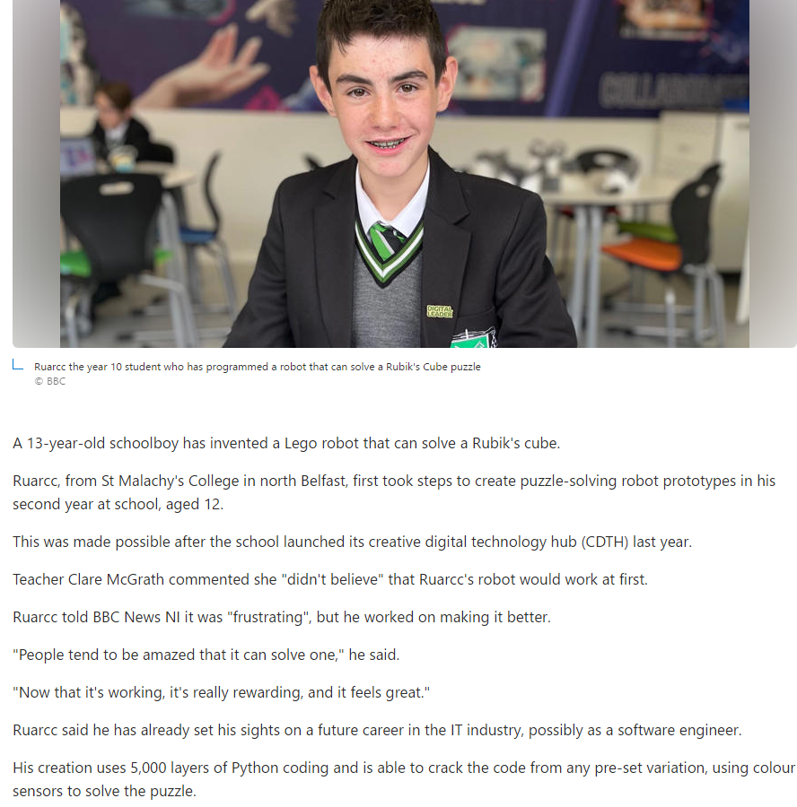

Discussion:

What qualities and skills do inventors possess?
Do kids have any advantage over adults when it comes to inventing? Why?
Share some childhood memories about ‘inventing’ something /or stories about genius children.

